Report of FOSM Project to Process Donation Wood with East Mountain High School Volunteers
at Balsam Glade Picnic Area, Wednesday, October 7, 2026

Sam Beard and Rene Archer

On Wednesday, October 7, nine FOSM volunteers worked with seventeen East Mountain High School students and three faculty members to process almost 1.5 cords of donation wood at Balsam Glade Picnic Area. This project was one option that students could select during Mountain Discovery Days at the school.

The processing included felling a couple of hazard trees, bucking logs already on the ground, splitting rounds, hauling the rounds in wheel barrows to the parking lot, loading them on Mike Oliver’s trailer, and unloading them at his woodlot.
The Mountain Christian Church Wood Ministry will distribute the wood to East Mountain families who heat their homes with wood this winter.

The wood was processed at five sites in Balsam Glade Picnic Area – (1) Near La Madera Canyon Overlook; (2) A low ridge beside the overlook trail; (3) A hillside near the upper parking lot; (4) The area behind the restrooms, and (5) The area between the trail and the lower picnic shelter.

Project photographs are presented below.
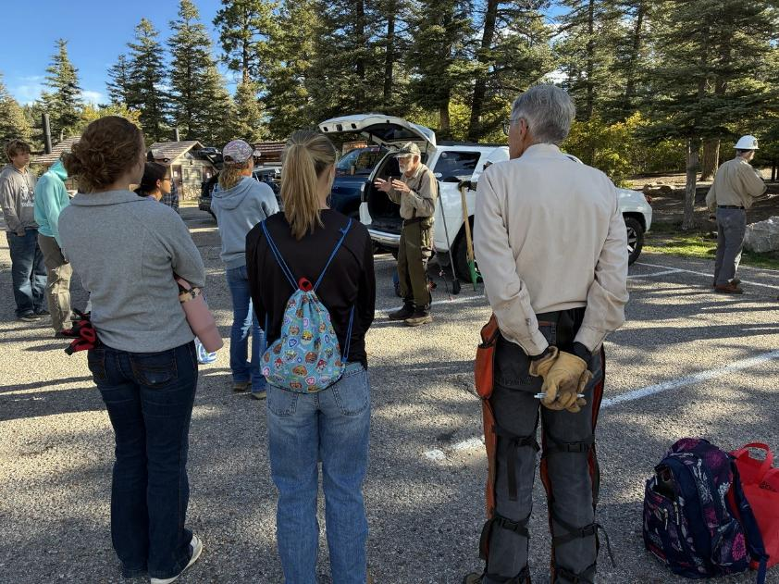
Sam Beard making the safety presentation in Balsam Glade parking lot.
All photos by Cliff Giles unless noted otherwise
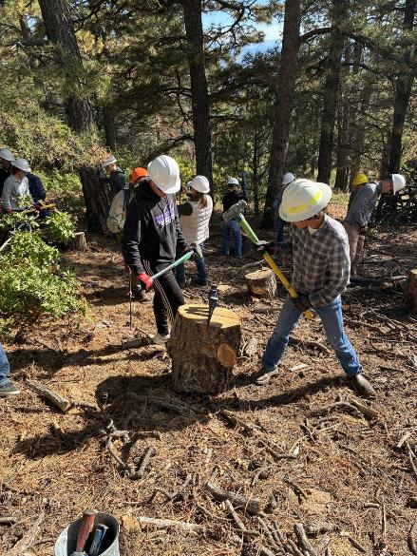
EMHS students splitting rounds near La Madera Overlook.
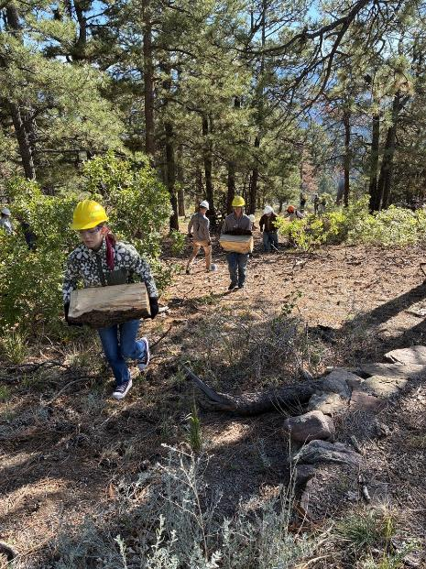
Students carrying wood up to the Overlook Trail.
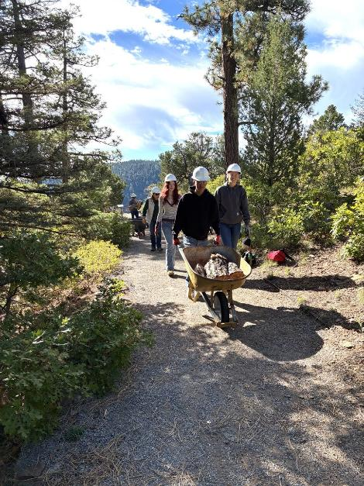
Hauling split wood on the Nature Tail to the Balsam Glade
parking lot.
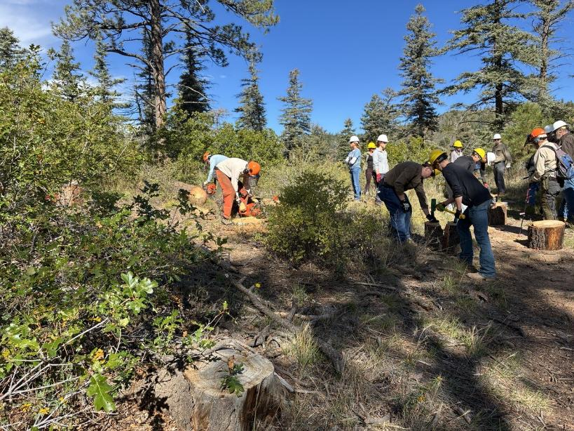
Students splitting rounds on the ridge near the overlook.
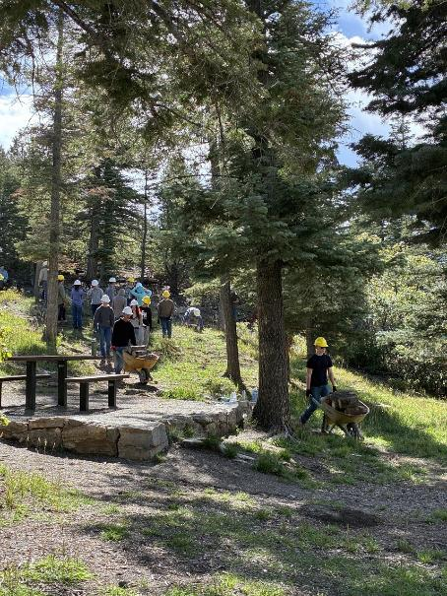
Hauling wood from upper picnic area to the parking lot.

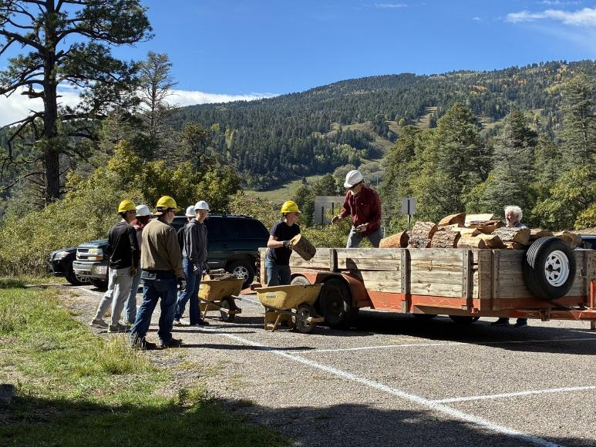
Loading wood on Mike Oliver’s trailer in eastern part of parking lot.
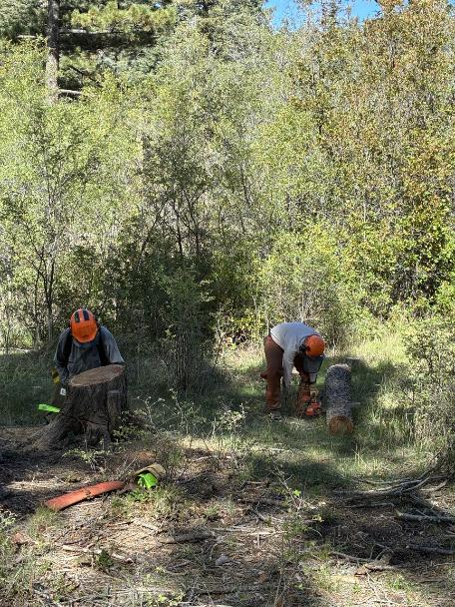
Low cutting stump and bucking log behind the restrooms.
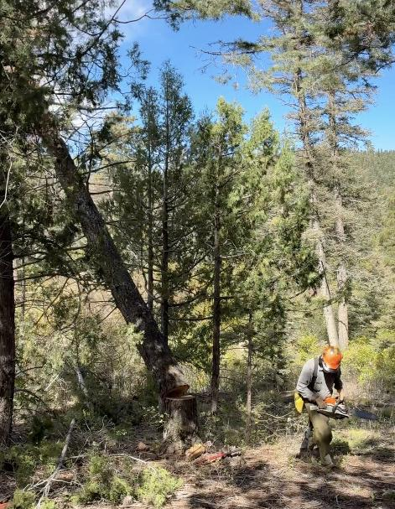
Jerry Carroll running away from the dead tree he
felled near the picnic shelter.
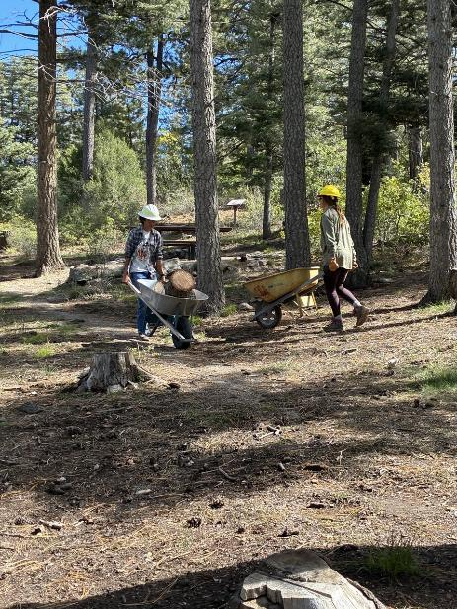
Hauling rounds from the felled fir tree to the parking lot.
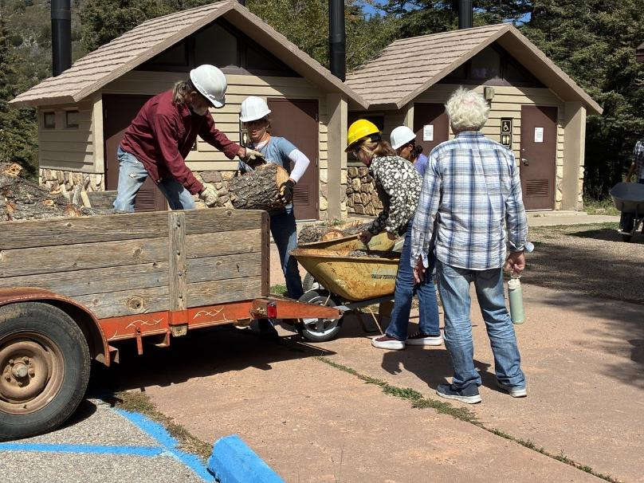
Loading rounds onto Mike’s trailer near the restrooms.

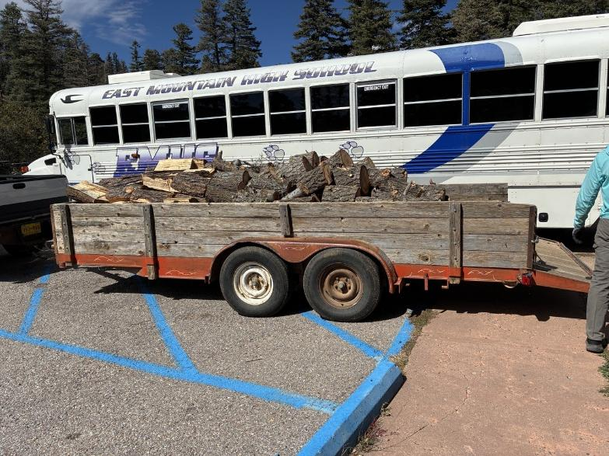
Almost 1.5 cords of donation wood on Mike’s trailer.
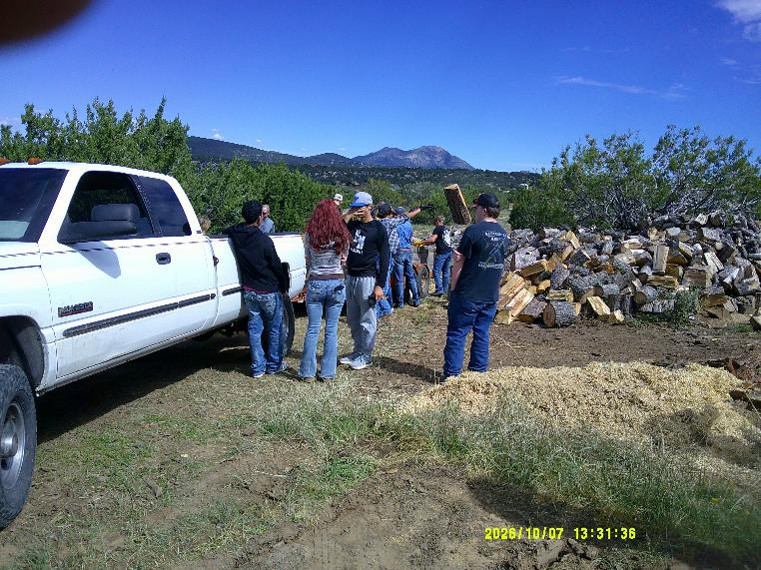
Students unloading wood at Mike’s woodlot.
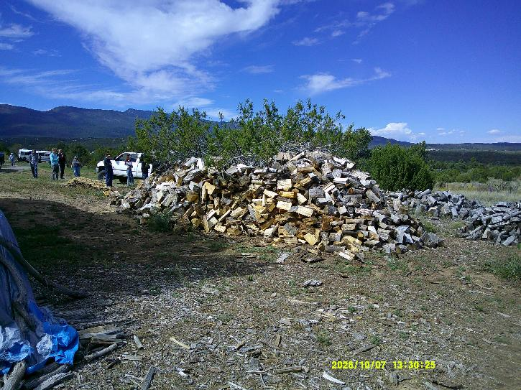
The large pile of donation wood processed by FOSM volunteers in FY2026.

