Thursday, 10/15/26- Buried Cable and Switchback: 15 volunteers showed up on the cold and windy crest for the push to finish the parts of Switchback and Buried Cable that we have access to at this time. The fire mitigation crew should be back working soon and hopefully we will have access to more debris covered trails before the snows come (Thinking optimistically here!) The heavy rains last month left some pretty crazy water erosion marks throughout the debris. Hopefully the massive winter snows will pack down the debris so it does a better job of holding in the moisture. The group finished 4,805 ft of Switchback and 1,083 ft of Buried Cable. This project started back on July 23, 2026 and we are happy with the completed work.

Volunteers: Kit French, Bill Perkins, John McNett, Bruce Hansche, Laura Leon, Steve Roholt, Silke Bletzer, Jamey Browning, Jim Houle, Luis Cuadros, Byron Garner, Eric Russell, Rich Fagioli, Claudia Bergsohn, Tony Pachelli
Pictures: Silke Bletzer and Laura Leon Data- Luis Cuadros (the numbers guy)

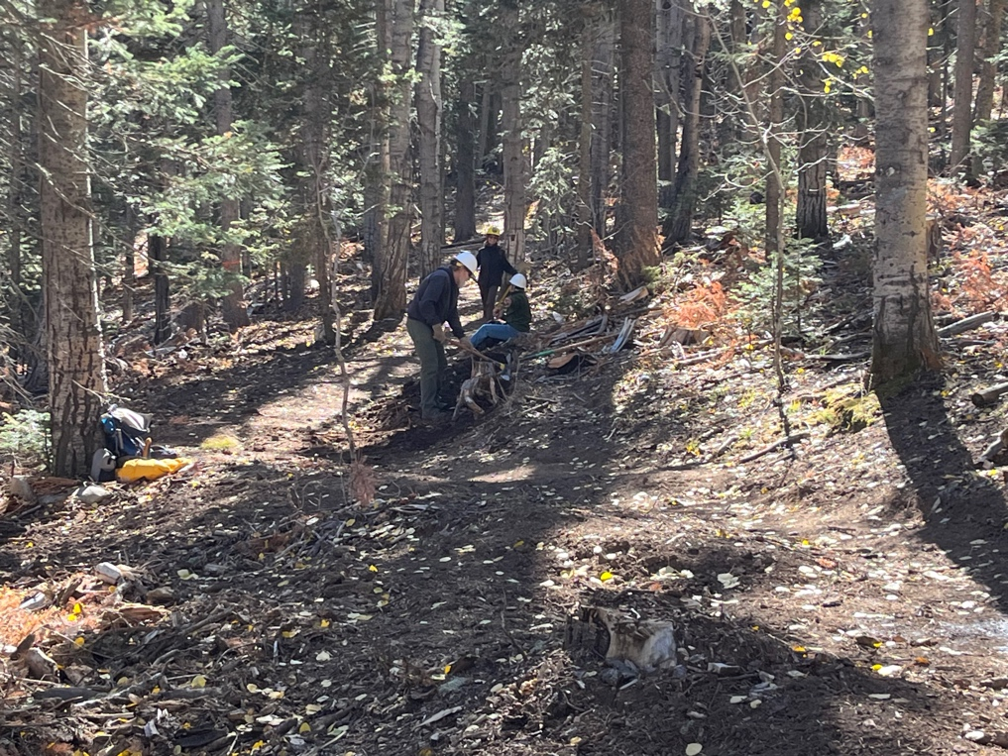
John, Steve and Silke having the time of their lives.

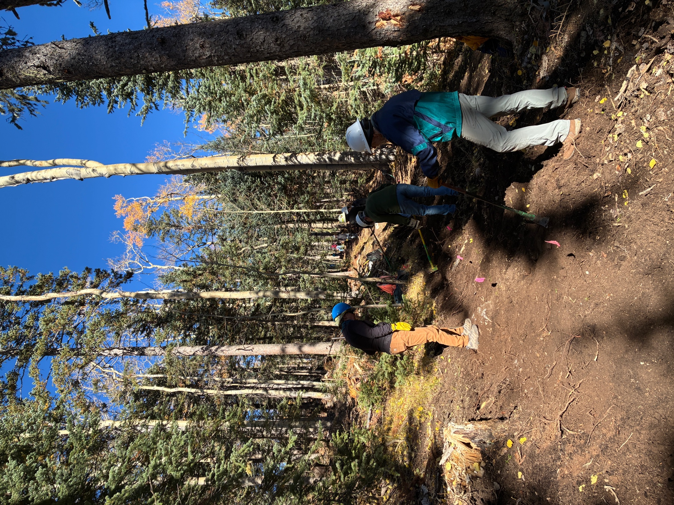
A long line of workers.

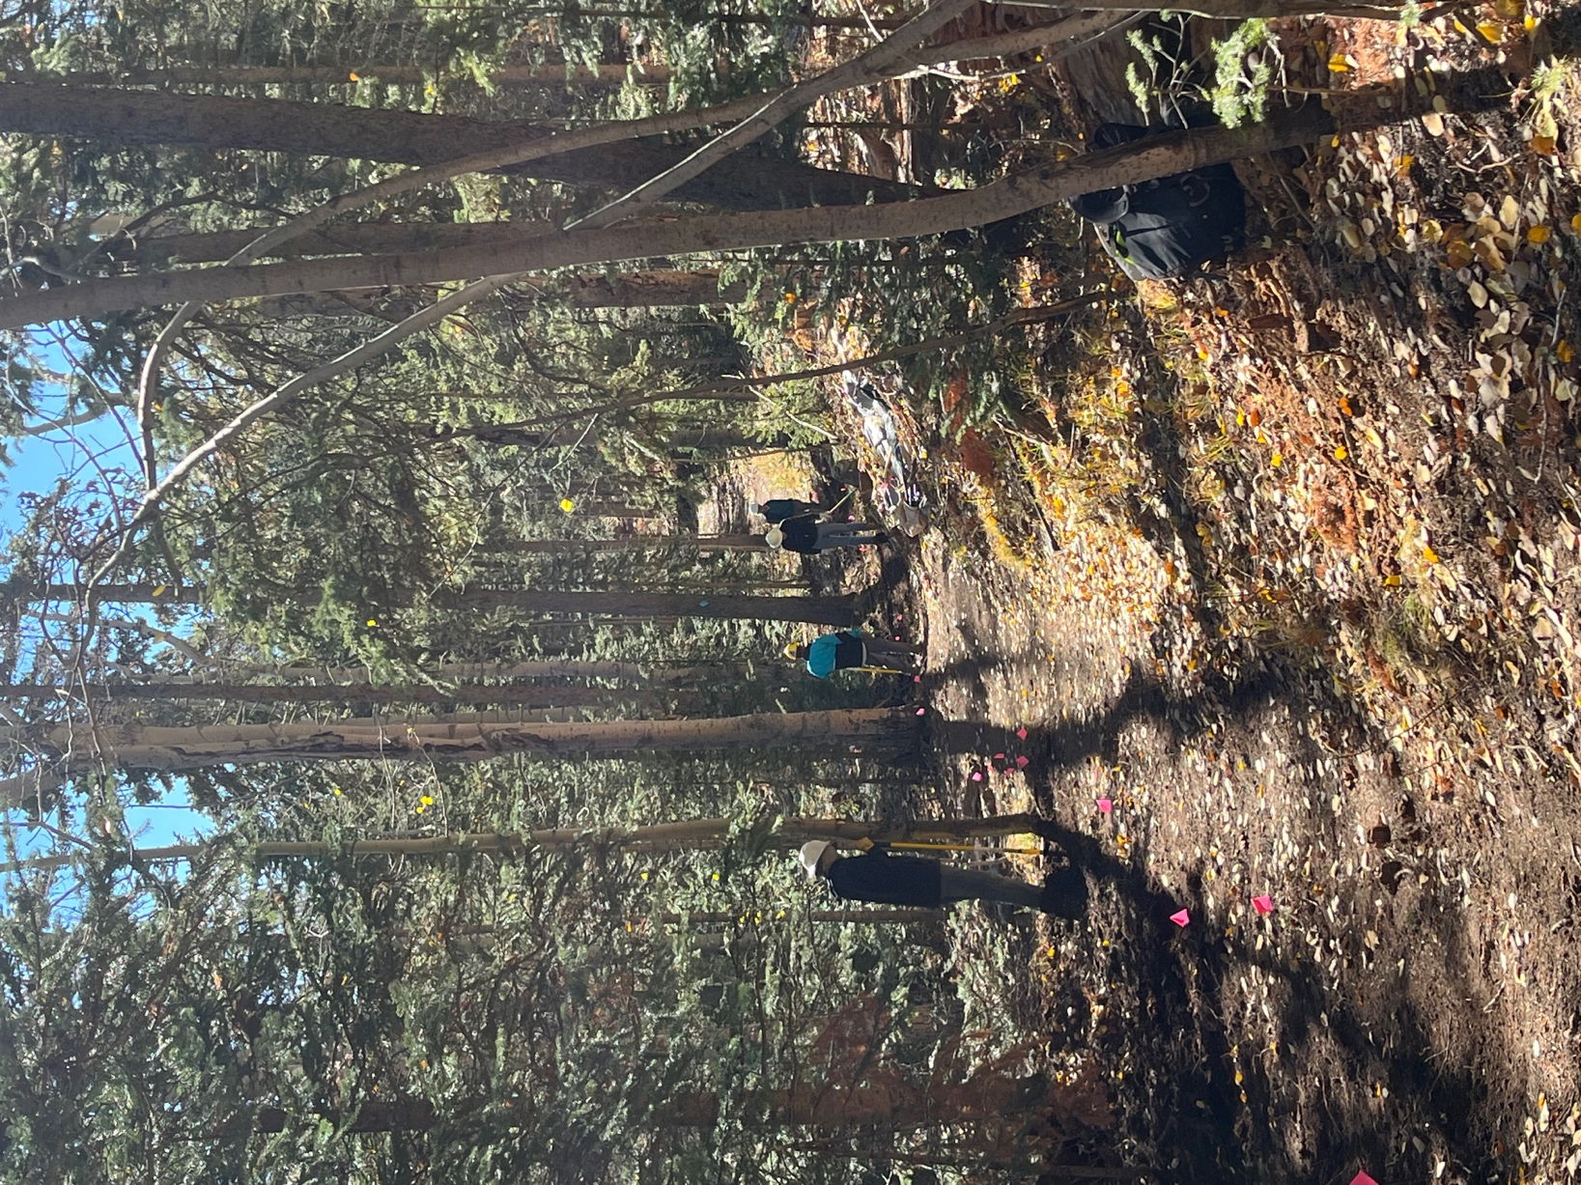
Nice and sunny but there was a definite chill in the air this week.
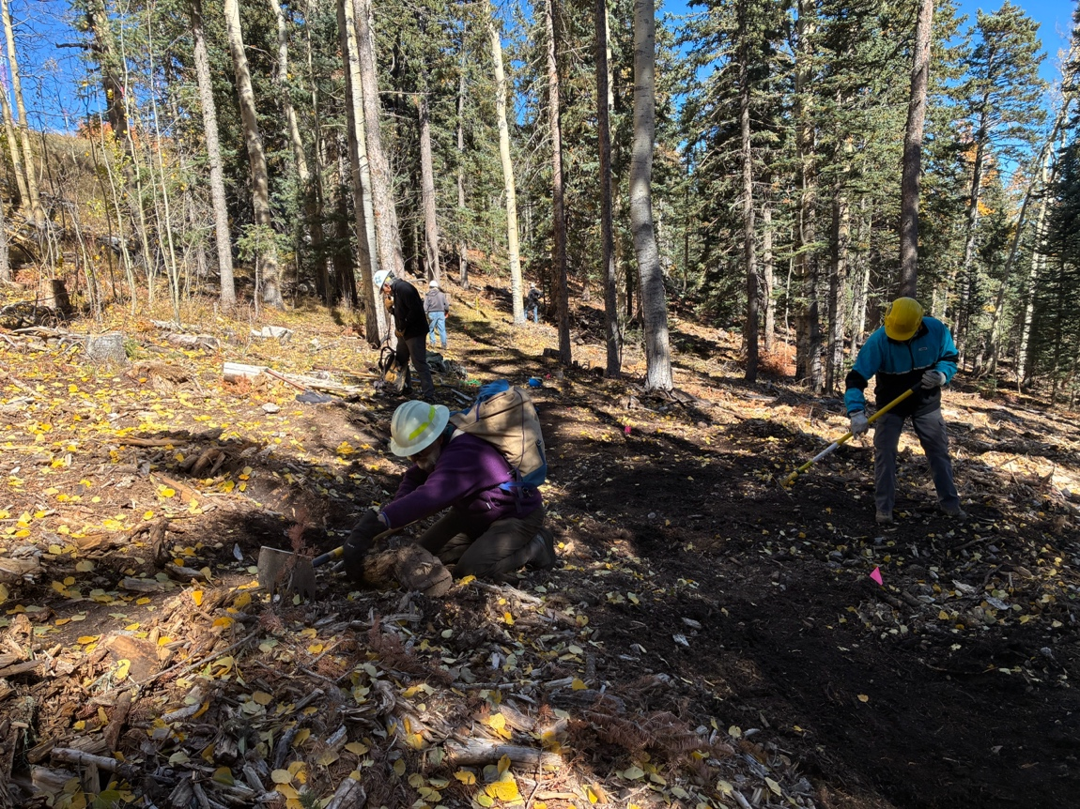
Bill, Kit and Luis work amongst the aspen leaves.
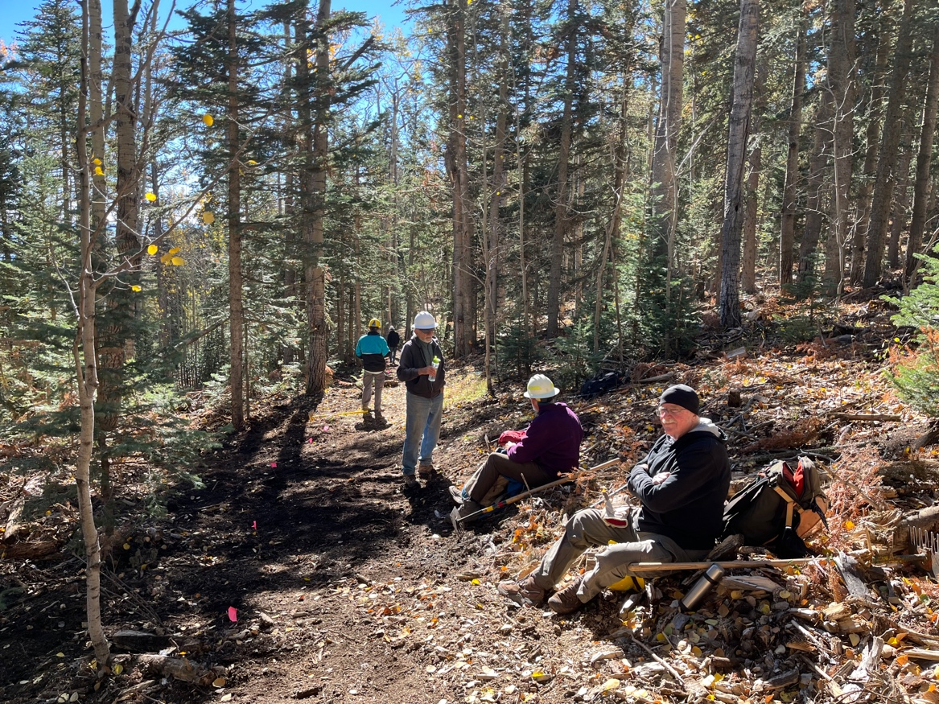
Taking a rest and trying to stay warm! Muffins helped…

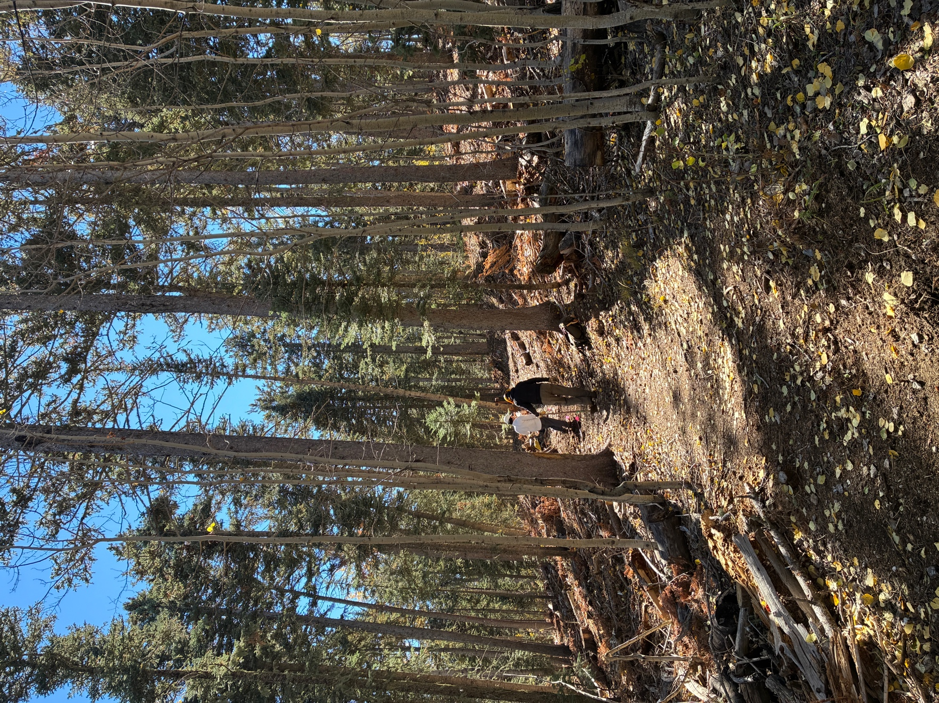
Nice and open, the forest looks great.
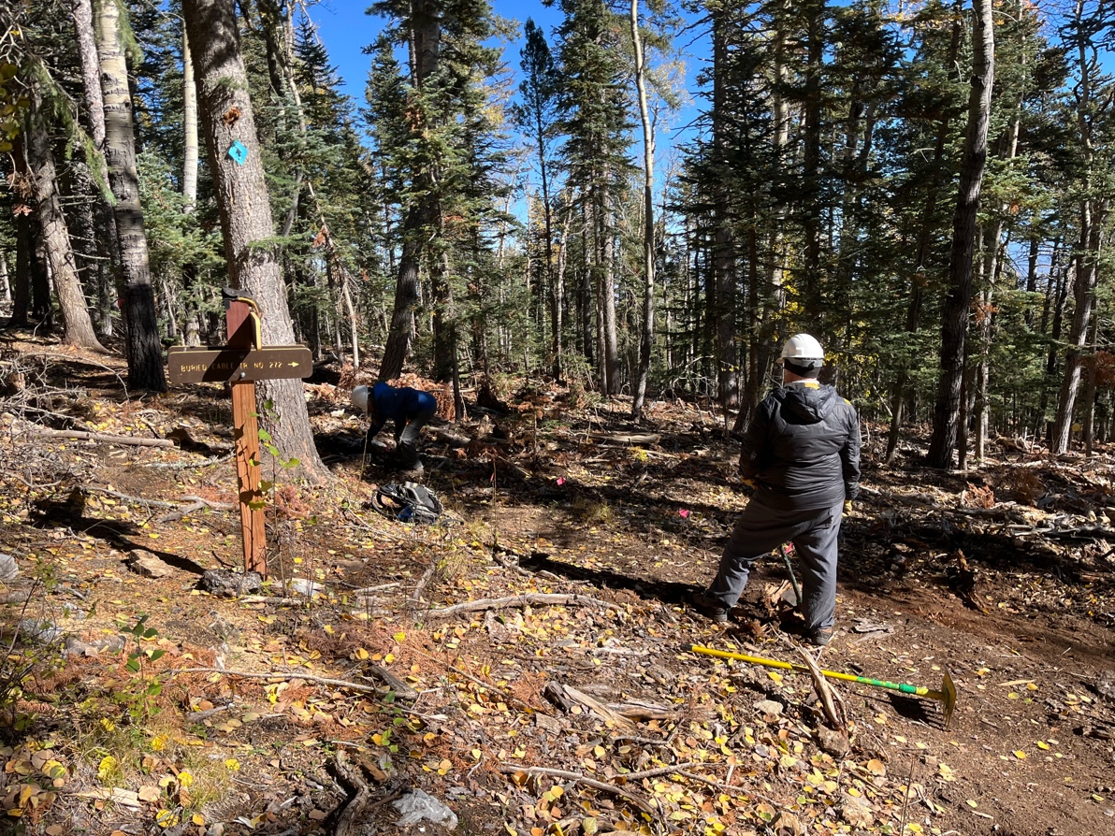
Rich and Claudia at a crossroad.
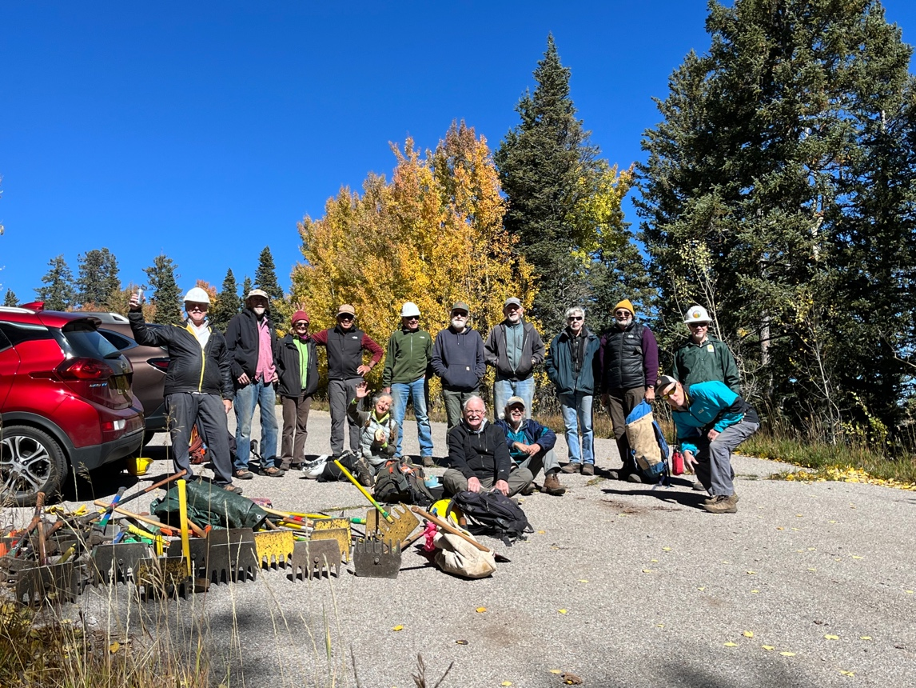
The crew minus Laura.
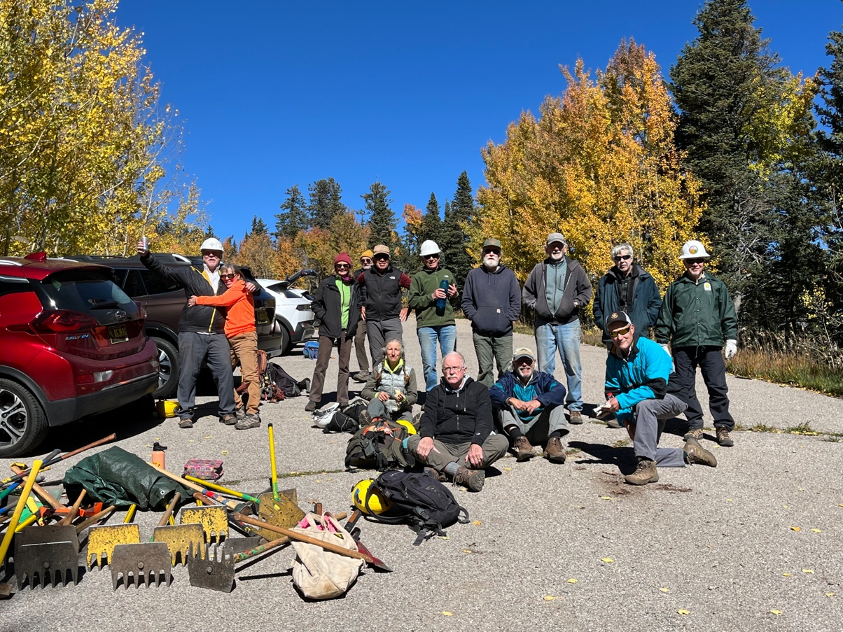
The crew minus Bruce and Jim.
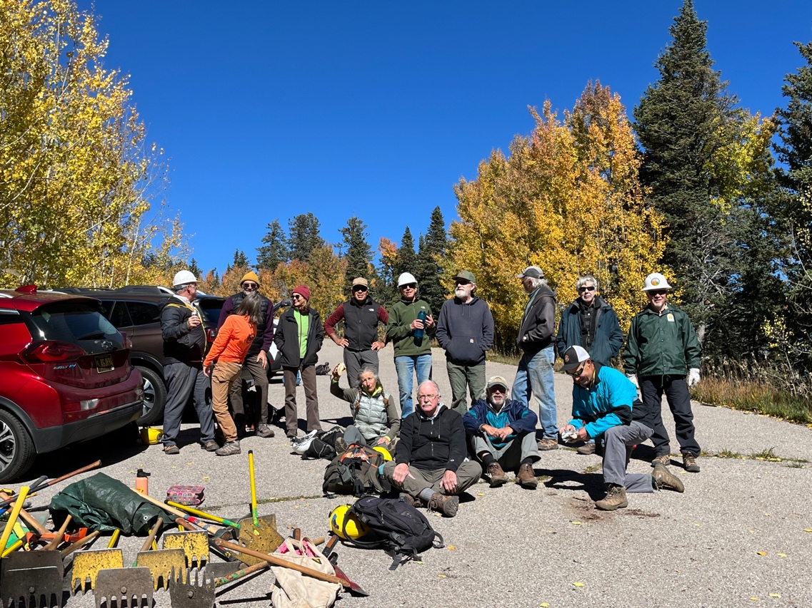
The crew minus Bruce. We need a bear to take the picture next time!

