Report of FOSM Project to Cut Brush in the Traffic Island at the Capulin
Snow Play Area on Wednesday, October 14, 2026

Sam Beard
On Wednesday, October 14, seven FOSM volunteers cut brush in the Capulin Snow Play Area to make room for Forest Service personnel to push snow onto the traffic island next winter when they are plowing the parking lot. The volunteers used chain saws and two power brush cutters to cut the brush.
The volunteers were Karen Greif, Sam Beard, Cliff Giles, Eric Russell, John Quinley, Chuck Logan, and Jerry Carroll.
Project photos are presented below.

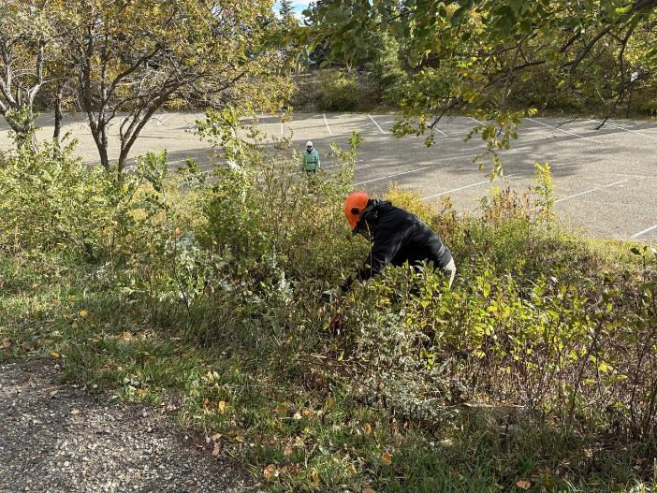
Eric Russell cutting brush with a chain saw with Karen Greif swamping in the background.
All photos by Cliff Giles

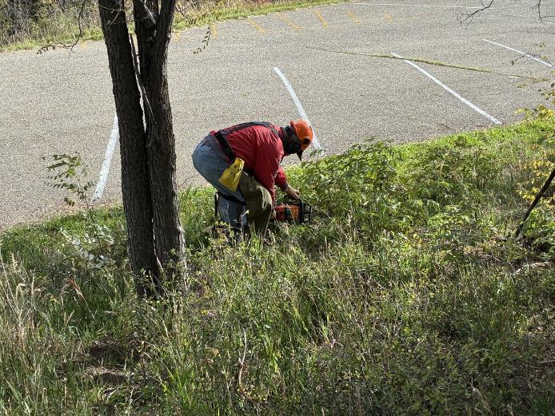
Jerry Carroll cutting brush with a chain saw.

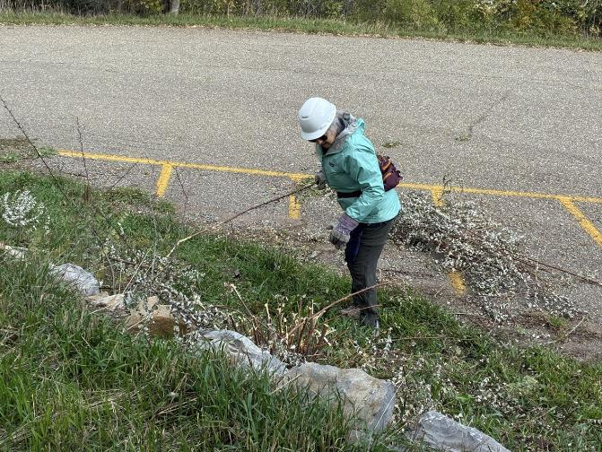
Karen moving slash onto the pavement.

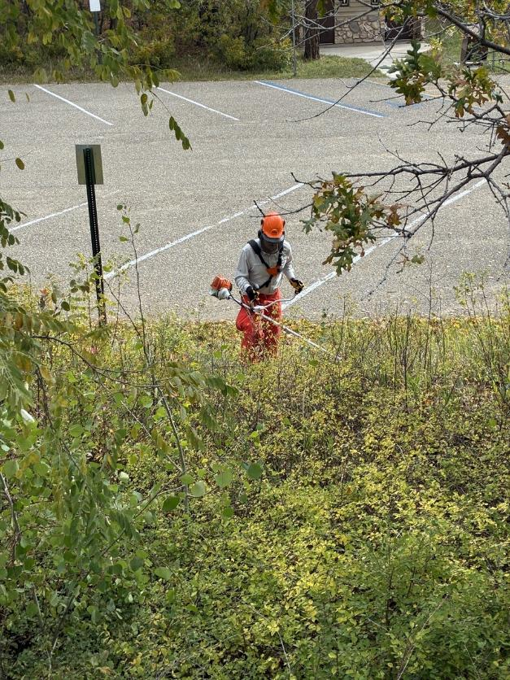
John Quinly cutting brush with a FOSM power brush cutter.
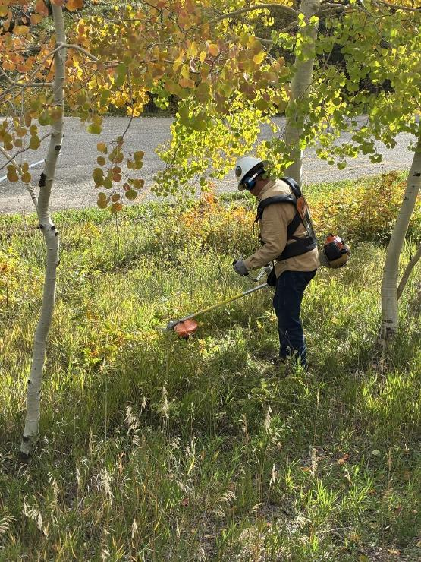
Chuck Logan cutting brush with a power brush cutter.
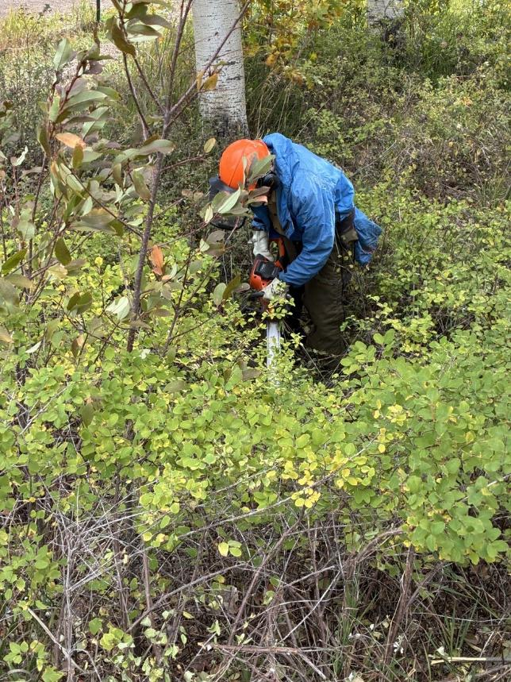
Sam Beard cutting brush with a chain saw.
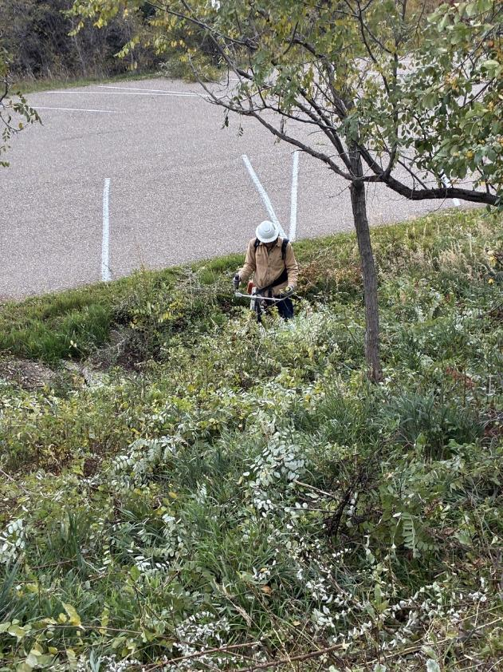
Chuck Logan cutting brush near the pavement with a power brush cutter.
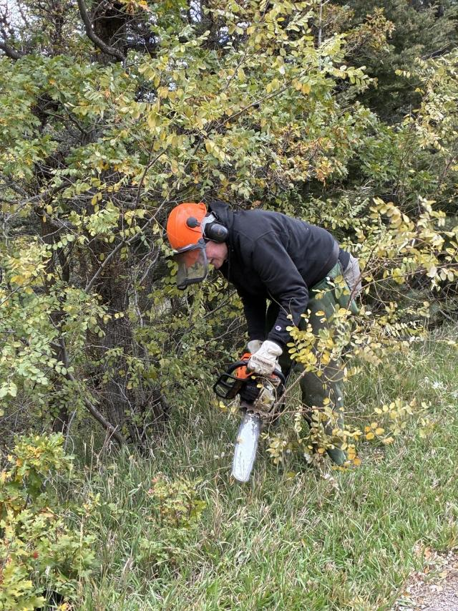
Eric cutting brush with a chain saw on the slope between the two parking lots.
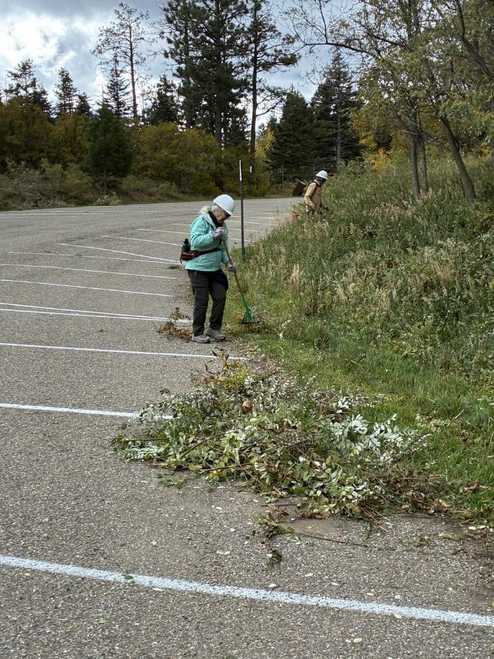
Karen raking slash onto pavement.
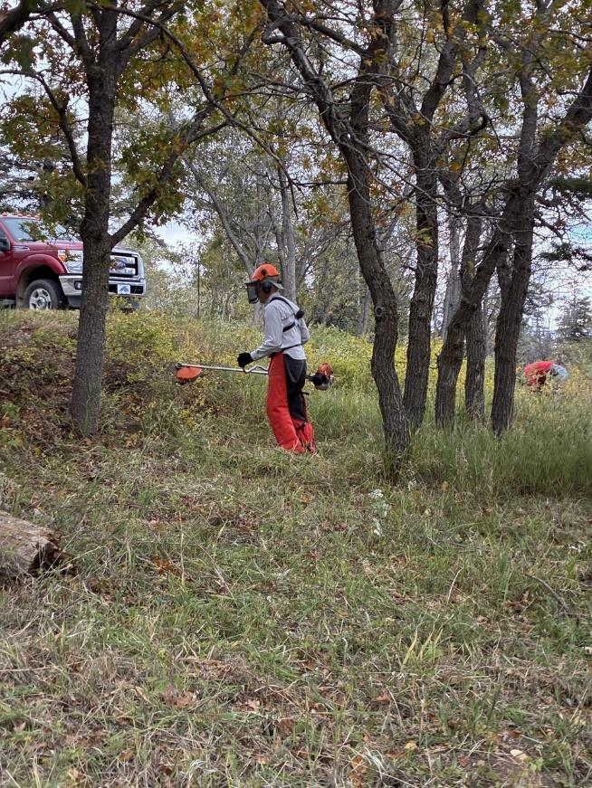
John cutting brush on the slope below the upper parking lot.

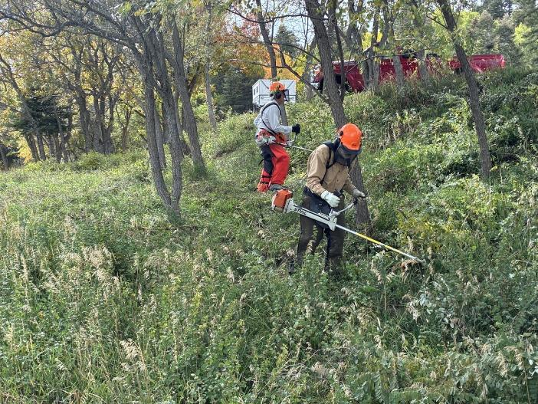
John and Sam cutting brush with power brush cutters below the upper parking lot.

