Thursday, 10/22/26 -Crest Nature Trail and S. Crest Trail: Nine volunteers joined Jen (SRD) for one last day of work at the crest. The machinery is not up and running so we are assuming it will be too cold and the soil will be too hard for us to work up there when they finally finish fire mitigation. We parked by the vault restrooms and walked out the Nature Trail which looked pretty good and only needed a bit of work where the machinery treads had left uneven surfaces. Then we headed down S. Crest which had plenty of debris heaps to move and spot work to do on the actual trail. We finished up a bit early, just as the clouds started moving in.
Volunteers: Jim Houle, Kit French, Rich Fagioli, Bill Perkins, Claudia Bergsohn, Eric Russell, Kerry Jones, Luis Cuadros and Laura Leon
Pictures: Laura Leon

Sunrise on Sandia.
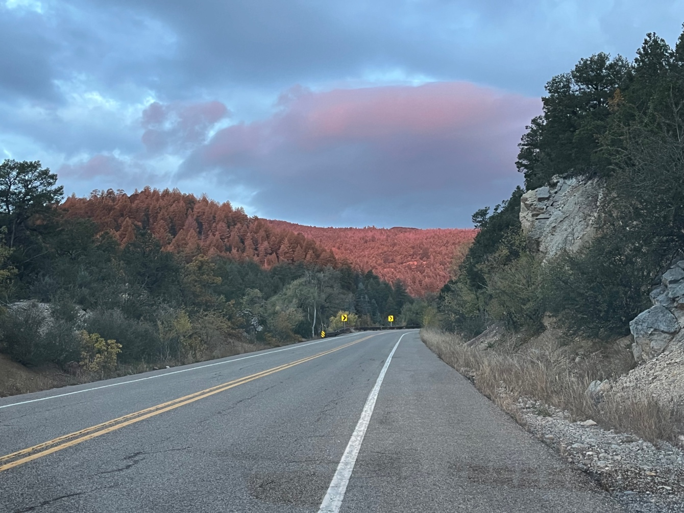
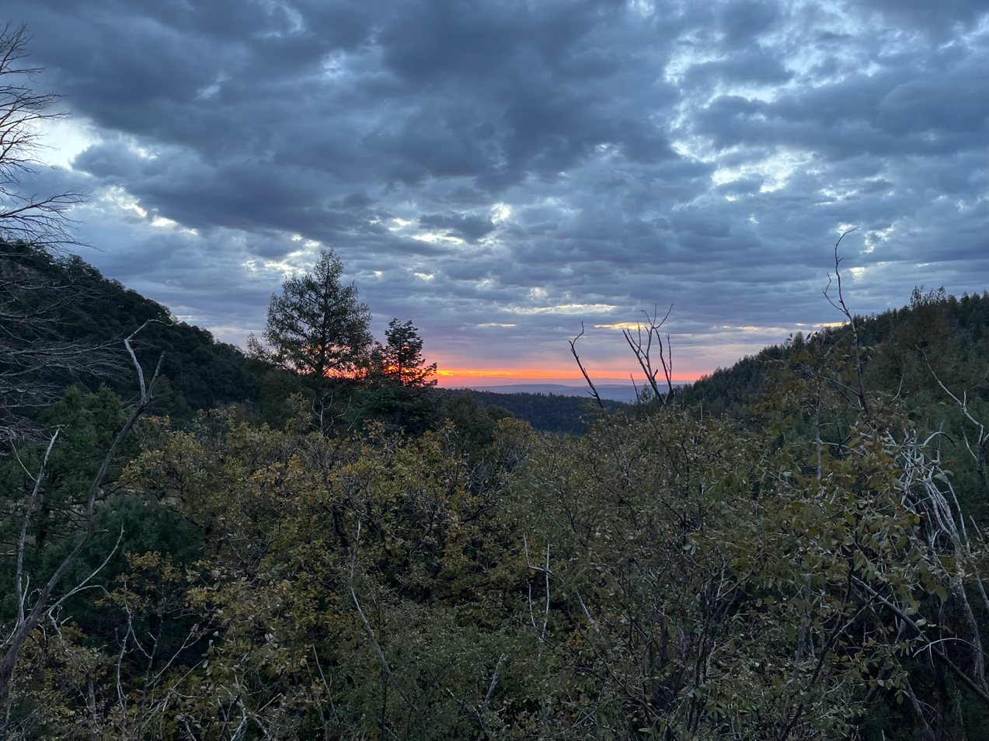
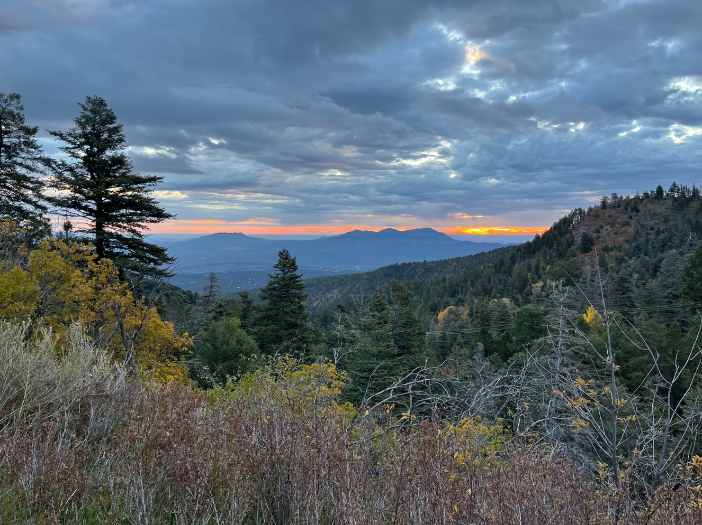
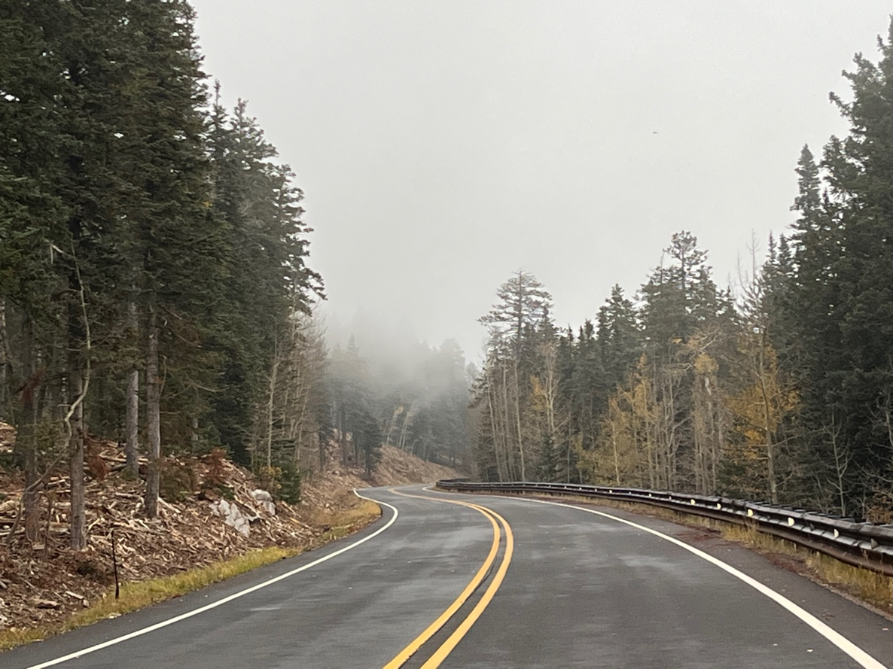
Low clouds on our arrival. Bill starts in on the first fix.
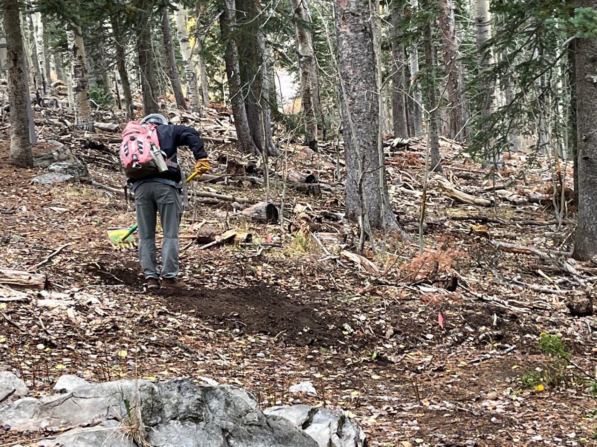
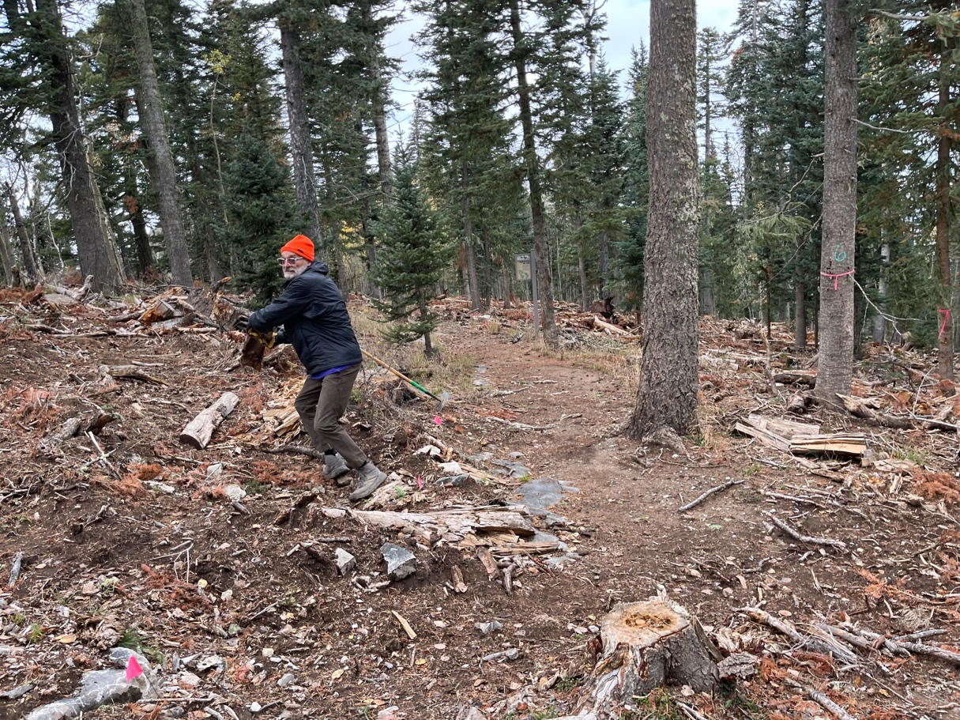
Trail building Olympics- Jim demonstrates the hammer throw.
Kerry removes debris.
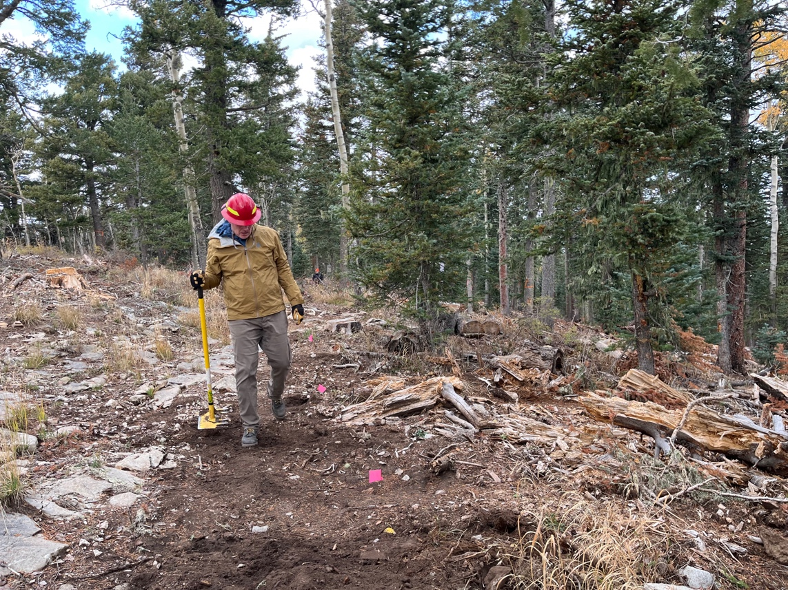
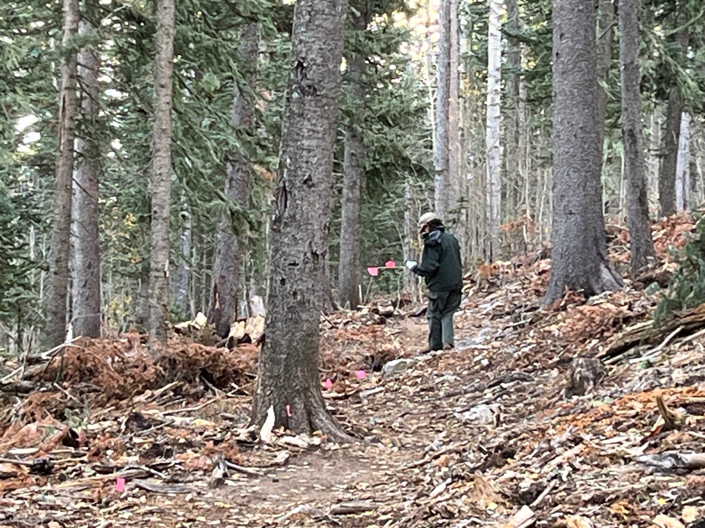
The illusive White Capped Jen plants flags. Piles of debris just off the trail.
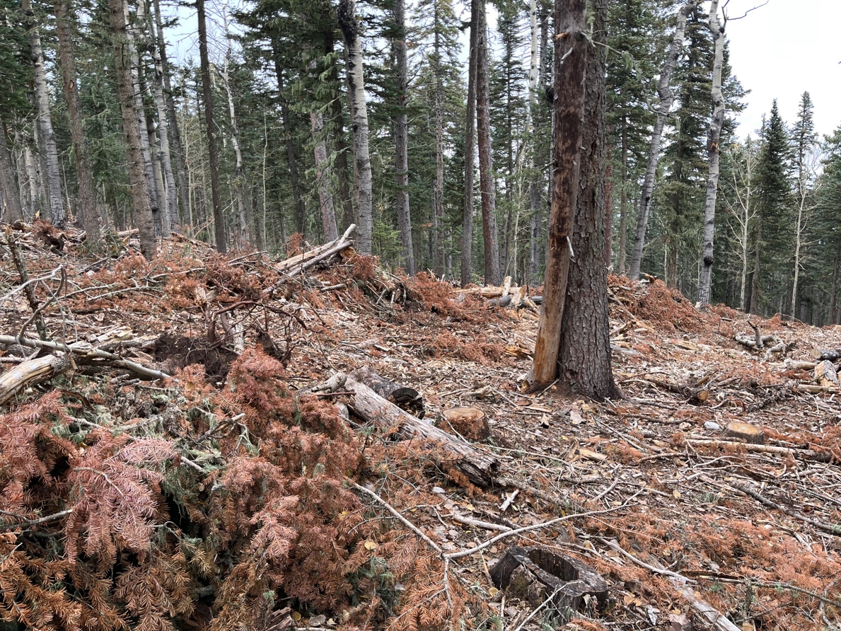
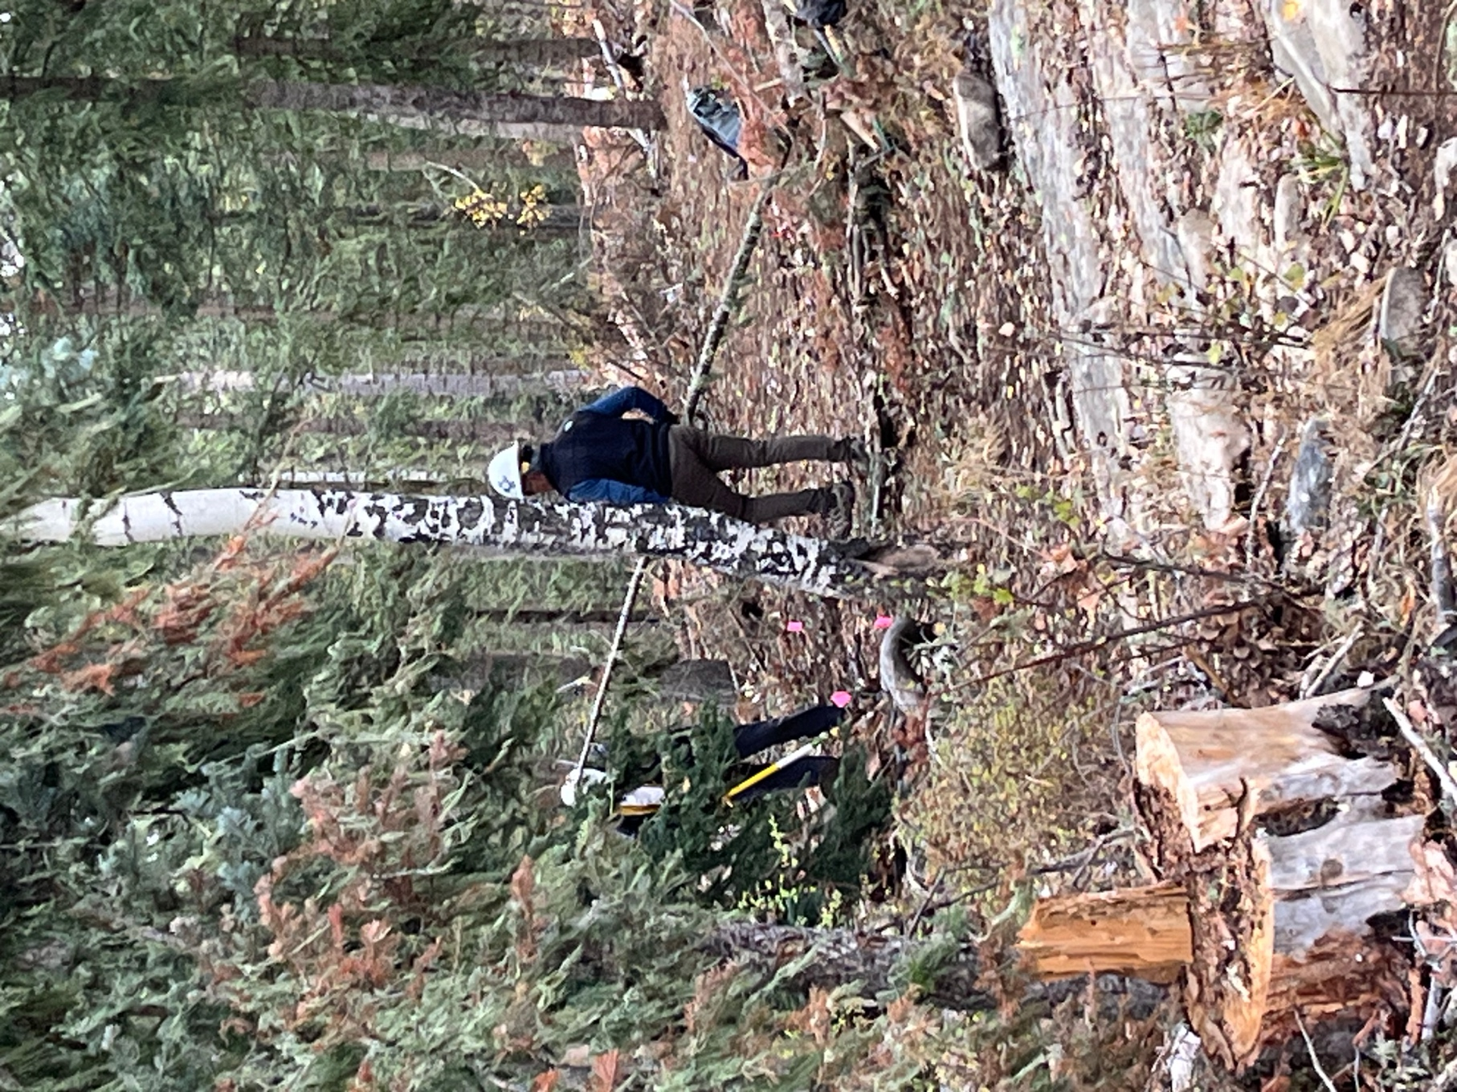
Luis tries to poke Rich’s eye out with a big stick. You have to watch these guys all the time.
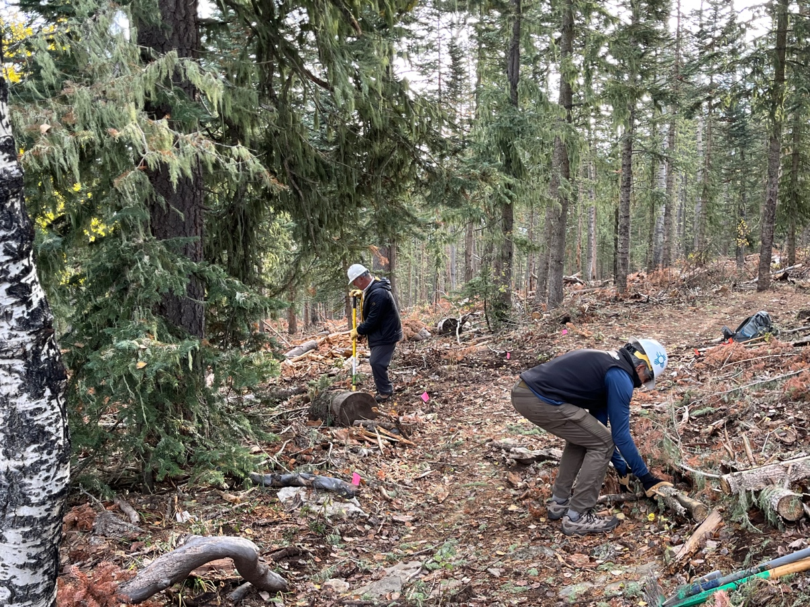
Back to work. Mr. Russell has a thing about removing large rocks.
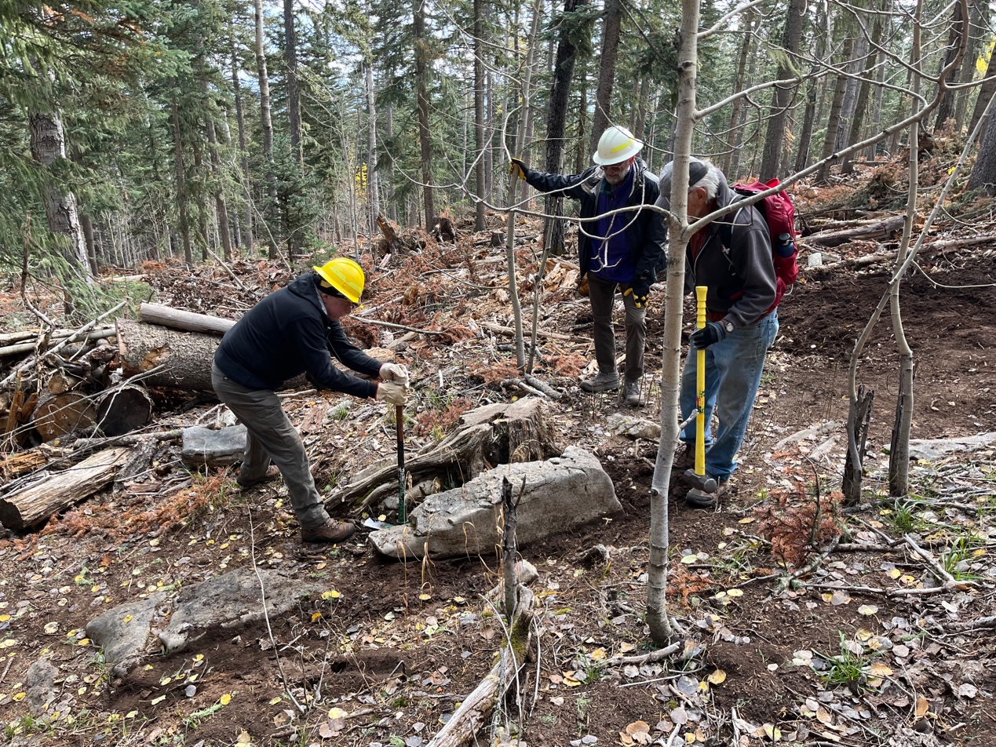
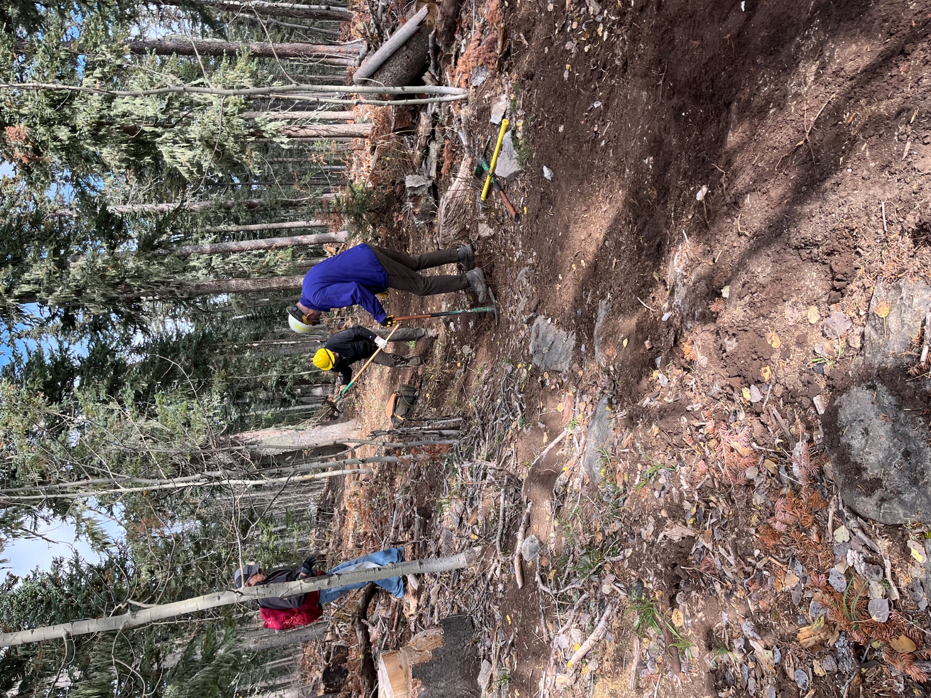
Kit and Jim add their thoughts and then, presto! Rock moved off to the right in the photo and a big hole is filled.
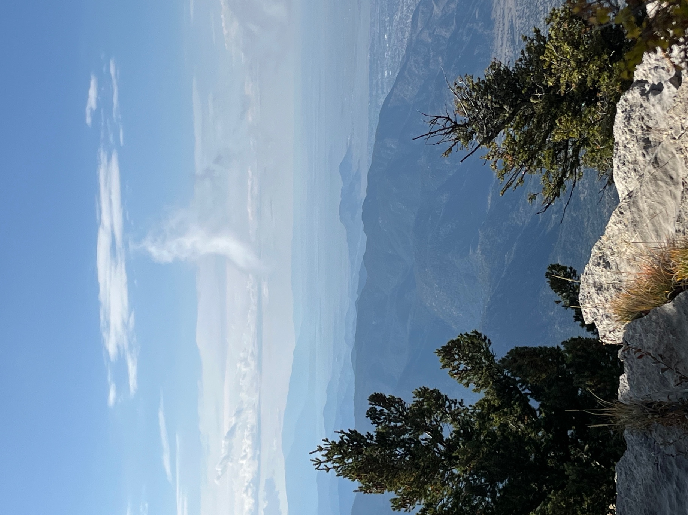
Interesting…. Looks a bit like a shite chile pepper.
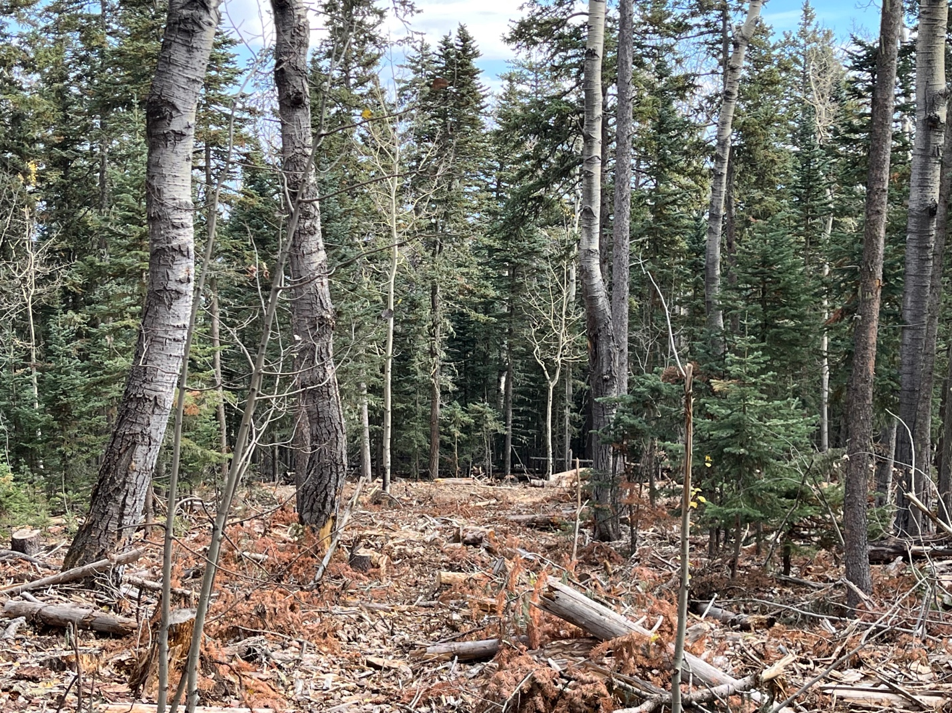

One last look through the cleared area to an untreated section of forest below- like night and day especially on a cloudy day.
Nex week we move back down the mountain to unfinished work.

