FOSM Project to Remove Brush at the Cienega PA Road and Crest Highway Intersection
and Prune and Cut Brush in Doc Long Picnic Area, Wednesday, October 21, 2026

Sam Beard
On Wednesday, October 21, five FOSM volunteers removed brush at two locations:
- Intersection of Cienega Road and Crest Highway
- Doc Long Picnic Area
The brushing was done with chain saws and the two FOSM Stihl brush cutters. Don Carnicom also cut brush with his personal brush cutter.
The five volunteers were Jerry Carroll, Sim Cook, John Quinley, Don Carnicom, and Sam Beard.
Project photos are presented below.

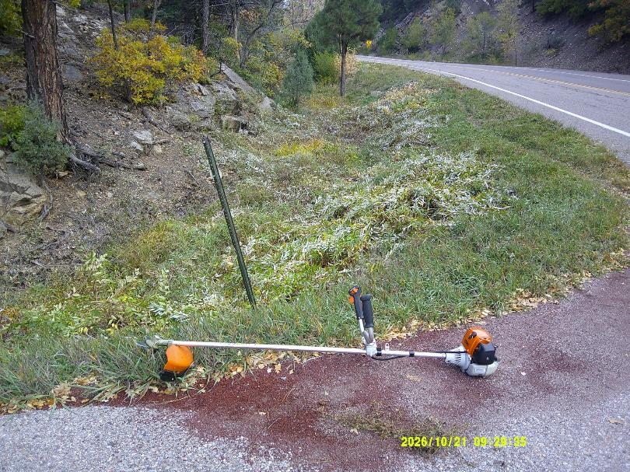
Brush was cut at intersection of Cienega PA Road and the Crest Highway. The small Stihl brush cutter owned
FOSM is shown in the foreground. All photos by Sam Beard
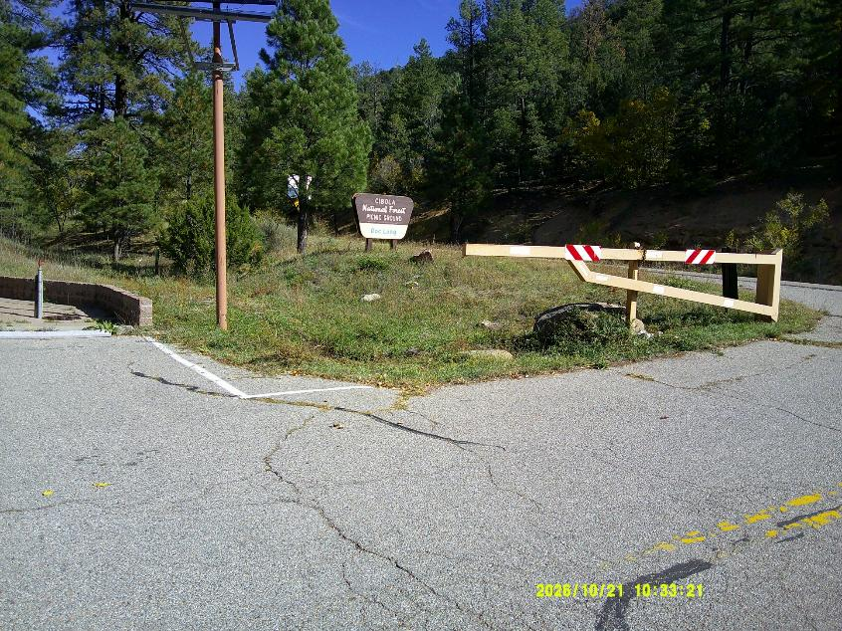
Brush was cut around the vehicle gate and between the gate and Cibola National Forest sign.
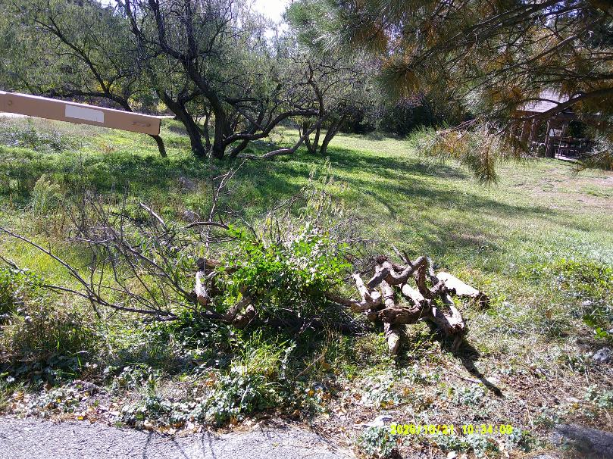
Large Russian olive trees were pruned at Doc Long PA, and brush was cut between the picnic shelter and the highway.
Large pieces of wood lying in the grass around the trees were added to the pile of brush at the picnic area entrance.
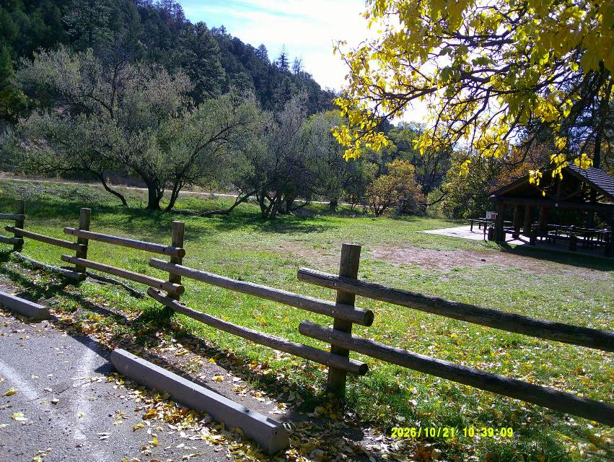
Dead lower tree branches and brush along the highway were removed.

