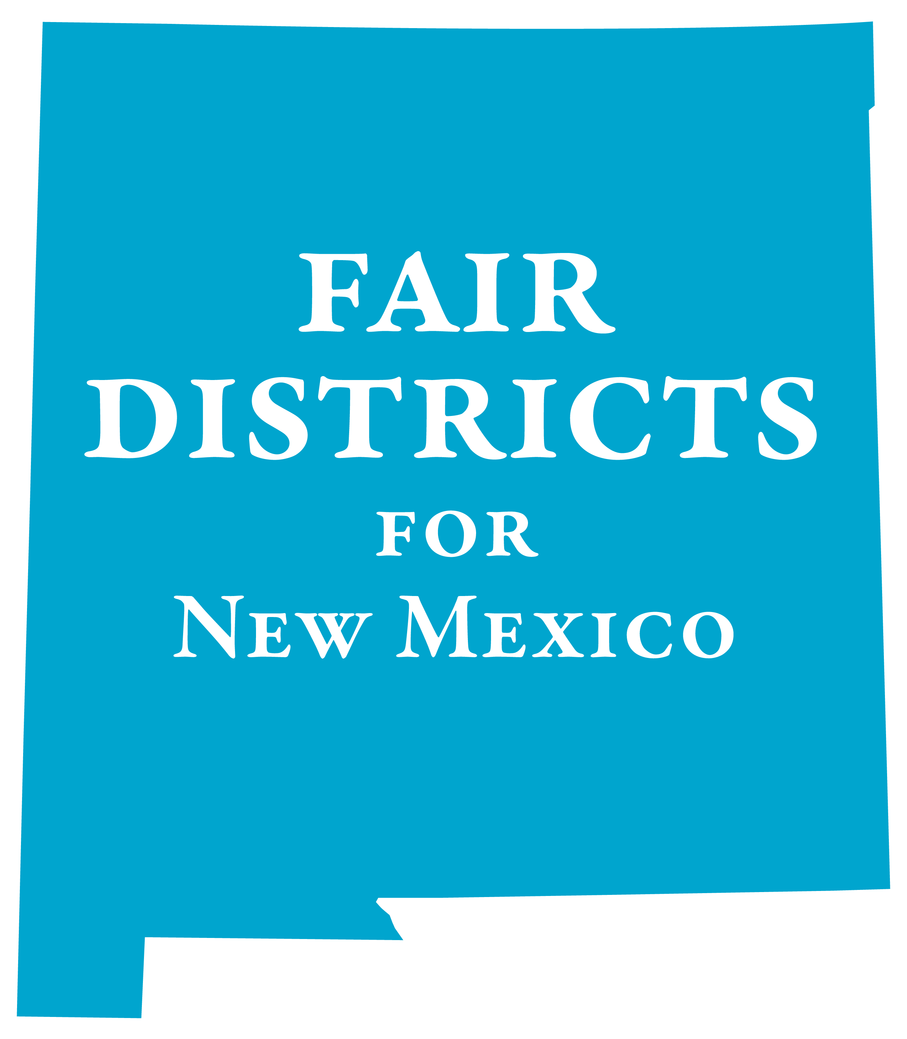
PLEASE SUPPORT HM8
House Memorial 8 (Rep. Daymon Ely) Redistricting Task Force
REQUESTING THE NEW MEXICO LEGISLATIVE COUNCIL TO CONVENE A REDISTRICTING TASK FORCE TO DEVELOP RECOMMENDED PROCEDURES FOR THE REDISTRICTING PROCESS FOLLOWING THE 2020 CENSUS.
What it would do
Create a redistricting task force that would include legislators, representatives from the Governor’s office, the Secretary of State and members of the public. The task force would start meeting in the late spring of 2020 and make recommendations to the relevant interim committee and the 2021 Legislature.
Why you should support it
Organizations Supporting Fair Districts for New Mexico: League of Women Voters of New Mexico; Common Cause New Mexico; New Mexico Ethics Watch; New Mexico Open Elections; Progressive Democrats of America Central New Mexico; Indivisible Corrales; The Brennan Center for Justice; Election Reformers Network; Princeton Gerrymandering Project; New Mexico First; Indivisible Nob Hill; ACLU-NM, New Mexicans for Money Out of Politics (NMMOP)
The 2001 and 2011 redistricting cycles ended up in the courts. The courts ended up setting the districts and it cost the state more than $6 million in legal costs. More importantly, it cost an additional loss of public confidence in the political process.
Fourteen states have independent redistricting commissions with four additional states considering creating commissions. At least six other states have some public participation/oversight of the redistricting process.
New Mexico needs relevant public participation and oversight to assure a fairer and more transparent redistricting process, which can be achieved via a task force.
Due to the publicity about gerrymandering and the Supreme Court decision to leave redistricting reform in the hands of the states, the public is much more engaged in the redistricting process. They will be watching.

Contact: Dick Mason: act@lwvnm.org; 505-239-3804;
Kathleen Burke; fairdistricts@lwvnm.org; 505-907-5355
Website: http://www.fairdistrictsnm.org

