I am selling my 2013 Trailfox TF01/SRAM XO mountain bike. It is in great condition. The bike has had very few miles put on it over the last couple of years due to graduate school. I would not be selling it, however, my wife and I had our first son and the money is needed. Looking to sell the bike for 3500.00. Below are the technical specs and a few pictures. Please email mgeter23@gmail.com if you are interested. I am currently in residency and due to time commitment, will respond to emails at the end of workday.

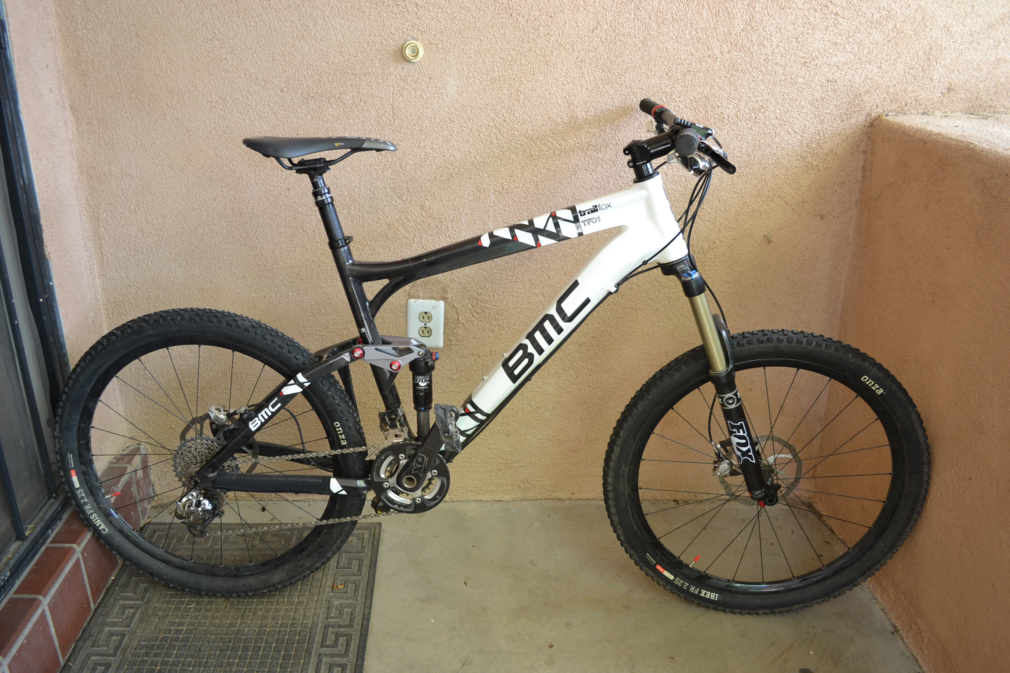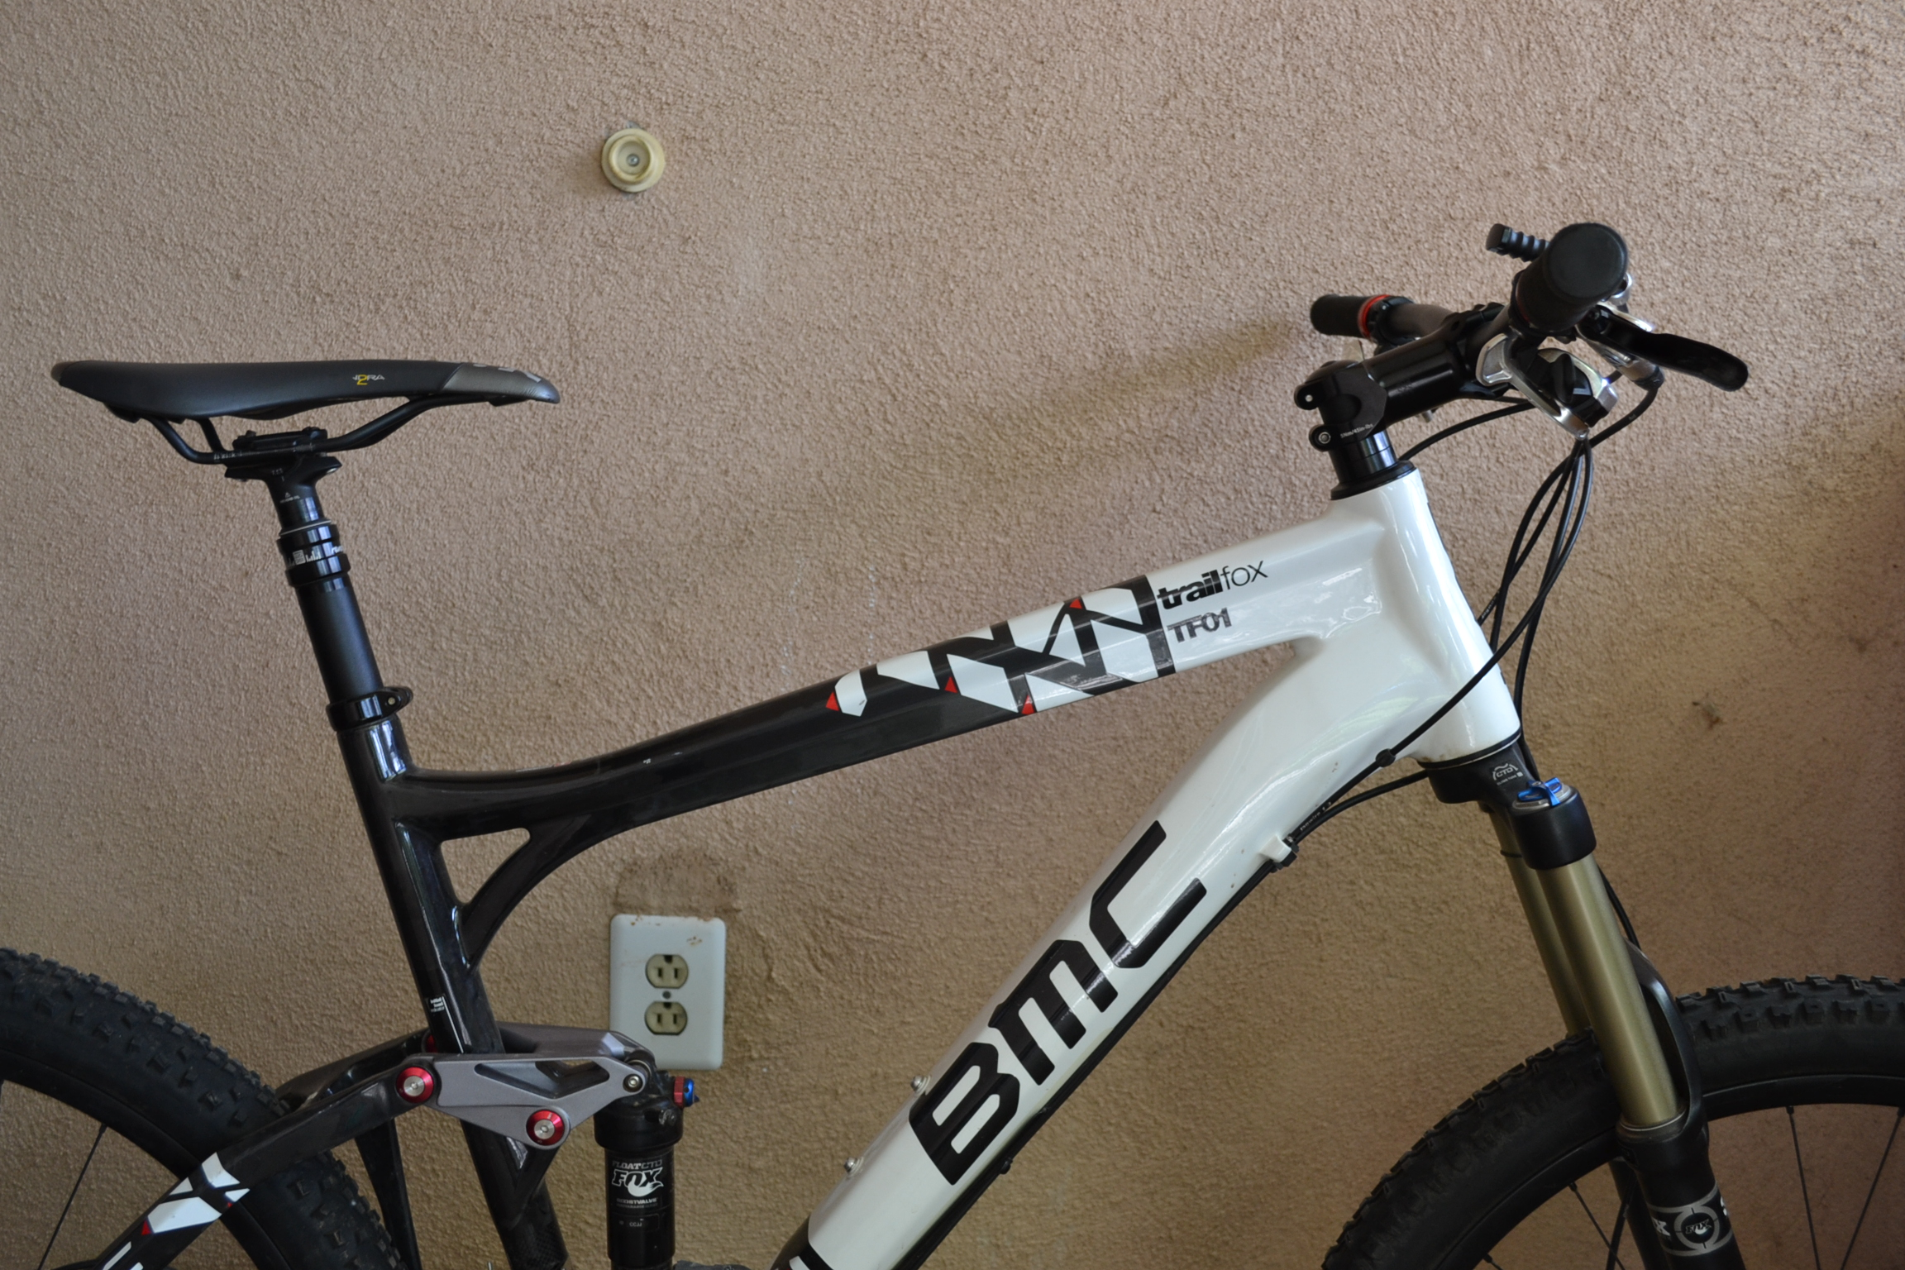
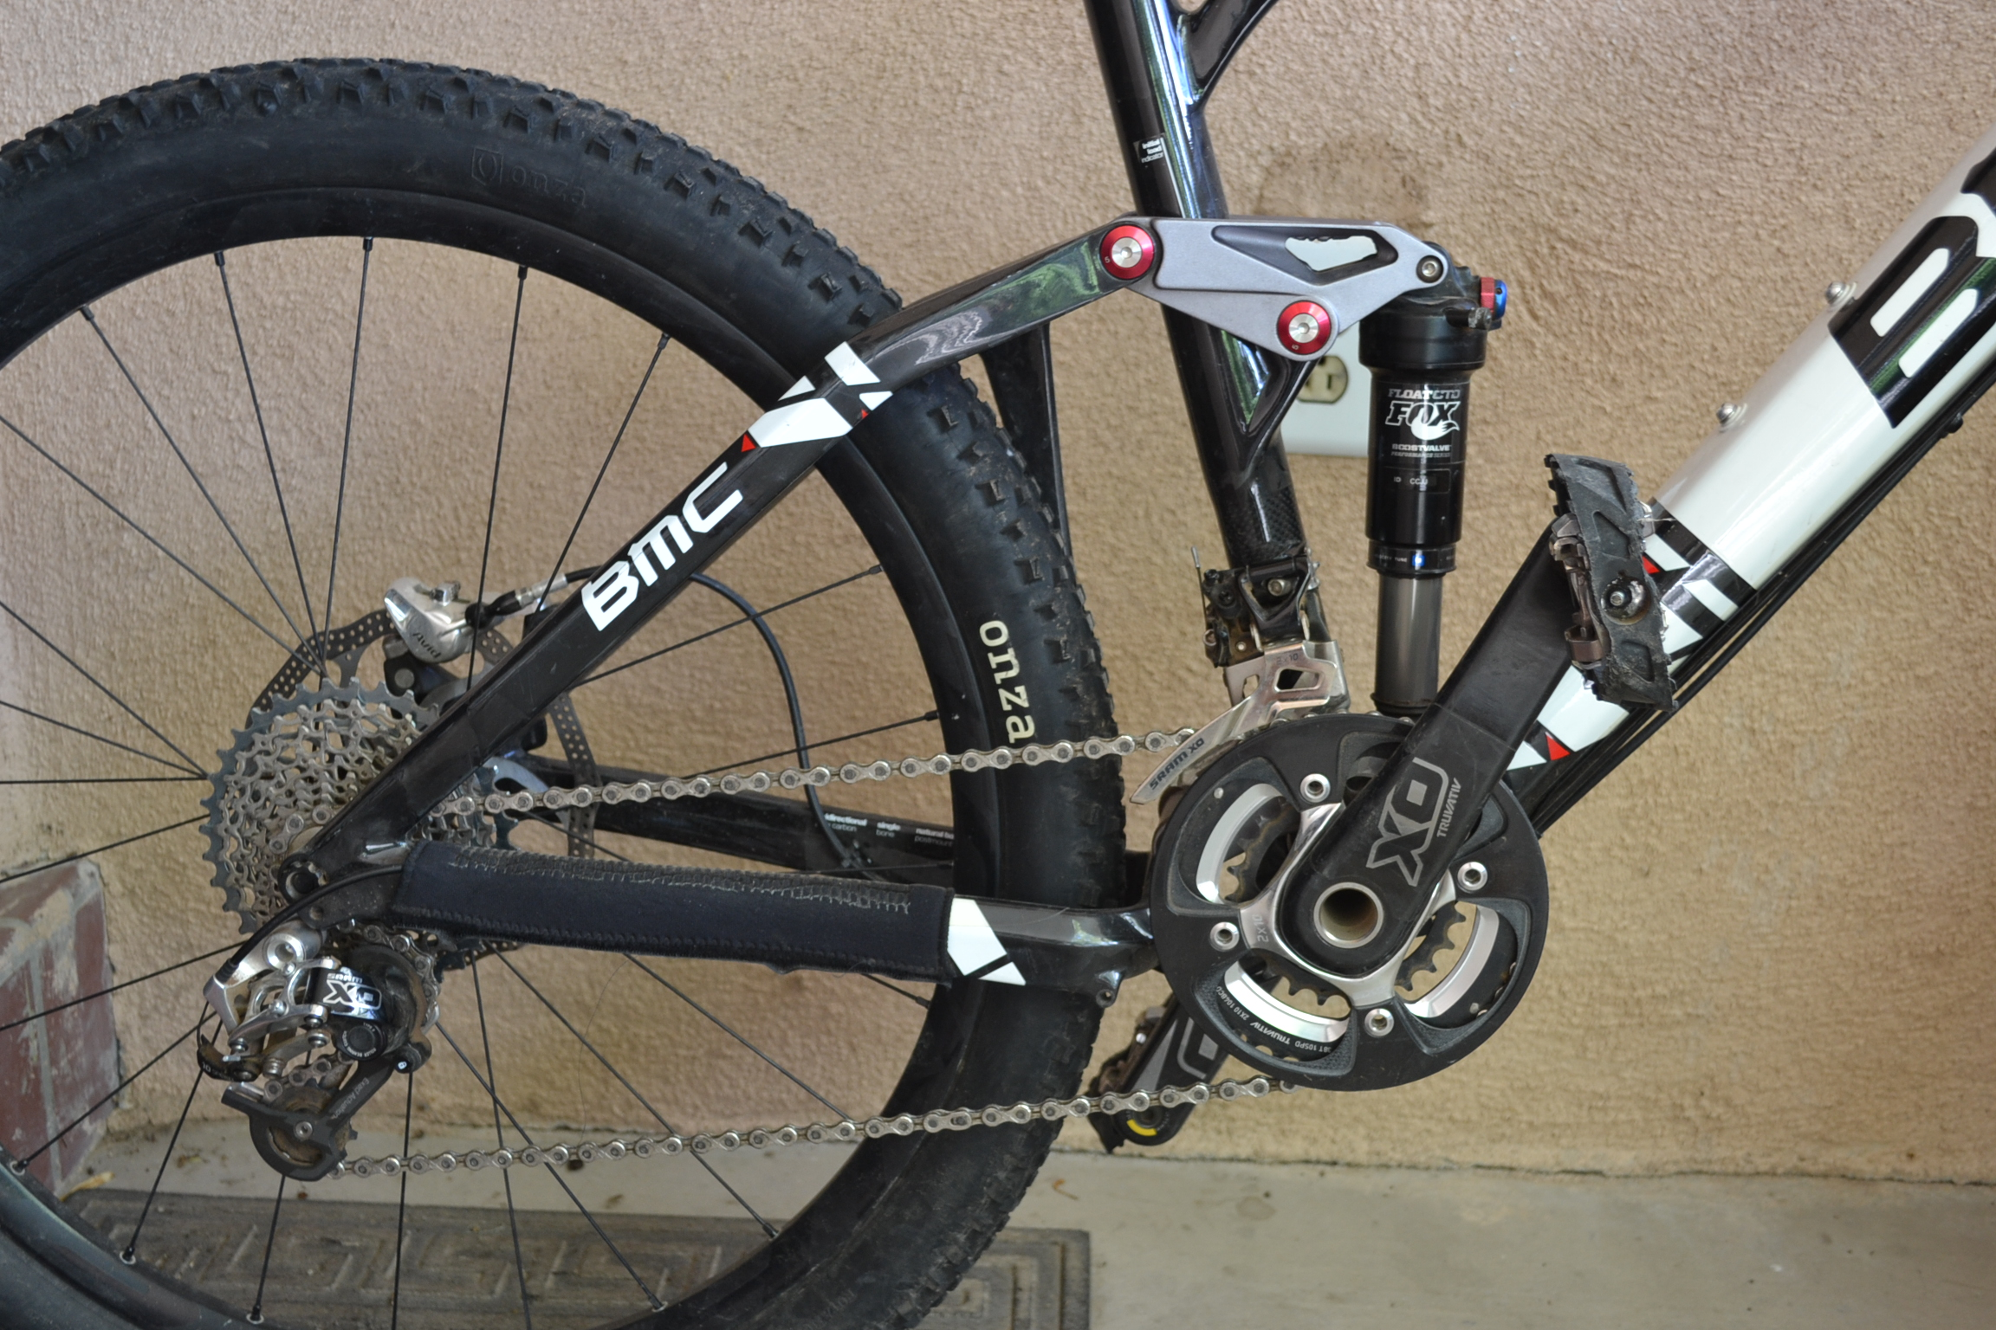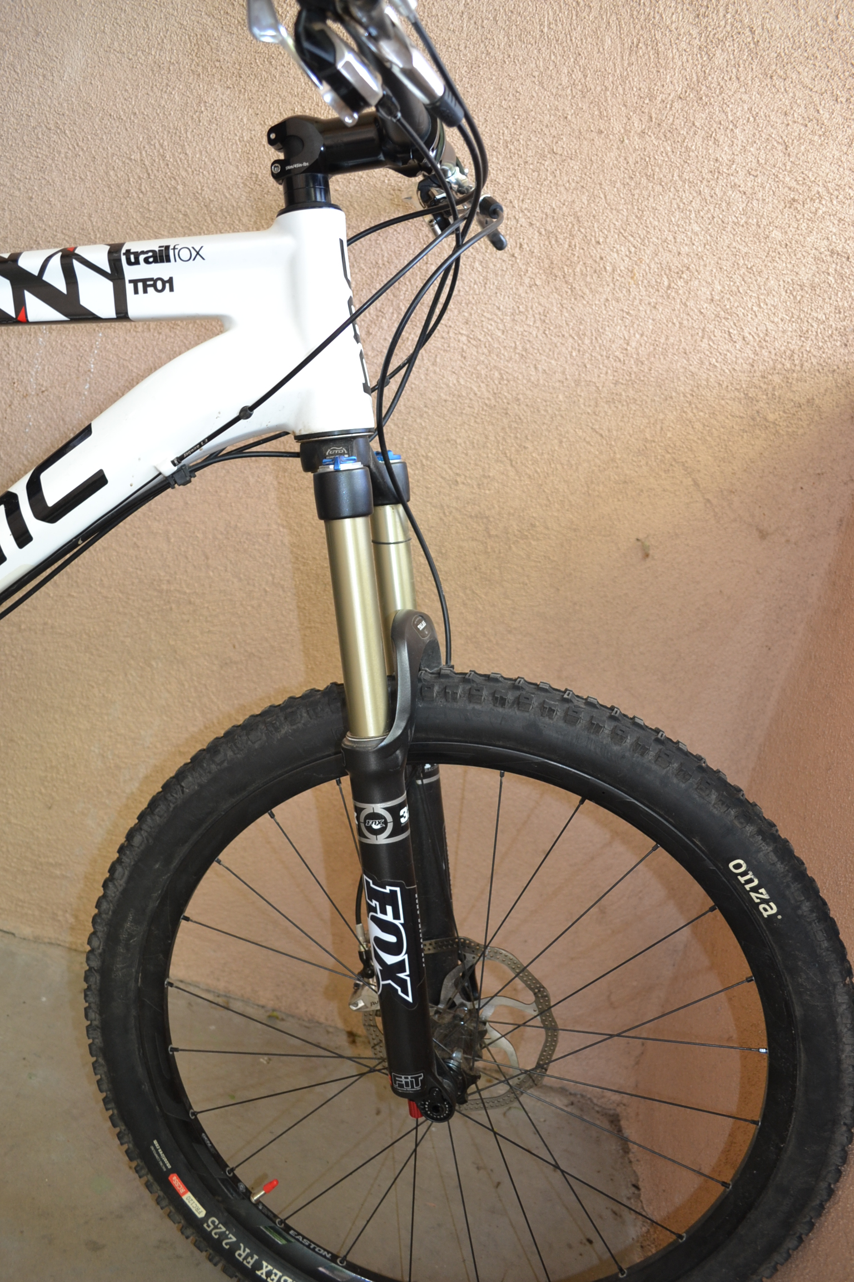

Tech Specs
Frame Material
Carbon Fiber
Suspension
APS
Rear Shock
FOX FLOAT CTD Evolution
Rear Travel
150 mm
Fork
FOX 32 TALAS CTD FIT Performance

Front Travel
150 mm
Shifters
SRAM XO
Front Derailleur
SRAM XO
Rear Derailleur
SRAM XO Type 2
Crankset
24/38 t SRAM XO
Bottom Bracket
SRAM GXP
Cassette
11-36 SRAM XO
Brake Set
SRAM XO
Handlebar
Eason Haven Carbon
Stem
Easton Haven
Saddle
Fi’zi:k Tundra 2 manganese
Seatpost
Rock Shox Reverb Stealth
Wheelset
Easton Haven
Tires
Onza Ibex/Canis
Tire Size
26 in x 2.25 in
Recommended Use
All Mountain

