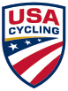
USAC Officials Certification
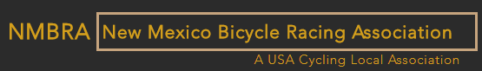

Sunday - January 14th – 2018
Time: 01:00 PM – 05:00 PM
@
Sport Systems
6915 Montgomery Blvd. NE Albuquerque, NM 87109
- The cost of the class will be free for all attendees.
- USAC License is required in order to register for the class.
- The cost for the first time Official Only license will be $25.00 dollars. https://www.usacycling.org/resources/schedule-of-fees
- NMBRA will reimburse your Official license cost after you have officiated 5 or more Road, CX or Mt. Bike races during a calendar year.
- Any questions please contact Pamala Thulen, pamalanmcycling@gmail.com or Silvio Menezes, NMVeloracer@gmail.com

