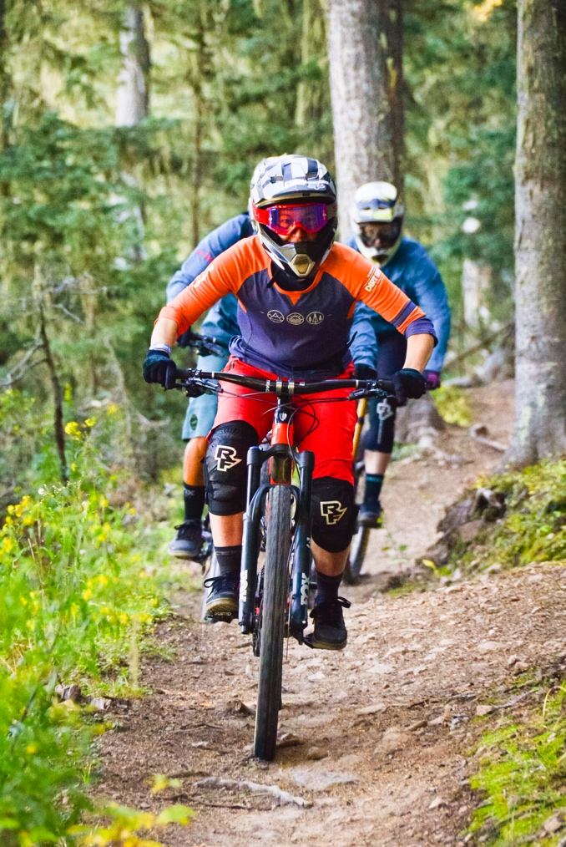

Photo courtesy of Angel Fire Resort

**ANGEL FIRE MTN**

**BIKE CLINIC**

Join us for an awesome fun-filled weekend expanding your mountain bike skills at Angel Fire Bike Park.

Angel Fire is an incredible mtn bike park filled with trails and obstacles for everyone, beginner to the advanced mountain bikers. This clinic is for

ALL levels of riders.

**Get ready for an amazing weekend in the northern mountains of New Mexico. Ride at one of the best bike parks in the country. Enjoy the wine festival and live music in Angel Fire or go to Taos in the**

**evening for even more great live music.**

***Space is limited – Sign up NOW!***

**We will start in the morning going over fundamentals at 9am before we break into groups based on skill levels. Then we will head up the mountain via the chairlift to practice and dial in our skills coming down the numerous trails as we progress our skills throughout the day.**

**What should I expect?** First and foremost to have a TON of FUN! You will learn fundamental skills to ride all types of terrain. We take great pride in helping riders improve skills and gain confidence in a safe and encouraging atmosphere no matter your level of skill.

**What level of rider am I?** Good question--and it’s a tricky one. We are here to help ALL level of riders at this clinic from beginner to advance intermediate. We will assist you in figuring that out if you don’t know, getting you in the appropriate group and taking you to the next level!

Whatever level you may be, we can help you improve and will show you the fundamental skills for ALL level riders!