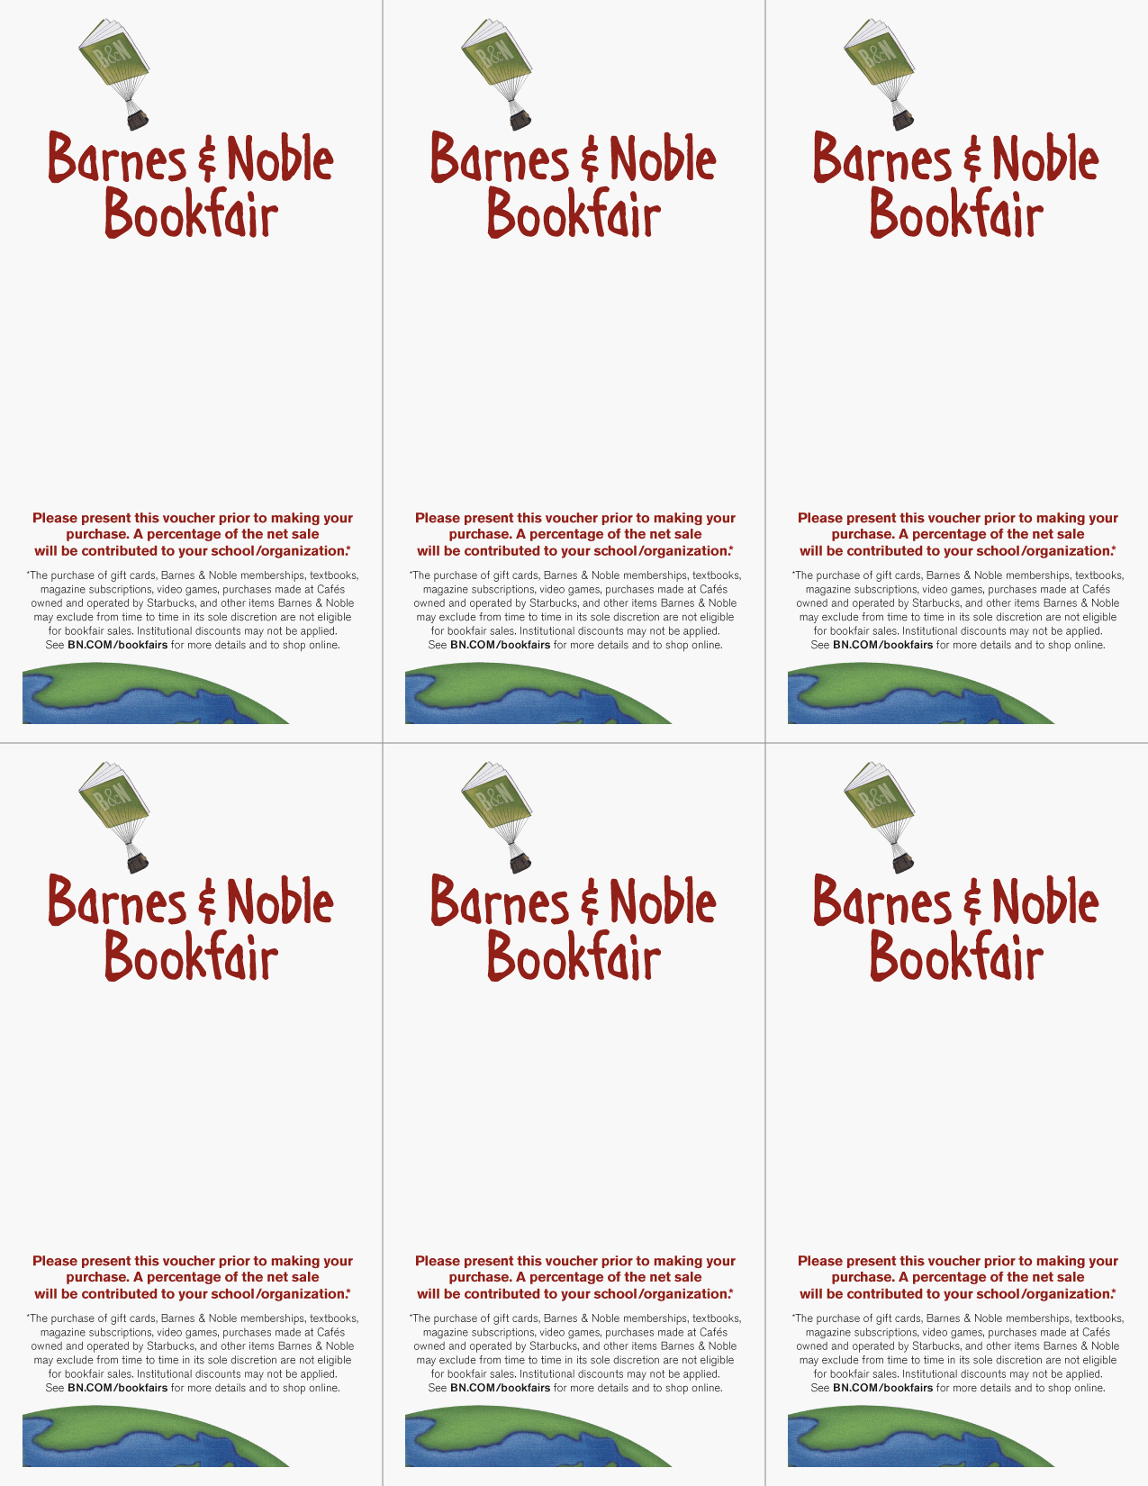
supporting
Highland High
School Band
December 19, 2017

Barnes & Noble
Coronado Center

Bookfair ID Number 12253449
supporting
Highland High School Band
December 19, 2017

Barnes & Noble
Coronado Center

Bookfair ID Number 12253449
supporting
Highland High School Band
December 19, 2017

Barnes & Noble
Coronado Center

Bookfair ID Number 12253449
supporting
Highland High School Band
December 19, 2017

Barnes & Noble
Coronado Center

Bookfair ID Number 12253449
supporting
Highland High School Band
December 19, 2017

Barnes & Noble
Coronado Center

Bookfair ID Number 12253449
supporting
Highland High School Band
December 19, 2017

Barnes & Noble
Coronado Center

Bookfair ID Number 12253449

