Cliff’s / Mass Band Concert!!!

Bands around the city are combining forces to put on a mass band collaboration concert! Here are the details:

**Friday, May 10th @ Highland HS for students**

3:30 – 5:30 pm Mass Band Rehearsal

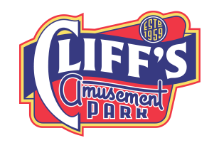5:30 – 6:00 pm Dinner

6:00 – 7:15 pm Games/Dye Party

**Saturday May 11th @ Cliffs Amusement Park for everyone**

12:30 – 1:00 pm Stage set-up

1:00 – 2:00 pm Concert

2:00 – 2:30 pm Stage tear-down

2:30 pm on Fun @ Cliff’s

Each participating student needs to provide $15 for lunch and entrance to Cliff’s on Saturday.

* Cliff’s is offering any interested friends, family, acquaintances the same deal! Normal entrance to Cliff’s is $27.95. ***However, if you pre-order and pre-pay for tickets, you can receive a discounted all-day ride pass for only $20.*** There is no limit to how many you can order so invite everyone!

There is no mass transportation scheduled (aka buses) so we are expecting students provide their own form of transportation. Please notify us if you need us to find a ride for your student. We are extremely excited to have this opportunity for the students and families. Please come out and join in the fun!

Please fill out the form below and return to school ***with paymen****t* by Friday, May 3rd.

**Cliff’s/Mother’s Day/Mass Band Concert Info Sheet**

* My student will be attending the rehearsal Friday, May 10th.
* My student will be attending concert at Cliff’s on Saturday, May 11th.
* We have provided the $15 student fee.
* I understand that the school will not be providing transportation and we are responsible to getting students to the locations or we can ask for help.
* We would like to buy extra tickets for the event. (Payment included.)
  + Yes! We would like to buy _________ extra tickets at $20 each for a total of $___________
* Total payment (student fee plus extra tickets). $________________