Summer Camp Fearless
Information about the Albuquerque Police Department's Summer Camp Fearless.
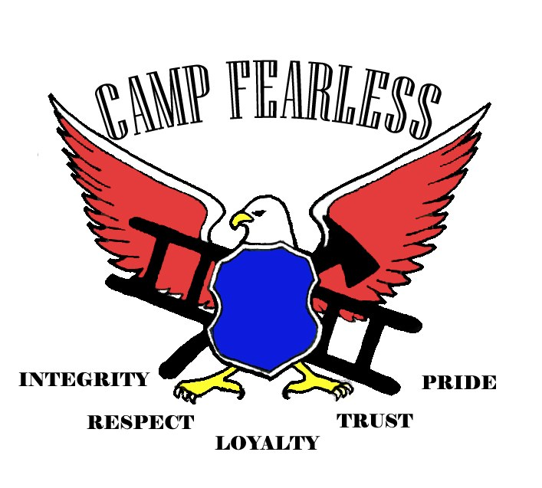

Information: Summer Camp Fearless
The Albuquerque Police Department would like to announce Camp Fearless!
The Albuquerque Police Department will conduct two summer type camps this summer:
- June 12 to 15, 2018, at Valley High School, 1505 Candelaria NW
- July 10 to 13, 2018, at Boys and Girls Club, 3333 Truman NE

About Camp Fearless
We are looking for youth attendees between the ages of 9 to 12 to participate.
Each camp will have a variety of activities focused on team building, self-responsibility, and education.

Daily Schedule
Each day, camps will start sharply at 8 a.m. and conclude at 4 p.m.
To participate please download and return a completed application form to the Albuquerque Police Academy at 5412 2nd NW by June 1, 2018.

More Information
For additional information or questions, please call (505) 343-5000.

