MINUTES OF BOARD MEETING

NOVEMBER 1, 2018

NOB HILL NEIGHBORHOOD ASSOCIATION

MONTE VISTA CHRISTIAN CHURCH, 3501 CAMPUS DR NE

Room 121 down the stairs and to the left as you enter the main door

**CALL TO ORDER, 6:35 pm,** Gary Eyster presided and produced minutes

Introductions

Establish quorum, Board members present: Eliza Peralta, Domenic Peralta, Govinda Haines, Veronica Salinas, Gary Eyster. The board has 11 members. 5 members is not a quorum.

**NEW BUSINESS**

- Safari Grill, 3001 Central Ave NE, requests a distance waiver from the City of Albuquerque as the proposed location is within 300 feet of the Calvary Church. Applicant is also requesting a restaurant liquor license with on premise consumption only (aka restaurant beer and wine license).

Bill Young is owner of the restaurant and the applicant. He introduced the restaurant and provided a letter dated July 5, 2018 in which Calvary Church approved the waiver to operation within 300 feet of their facility.

Board members asked several questions related to the excerpt of the NM Alcohol and Gaming Division Rules and Regulations (below).

Mr. Young verified that he intends to fulfill A; He has had a restaurant elsewhere in the city for 8 years. Sales have been 80%/20% food/alcohol.

He will fulfill B except if a patron does not finish a bottle of wine the restaurant can place it in an approved, sealed plastic bag so the patron can transport it home in his car.

The latest hours of Safari Grill are 10 pm on weekends.

He agrees the license is non-transferable as stated in D.

He will fulfill E.

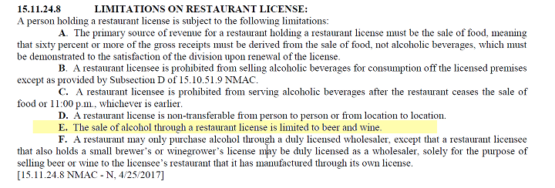

5 neighbors were present, all of whom reside in NHNA boundaries. Each expressed support for the waiver and the license. Several observed that a restaurant would have a hard time making it without beer and wine and they are pleased to see this location with a business in it.

Because a quorum was not achieved the president did not ask for a motion from the board.

The email address for Sandra Chavez, City Council staffer for alcohol issues, was distributed. Anyone can send their positions to her at [smchavez@cabq.](mailto:smchavez@cabq.)gov until November 6. Anyone can appear at the hearing on November 9, 2018, City Council Committee Room, 9018, One Civic Plaza. Sandra can be reached at 768-3417.

**MEETING WAS ADJOURNED AT 7:40 PM.**