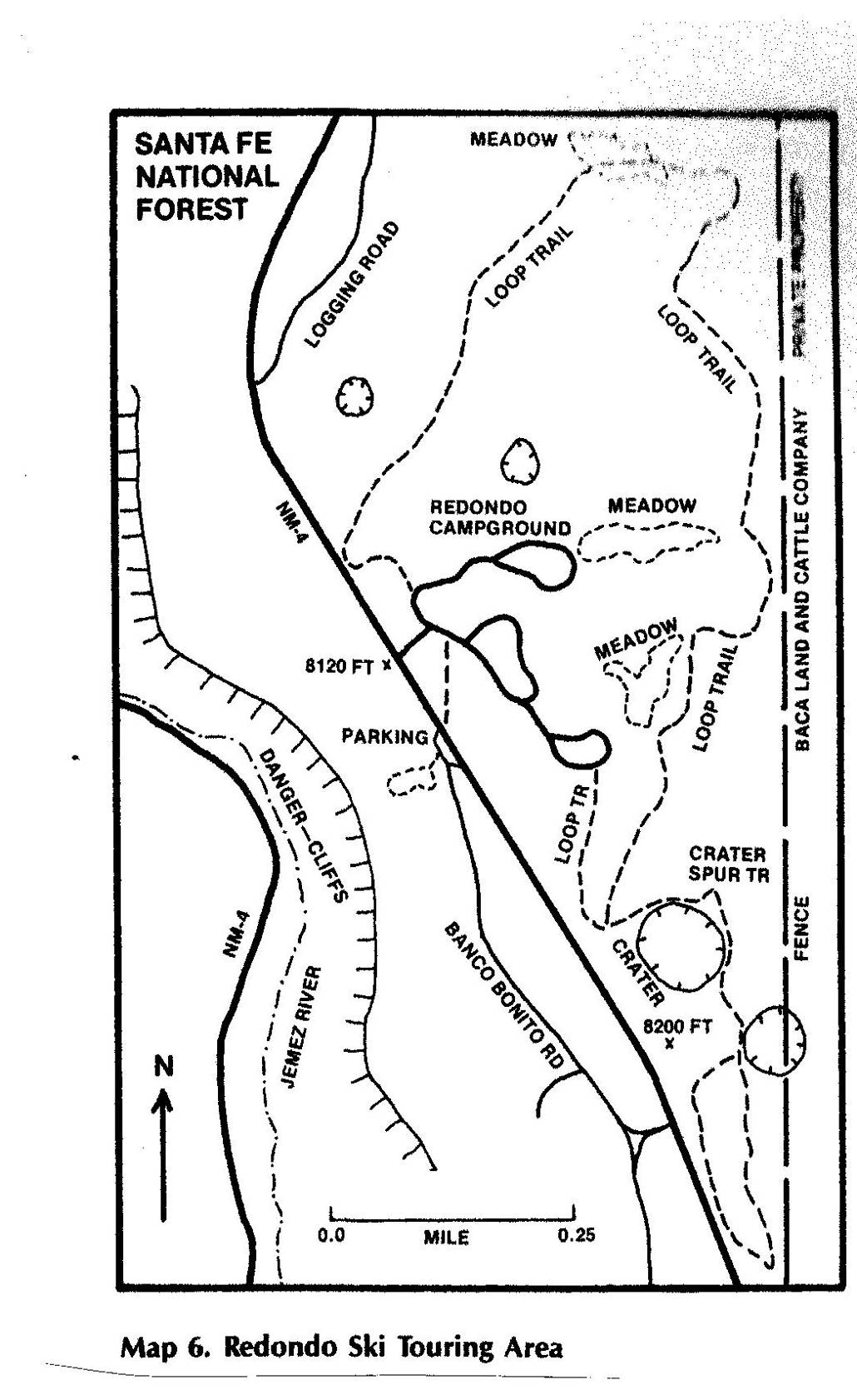

Map of Cross Country Ski Trails near Redondo Campground in the Jemez Ranger District.

The campground roads are shown as wide black lines in the center of the map. Trails are

shown as dashed lines north and southeast of the campground. On Saturday, we skied

the LoopTrail going to the north and part of the Crater Spur Trail to the southeast.

(Map from Ski Touring in Northern New Mexico by Sam Beard)

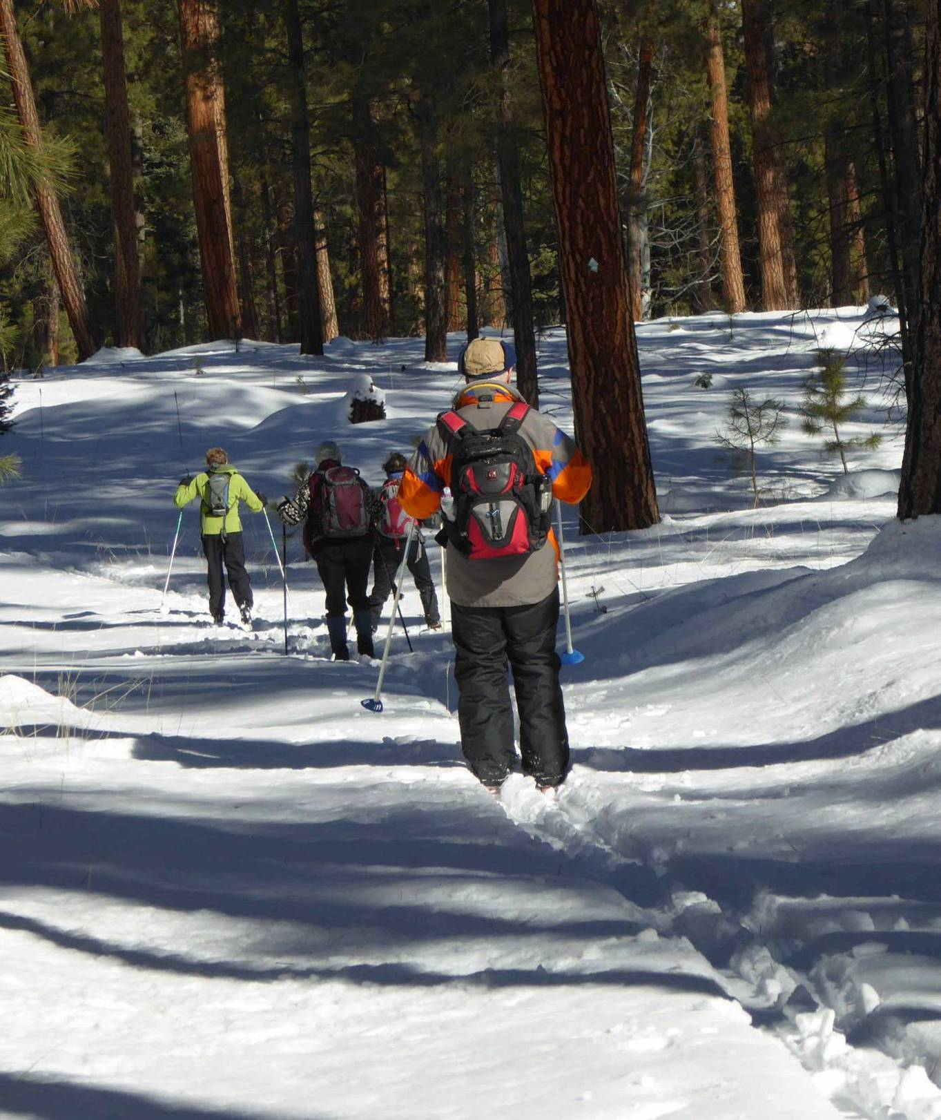

Ellen Bauman leading a group of skiers in the large trees that surround the camground.

All photos by Tom Katonak.

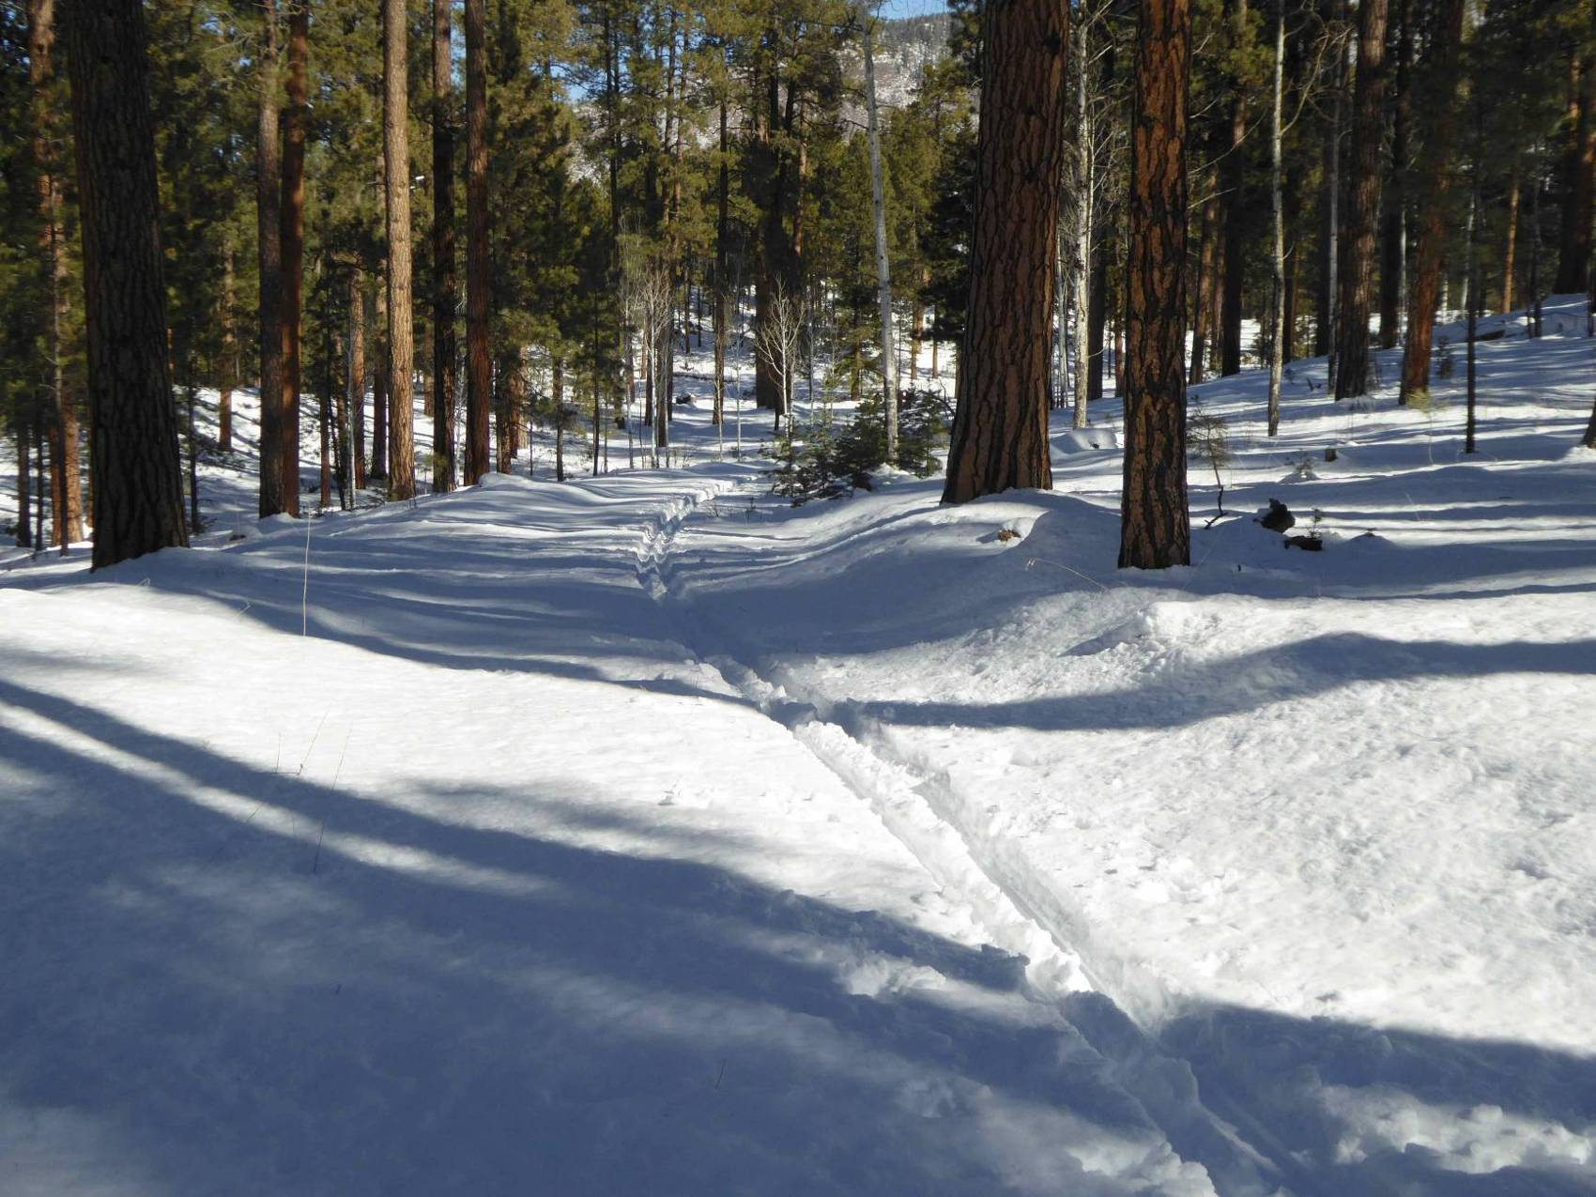

Tracks on the northwest part of the Loop Trail. Note the large meadow in the sun through the trees.

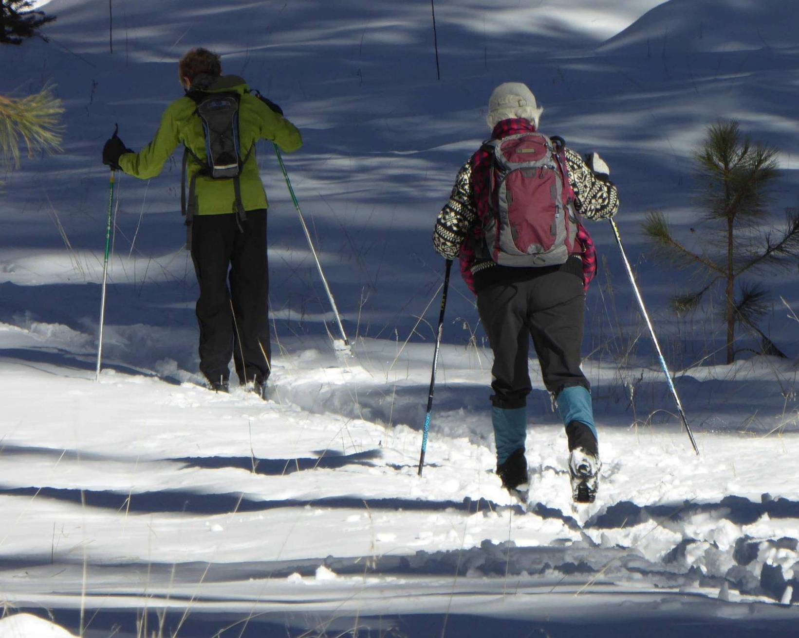

L to R: Ellen Bauman and Marcy Dochester.

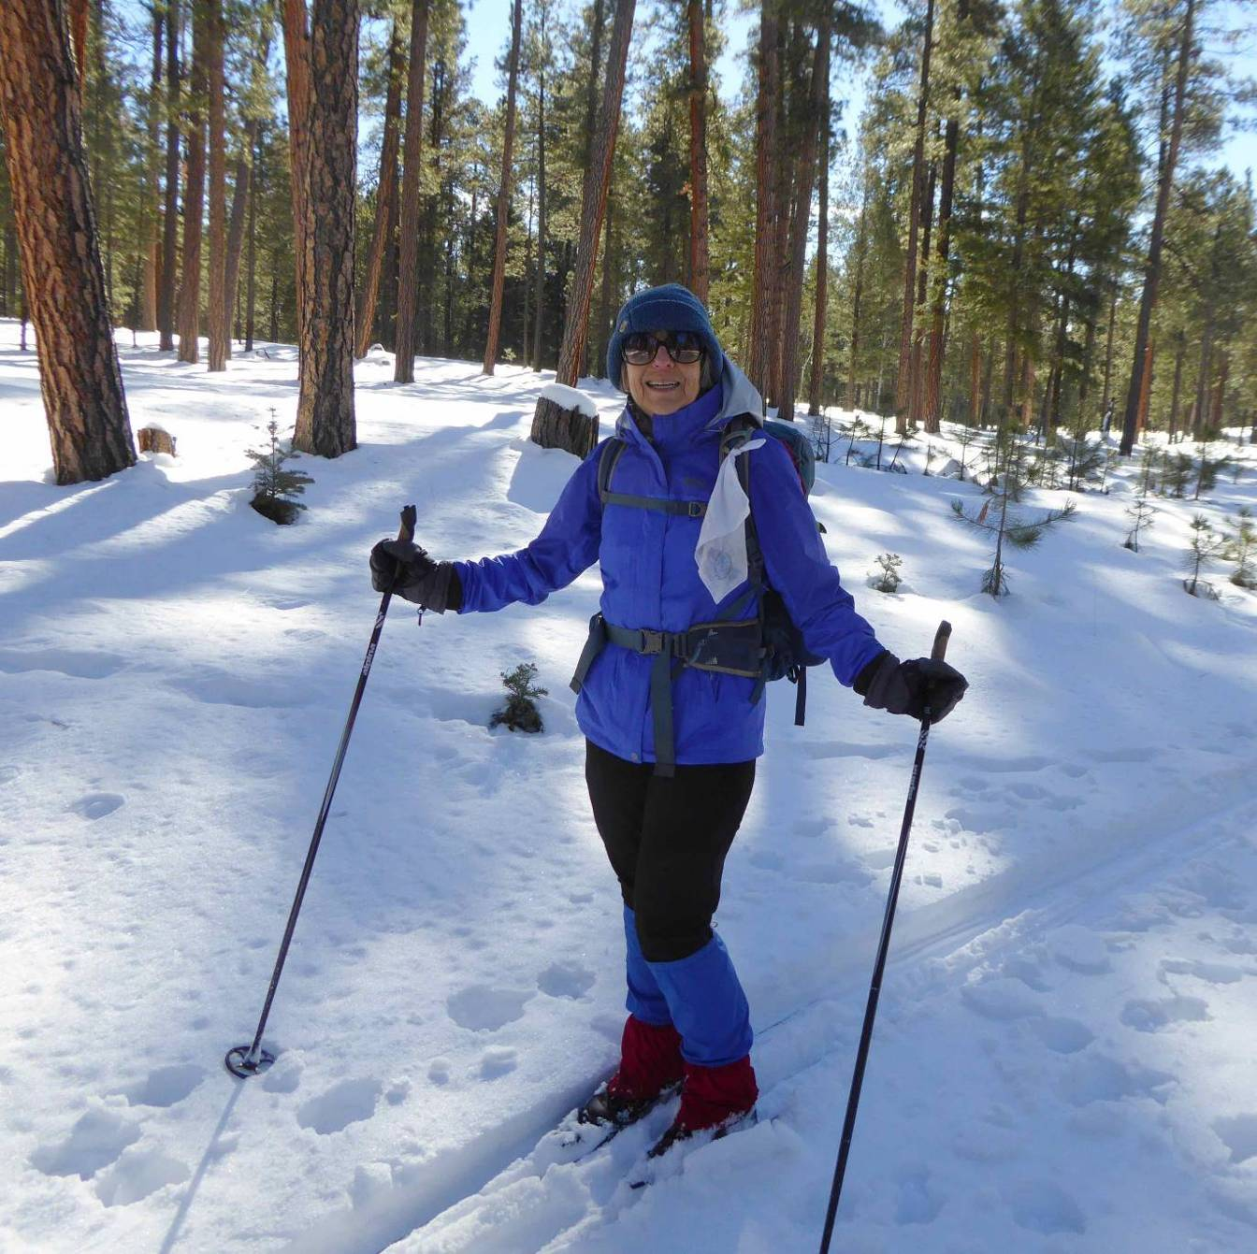

Bronwyn Willis.

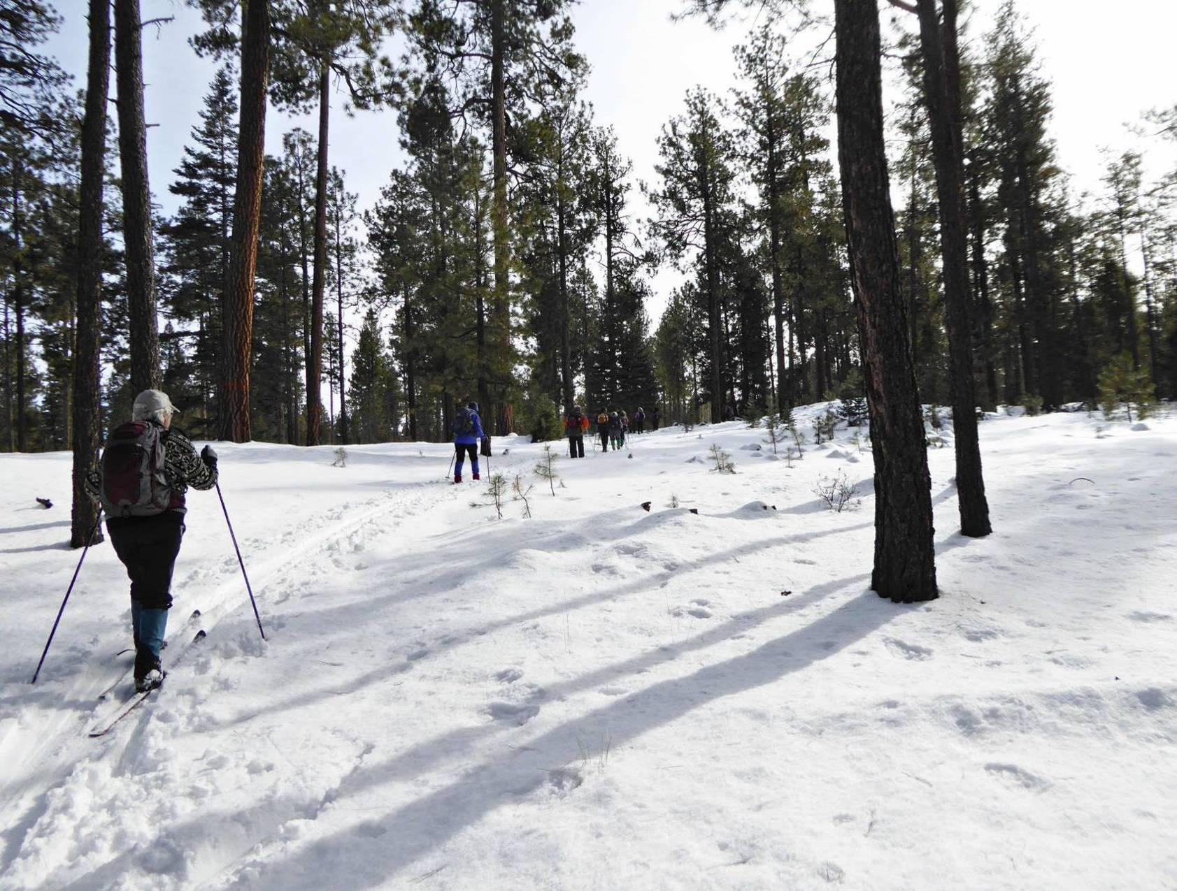

Skiers going up a low hill.

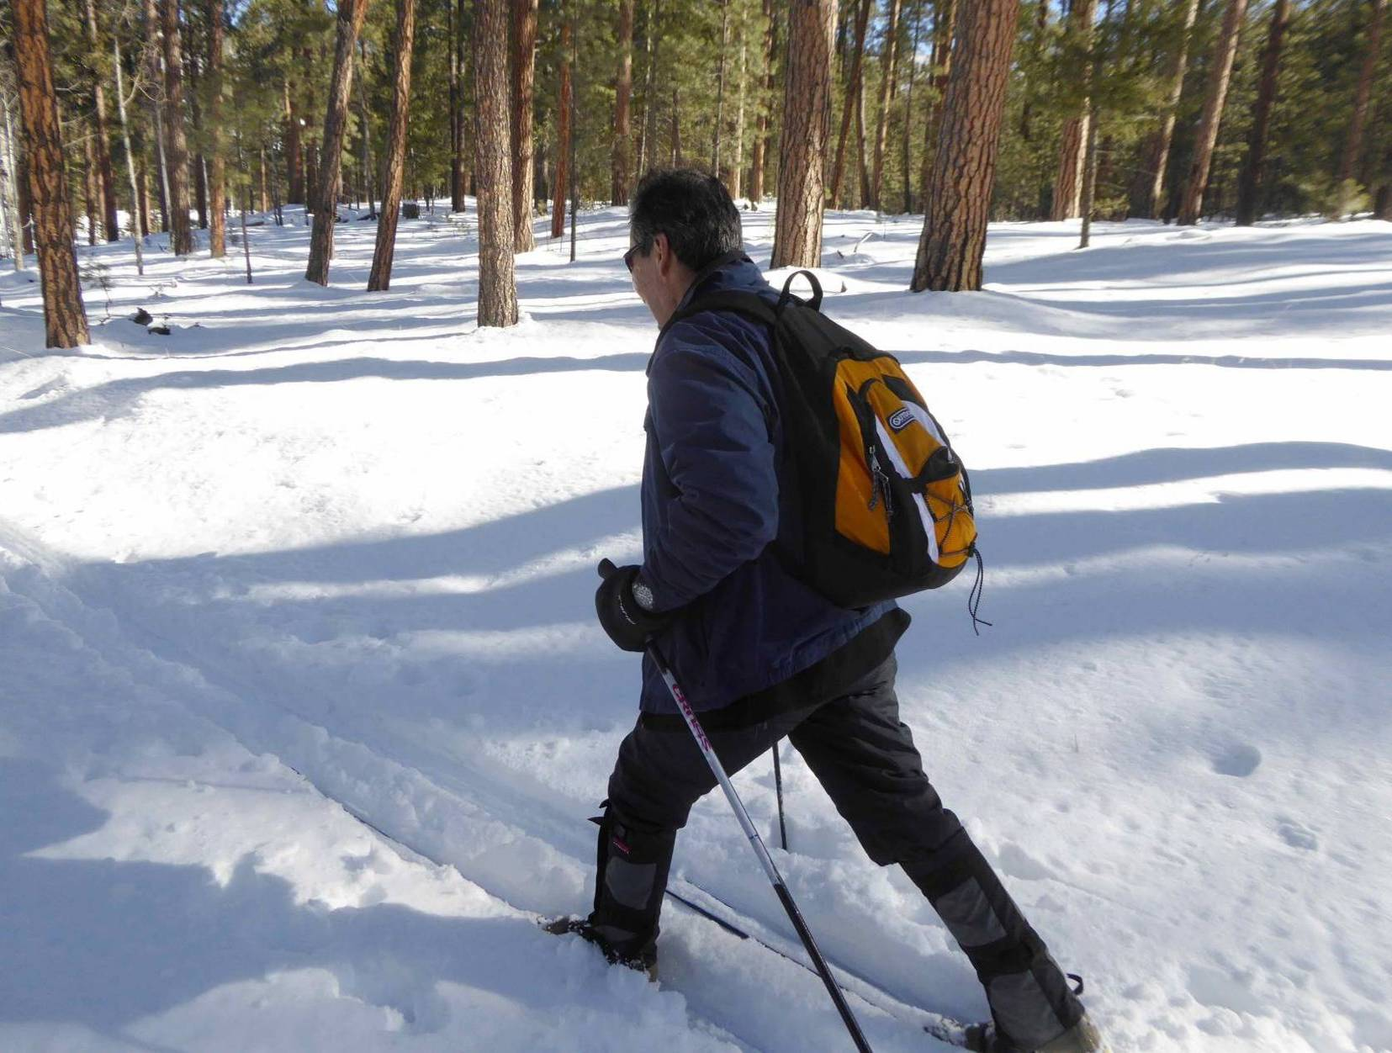

Daniel Salazar.

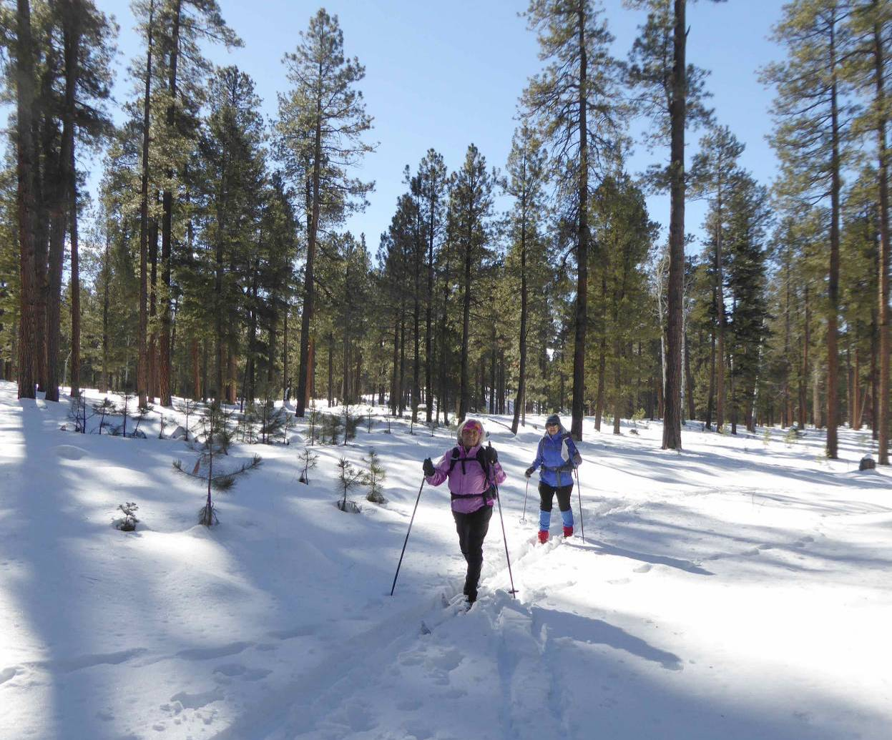

L to R: Holly Noland and Bronwyn Willis.

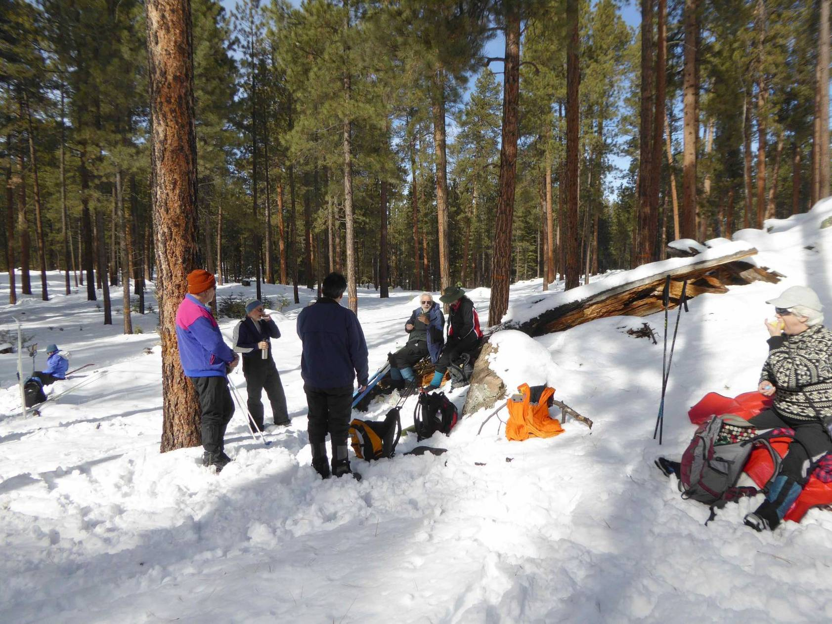

Lunch on the east side of the Loop Trail adjacent to the boundary fence between the Santa Fe National Forest

and the Valles Caldera National Preserve. In the thinned forest it we did not find many large logs to sit on.

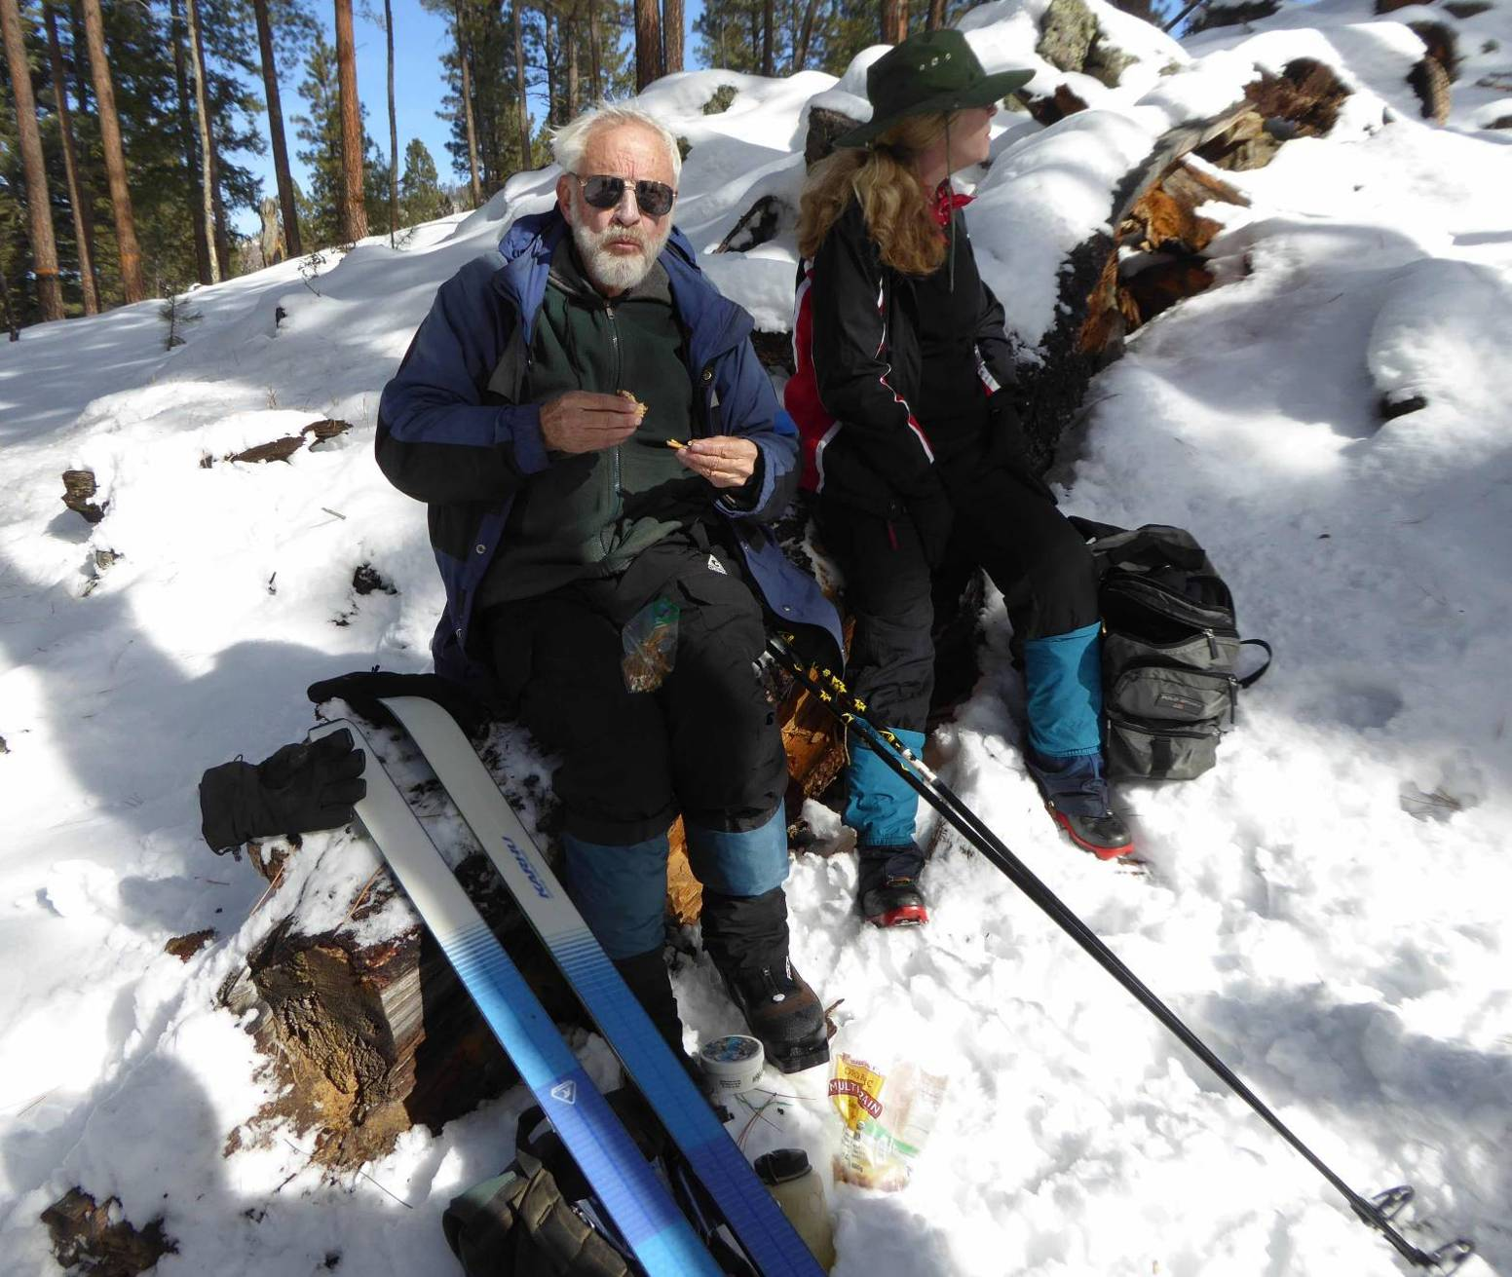

Sam Beard and Kim Kaufman having lunch on a large log.

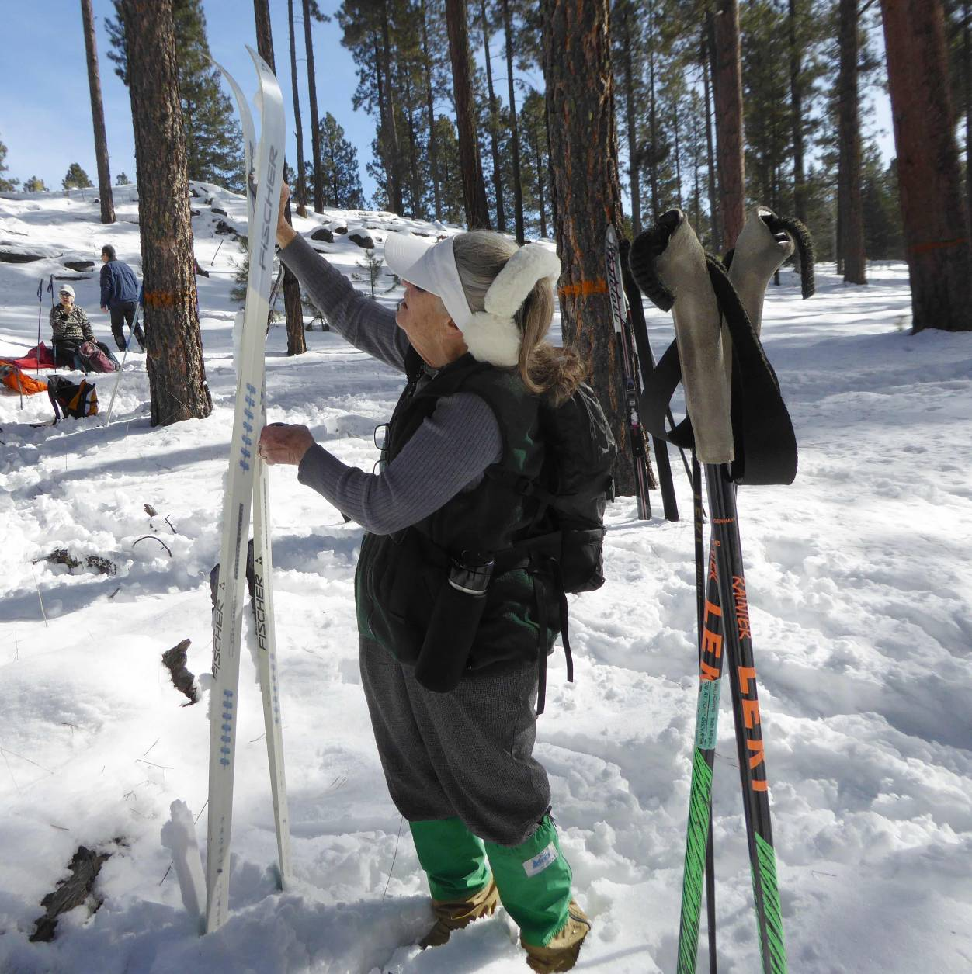

Lynda Katonak waxing at lunch time. The weather was warm, and skiers were putting

Maxi-Glide on the skis so that snow would not stick to the bottoms.

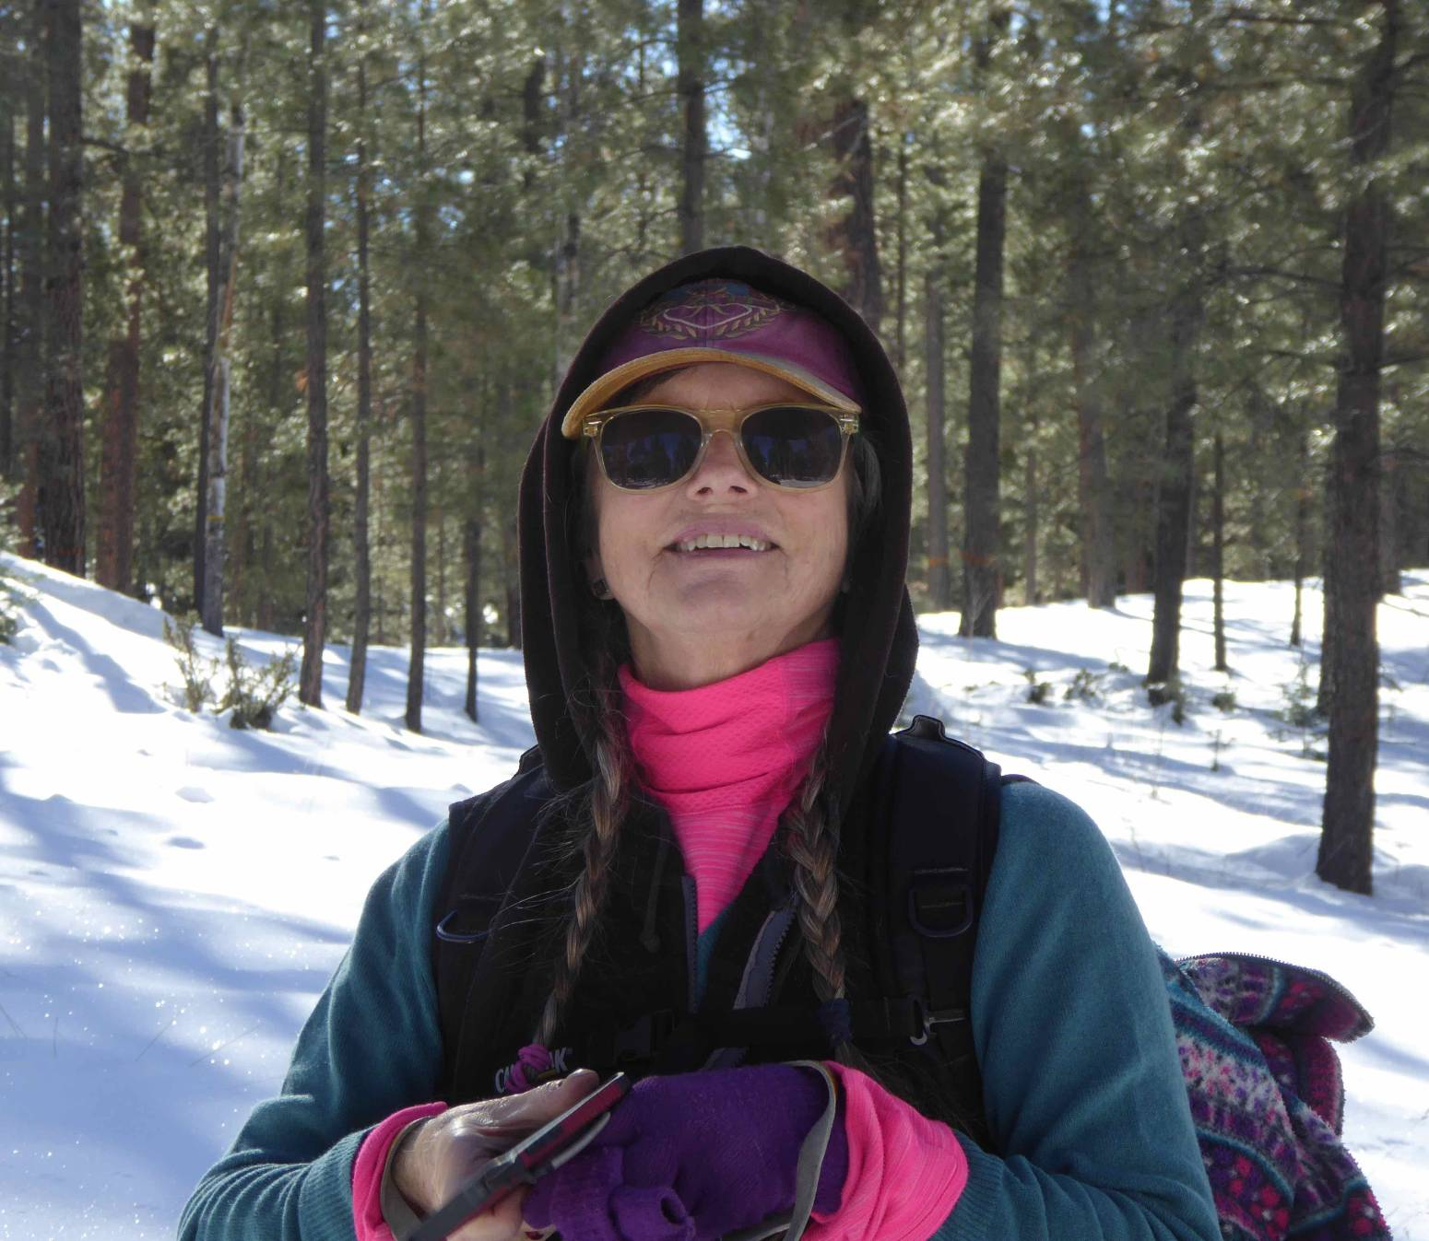

Geri Newton.

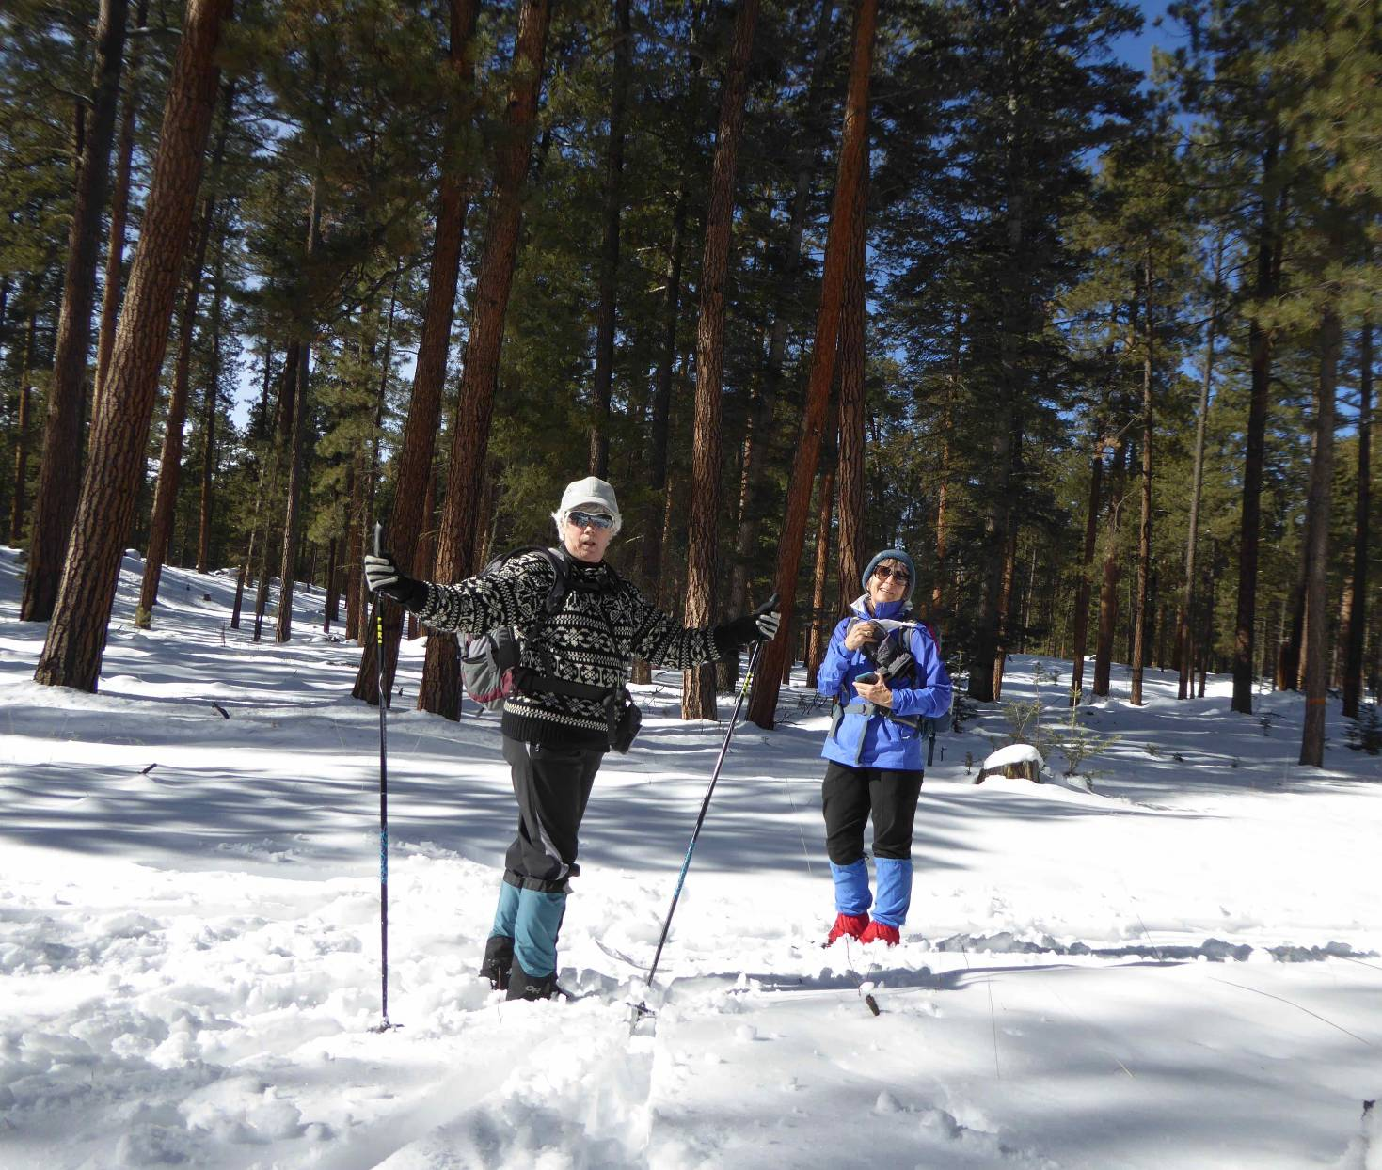

L to R: Marcy and Bronwyn.

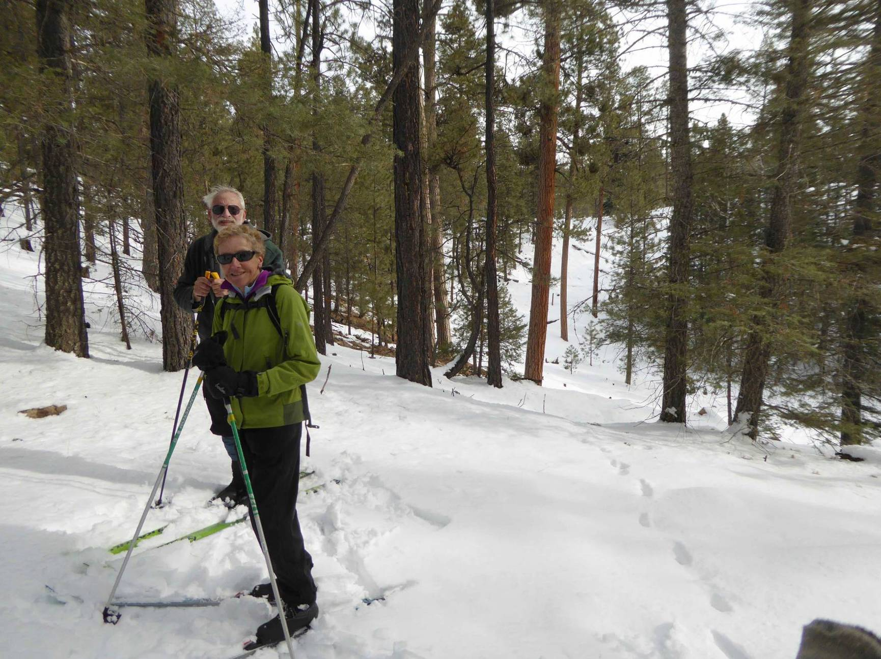

Sam and Ellen on the north edge of the small crater on the Crater Spur Trail.

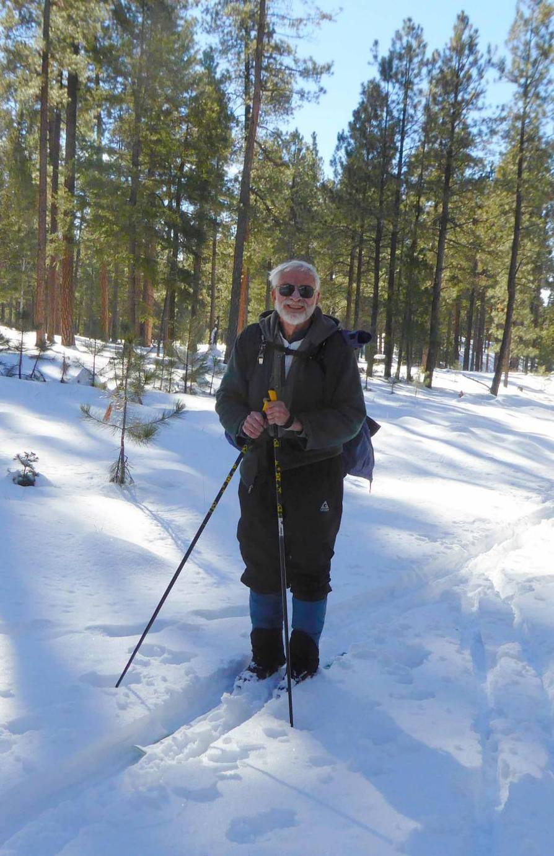

Sam on the west side of the Loop Trail.