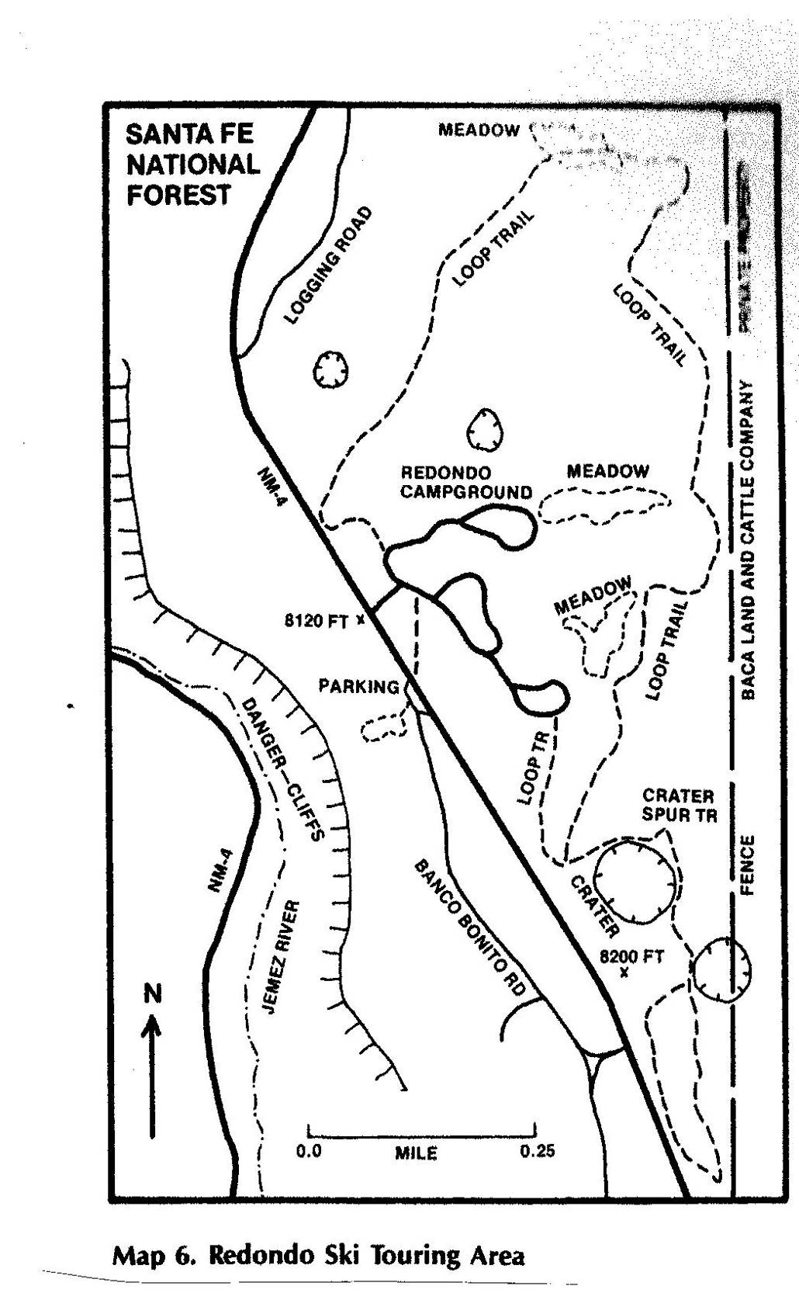

The Redondo Loop Trail goes from the NW corner of the campground through large

trees to a meadow about one-half mile N of the CG, S along the boundary

of the Valles Caldera National Preserve (VCNP), and then to the SE corner of the CG.

The Crater Spur Trail is located SE of Redondo Campground and just east of NM-4.

It passes two craters that are related to volcanic activity in the Valles Caldera

that erupted 1.25 millions years ago. The Baca Land and Cattle Company property

on the east side of the map is now the VCNP.