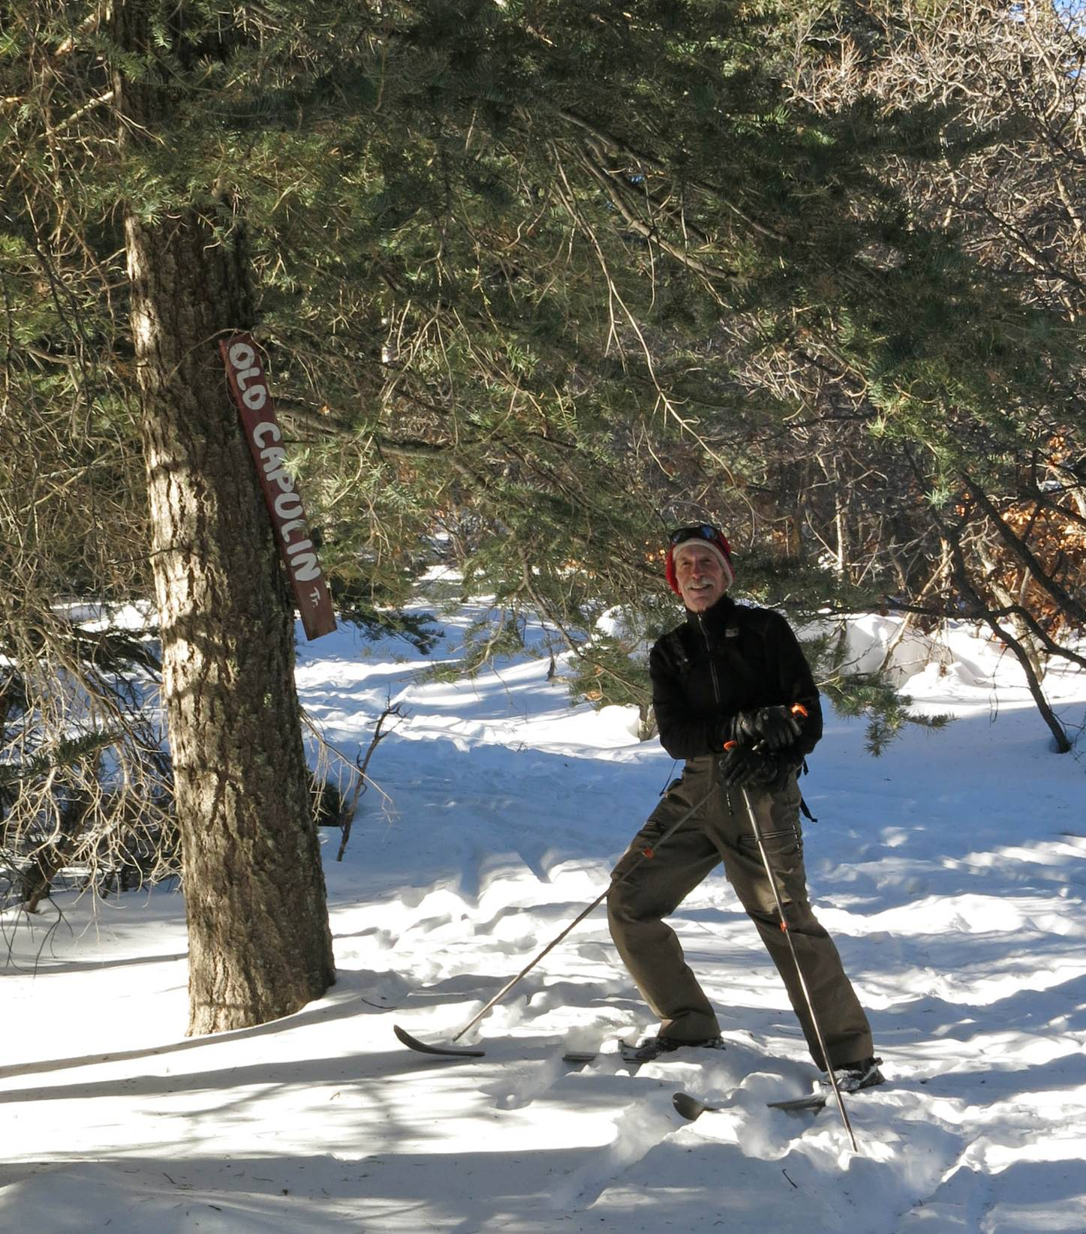
Peter Marks beside a fir tree with a sign “Old Capulin,” a major trail in the former ski touring center
based at the Snow Play Area. All photos by Carl Smith

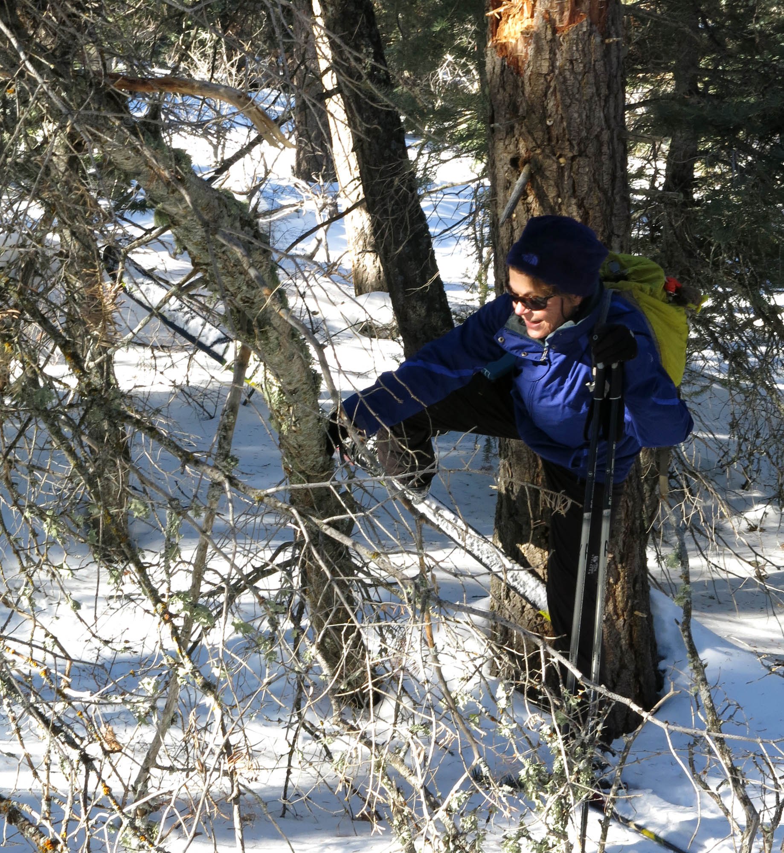
Bet untangling herself from a group of three trees on the way to the overlook.

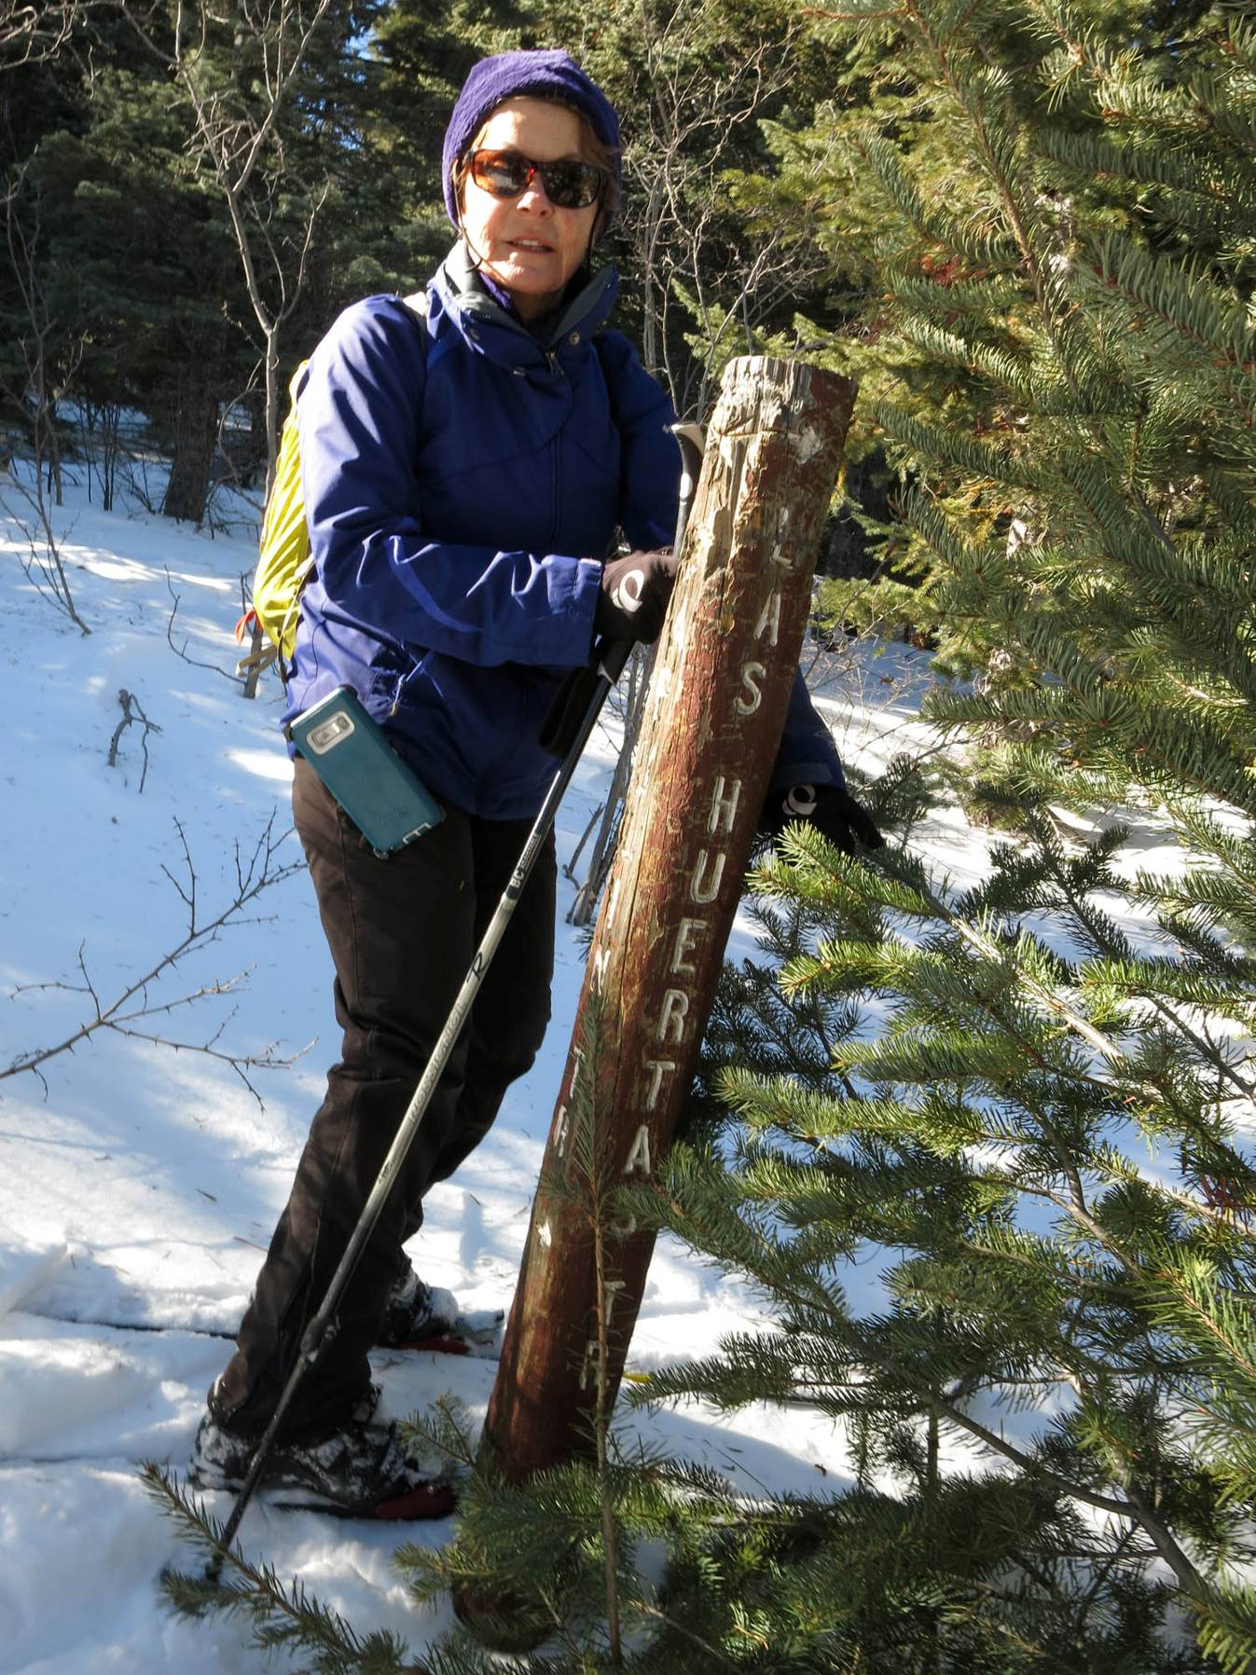
Bet Gendron at a sign post at an intersection where the trail to the right leads
to Las Huertas Canyon Overlook

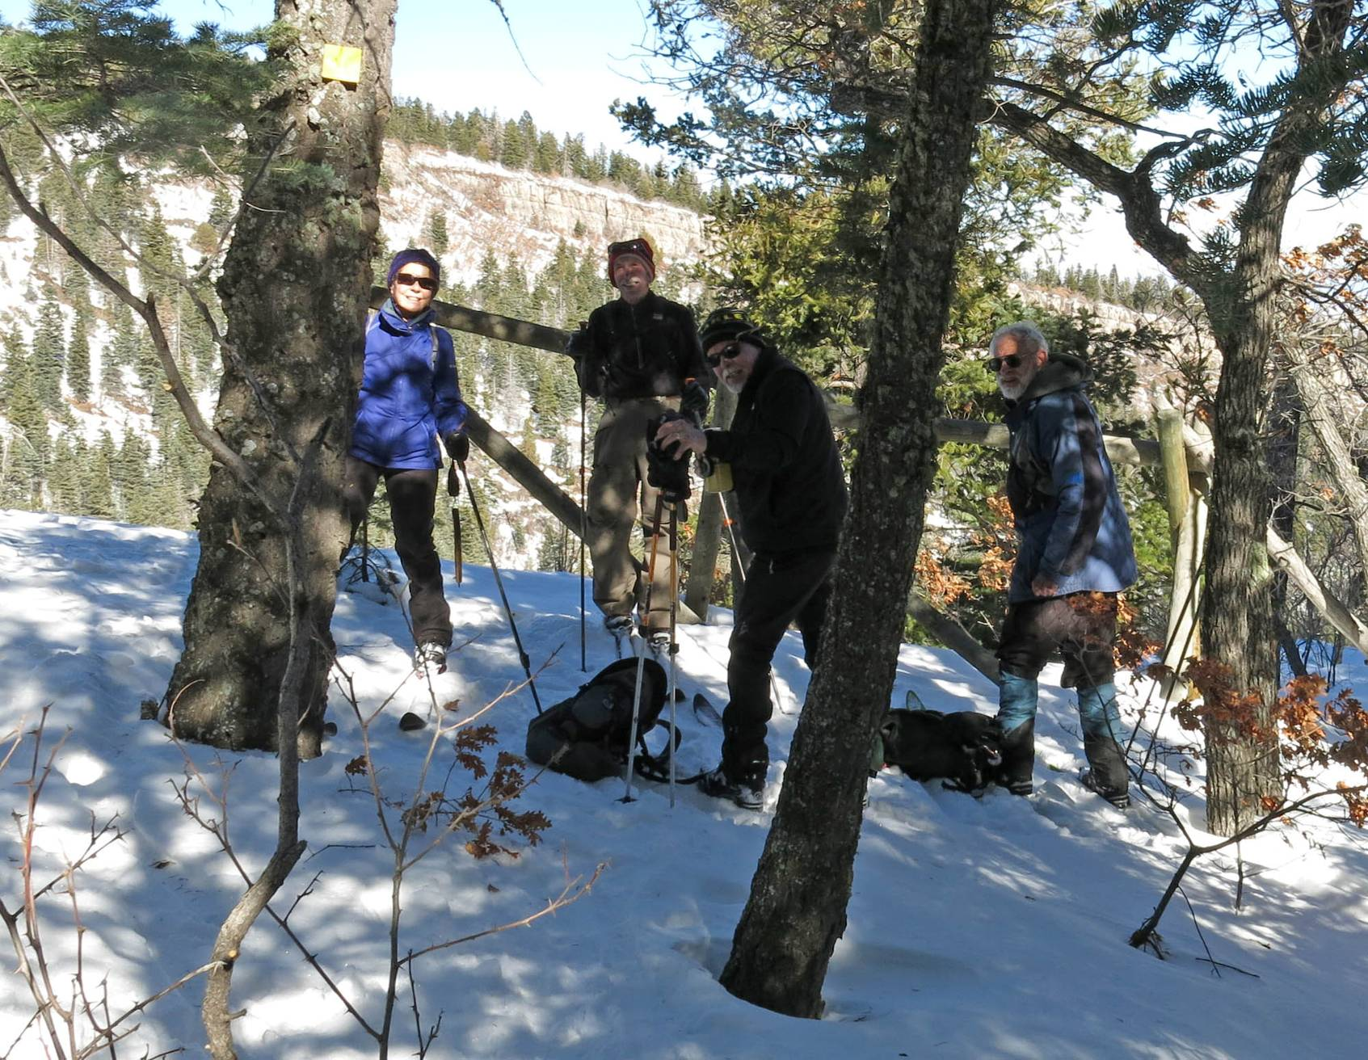
Bet Gendron, Peter Marks, Steve Gendron, and Sam Beard at Las Huertas Canyon Overlook. Sam helped construct and install
the buck and pole safety barrier at the cliff edge.
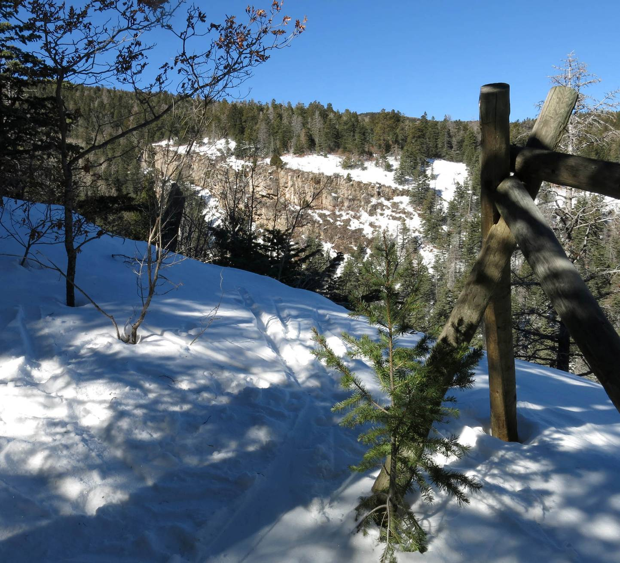
Las Huertas Canyon where it is very deep with near-vertical walls. Uphill to the left about one-quarter mile,
where the canyon has divided into two less deep segments, is an unmarked route
that crosses the canyon and continues to Media Spring.

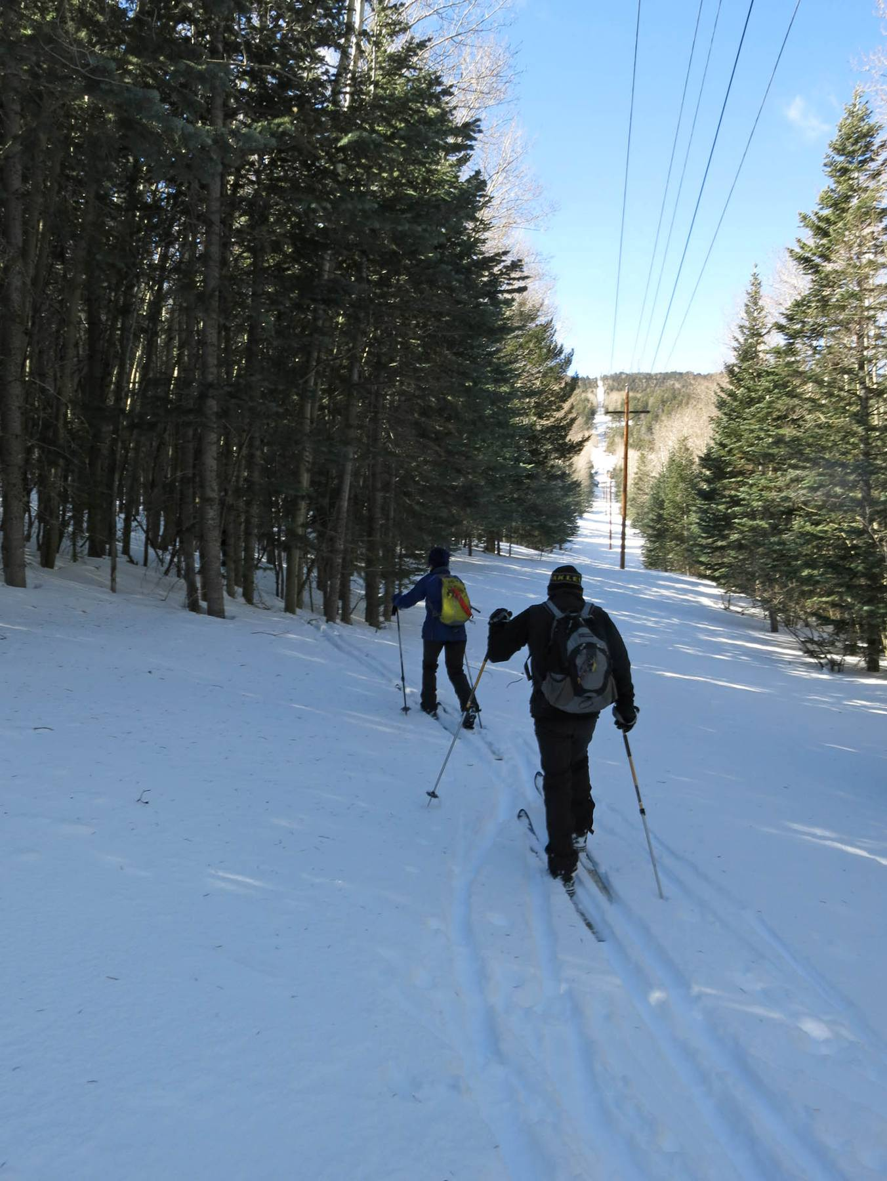
Skiing under the power line about 0.8 mile up the mountain from the Snow Play Area.

