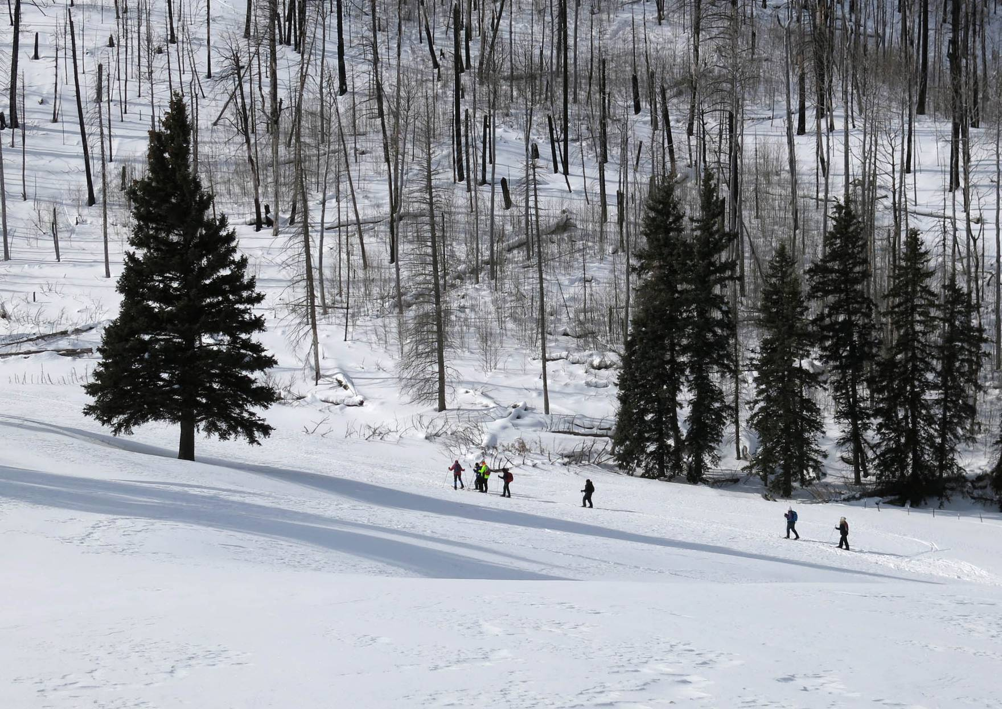
Skiers going up Corral Canyon Trail to the beginner practice area.
Photo by Carl Smith

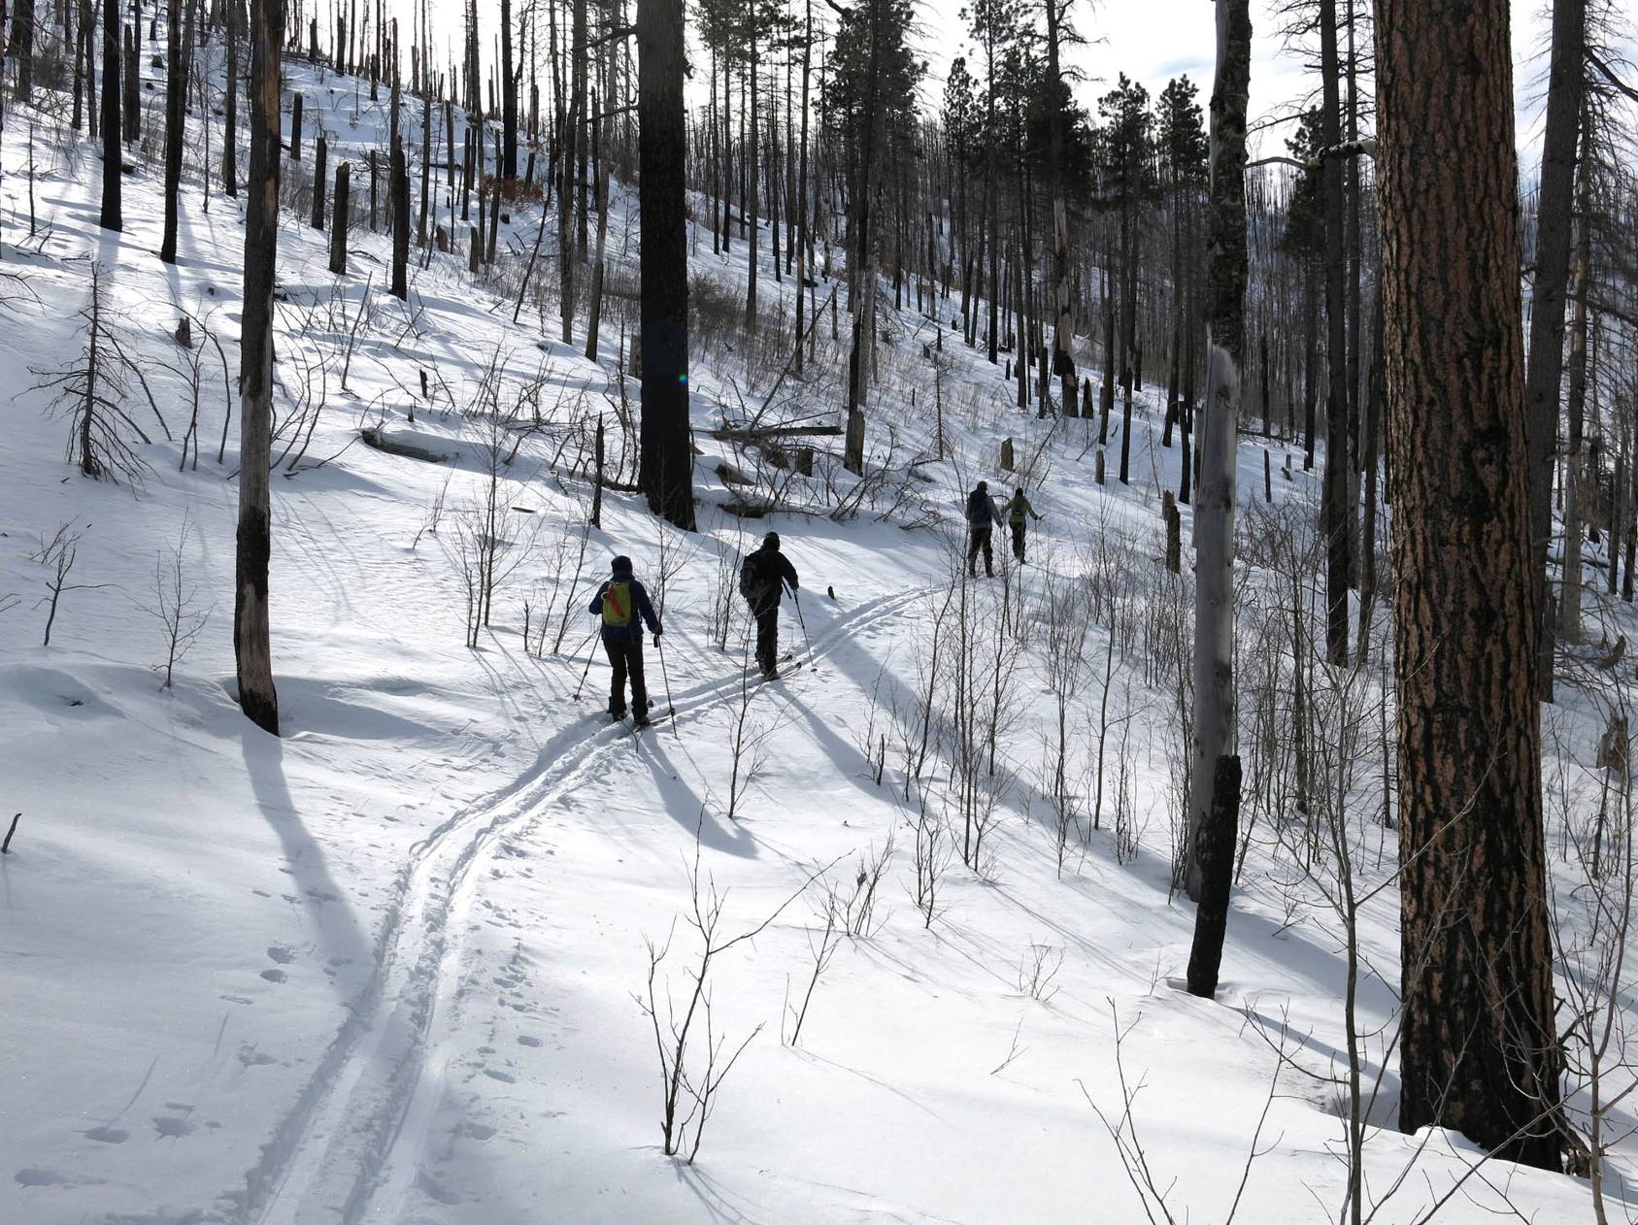
Class II skiers on Calzada Trail through the forest burned in the Las Conchas Fire in 2011.
Note the large number of young aspen trees.
Photo by Carl Smith

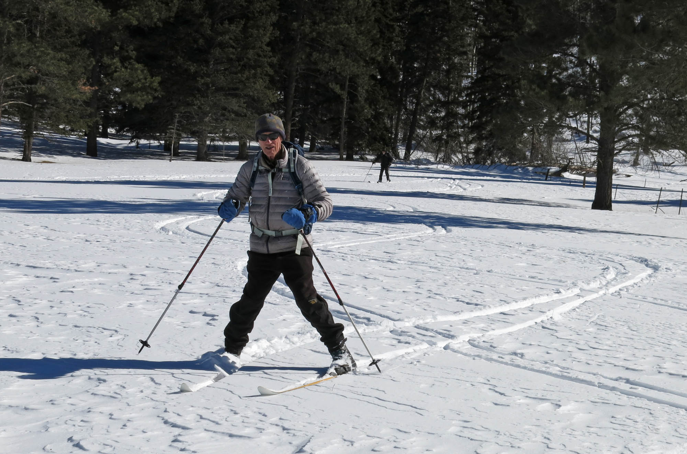
Bernie Rubenstein making a turn on the slope on the east side of Corral Canyon.
Photo by Carl Smith

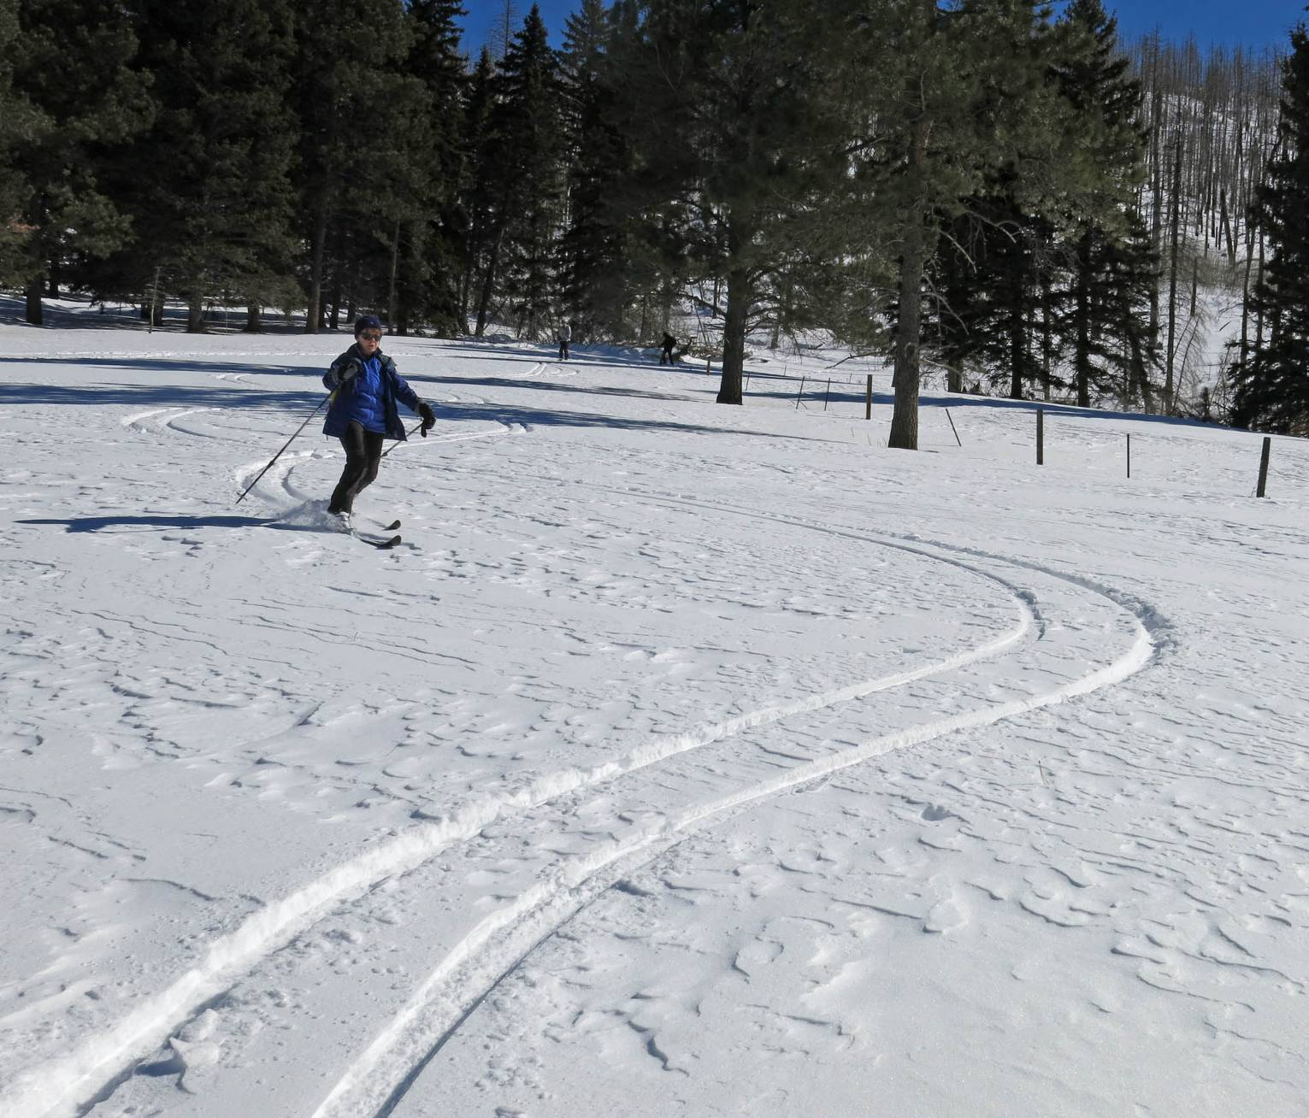
Bet Gendron making Telemark loops on the side of Corral Canyon
Photo by Carl Smith

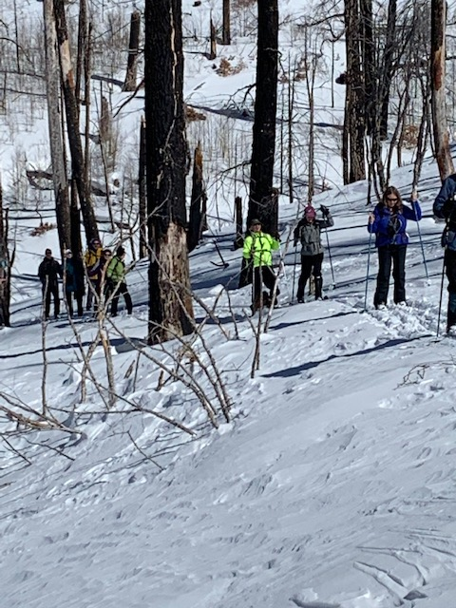
Class I skiers on Calzada Trail after completing their class on turns
in the bottom of Corral Canyon.
Photo by Michael Arndt

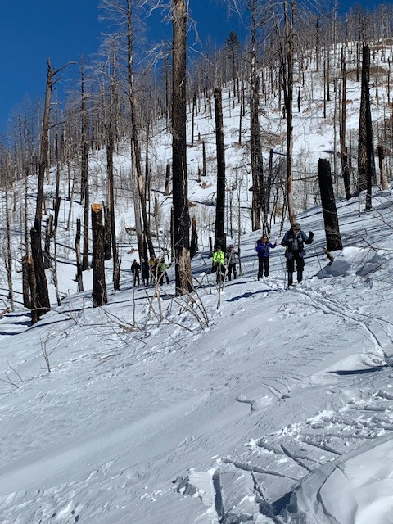
Leaving Calzada Trail and starting down to the middle part of Corral Canyon.
Photo by Michael Arndt
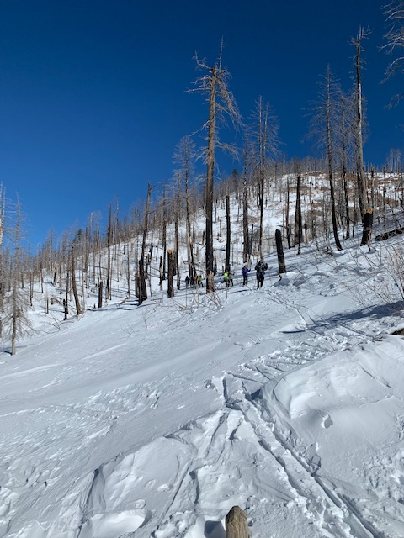
Skiers on Calzada Trail with burned forest in background.
Photo by Michael Arndt

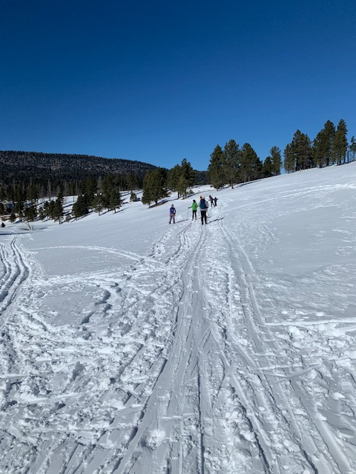
Skiers returning to the highway after a four-hour outing on a beautiful Jemez day.
Photo by Michael Arndt

