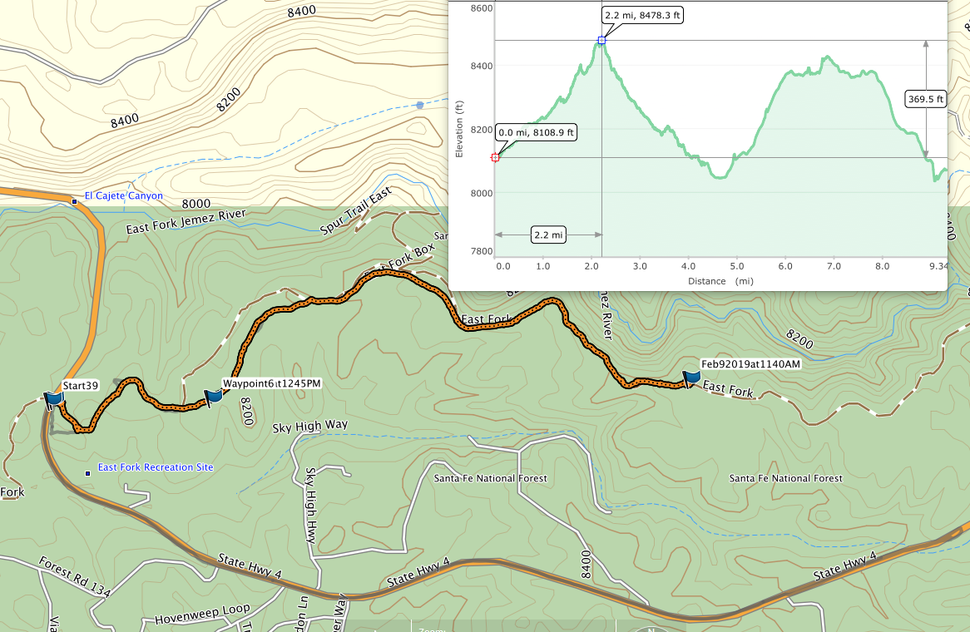
GPS data map of the 2.2-mile ski tour on the East Fork Ridge Trail from the west trailhead on NM-4 to the lunch spot. The elevation map of the tour is presented in the inset that shows that the elevation increased from 8109 feet to 8478 feet. The brown line with white dots is the
official USFS East Fork hiking trail (No. 137). When the skiers came to the thinned area where the old logging road was no longer visible, they
began skiing on the hiking trail. (Ignore the elevation data after 2.2 miles) Map by Mike Meier.
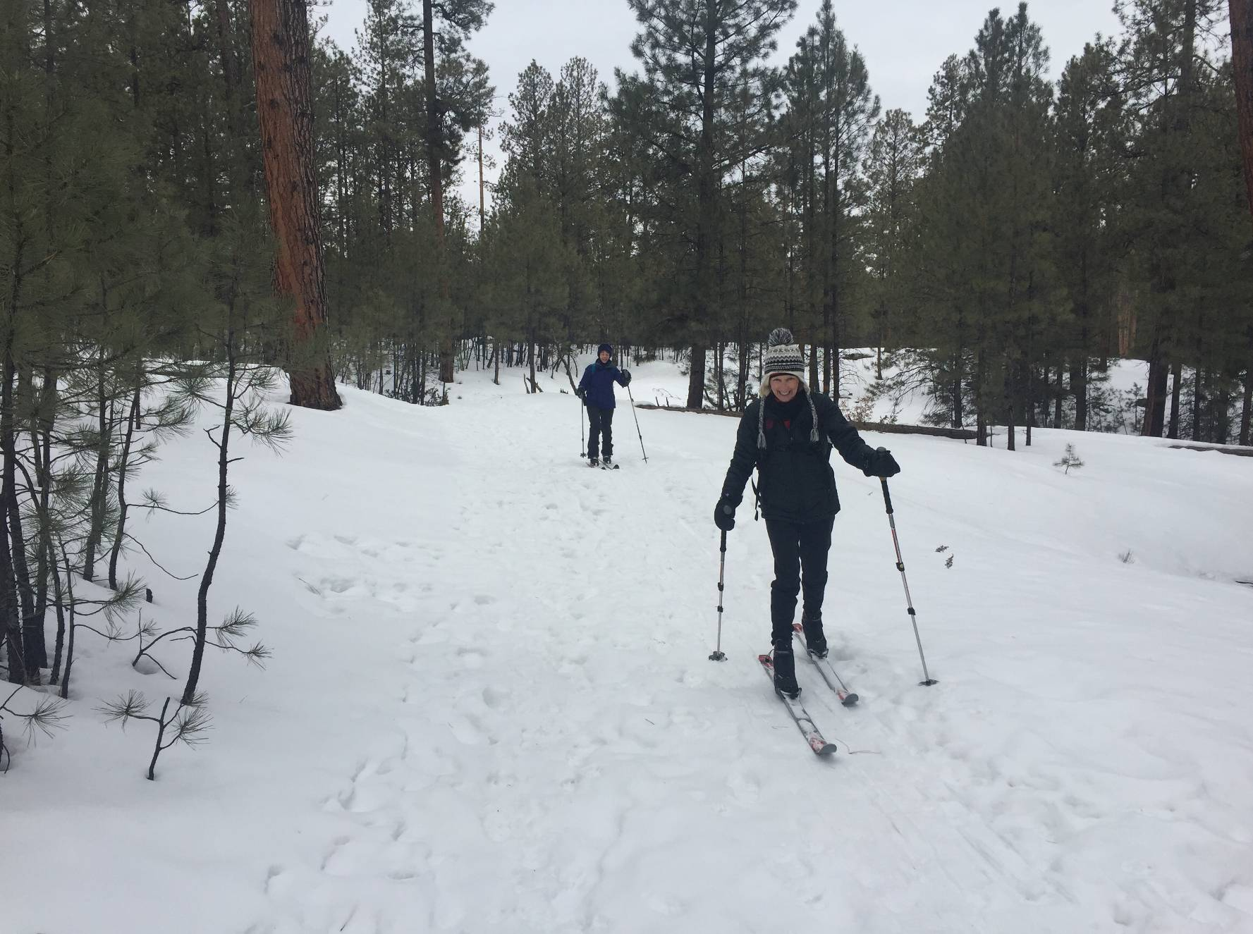
L to R: Bet Gendron and Anne White on the ski trail on the former logging road. The terrain, vegetation, and snow cover
in this photo are typical of that found along the ski trail up to the point where it was no longer visible due to the forest thinning.
Photo by Bill White.

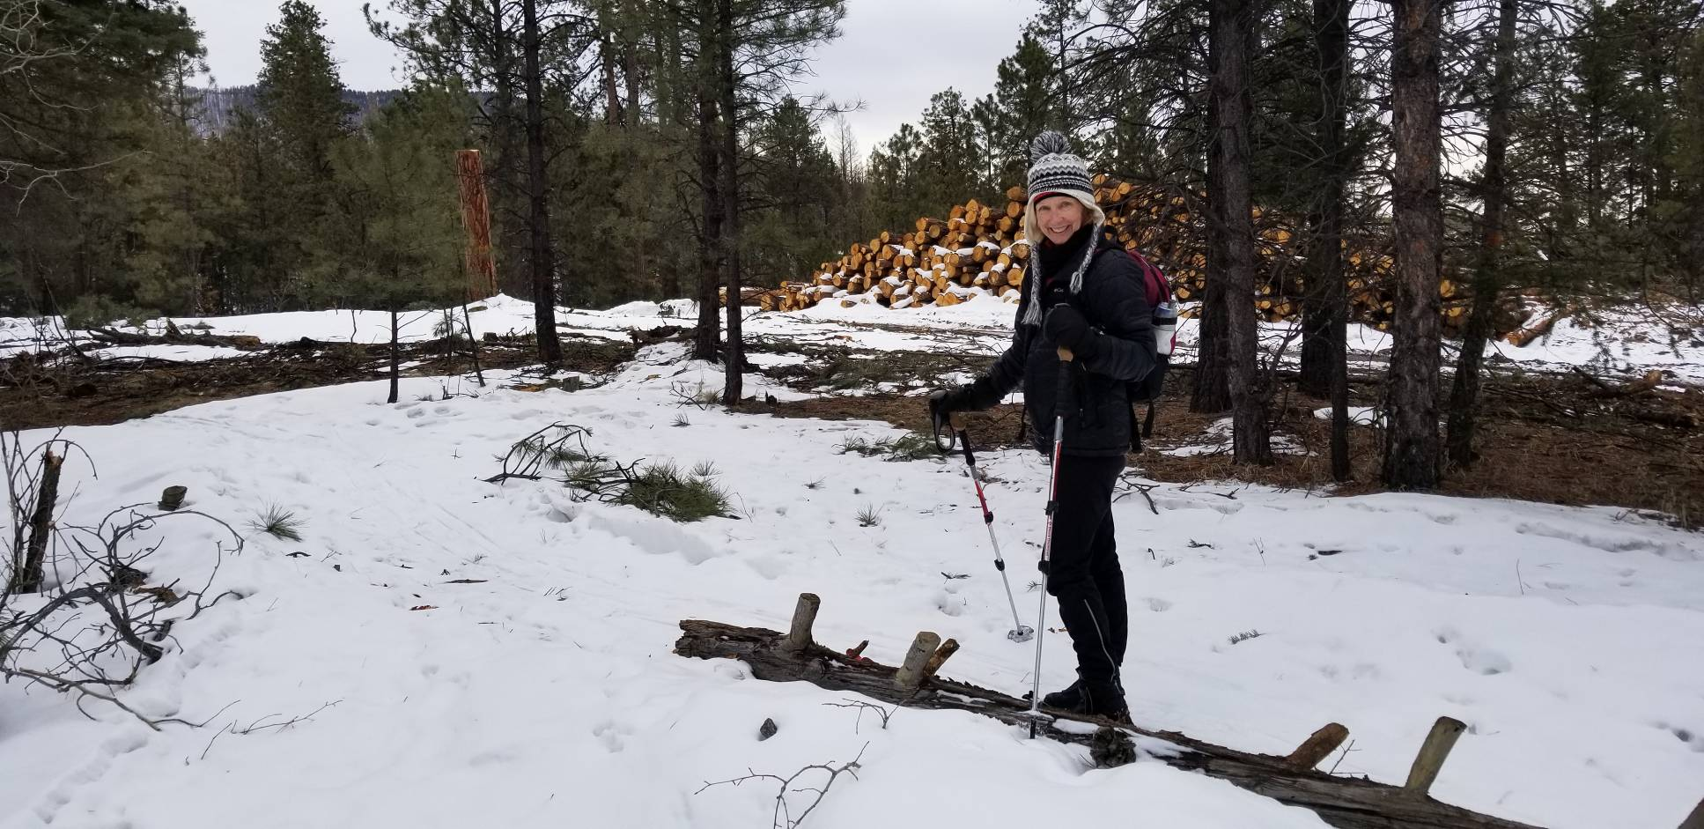
Anne White on the edge of the thinned area with a very large pile of logs in the background. The thinning extended to the East Fork ridgeline,
and fortunately some of the ski trail on the old logging road and most of the hiking trail were on the north side of the ridgeline.
Photo by Bet Gendron

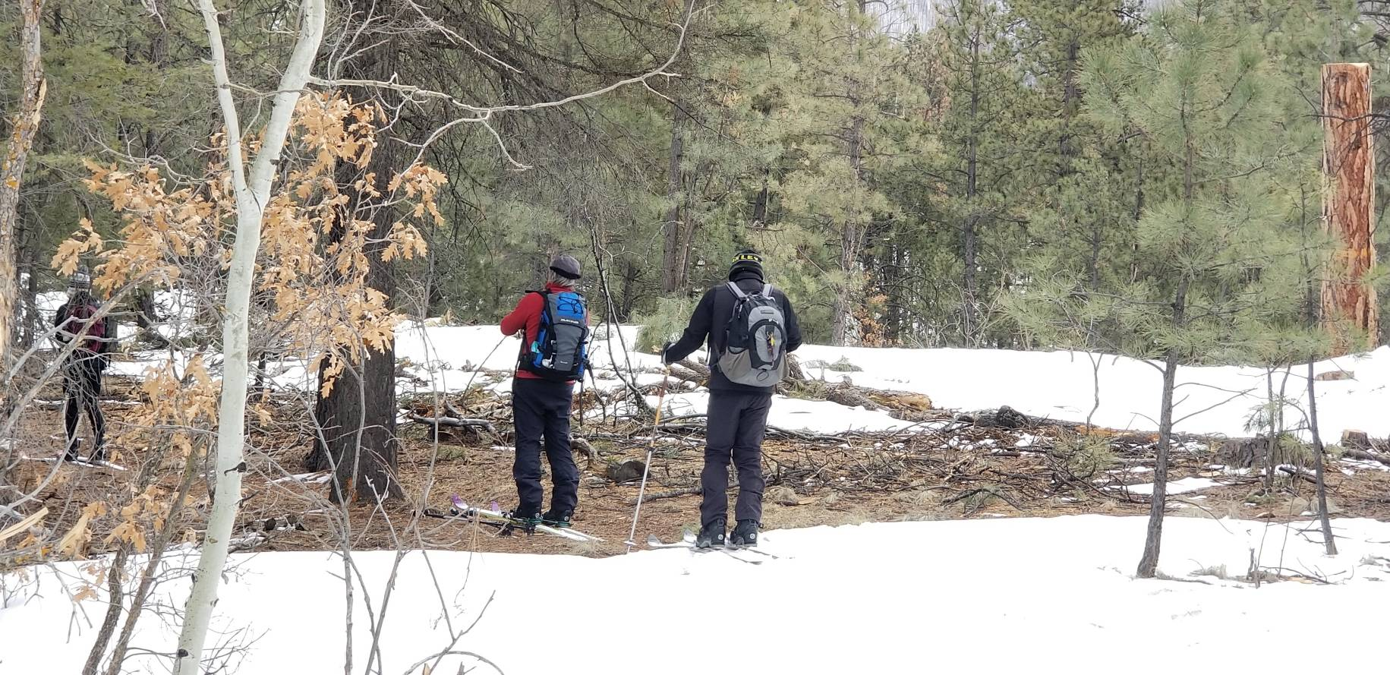
L to R: Anne White, Bill White and Steve Gendron on the hiking trail on the north edge of the thinned area where the sun had
melted the snow. When the trees on the right side of the trail were removed, the sun could then fall on the trail tread.
Photo by Bet Gendron

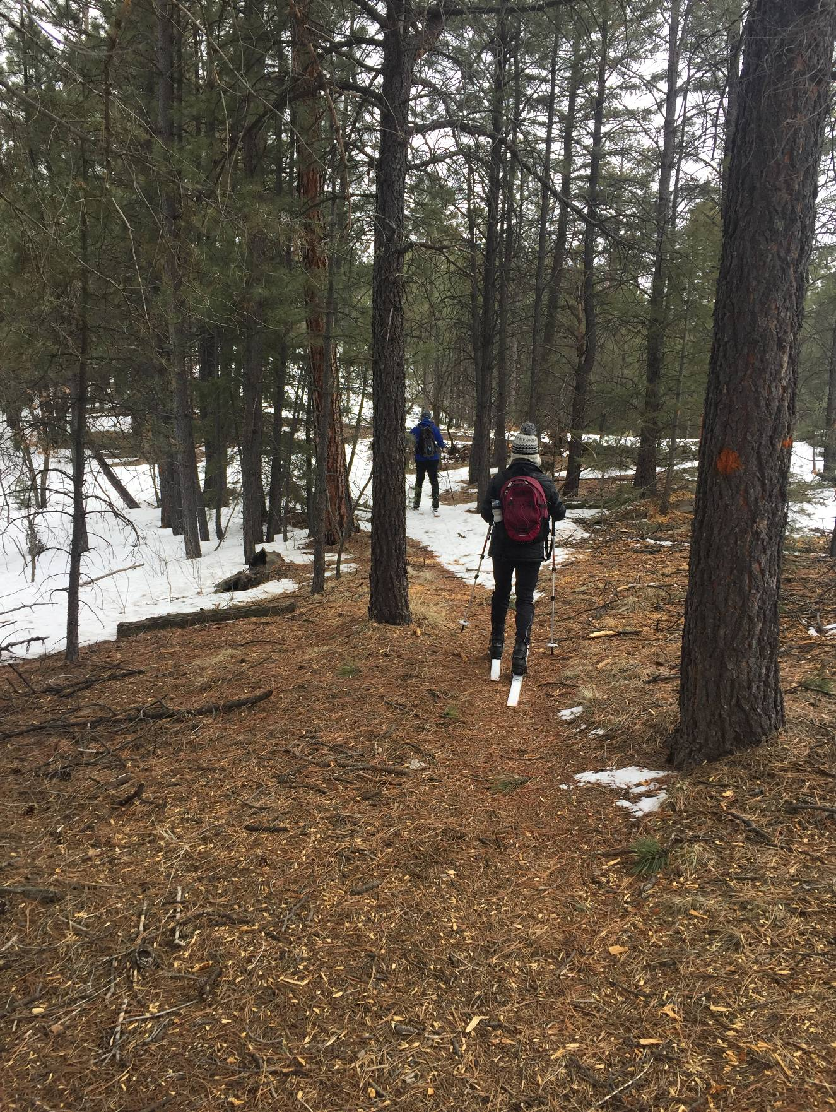
Skiing (walking) on another section of the hiking trail on the north edge of the thinned area.
Photo by Bill White

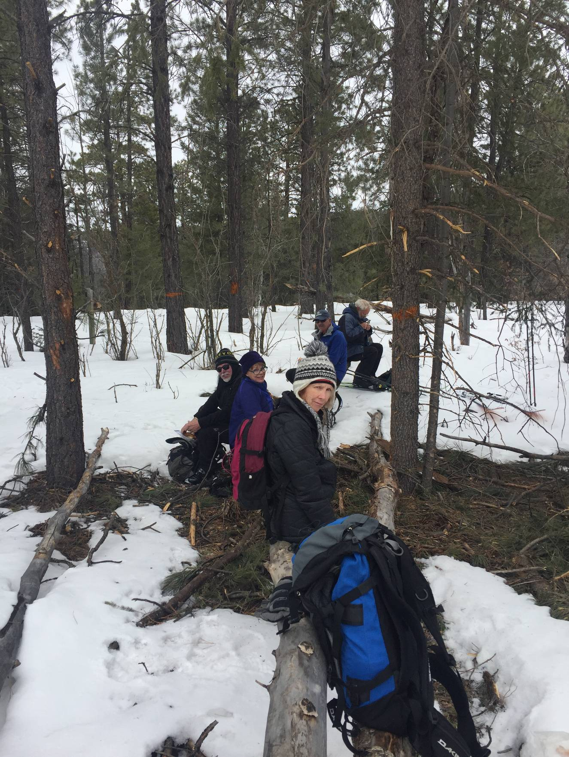
The skiers at the lunch spot on the hiking trail. L to R: Steve Gendron, Bet Gendron, Anne White,
Mike Meier, and Sam Beard. Photo by Bill White

