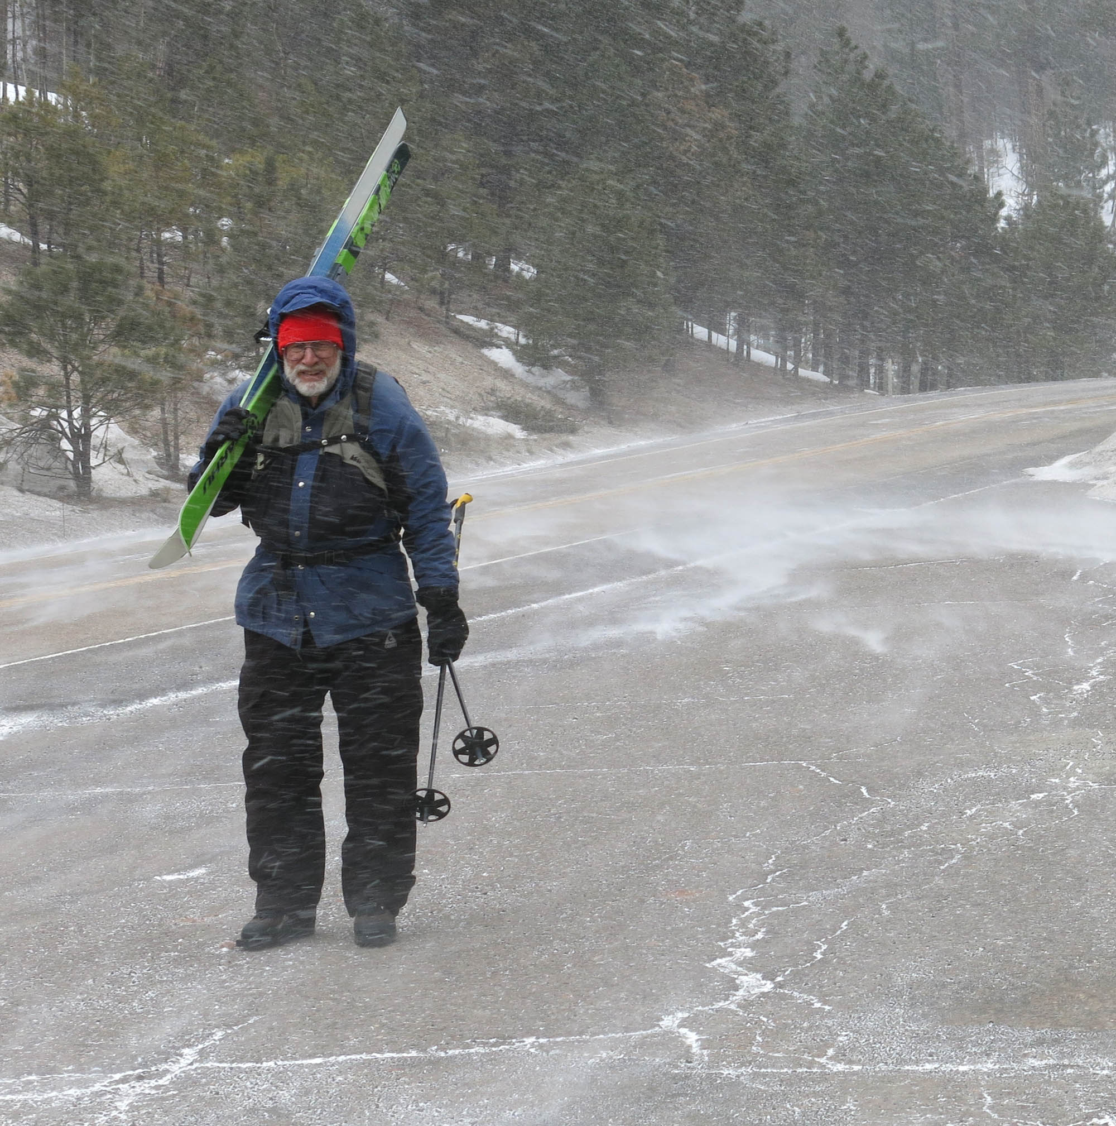
Sam ready to start the outing in the blizzard at Los Griegos parking lot.
All photos by Carl Smith.
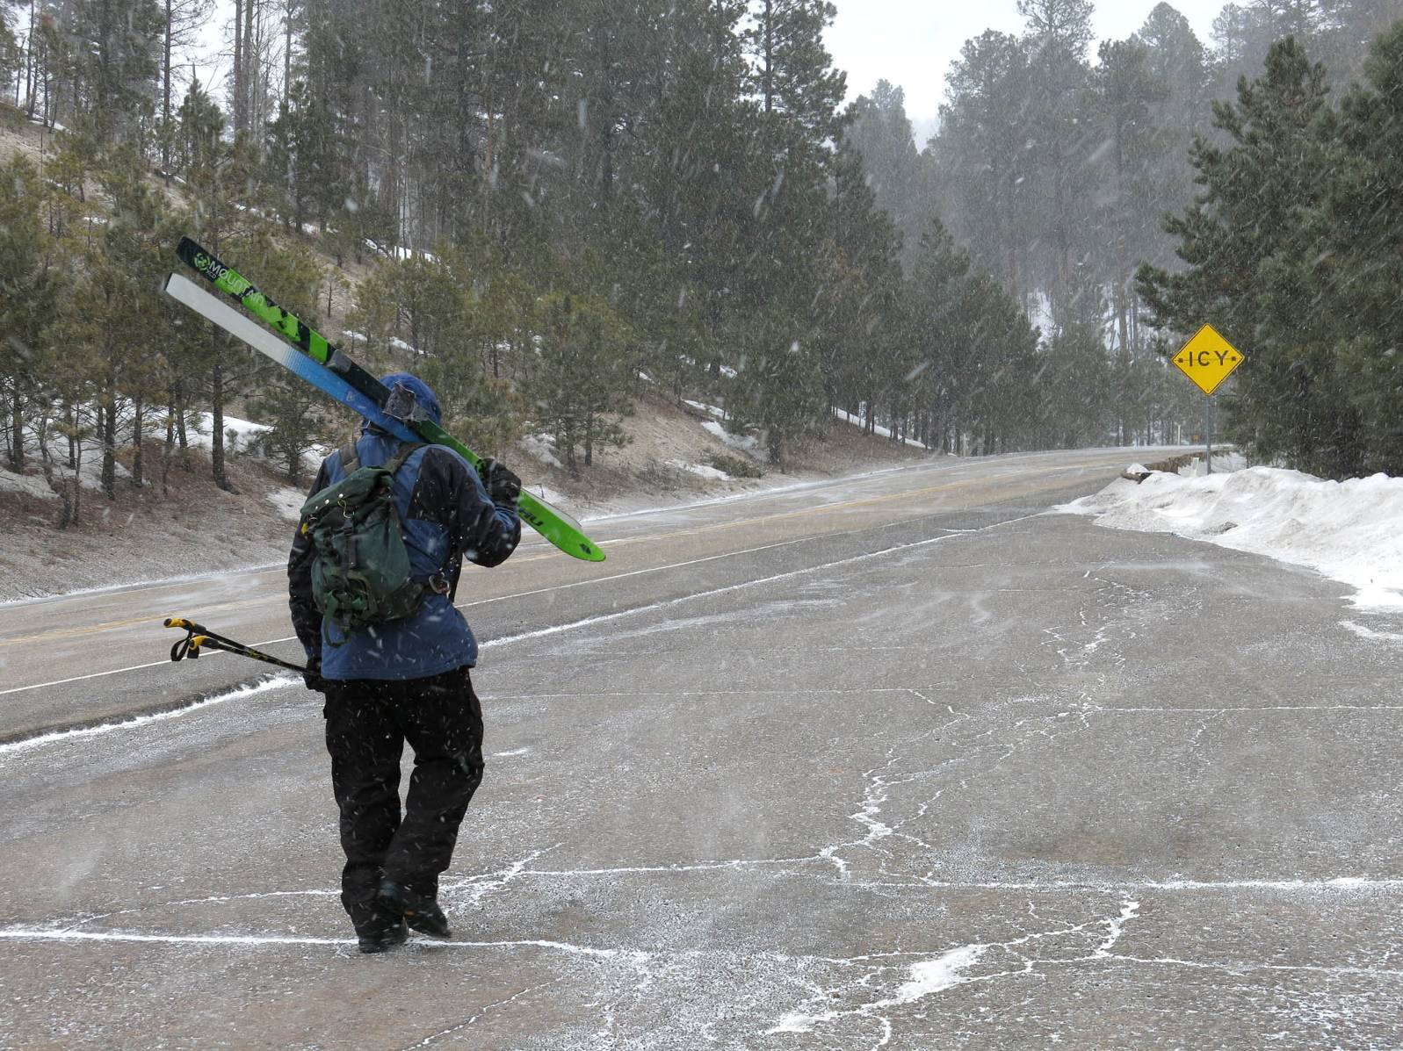
Sam on his way to the trailhead on the other side of the highway. The objective of the outing was to scout the Mistletoe Canyon
route in preparation for leading a Club tour there.

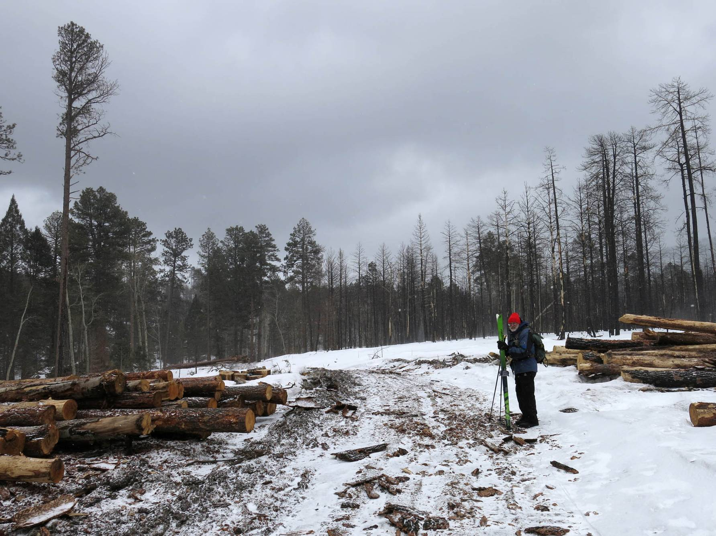
After skiing up Burn Trail to the Mistletoe Canyon Trailhead, we quickly learned that the upper part of the route was not skiable
due to the thinning/logging project on East Fork Ridge.
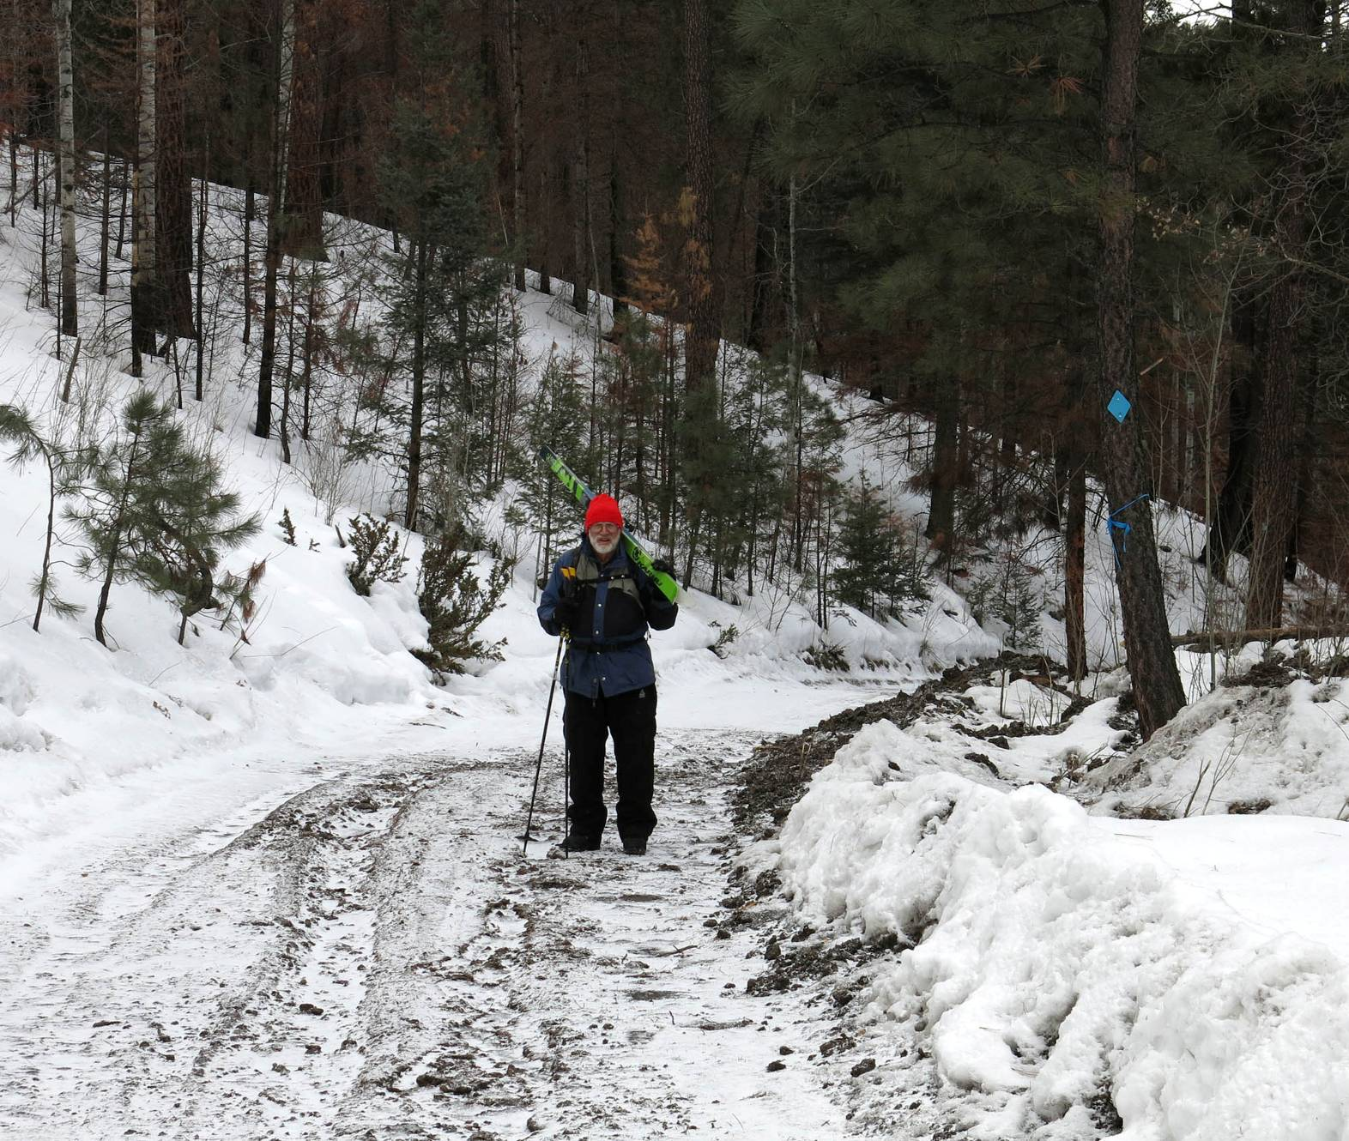
The road descending the upper part of the canyon was also obviously not skiable, and even walking
on the frozen ground and ice was treacherous
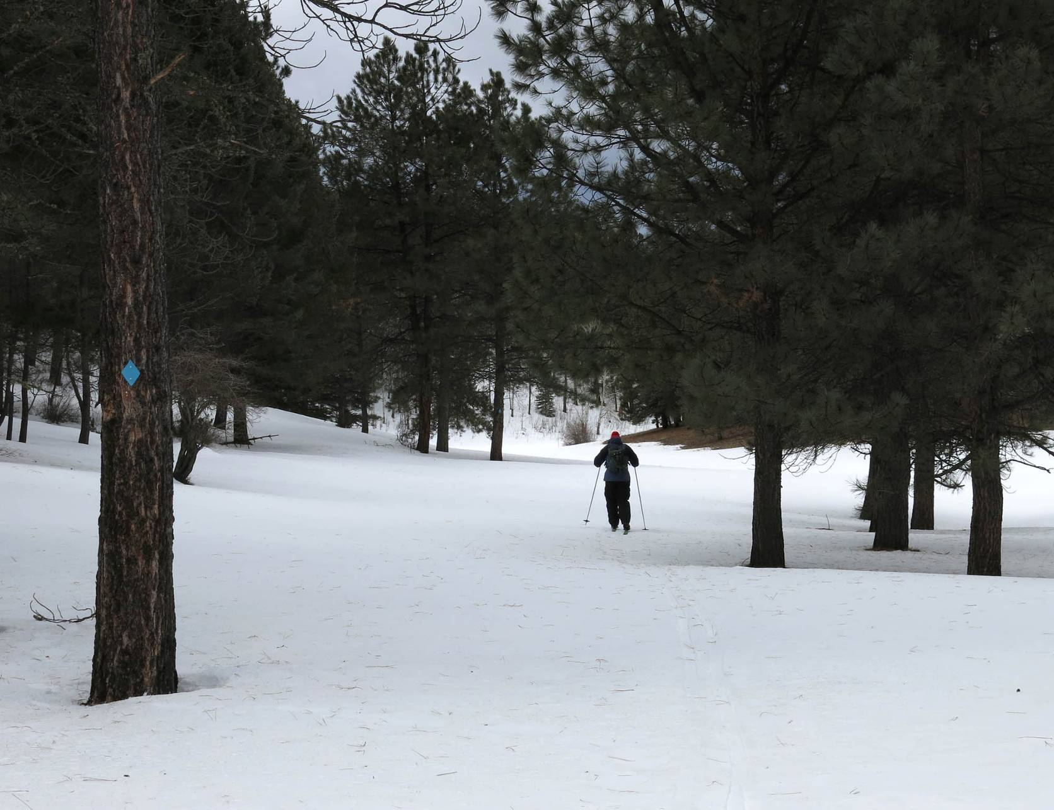
We finally found snow for skiing in Mistletoe Meadow.

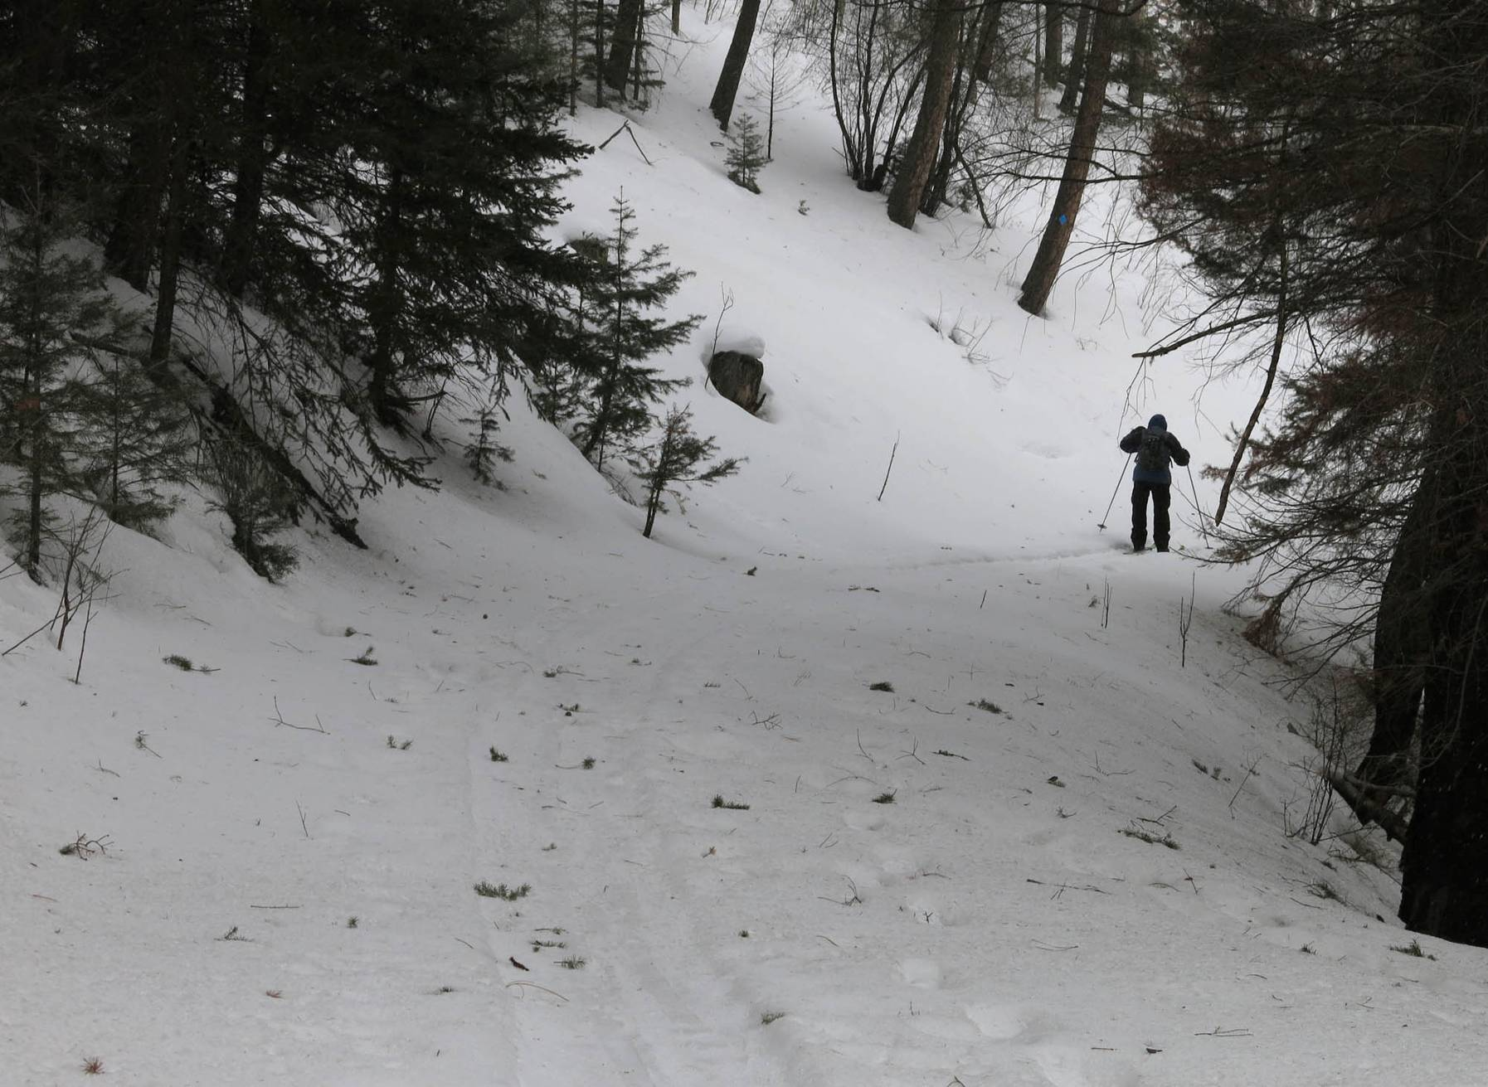
The most enjoyable part of the route – skiing down the former logging road on a north-facing slope with better snow.

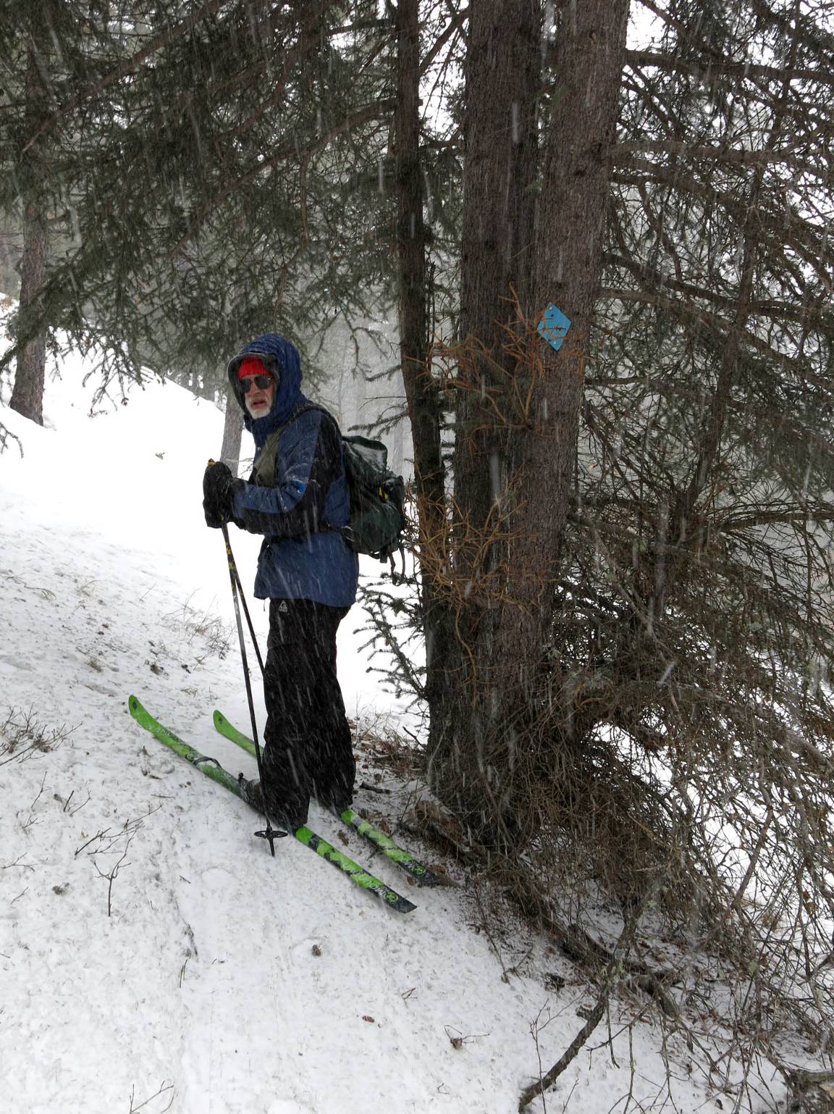
Leaving the canyon on a narrow traversing trail to ski around private property.

