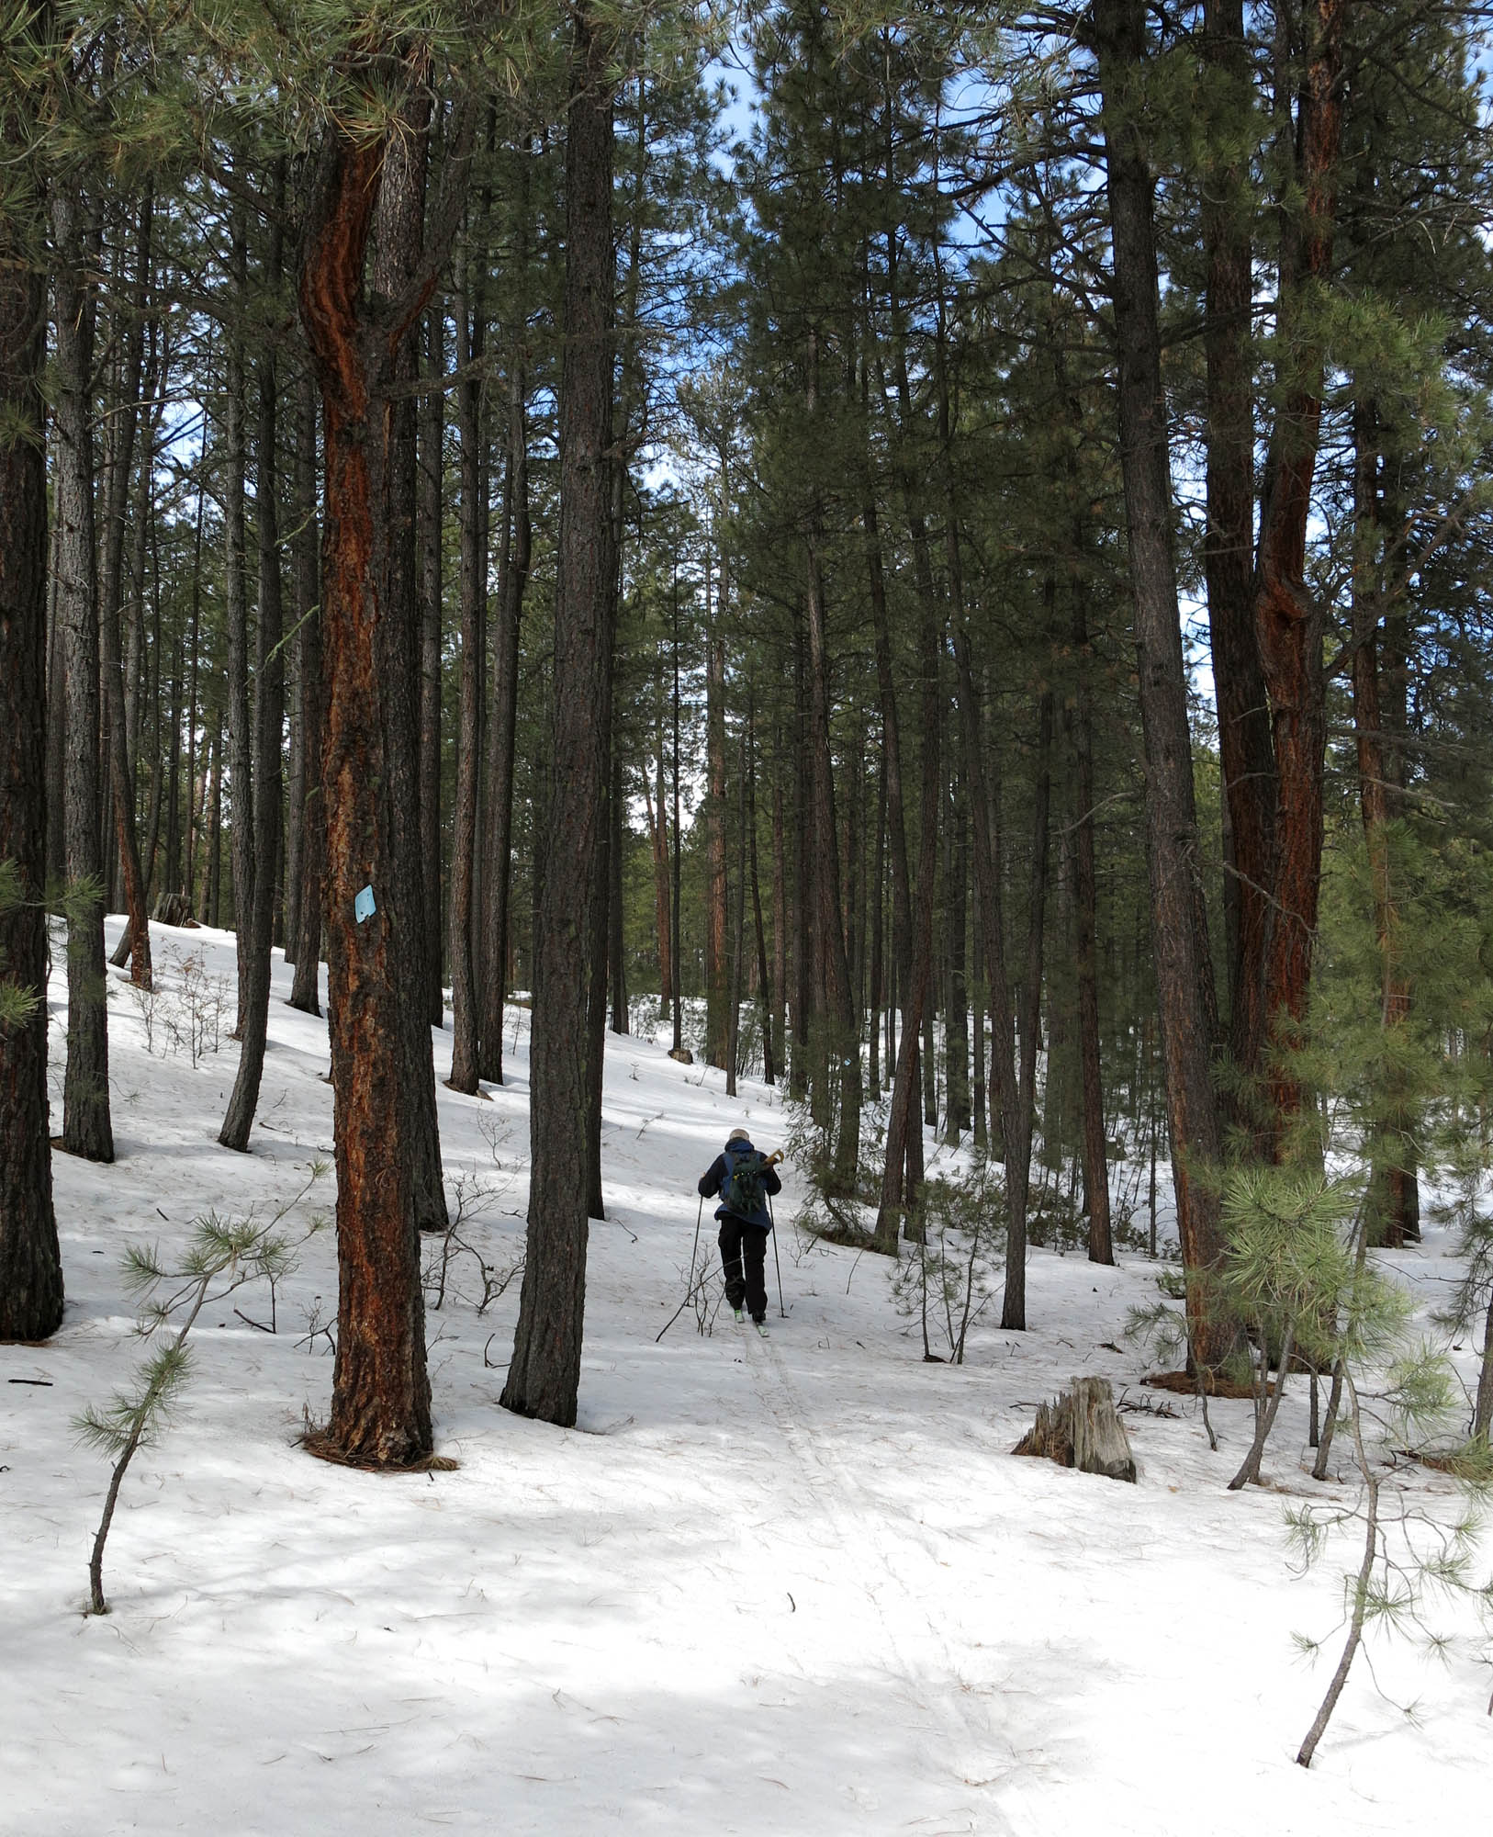
Skiing up Mistletoe Canyon Trail just west of Bennett Lane where the many mail boxes are located
on NM-4 at the intersection with Forest Road 10.
All photos by Carl Smith

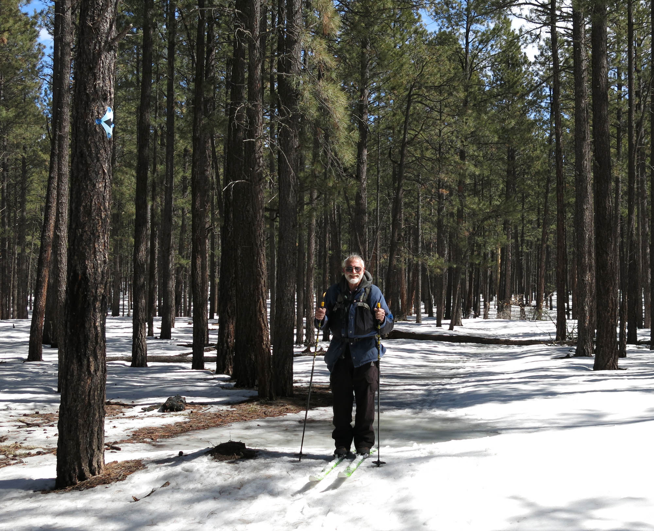
Sam at the west end of Mistletoe Canyon Trail at the intersection with the East Fork Ridge Trail.
Note the large blue diamond and arrow high on the tree indicating that EF Ridge Trailhead is the left.
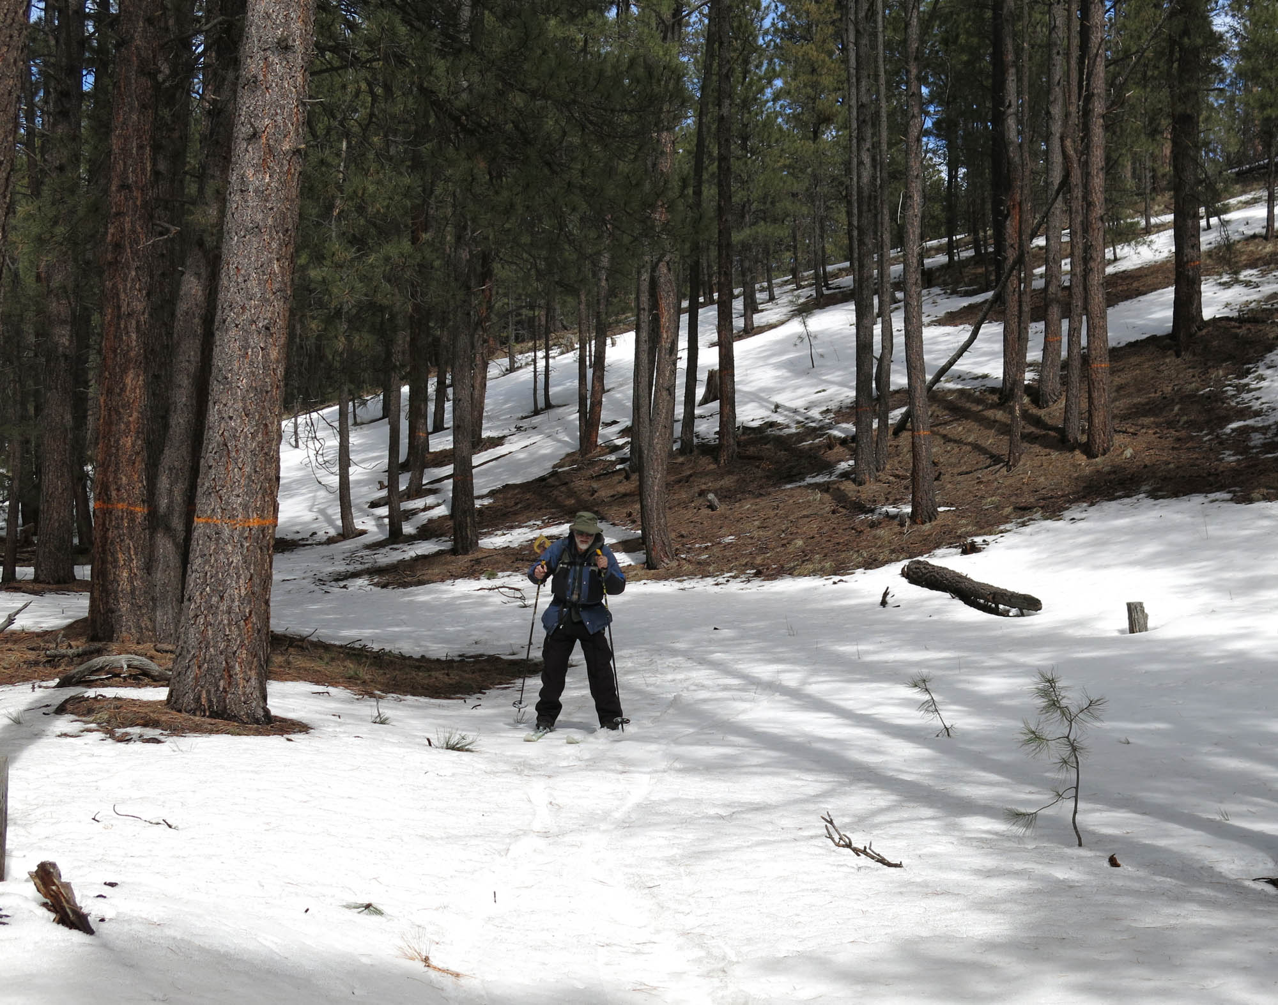
Sam snowplowing in the spring snow in the canyon between the EF Ridge Trail and the meadow and power line.
The tree shadows and bare areas indicate that this canyon faces south.
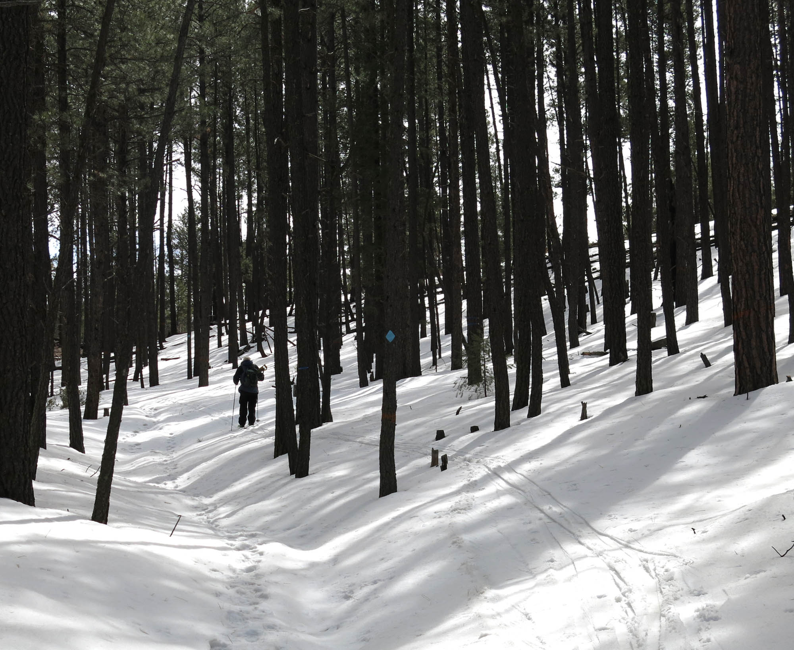
Skiing back to Bennett Lane on a north-facing slope with good snow cover. NM-4 and the mail boxes
are just over the ridge on the right.

