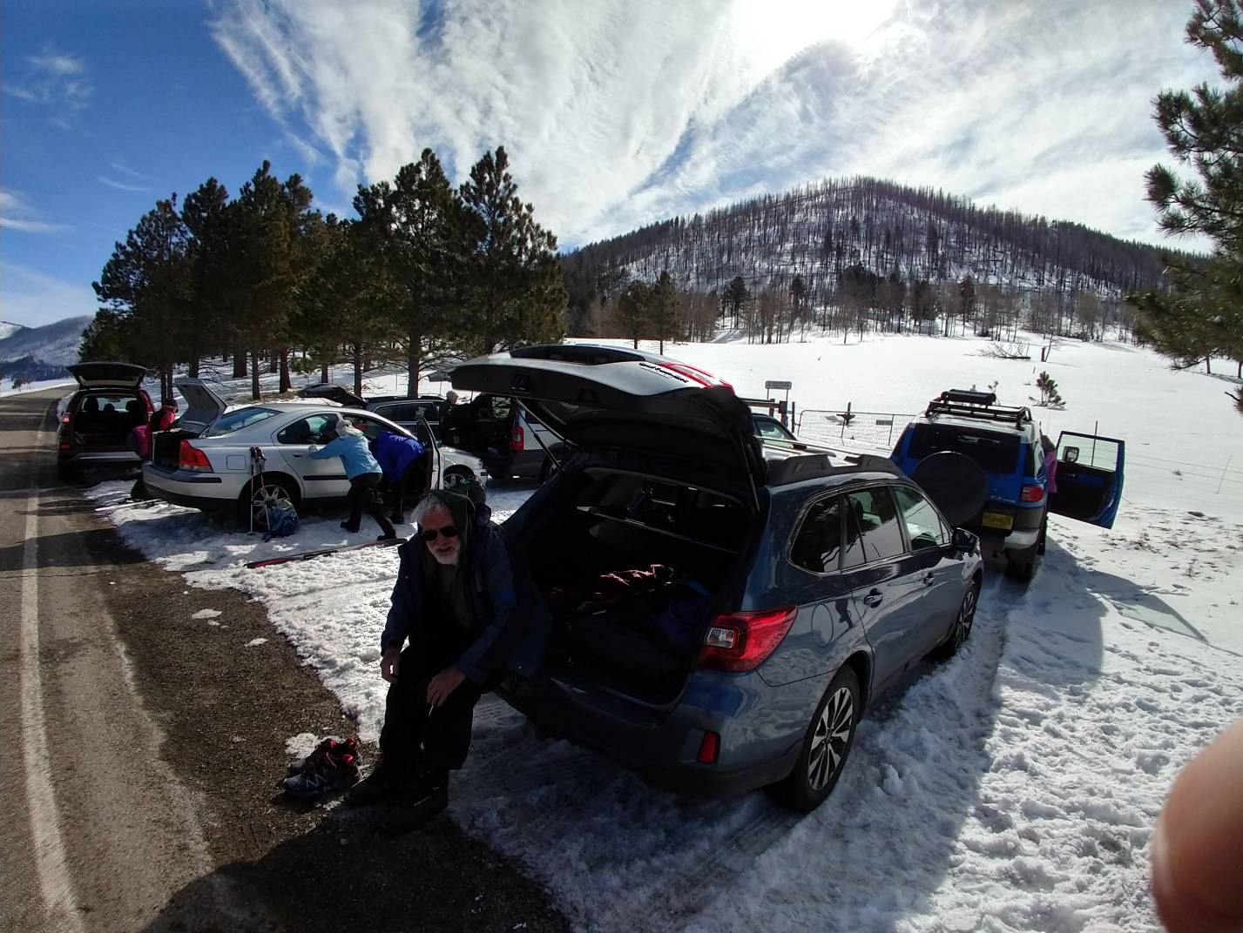
Skiers preparing to begin the tour at the Coyote Call Trailhead.
Photo by Tony Hsu
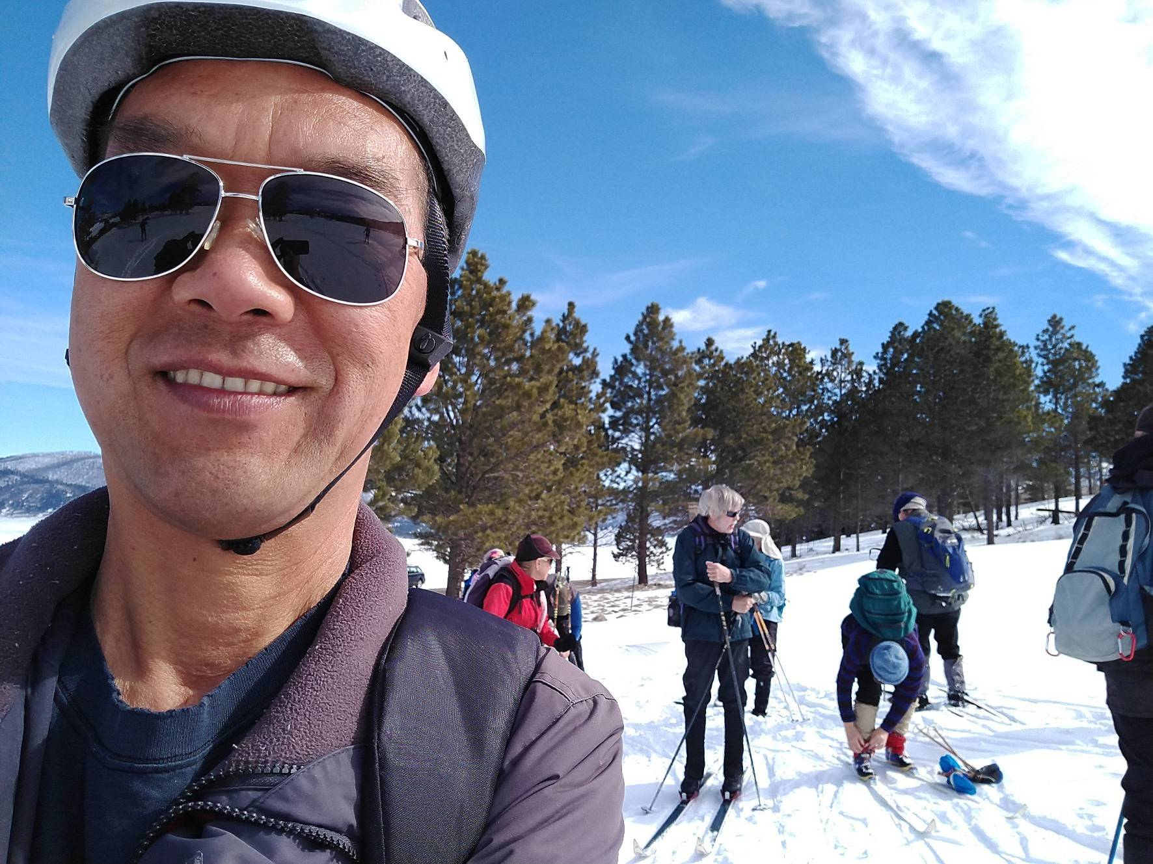
Selfie with other skiers getting ready to leave trailhead.
Photo by Tony Hsu
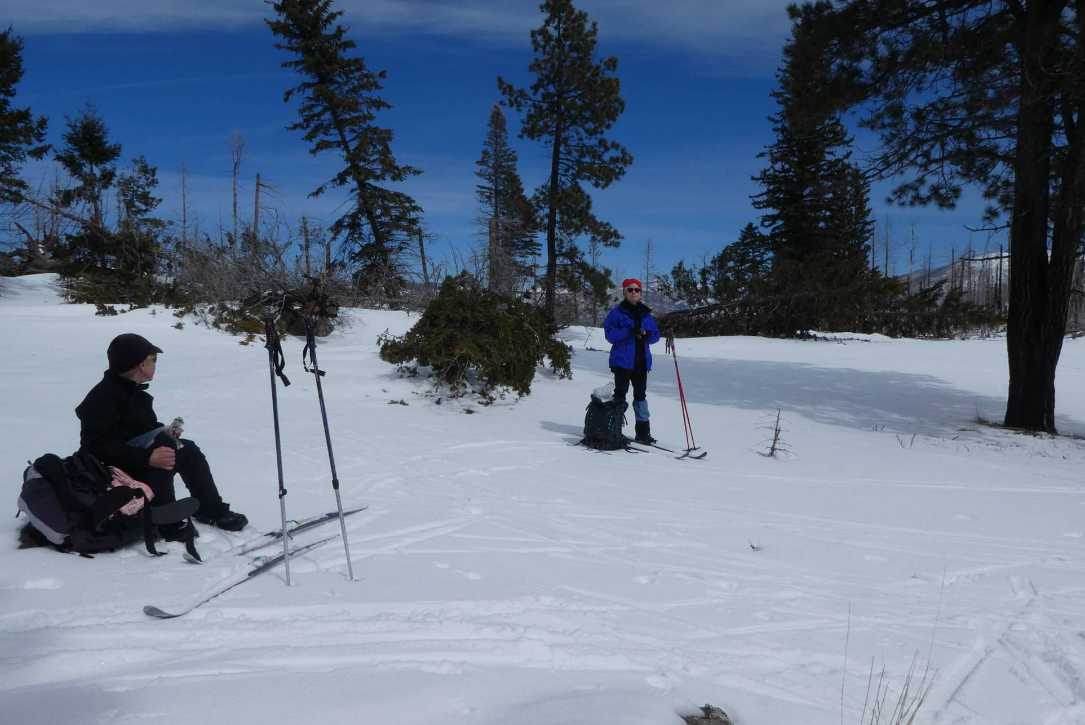
Skiers having lunch and conifers blown over by strong winds on the north side of the saddle between Rabbit Ridge and Scooter Peak.
Photo by Sam Beard
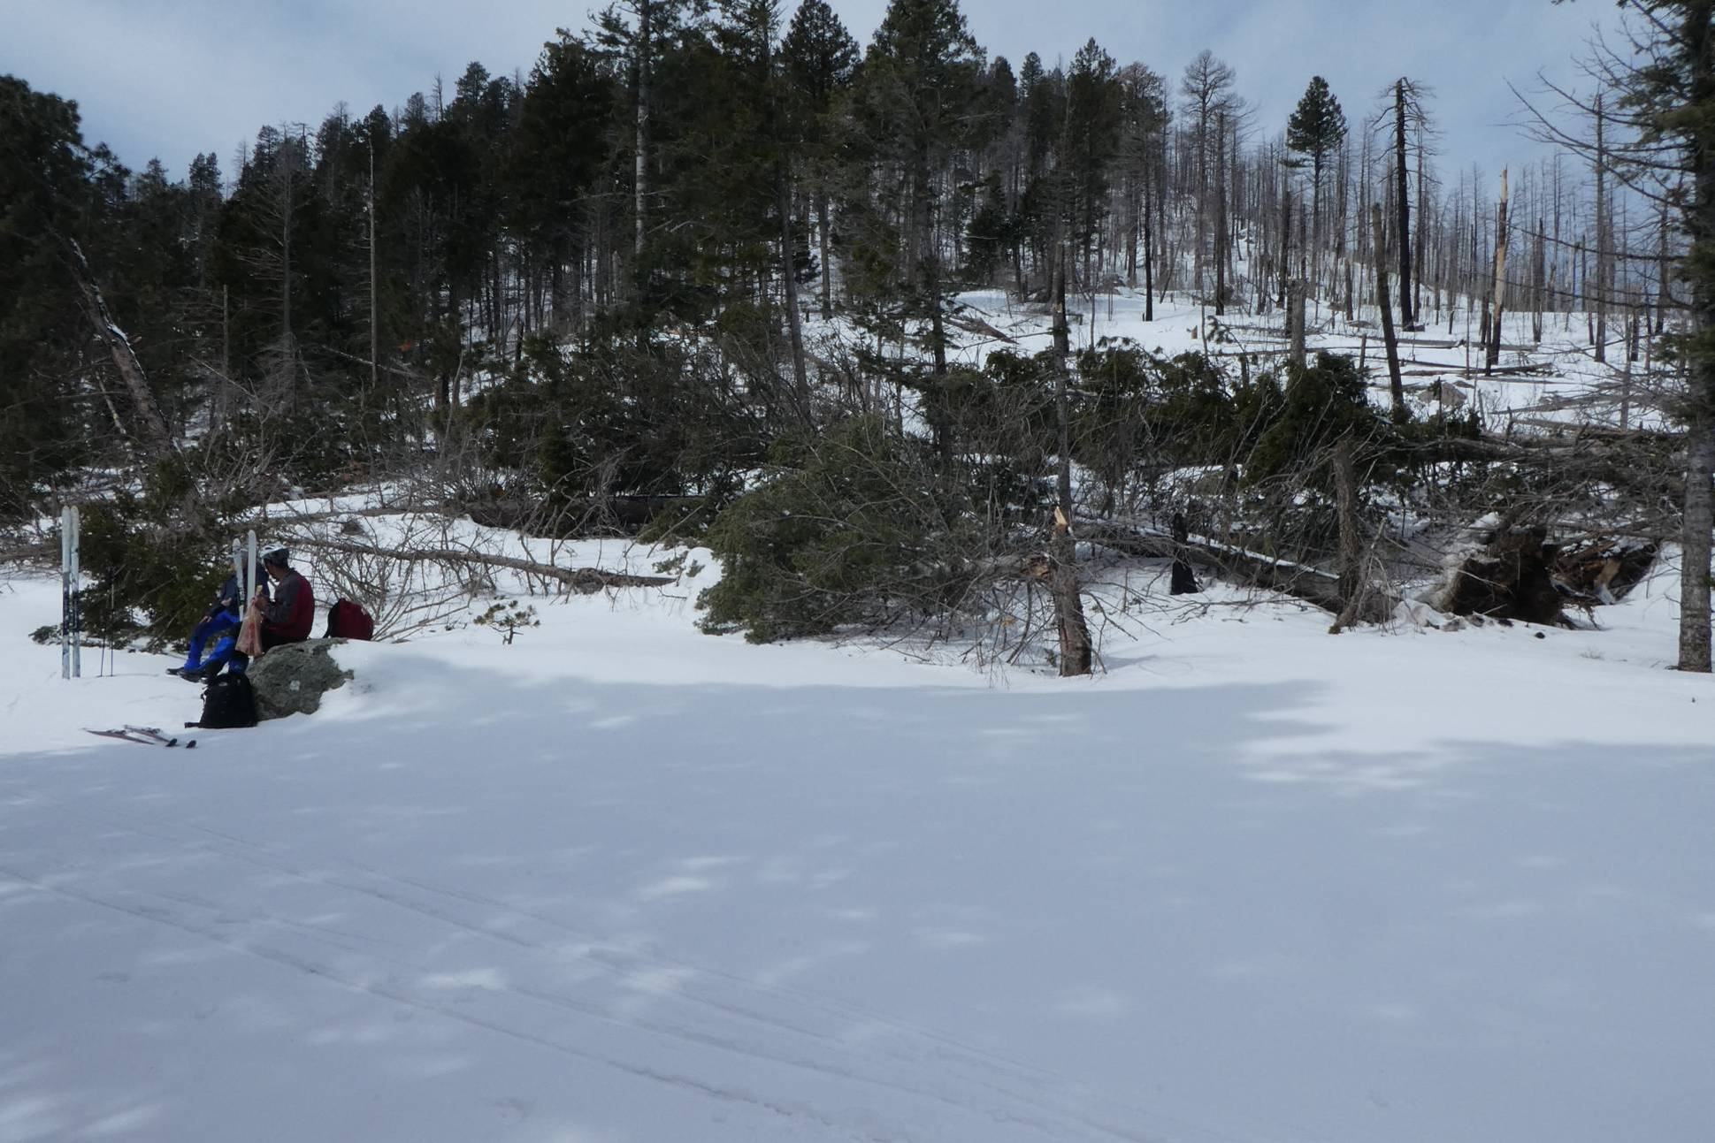
Skiers having lunch and conifers blown over by strong winds on the west side of the saddle between Rabbit Ridge and Scooter Peak.
Photo by Sam Beard

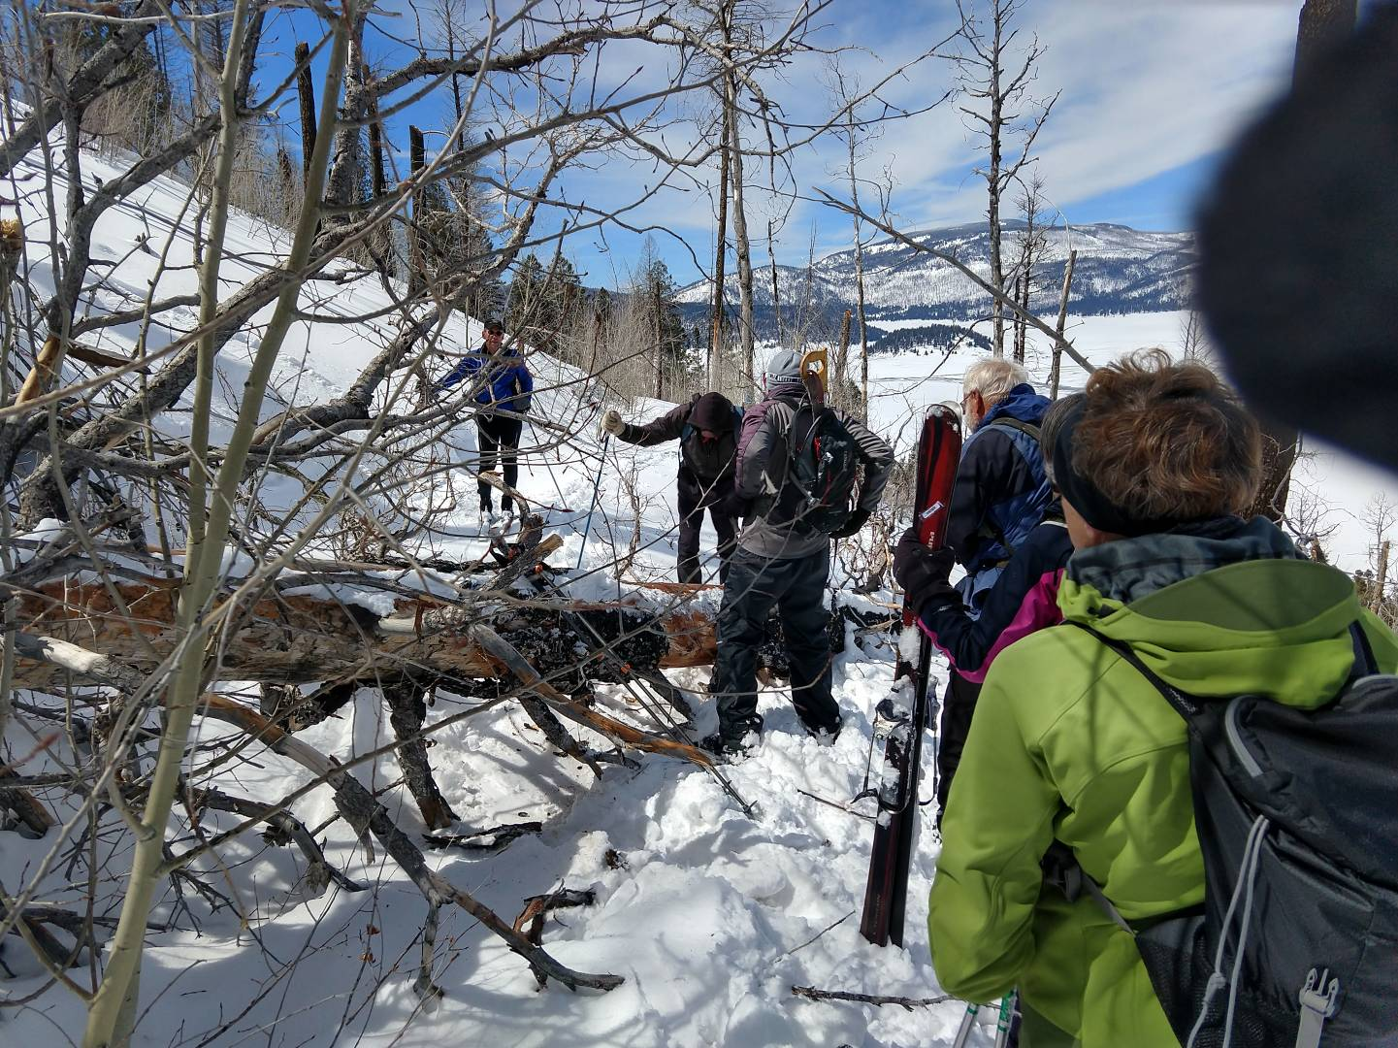
One of the fallen trees that skiers had to cross.
Photo by Tony Hsu
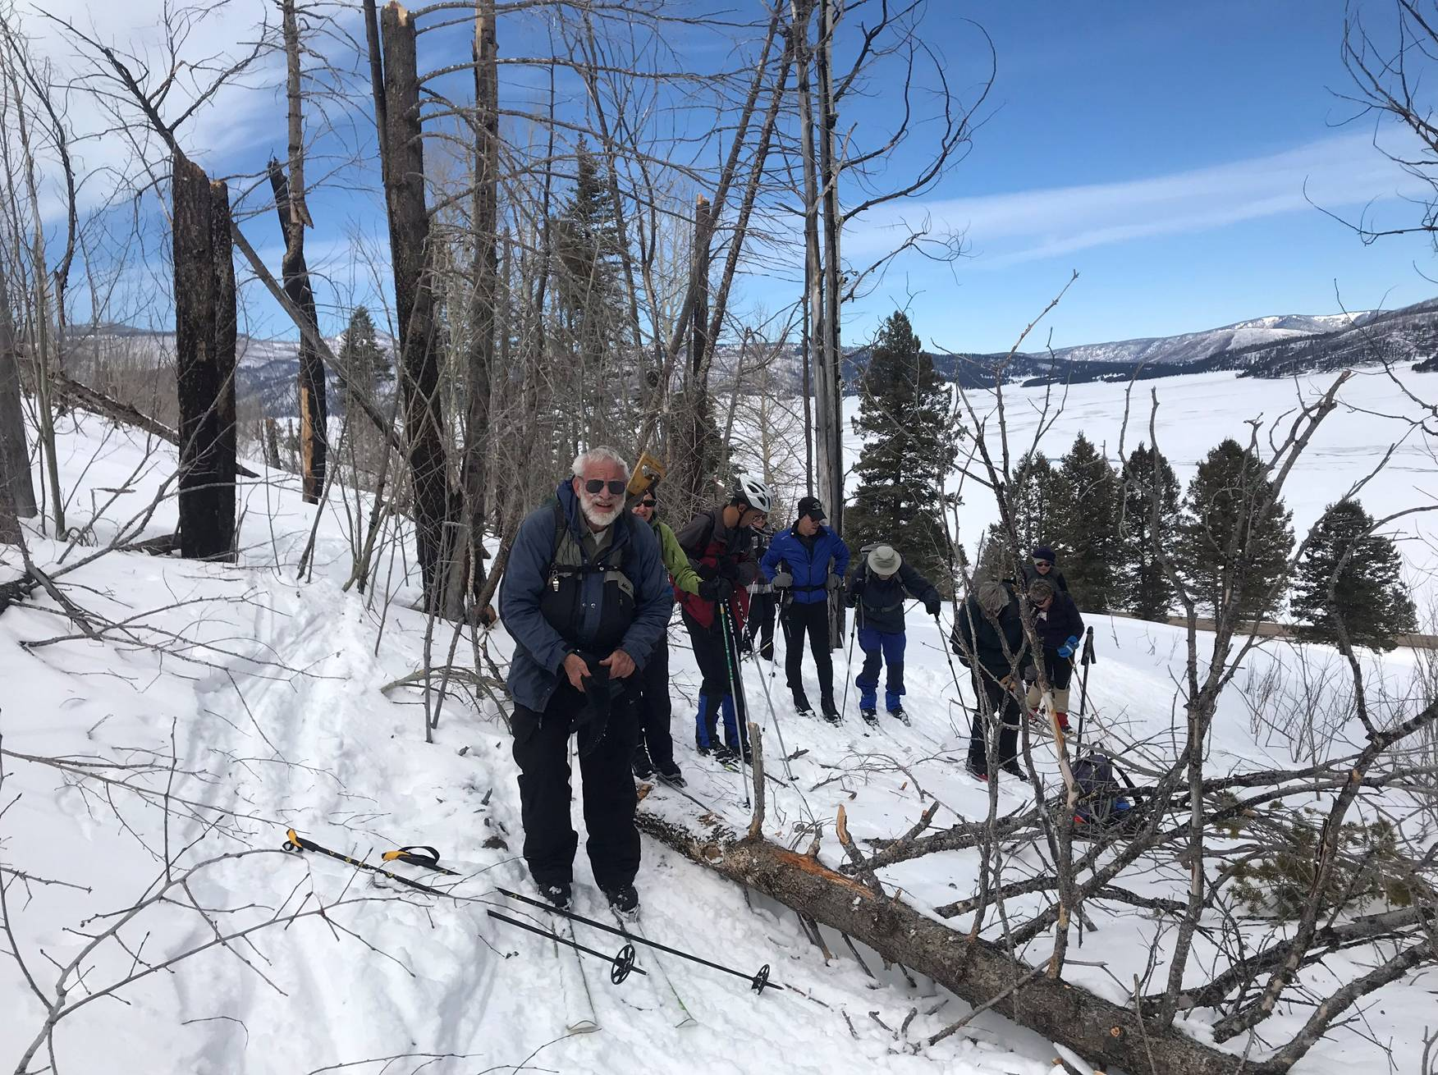
Crossing another tree.
Photo by Steve Roholt
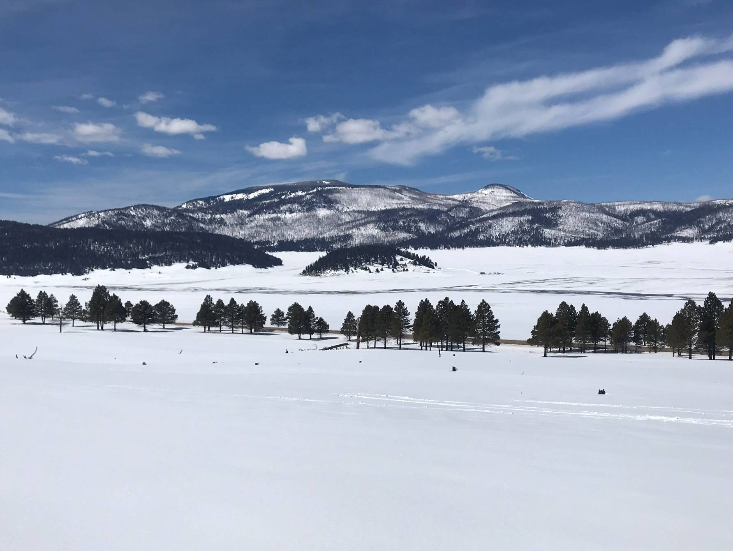
West side of Valle Grande. Note the two dark lines where melted snow is flowed.
Photo by Steve Roholt
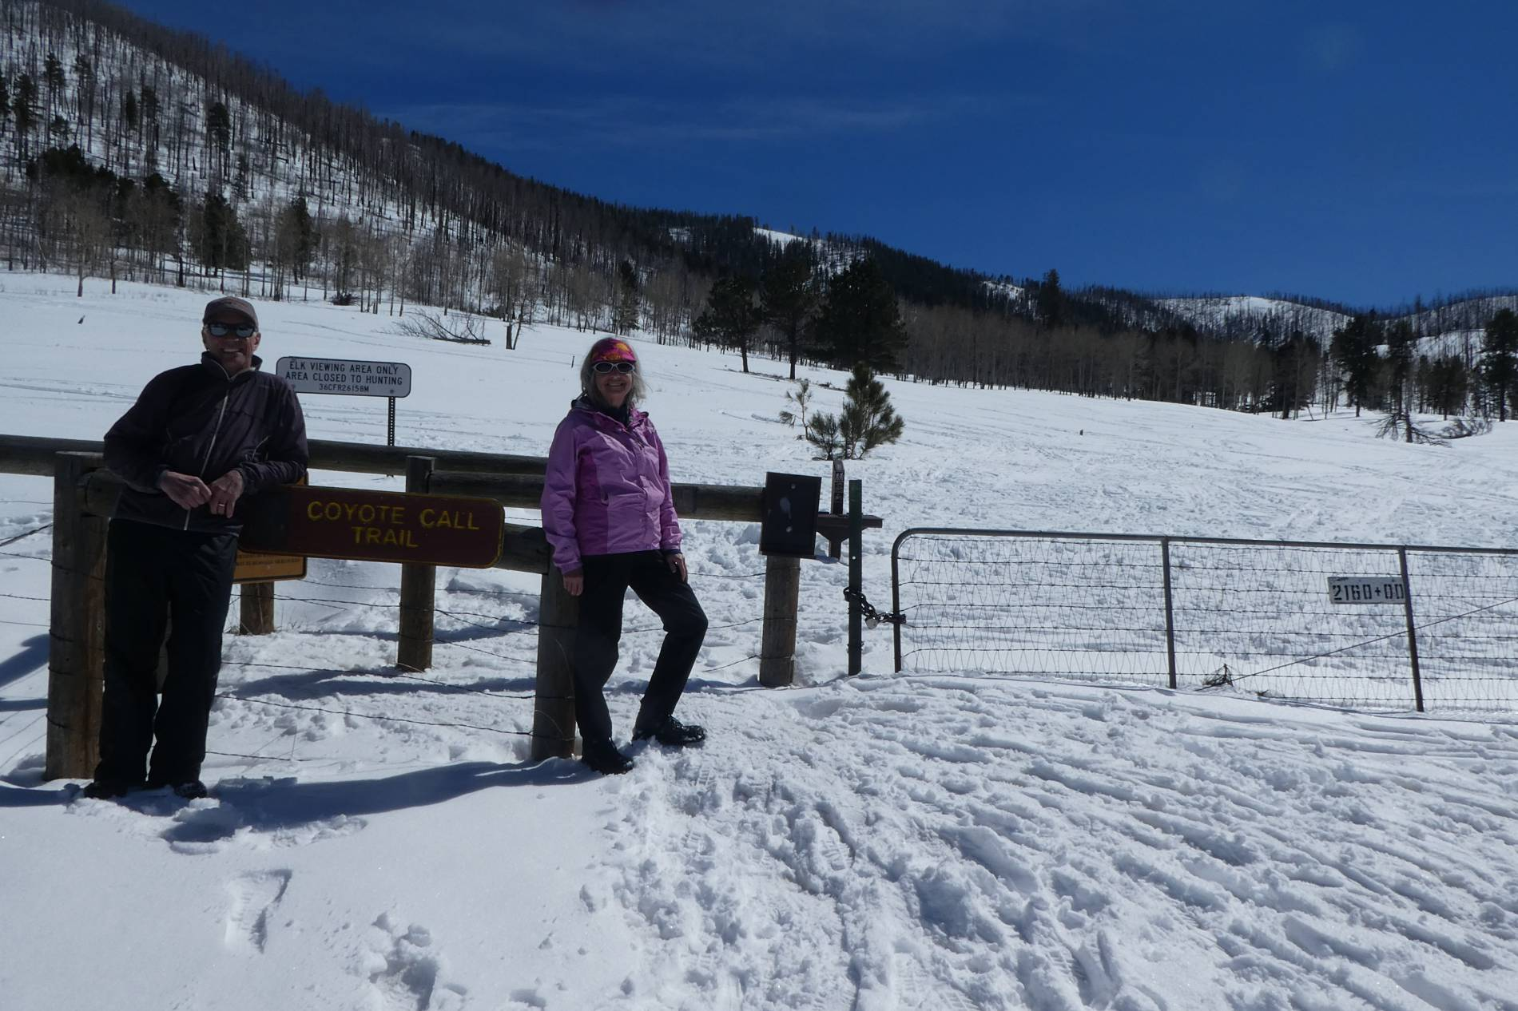
Steve Roholt and Holly Noland at the trailhead after all the skiers had returned.
Photo by Sam Beard

