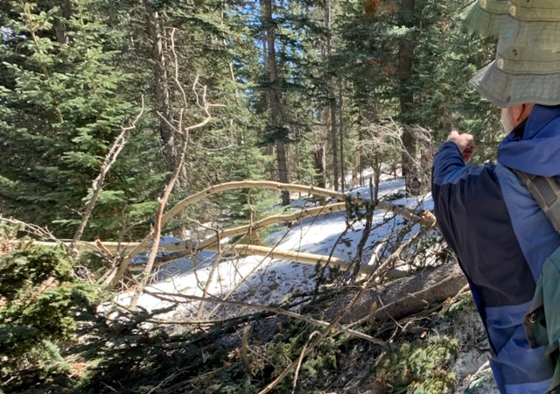
After skiing around several down trees, we came to this small train wreck near the upper end of Kerry’s Trail.
All photos by Michael Arndt

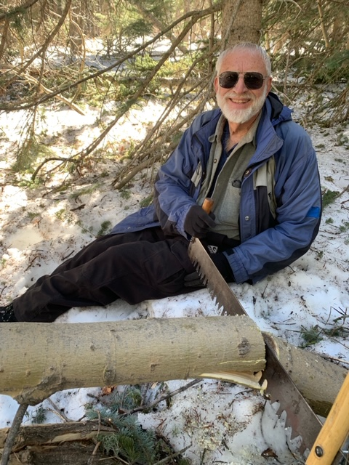
The first cut with my new short crosscut saw.

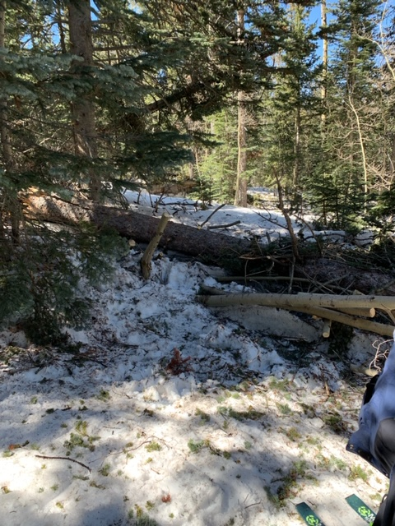
One large log remains after three small aspens had been removed.

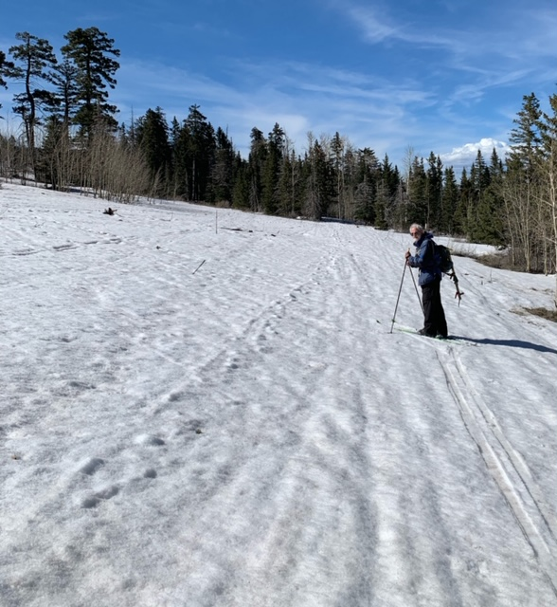
Sam on a trail groomed earlier this winter.

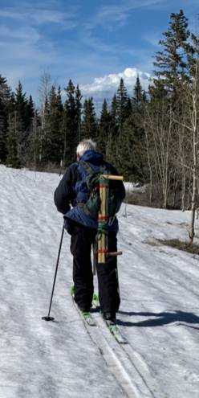
Sam with the short saw strapped to his pack.

