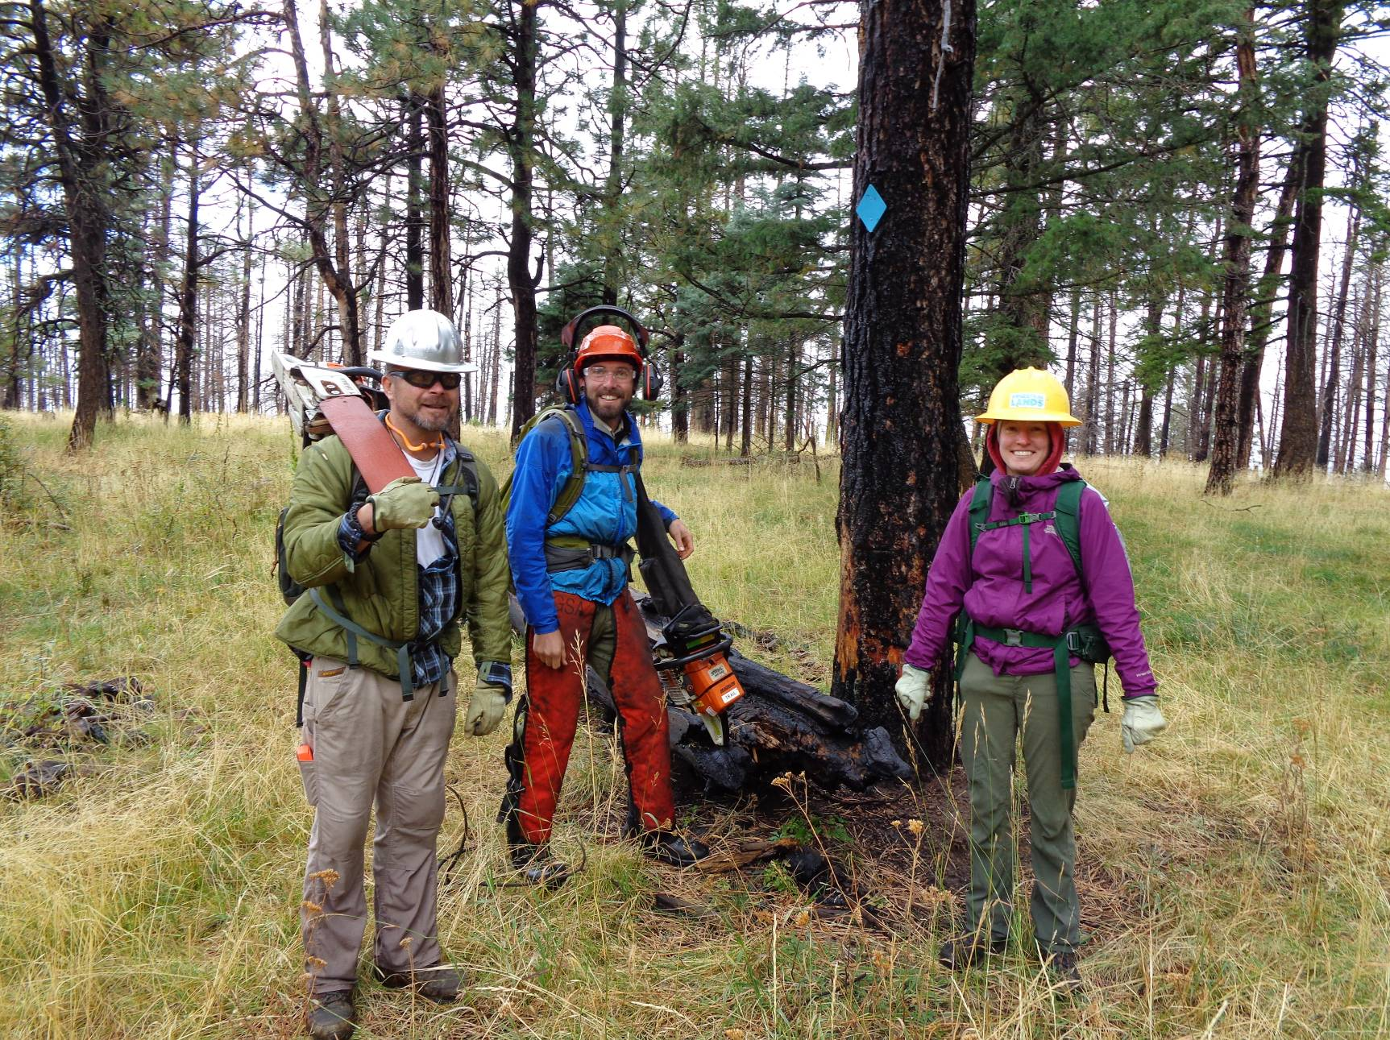
L to R: Michael Arndt, Brett Flaharty, and Leah Hurley. Michael is a relatively new Ski Club member, Brett is
the Jemez Ranger District (JRD) Recreation Trails/Wilderness Program Manager, and Leah is the JRD
Recreation Staff Officer. Note the new blue diamond on the tree. All photos by Sam Beard
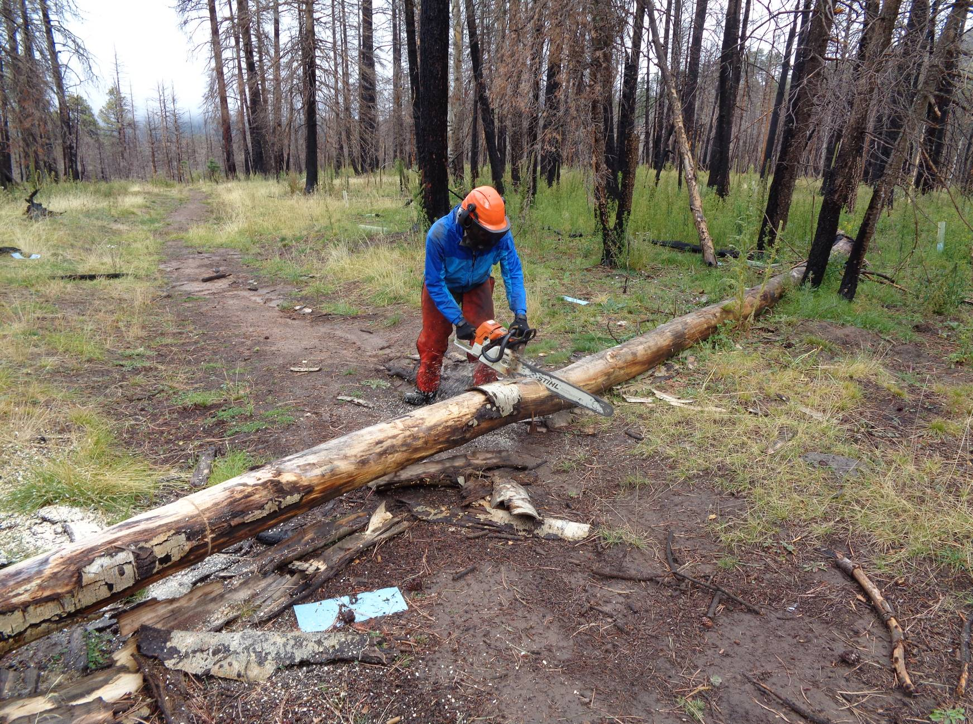
Brett cutting a tree down on Lower Road at Griegos Junction. The weather was wet and cool.
The dead trees were burned in the Cajete Fire a few years ago.

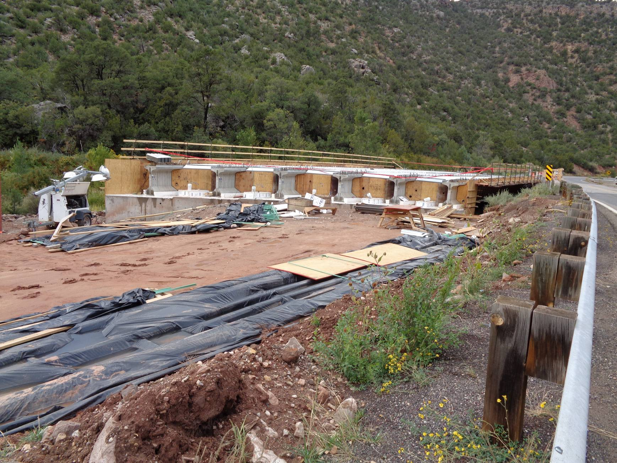
The bridge being constructed across the Jemez River at the Ranger Station. The six grey objects in the photo are very large
I-beams that span the river and will support the weight of the bridge and vehicles.

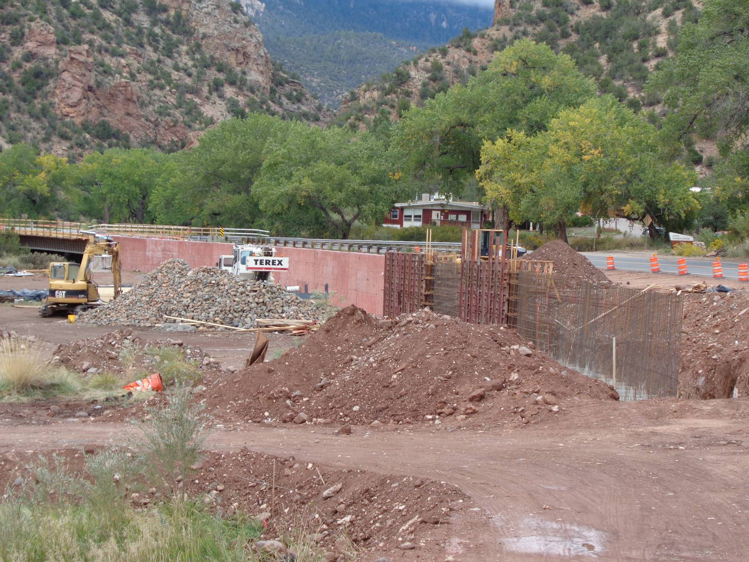
Bridge construction site near the Jemez Ranger Station. The Ranger Station is in the center of the picture, and the
new bridge is on the left edge of the photo. The large reddish structure in the center of the photo is a tall retaining wall
that will support the fill dirt for the highway.

