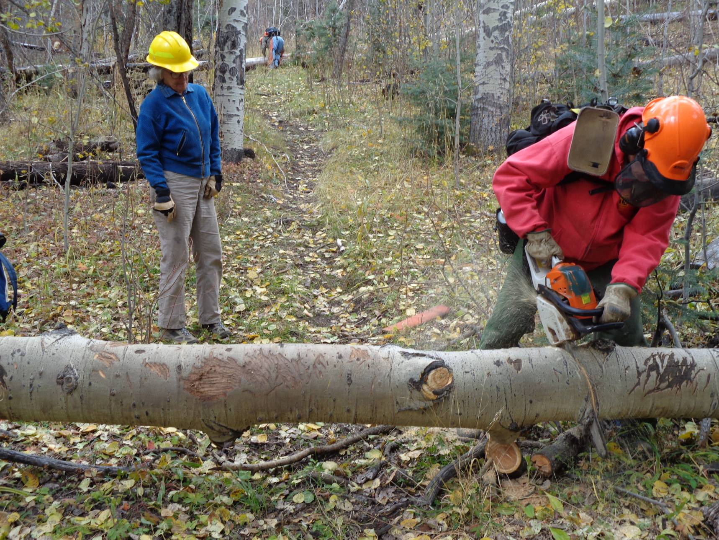
Jerry Carroll bucking an aspen tree with Wendy Cox observing in Squirrel Canyon on Los Griegos Mountain.
Photo by Sam Beard
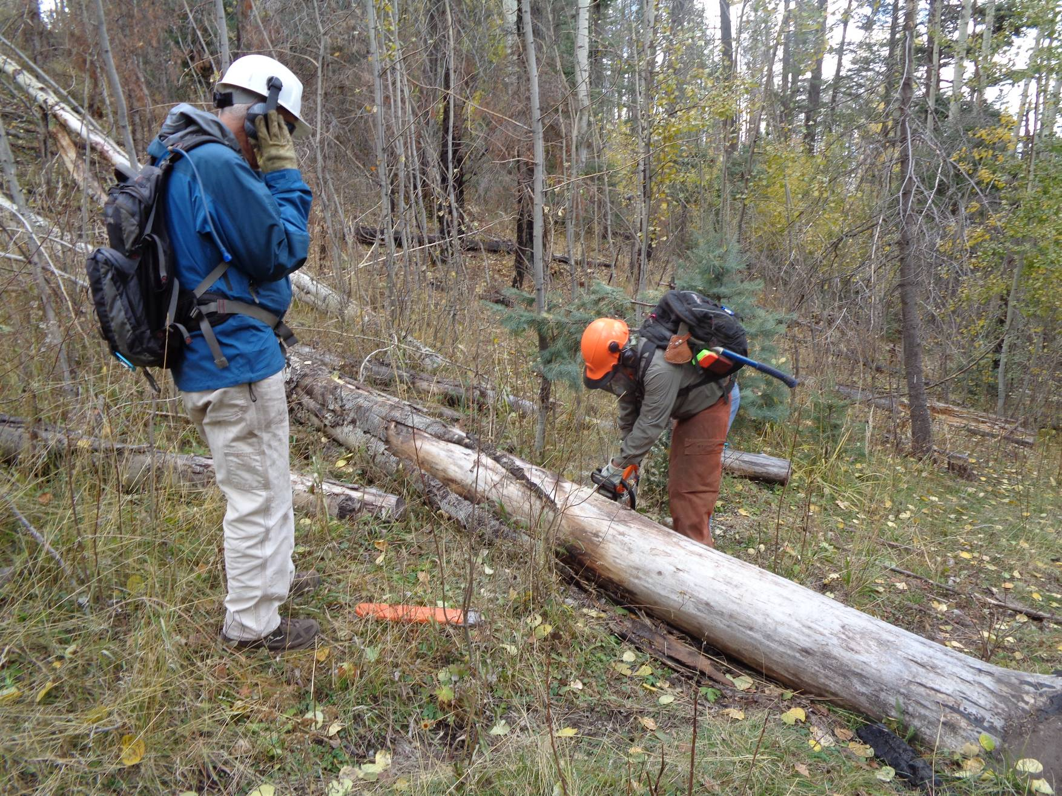
Bill White bucking a down tree with Mike Meier observing.
Photo by Sam Beard
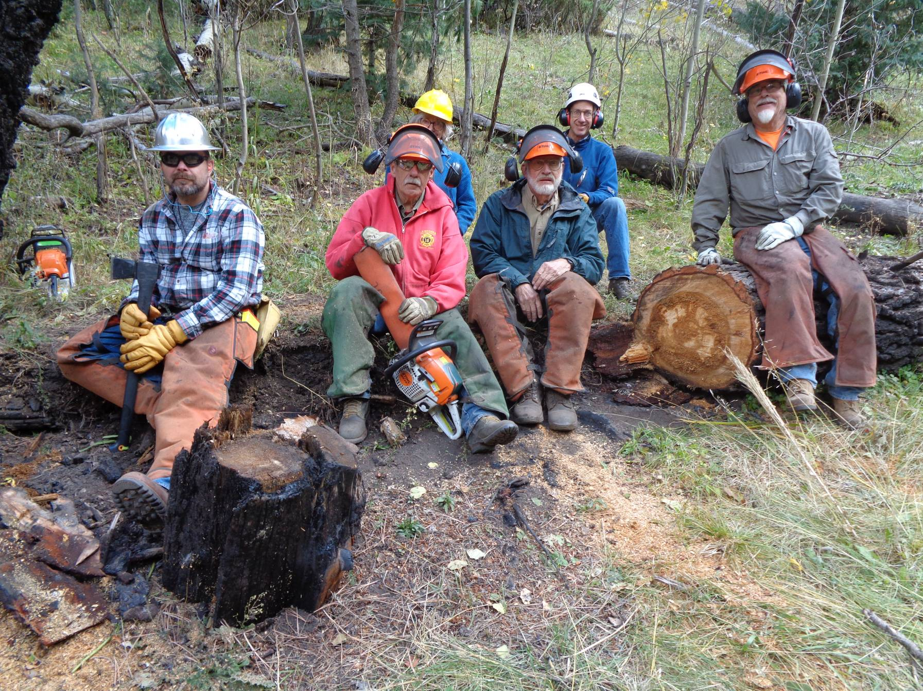
Ski Club volunteers on Friday on Los Griegos Mountain. L to R: Michael Arndt, Jerry Carroll, Wendy Cox, Sam Beard,
Dean Athow, and Bill White. Photo by Mike Meier

