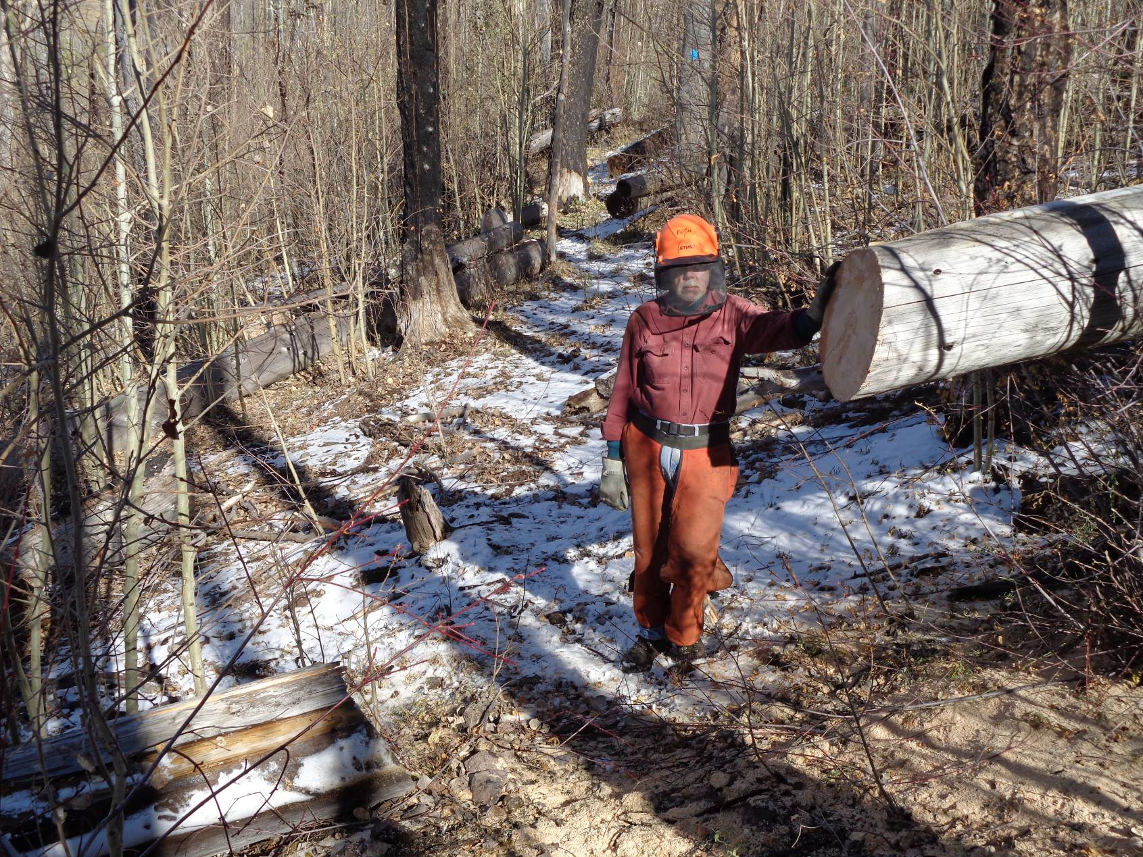
Byron Garner and an 18-inch diameter down tree removed from the upper part of Corral Canyon Trail on the north side
of Boomer Mountain. Note the ends of the logs in the background that were cut earlier to keep the trail open. Photos by Sam Beard
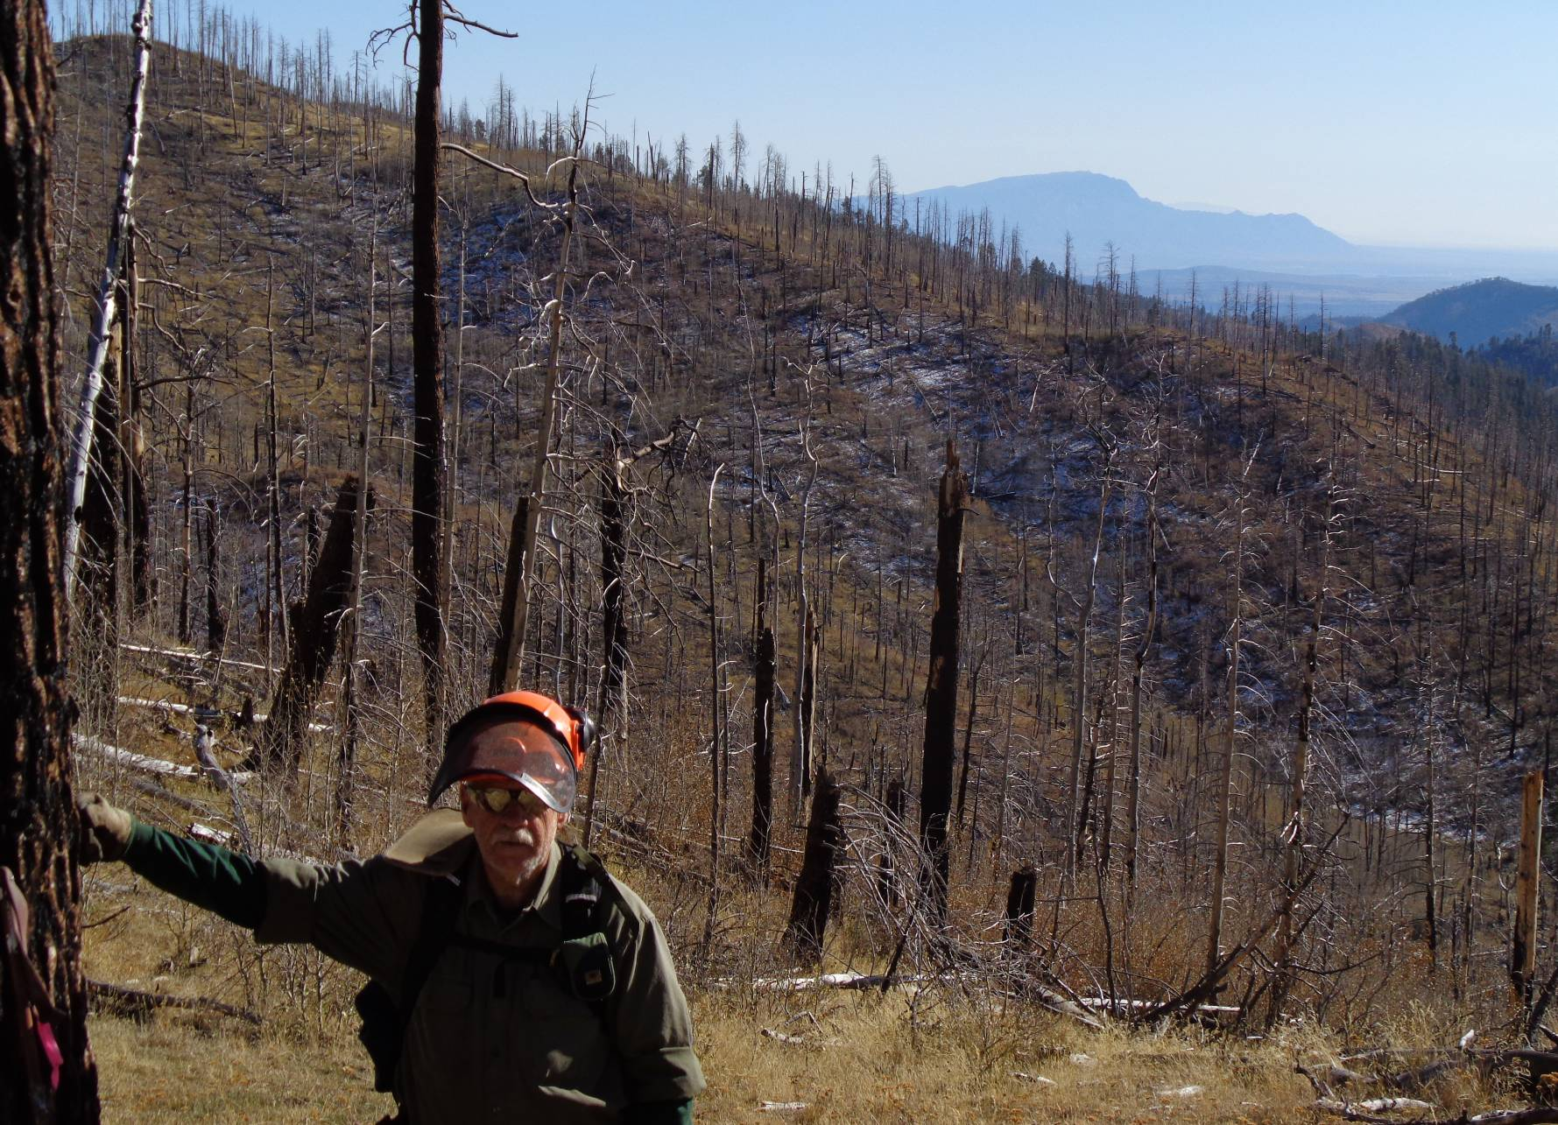
Jerry Carroll at the overlook on Boomer Mountain where the Las Conchas Fire killed all the trees eight years ago. Sandia Mountain
with the Rincon extending to the west is in the background. Many years ago we found a stone engraved with the word “Boomer”
at this site and assumed that Boomer had been a pet whose ashes were scattered here.

