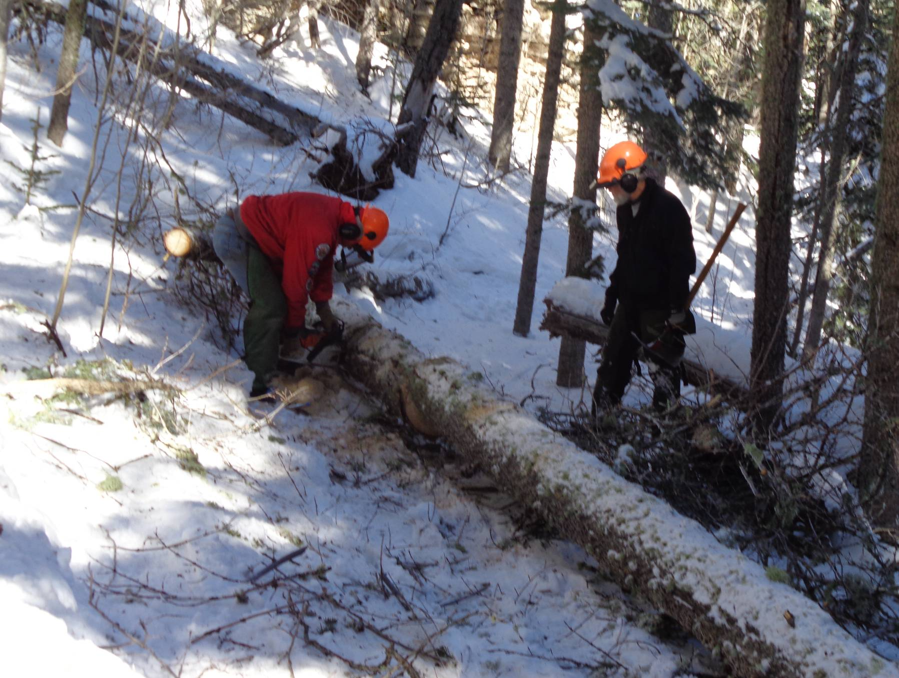
David D’Antonio observing Jerry Carroll cutting a 12-inch diameter log on Survey Trail north of the Crest Highway.
All photos by Sam Beard
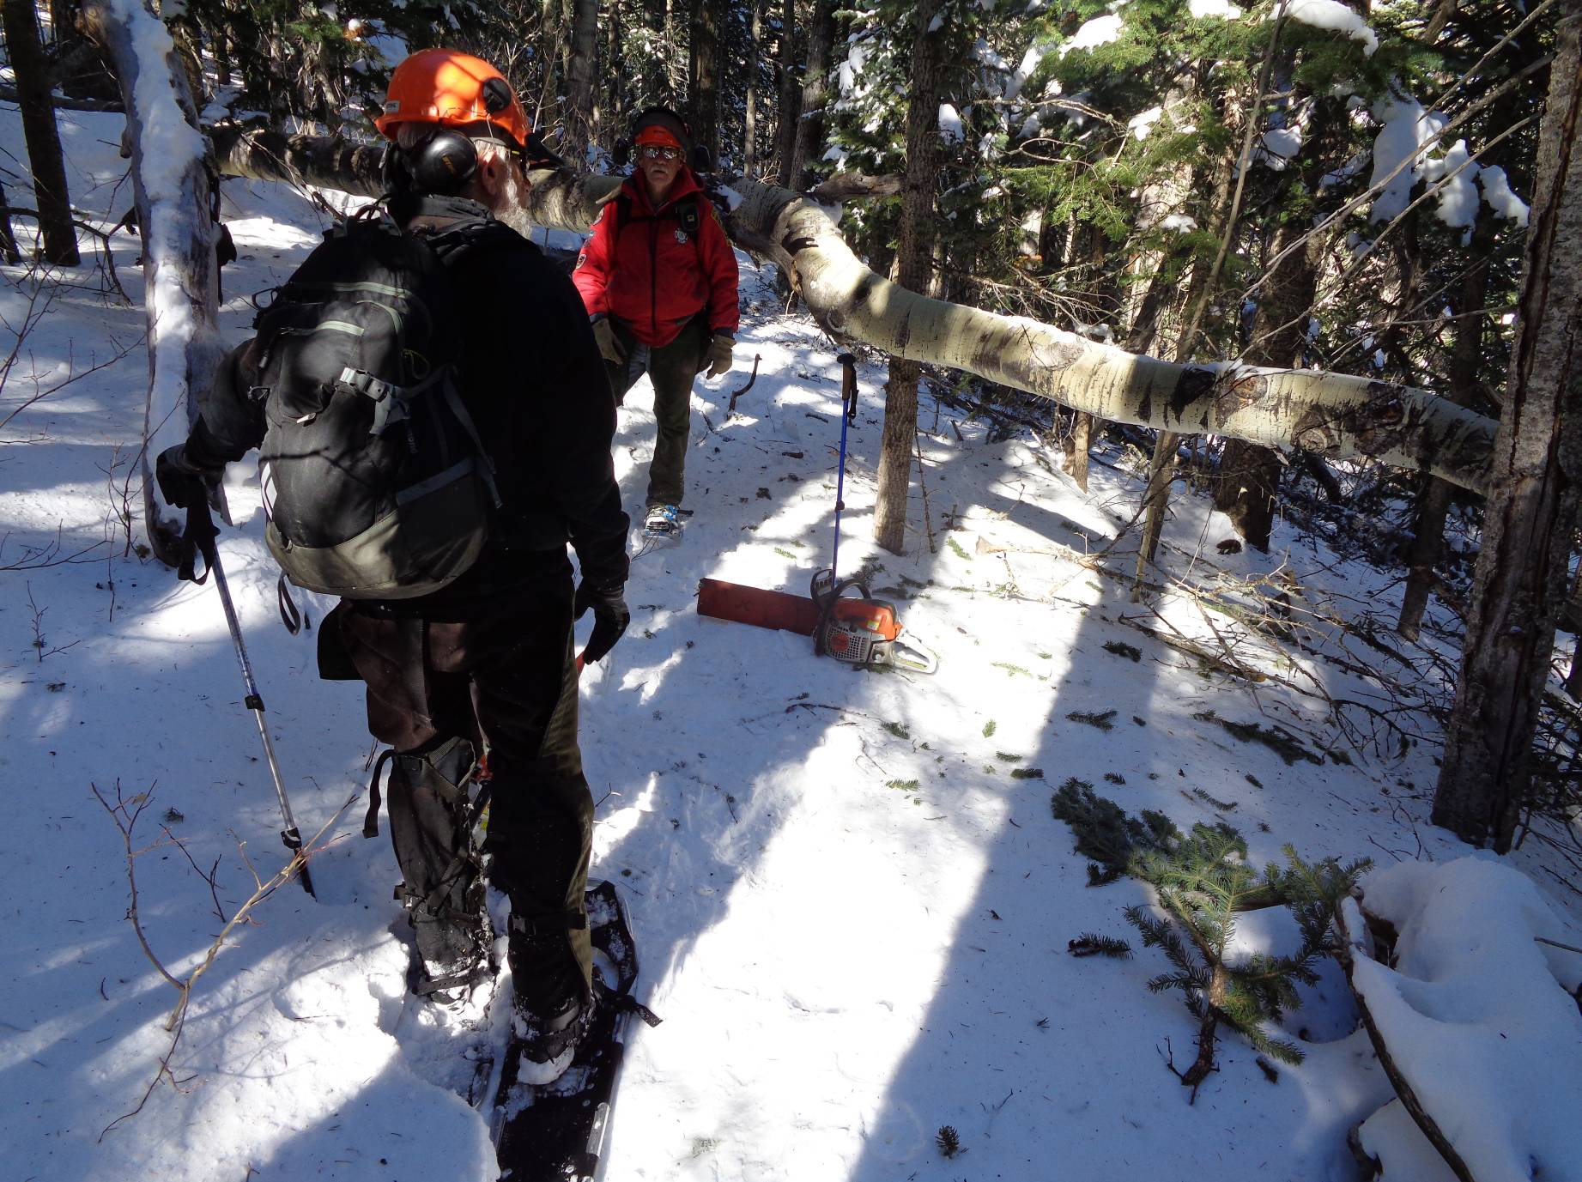
10-inch diameter aspen tree across the trail at shoulder height.
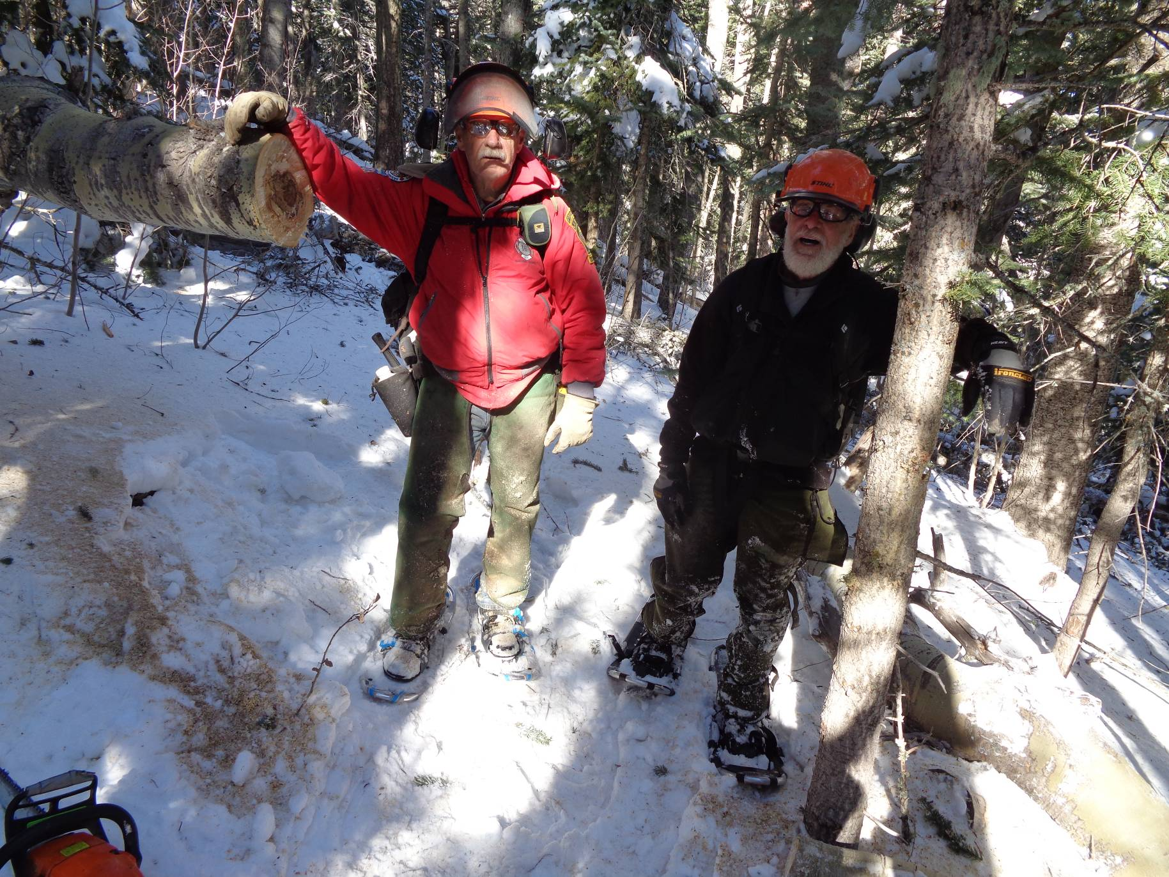
Jerry and David standing between the ends of the cut aspen.
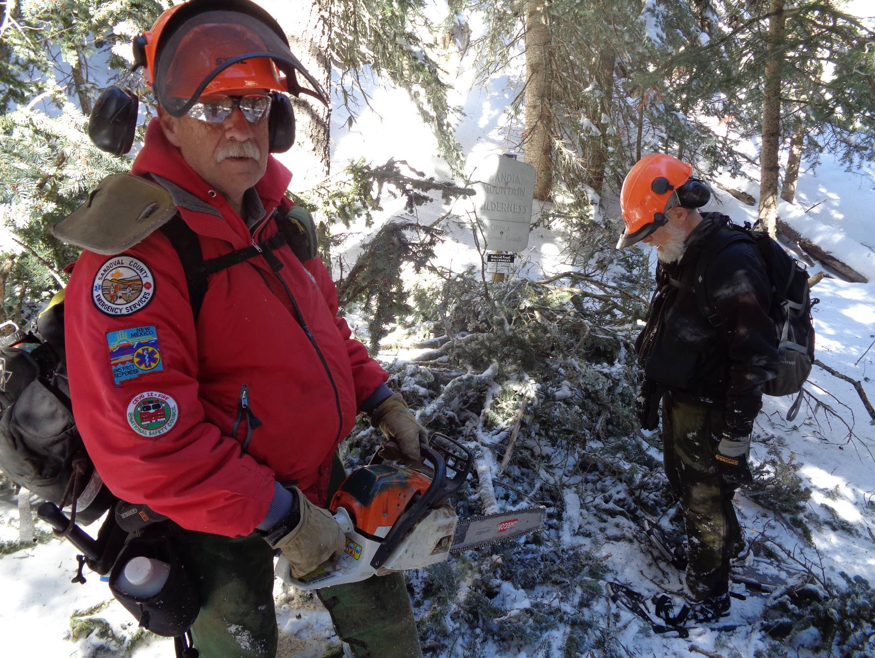
The last tree removed was at the wilderness boundary just past the power line to the Crest.
Note the gray wilderness boundary sign in the center of the photograph.

