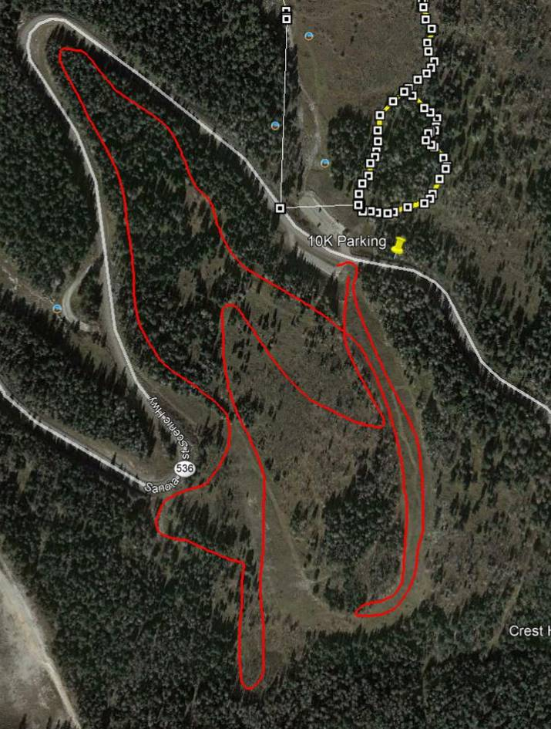
Tour route is the red line drawn on a Google Earth satellite photograph of the new groomed
ski area south and northwest of 10K South Trailhead. The tour length was 2 miles.
All photos by Sam Beard

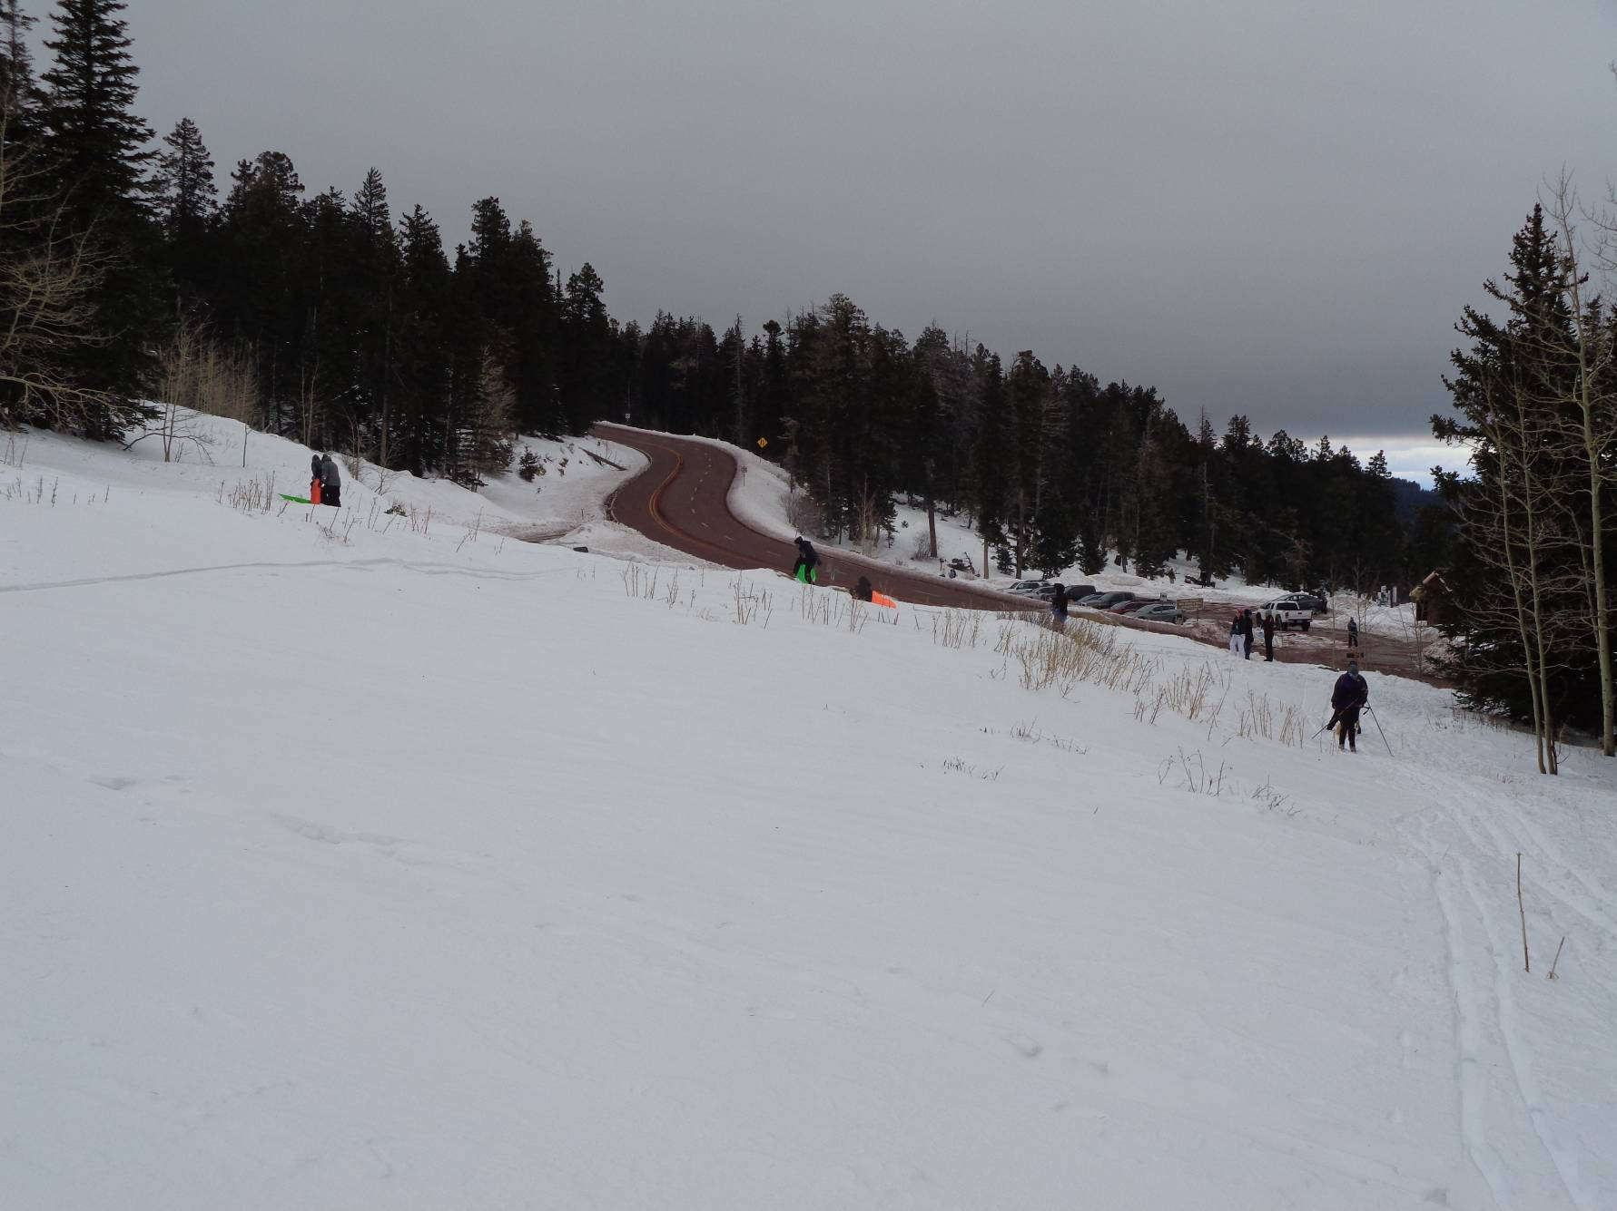
Looking over 10K North parking lot from the meadow above the 10K South Trailhead.
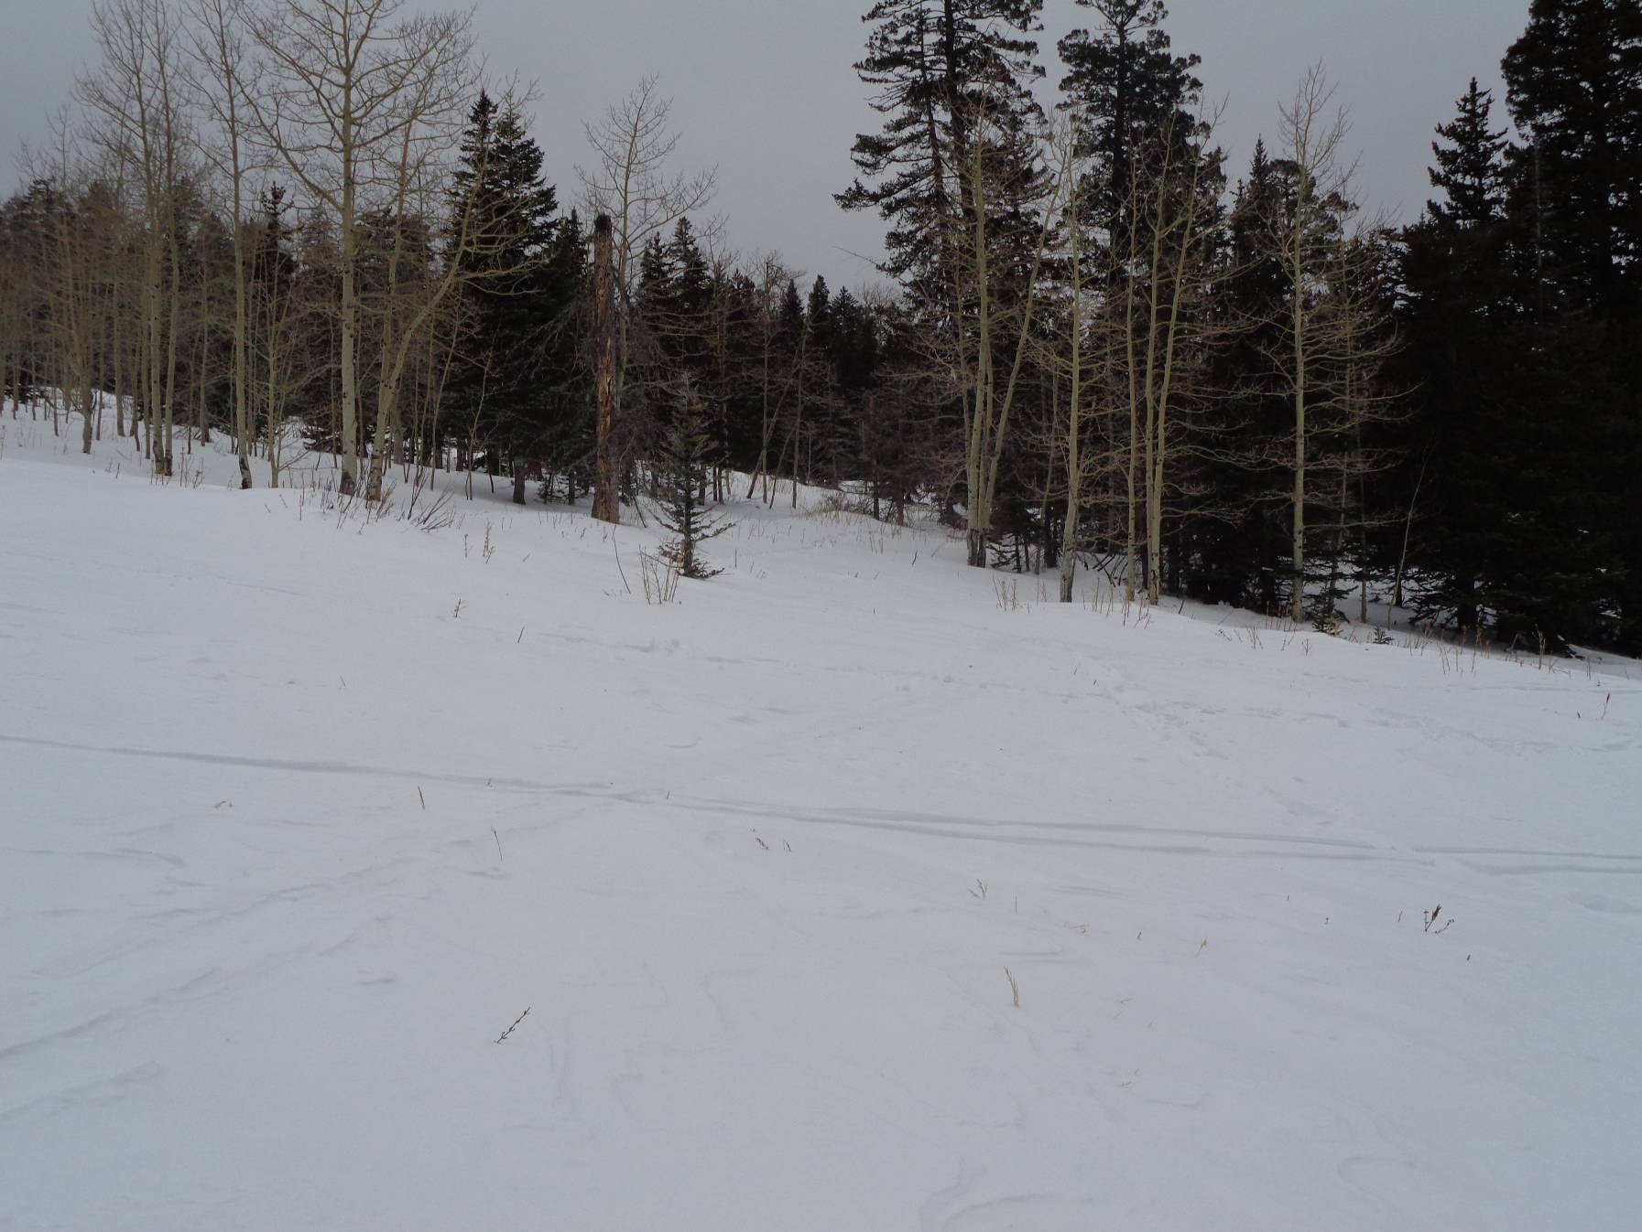
An overcast day in the Sandias. We were skiing in fog during most of the outing. One of the groomed trails
above the 10K South Trailhead is located in the center of the picture.

