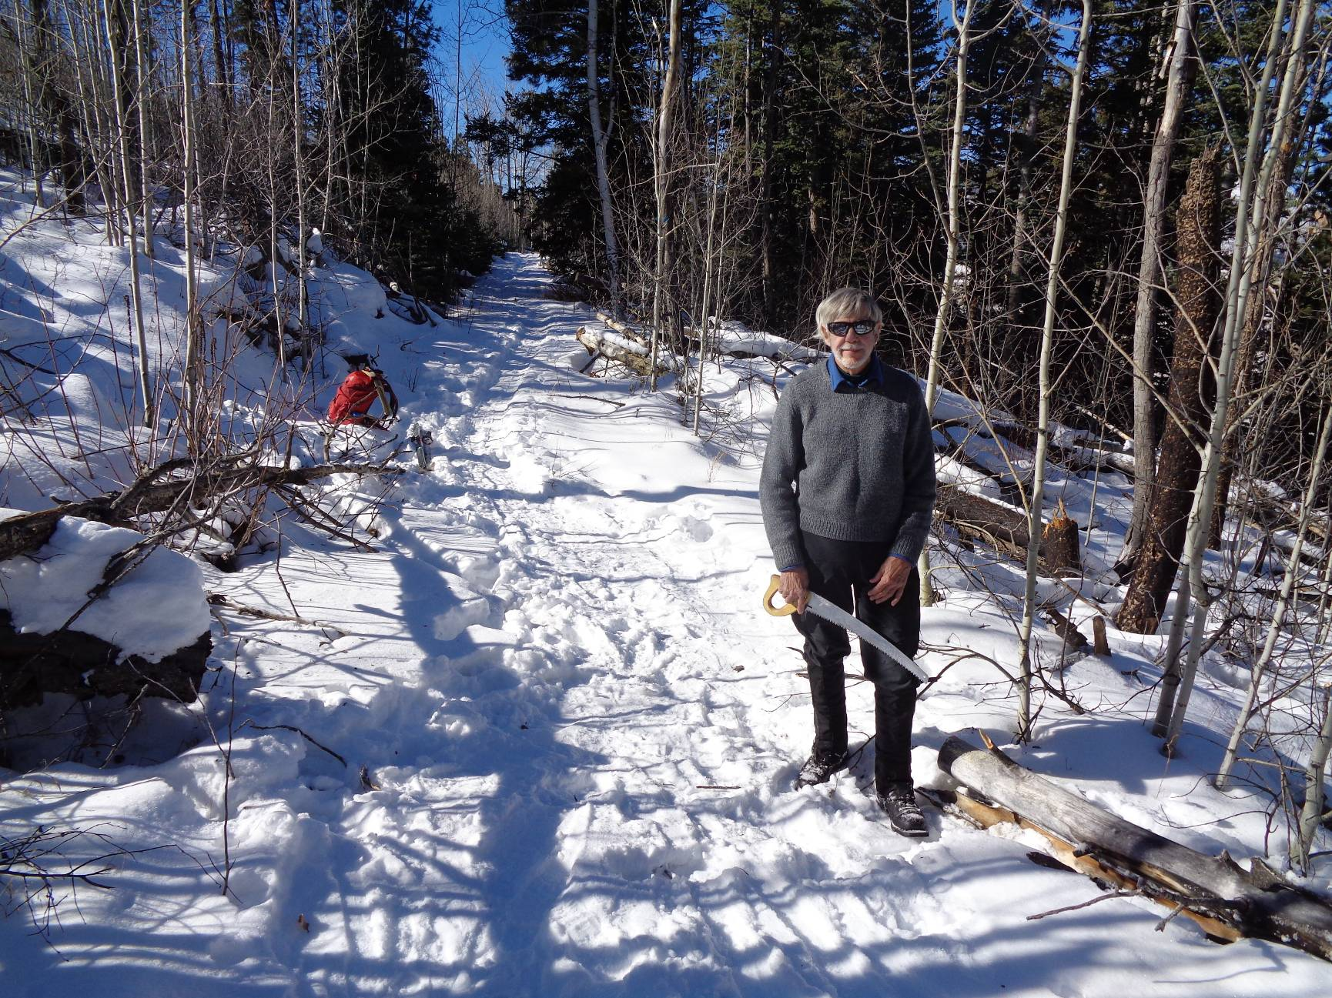
Byron Garner standing beside the 4-inch diameter tree that he has just cut and moved off Coyote Call Trail
on the Valles Caldera National Preserve in the Jemez Mountains. This segment of the trail is near NM-4 and south
of Valle Grande. Photo by Sam Beard

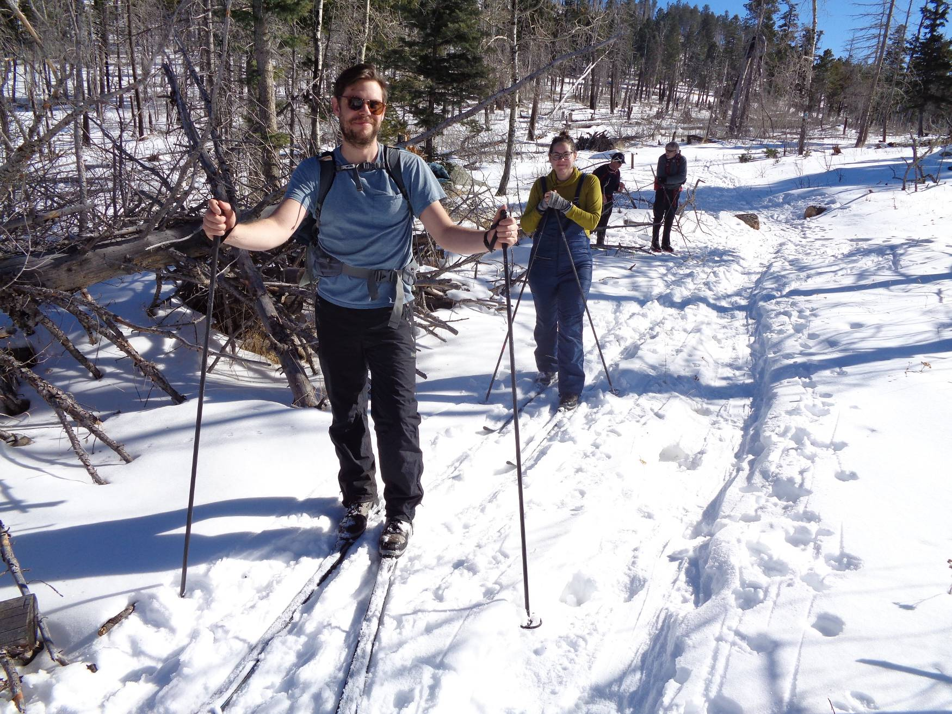
Gabi Griggs and Hanna Mesraty have just had lunch at the saddle between Scooter Peak and Rabbit Ridge.
Photo by Sam Beard
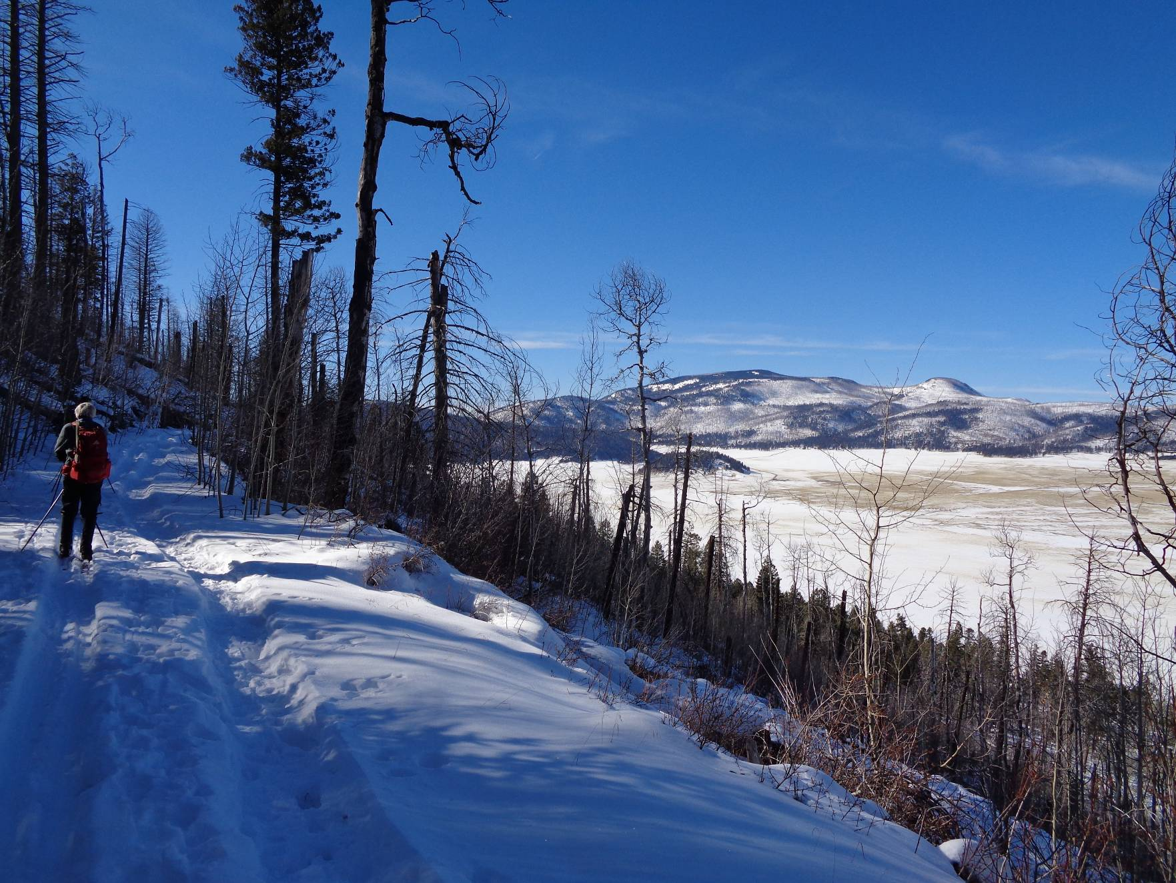
Byron is on the upper segment of Coyote Call Trail and looking to the northwest across Valle Grande to
Redondo Peak and the smaller Redondito Peak in the background. Photo by Sam Beard

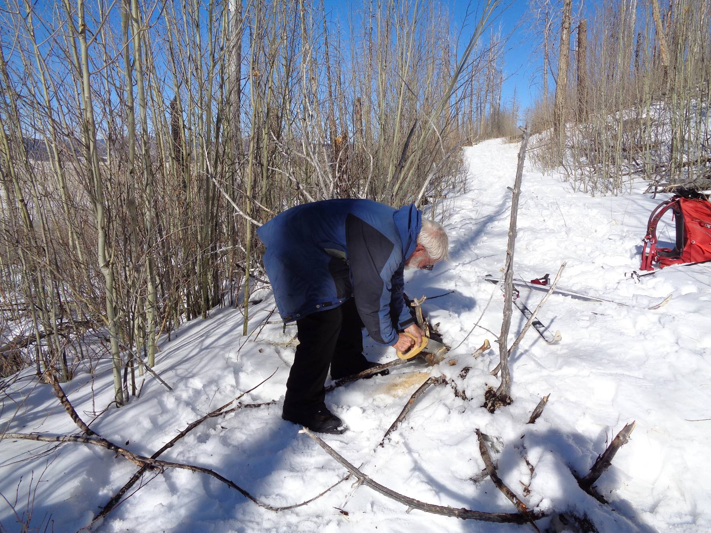
Sam Beard cutting a 5-inch diameter tree near the southwest corner of the route. The short branches on his right
made this tree especially difficult to step over on skis. Photo by Garner Garner

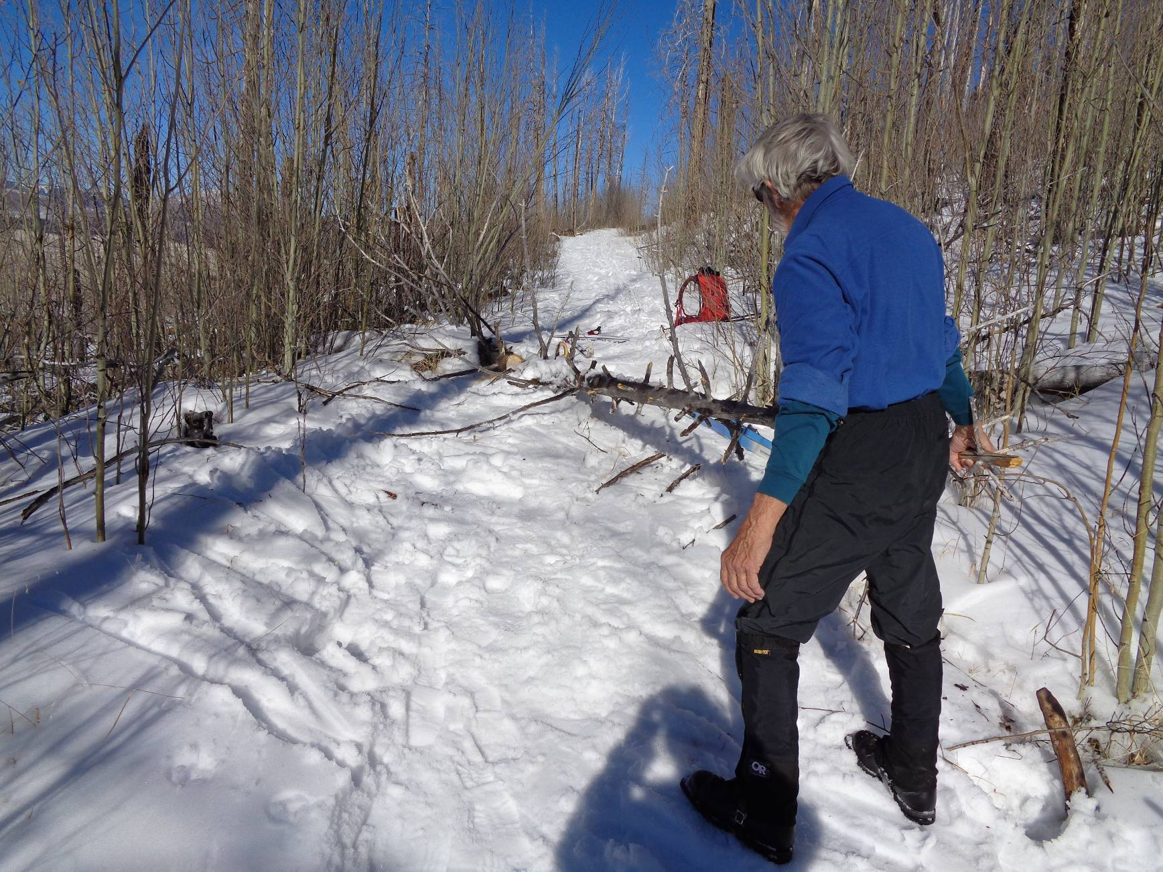
Byron moving the tree off the trail.

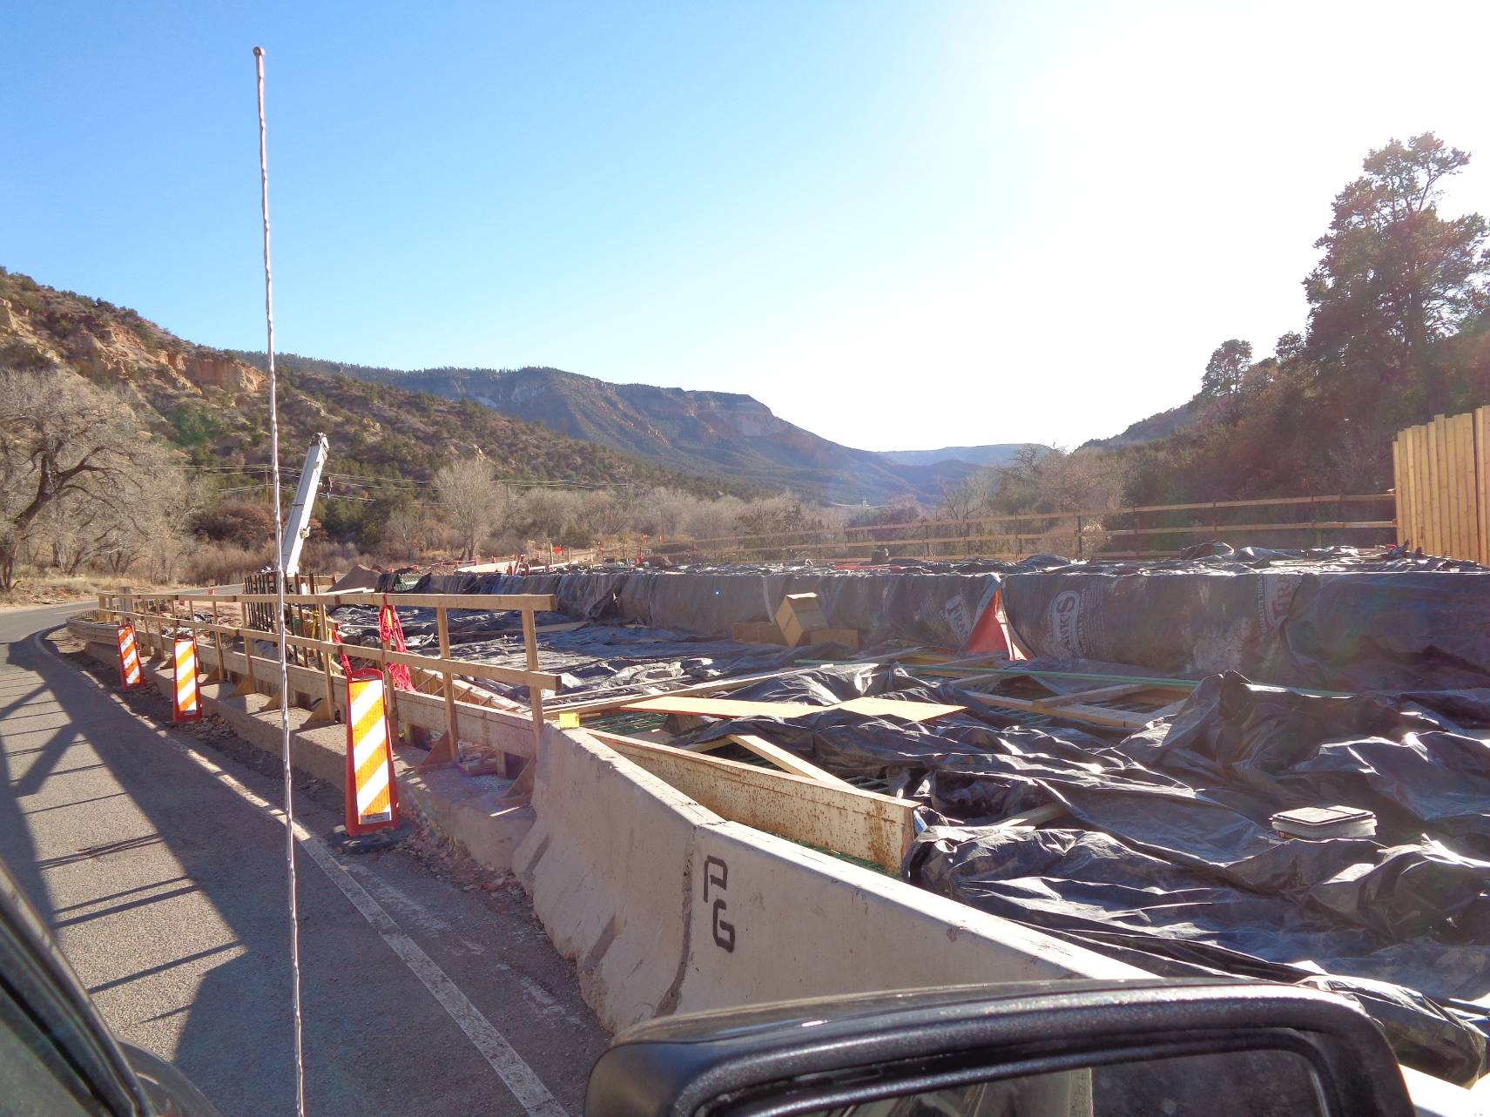
It appears that the concrete deck of the new bridge on NM-4 near the ranger station has been poured.
Photo by Sam Beard

