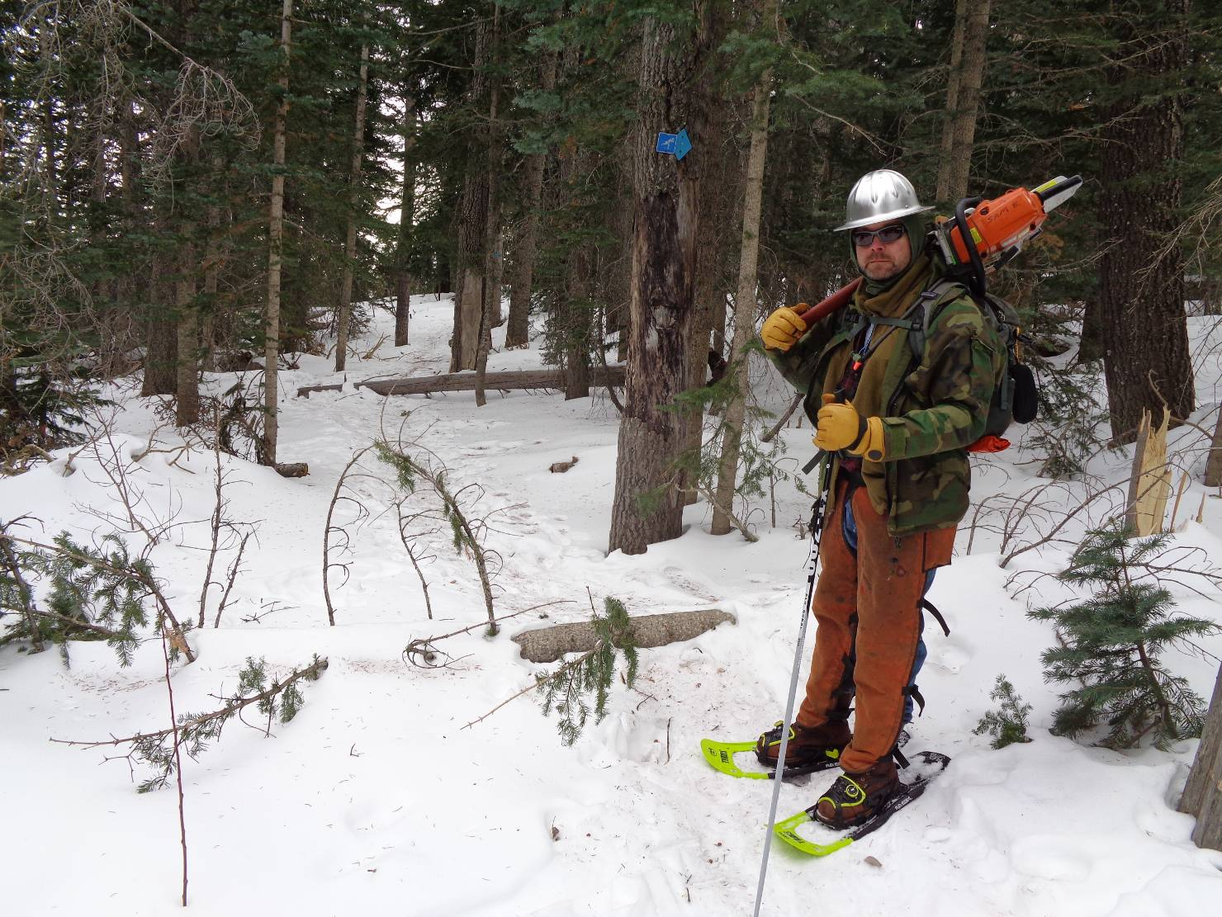
Sawyer Michael Arndt at the two down trees that were reported on 10K South Trail near the trailhead.
All photos by Sam Beard
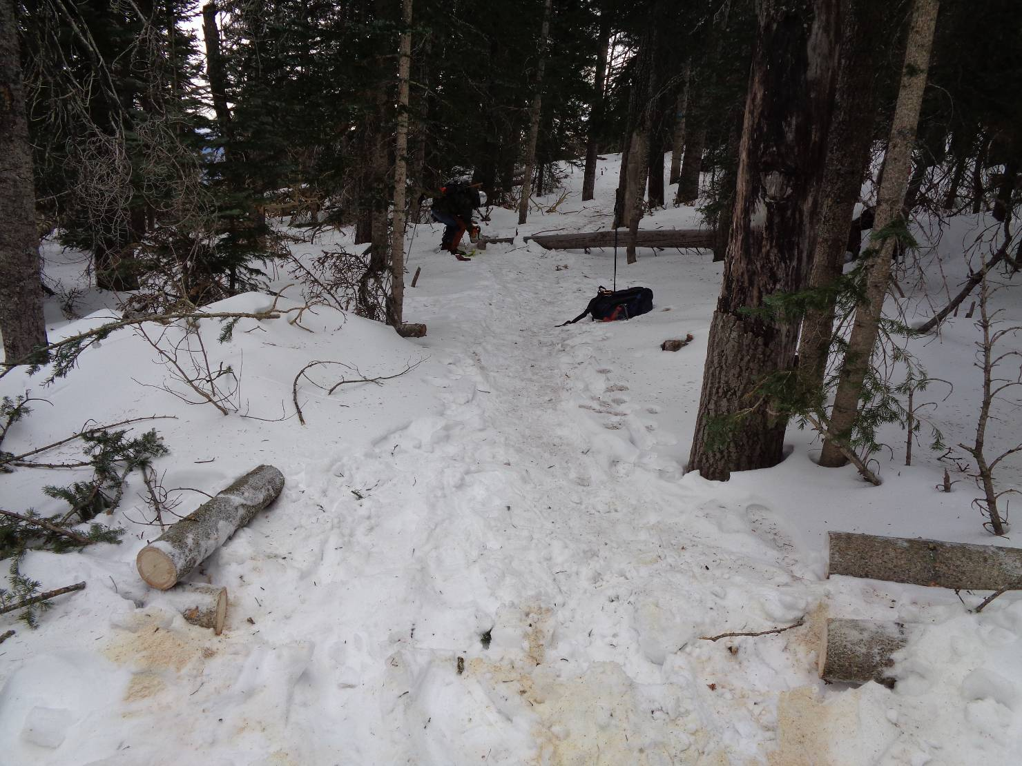
The first tree has been removed, and Michael is working on the second one.

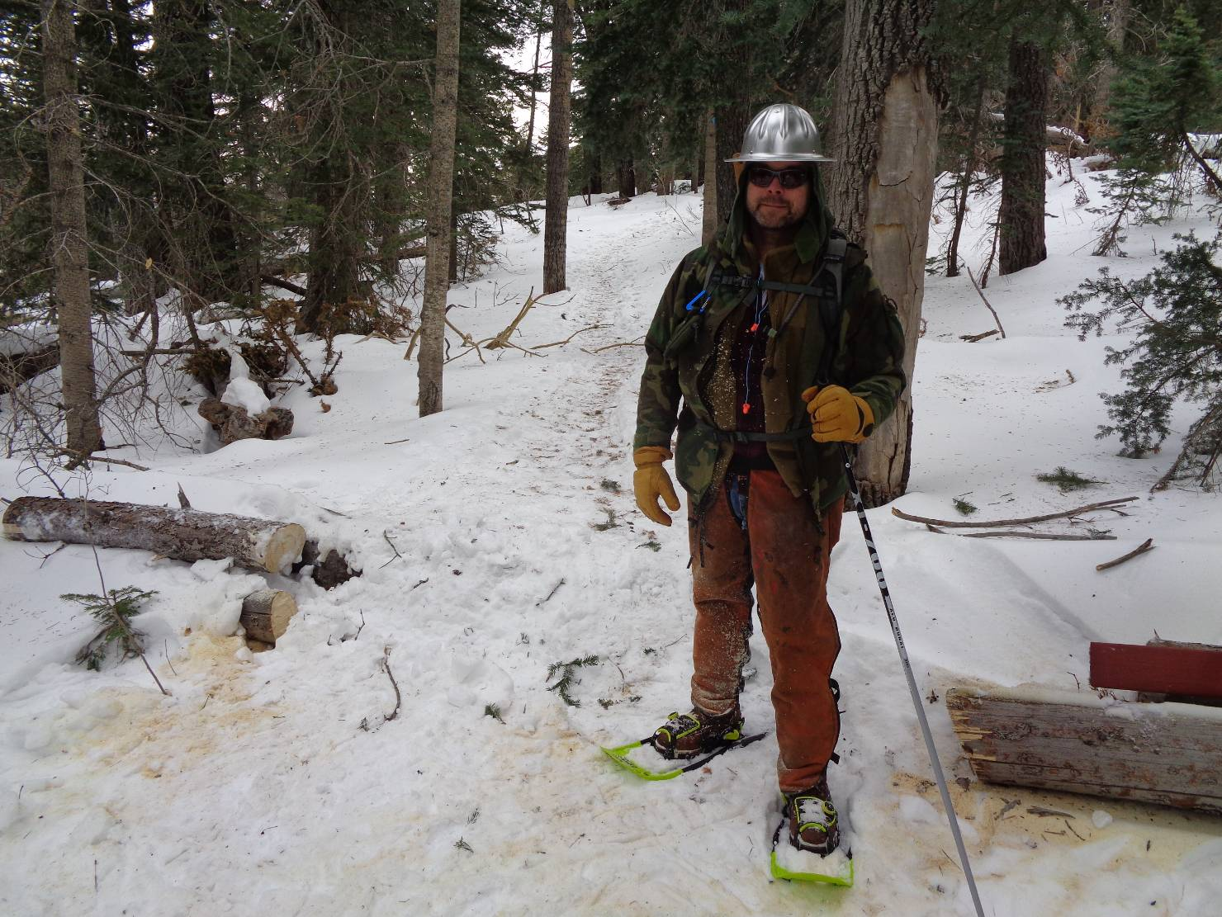
This part of the trail is not clear.

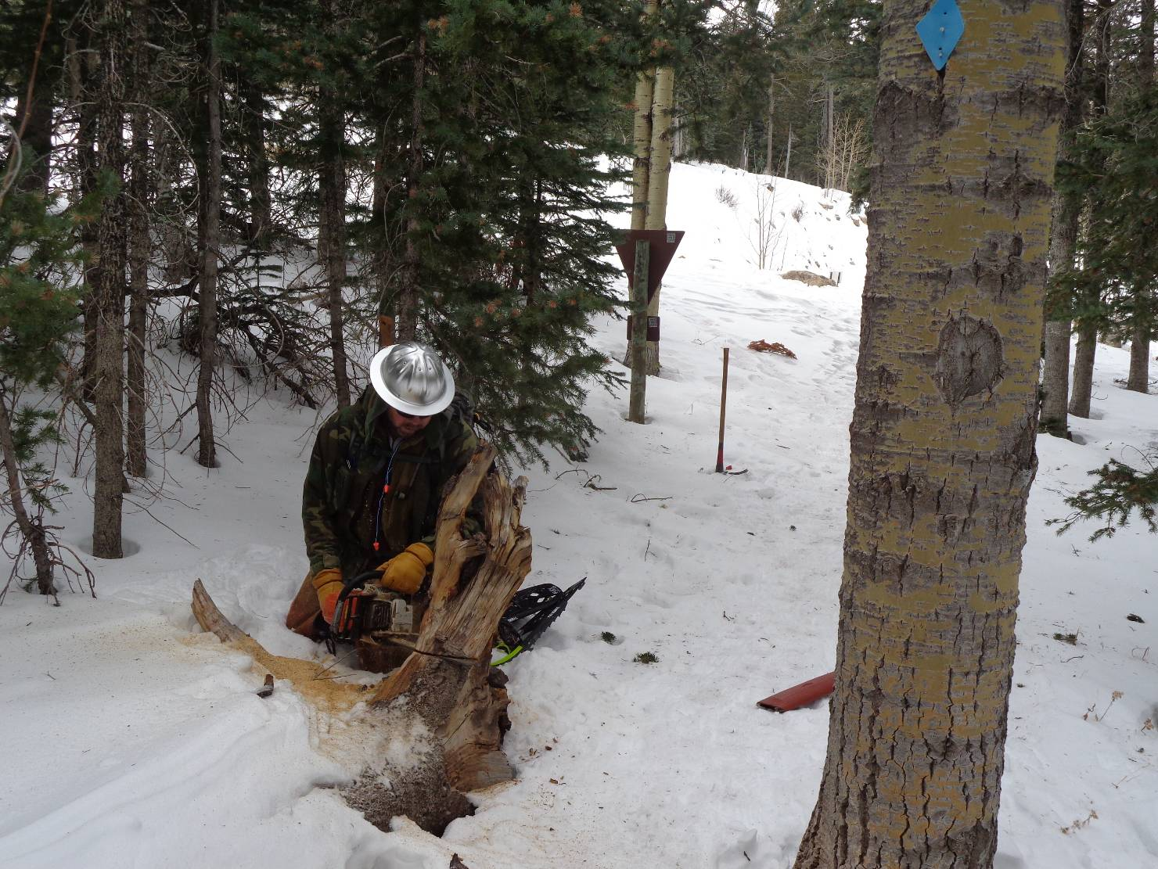
Michael cutting a root that was about 3 feet high next to a narrow part of the trail. The 10K South Trailhead is in the background.

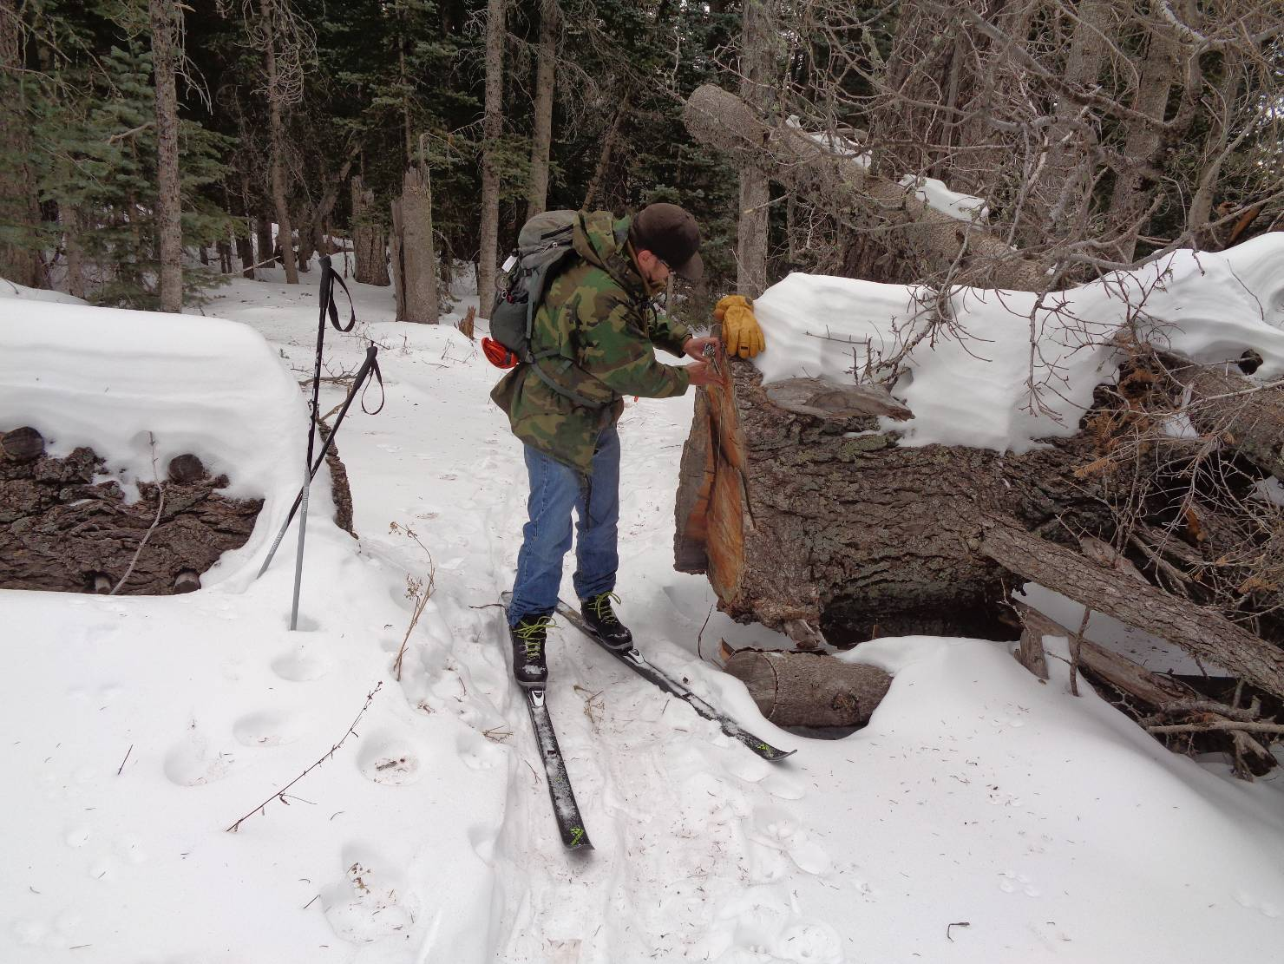
This very large oval tree trunk is 41 inches by 32 inches in cross section. Jerry Carroll cut this log on Sam’s Trail
several years ago. This log is one of the largest that Sandia Ranger District volunteers have cut with a chain saw.
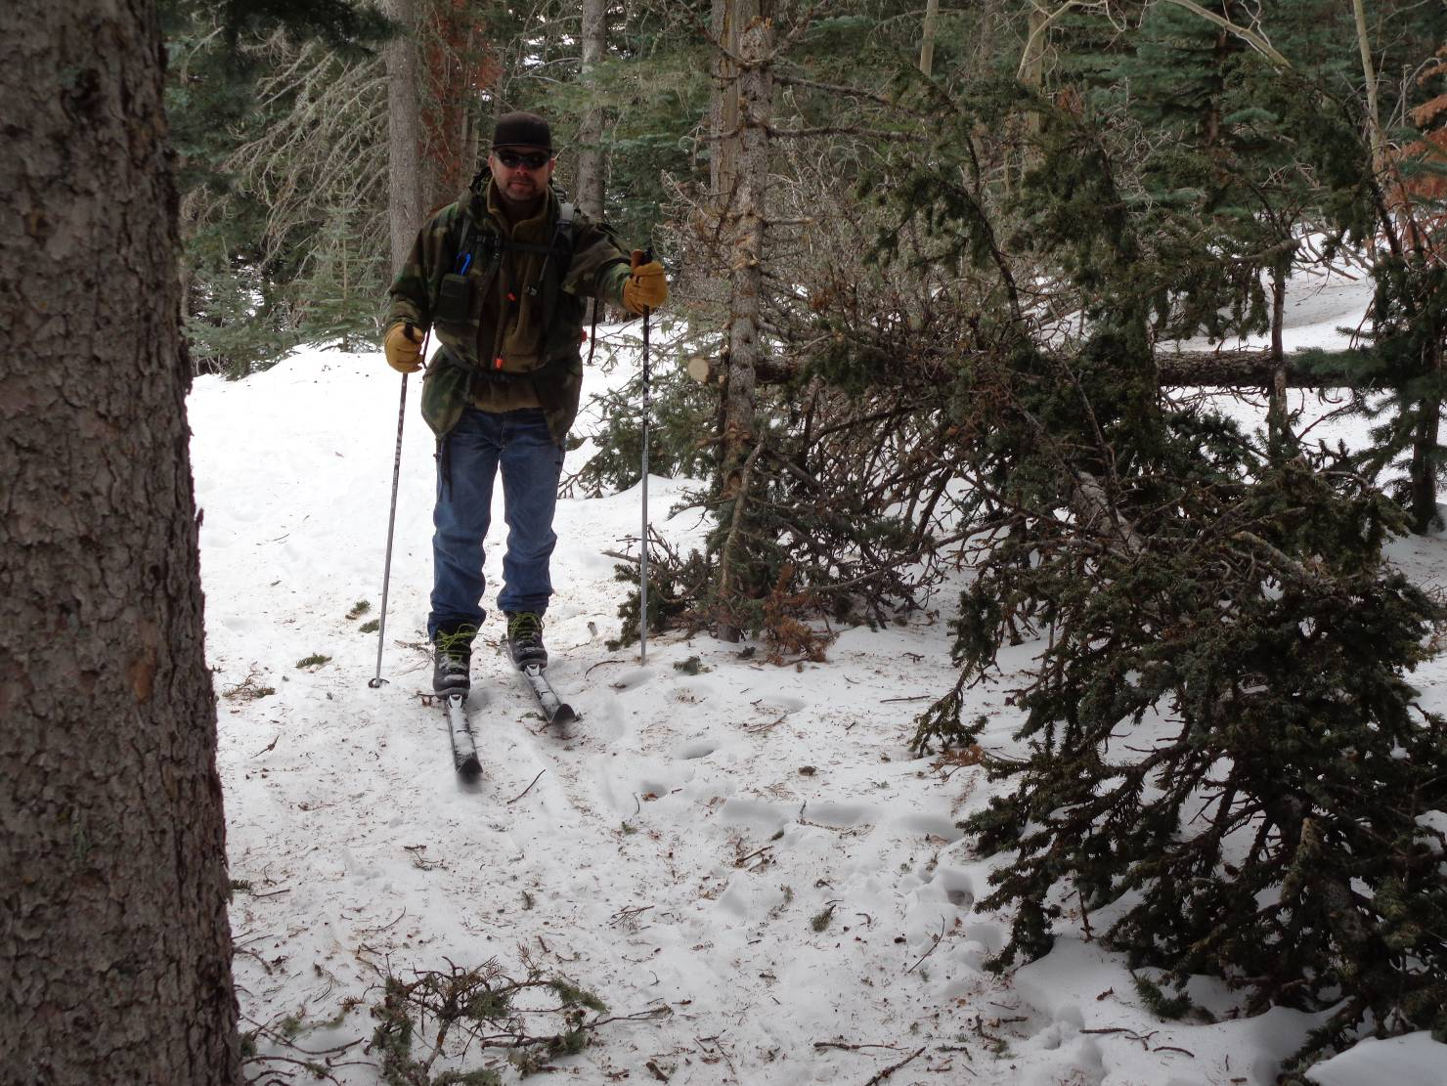
The mini-train wreck on Kerry’s Trail was cleared a few weeks ago

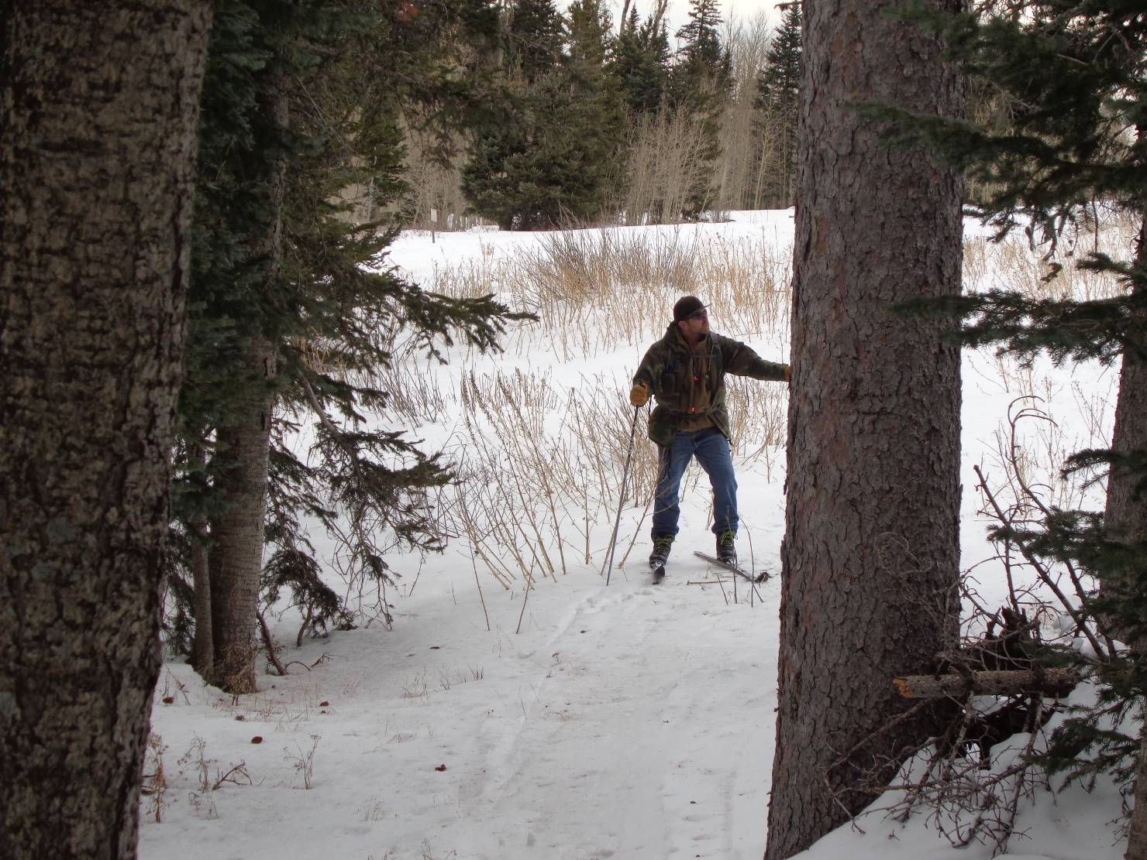
The south end of Kerry’s Trail where skiers enter one of the meadows on the old road clearing where a road to
Placitas was never completed. This site is just below the first switchback in the Crest Highway below Ellis Trailhead.
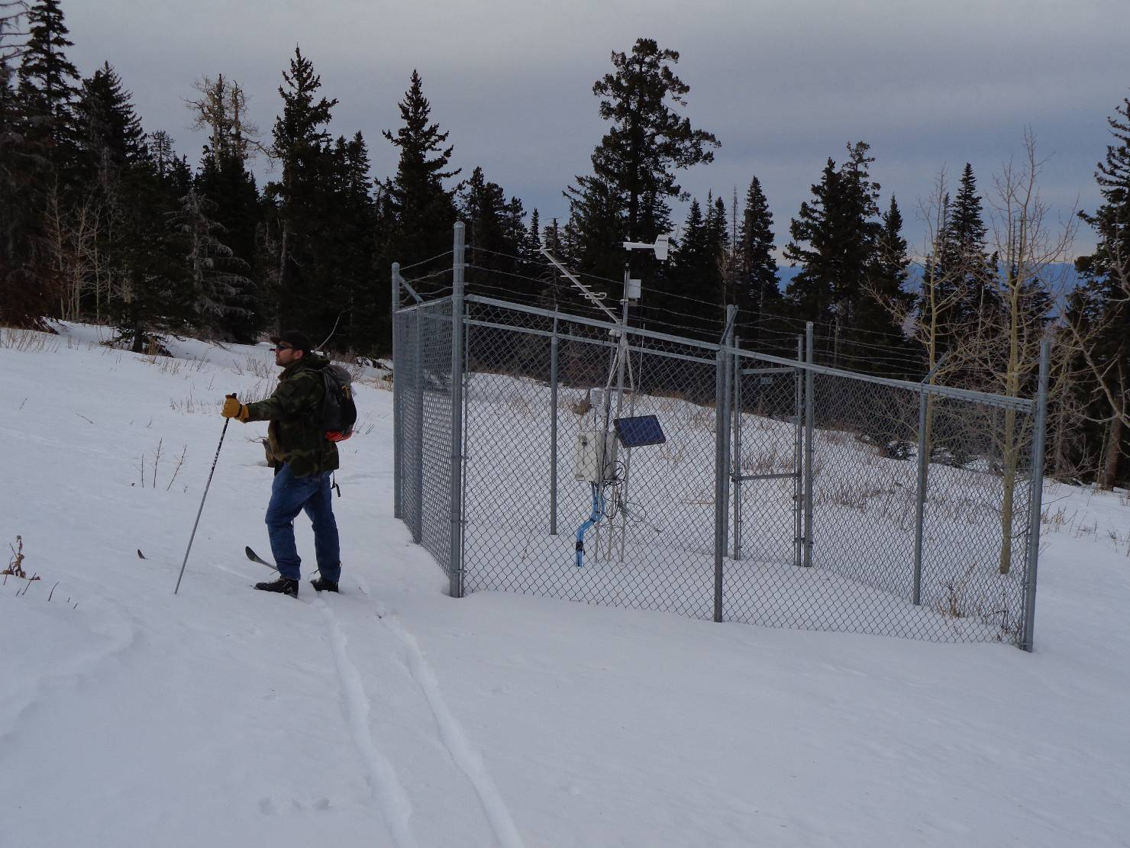
The weather station at the north end of the aspen regeneration project above 10K South Trailhead.

