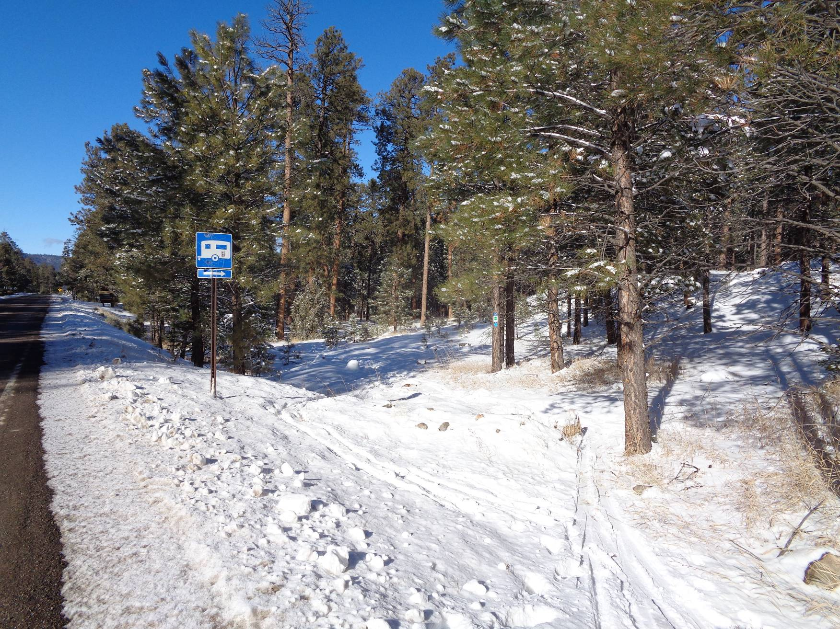
Entrance into the Redondo Campground ski area from the highway. Parking is in a large paved and plowed area
across NM-4 from the campground. Photo by Sam Beard
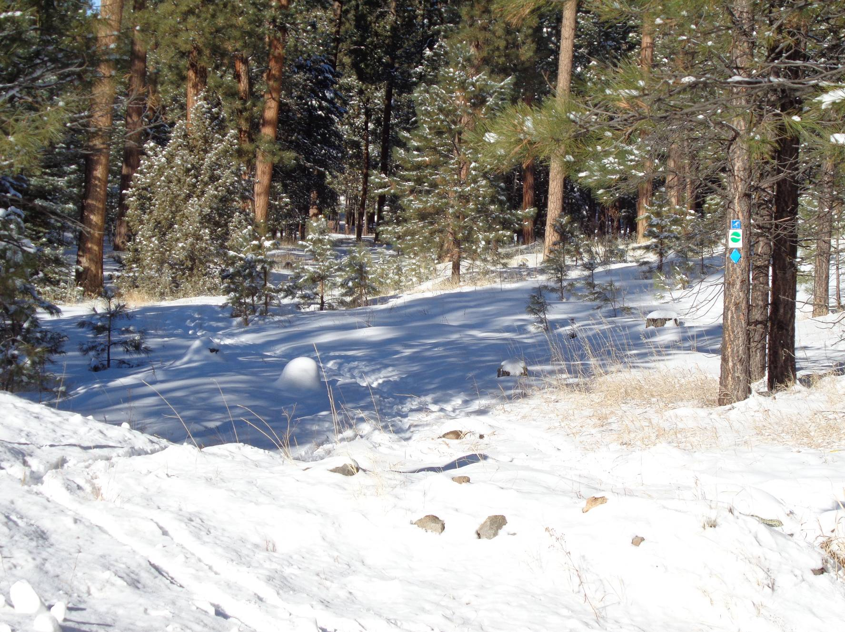
Another view of the entrance to Redondo CG with the trailhead signs on the pine tree on the right. Photo by Sam Beard
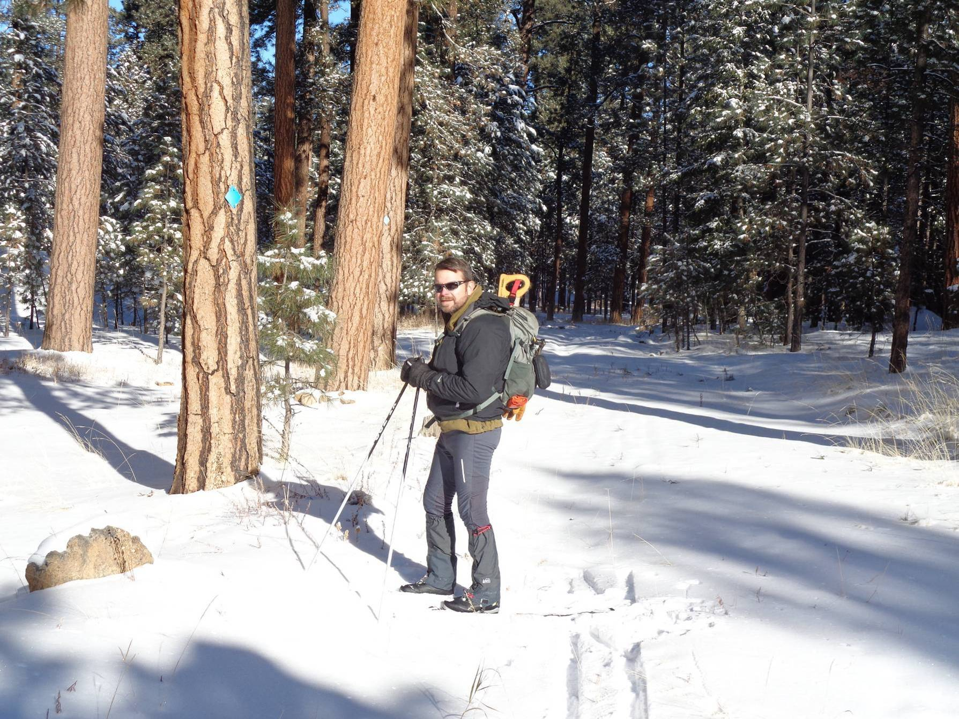
Michael Arndt beside a blue diamond on the old road into the area.
Photo by Sam Beard
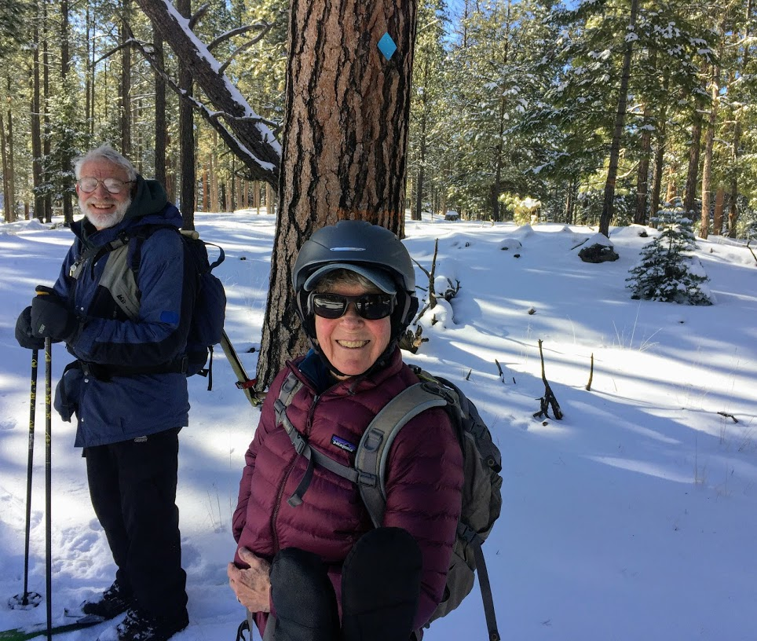
Sam Beard and Frances Meier skiing in the Redondo area. Photo by Mike Meier
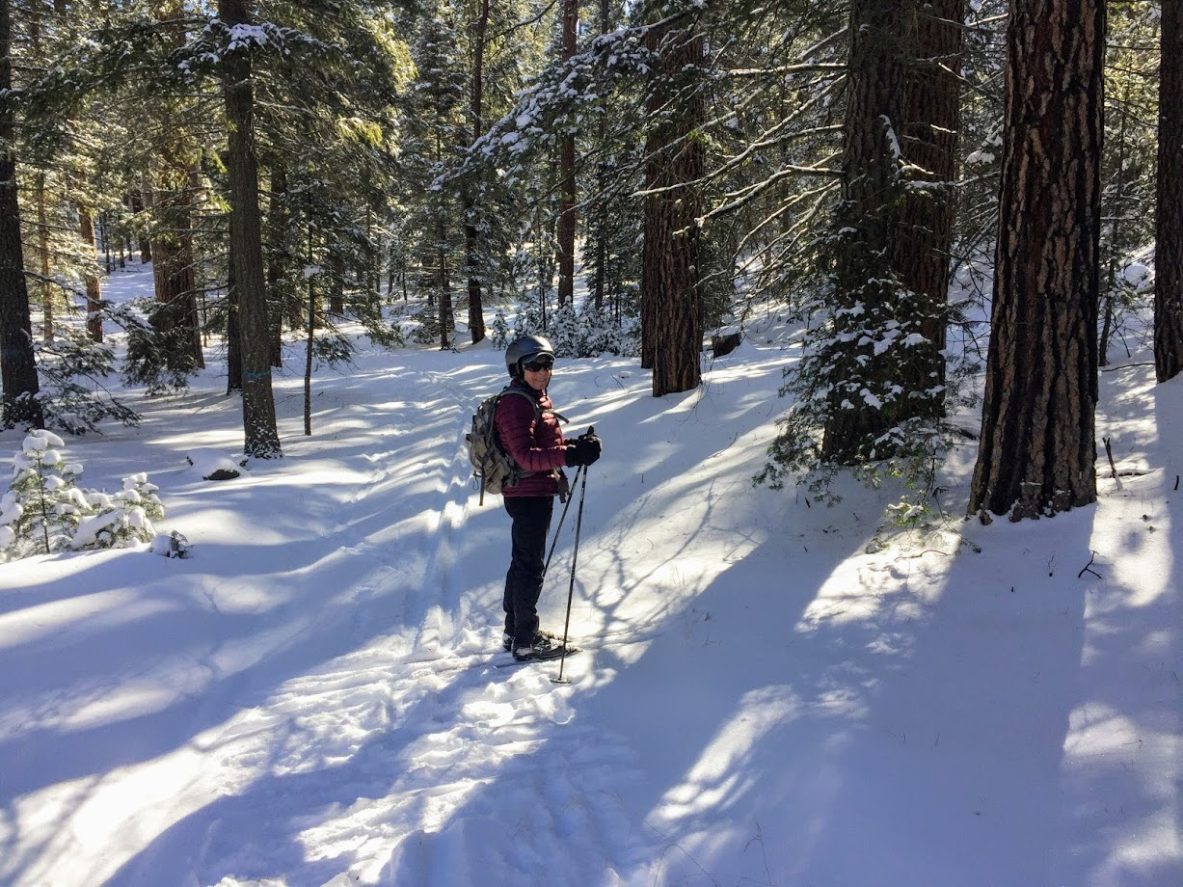
Frances surrounded by tall pine trees. Photo by Mike Meier

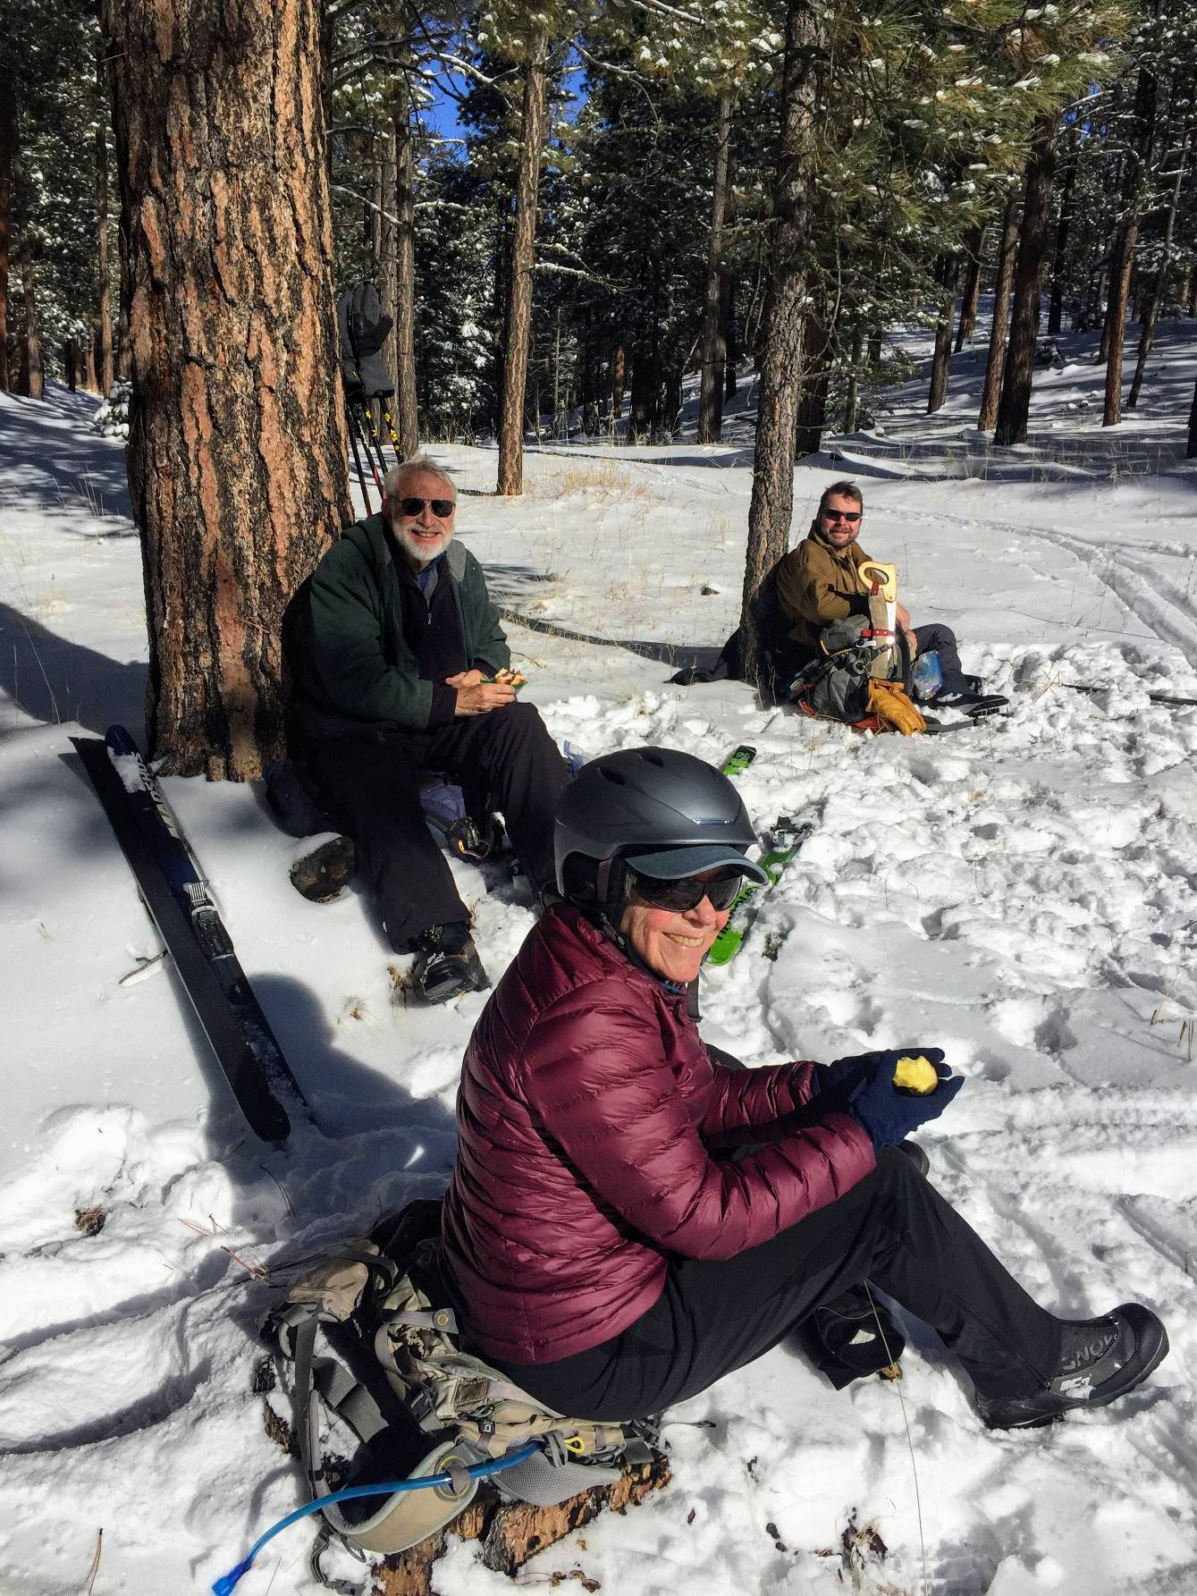
Sam, Frances, and Michael enjoying lunch where the Loop Trail is near the highway.
Photo by Mike Meier

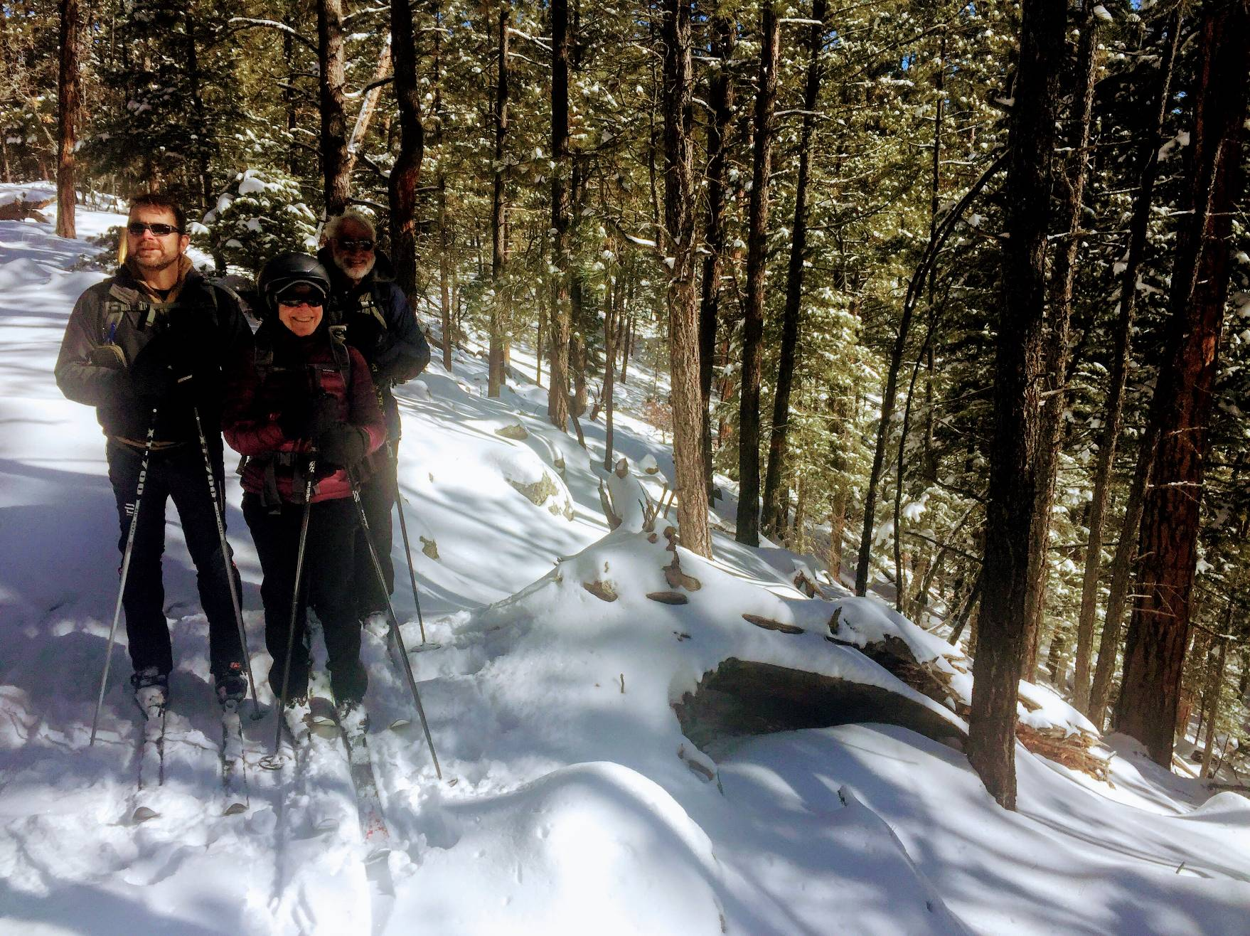
Michael, Frances, and Sam on the edge of the largest crater. Note the trees on the slope of the crater wall.
Photo by Mike Meier

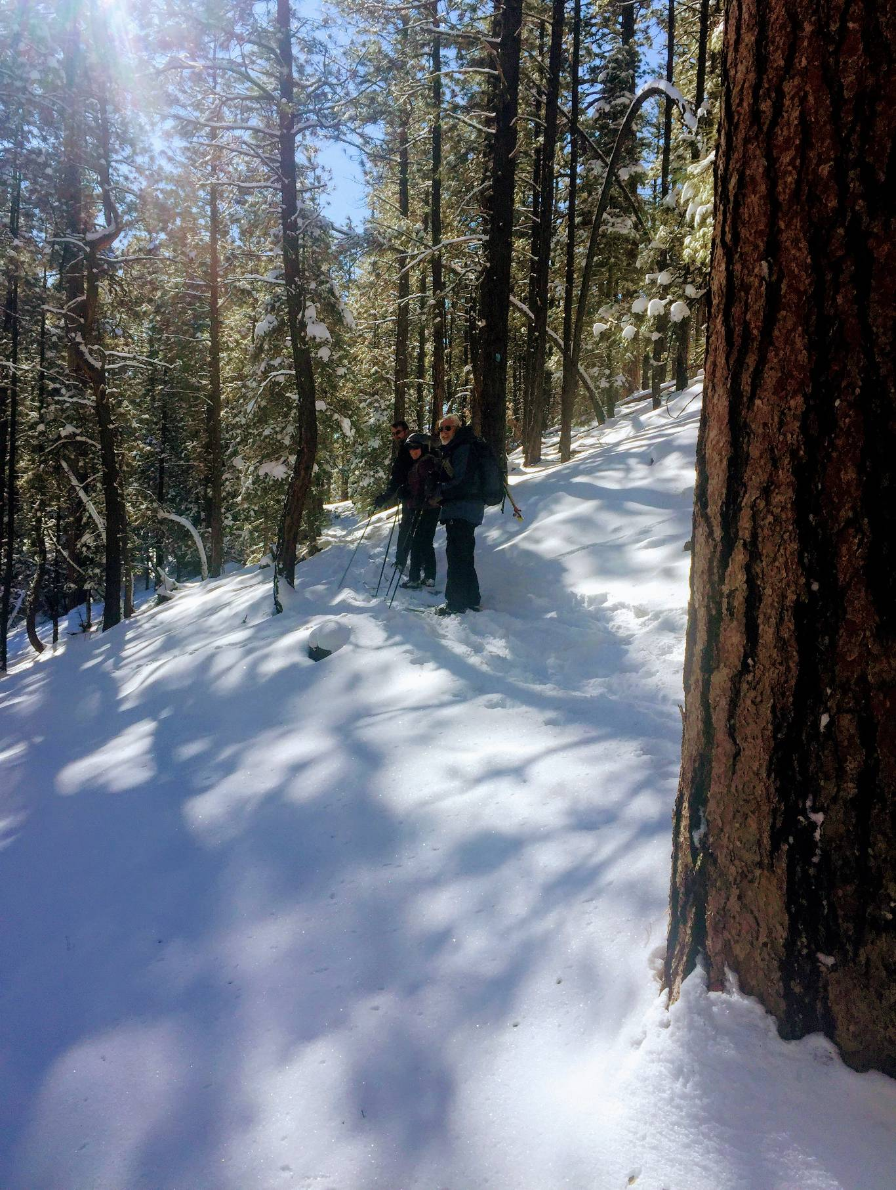
Michael, Frances, and Sam on the narrow trail leading past the small crater on the Crater Spur Trail.
Photo by Mike Meier
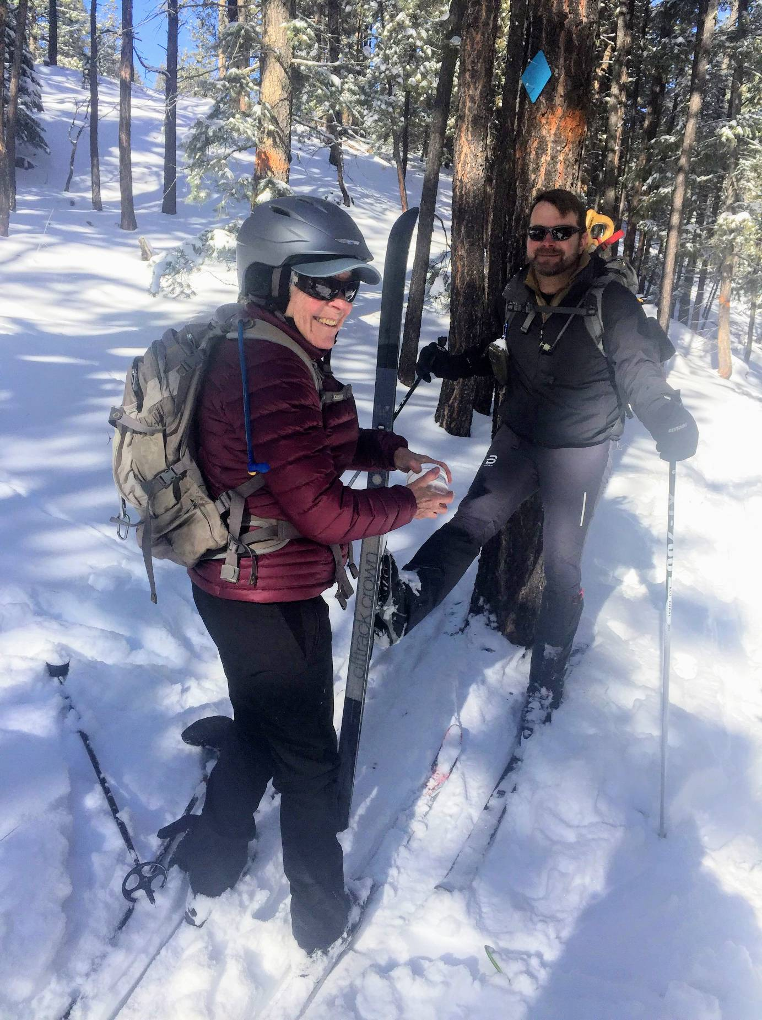
Frances applying MaxiGlide to the bottom of Michael’s ski while he leans against a tree.
Photo by Mike Meier

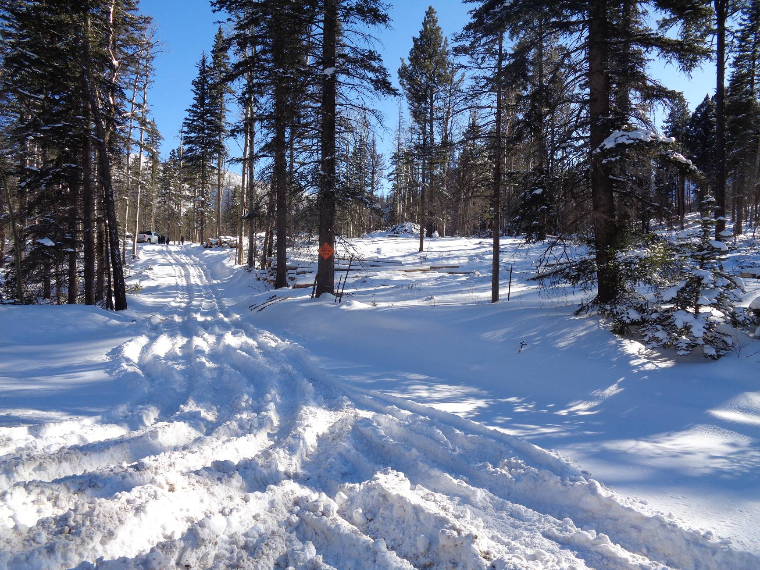
New road on the south side of the highway leading into an area that is being thinned and masticated. We may
eventually use this road to access Big Pine Canyon and the Elk Ridge Trail area. Photo by Sam Beard

