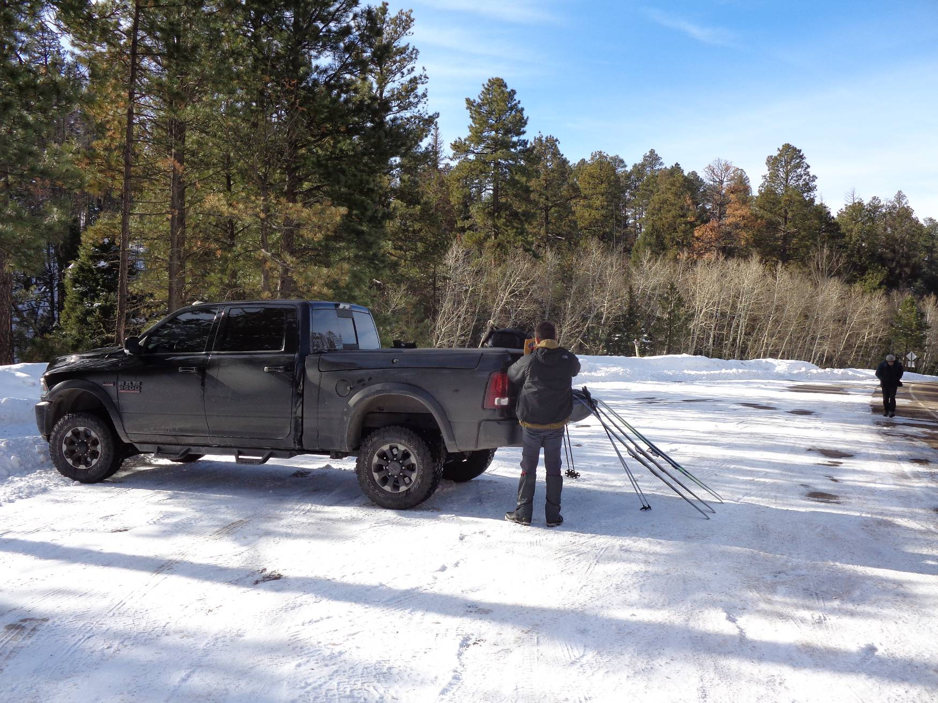
Michael Arndt’s pickup at the Los Griegos Mountain parking area on the south side of NM-4.
All photos by Sam Beard

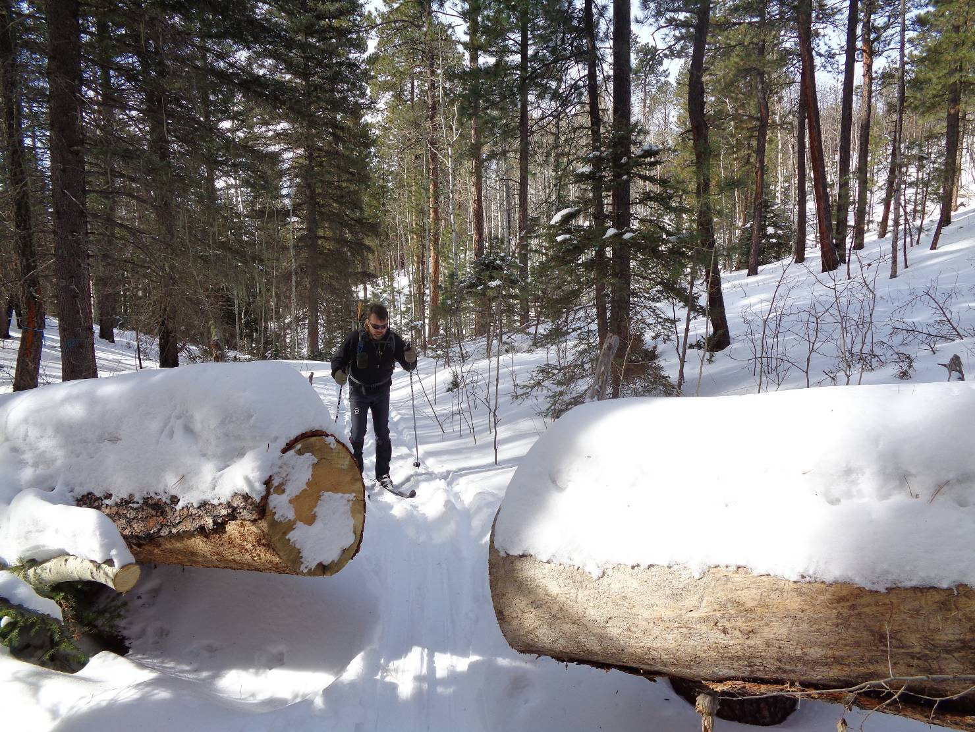
Michael skiing up to a large log cut by unknown persons in the East Fork East Loop area.

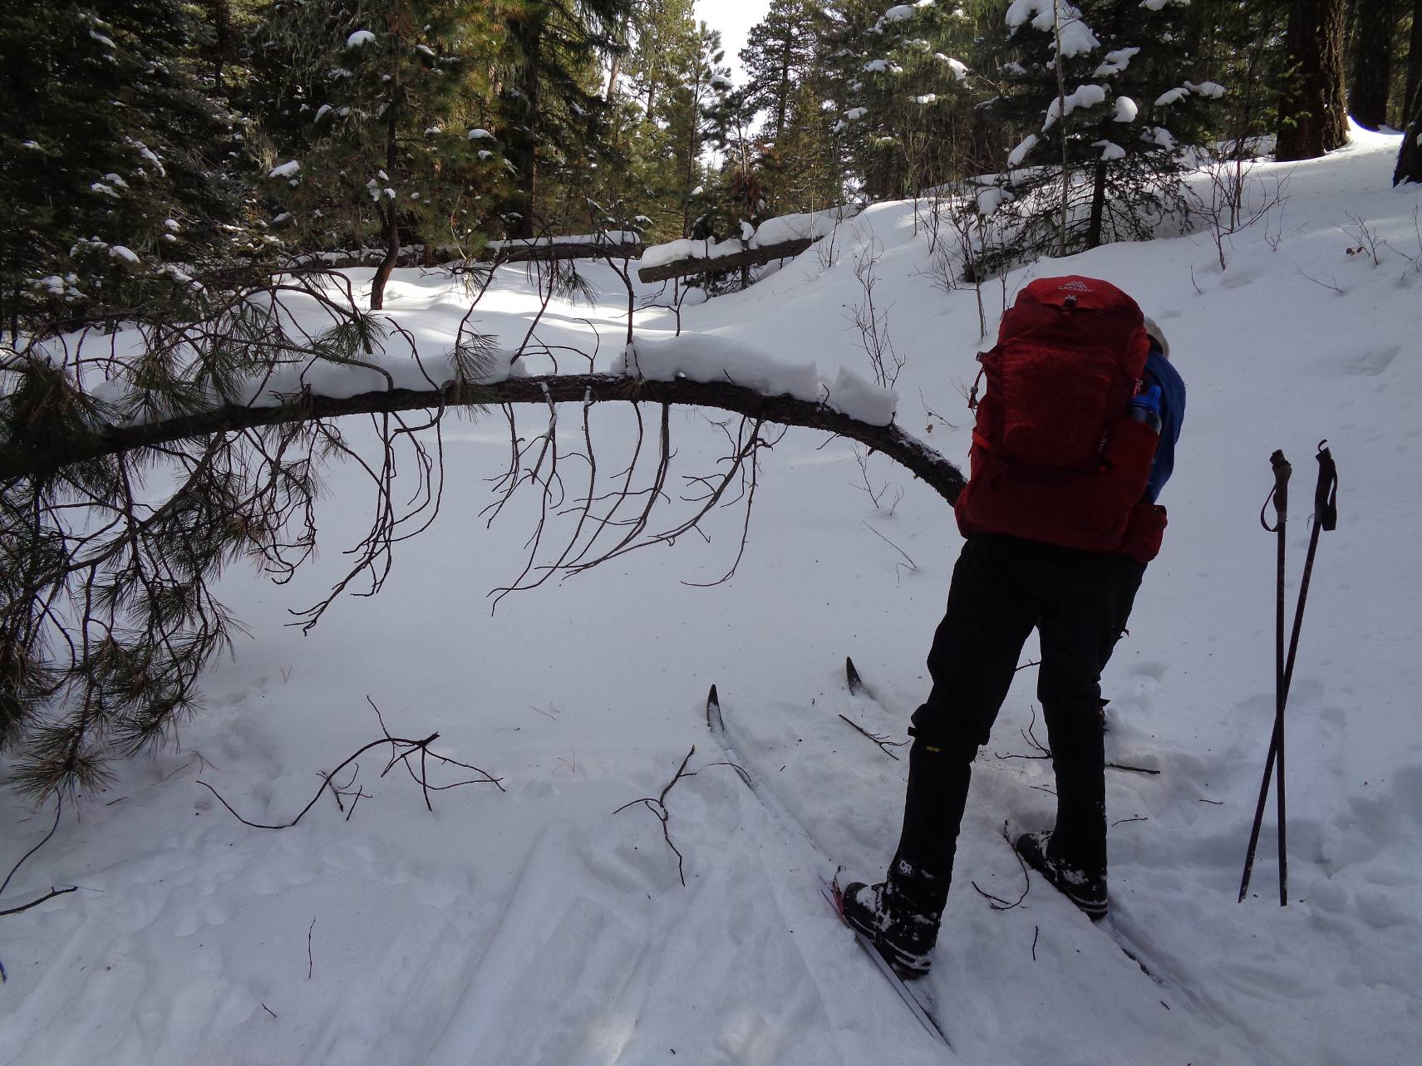
Byron Garner cutting a small pine tree with his pruning saw on the north side of the East Loop.

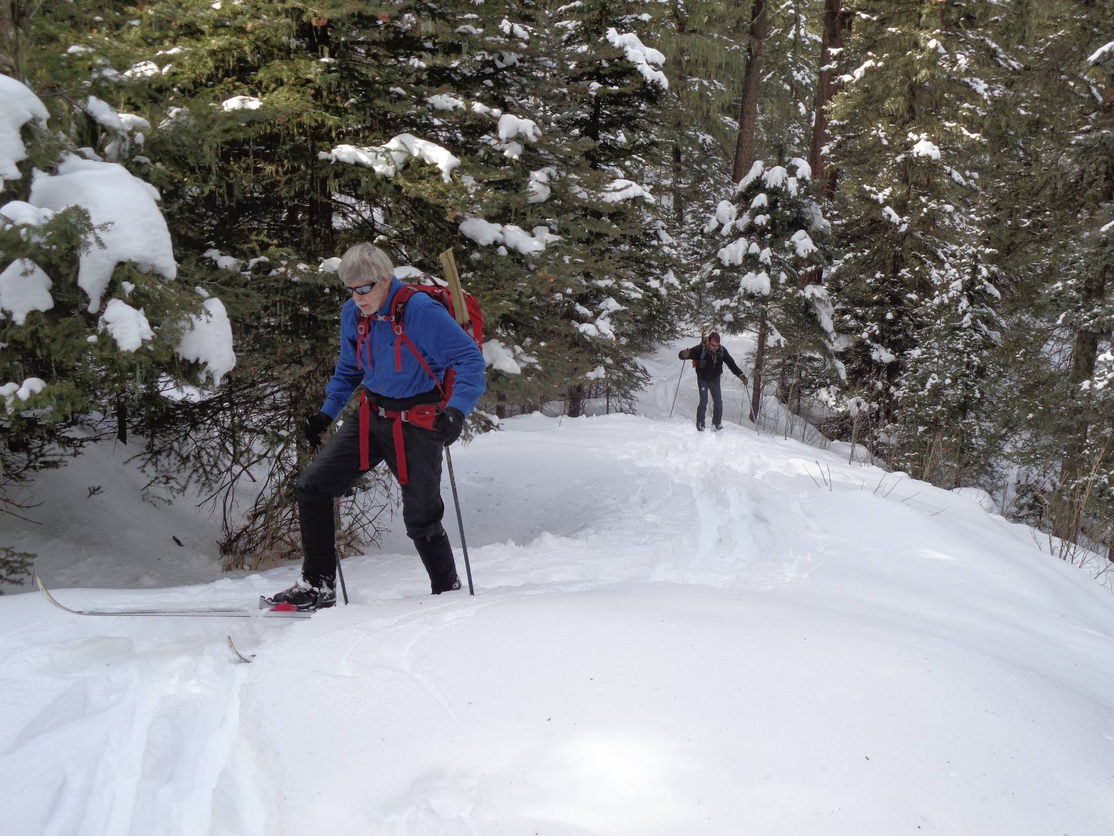
Byron and Michael climbing up the trail near the east end of the loop.

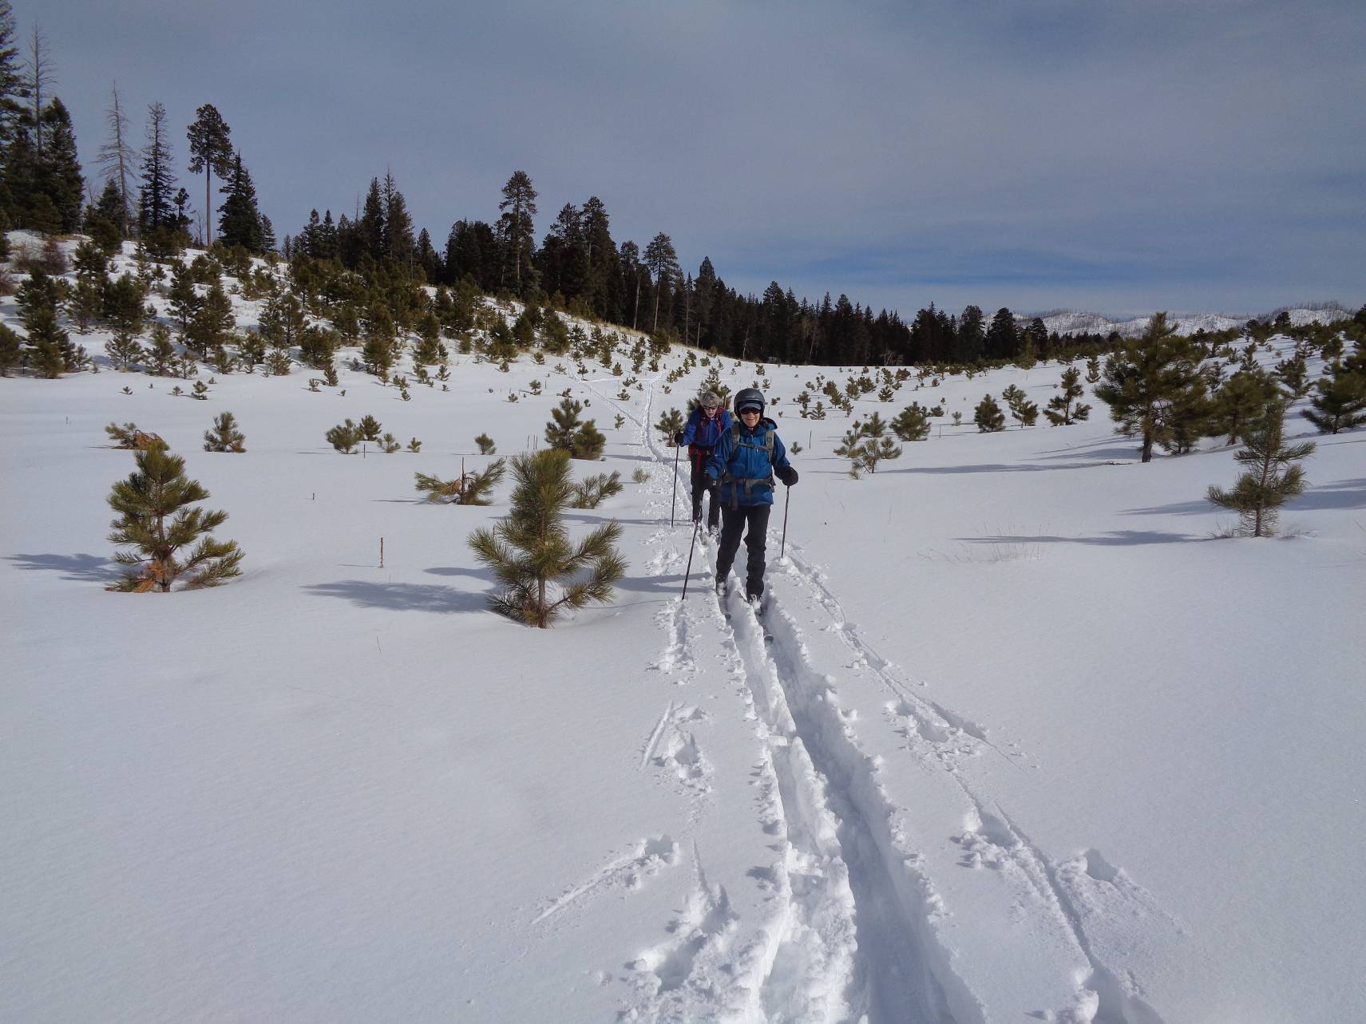
Frances Meier and Byron crossing the old pumice mine. Note the small trees growing in this area. We had lunch
on the north rim of the mine in the background.
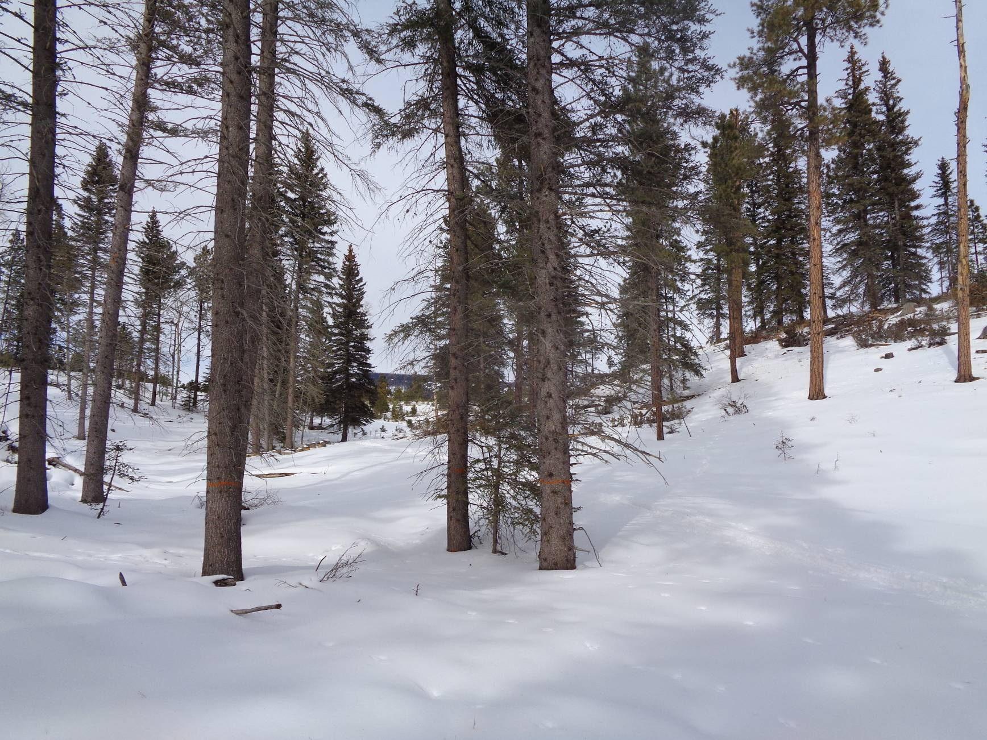
An area between the highway and the old mine that was thinned one year ago. The site of the old mine can be seen between the trees
in the center of the photo. NM-4 is a short distance behind the photographer.
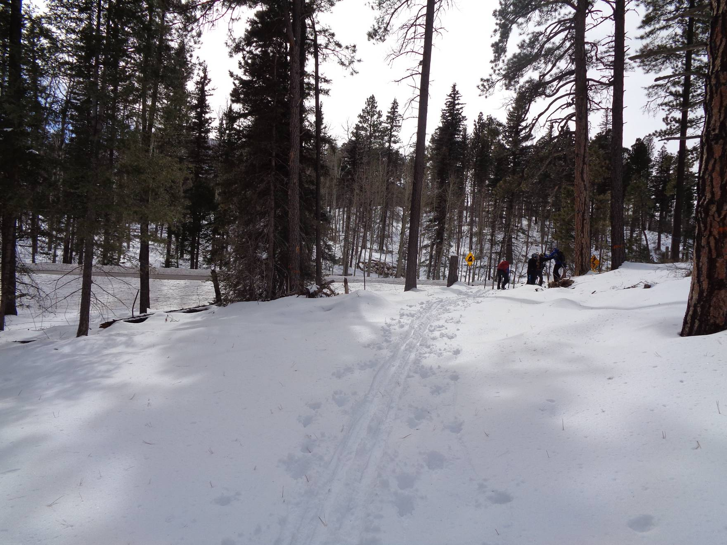
The group is going through the gate on the north side of NM-4 where the thinning was completed one year ago.
The present thinning operation is on the other side of the highway.

