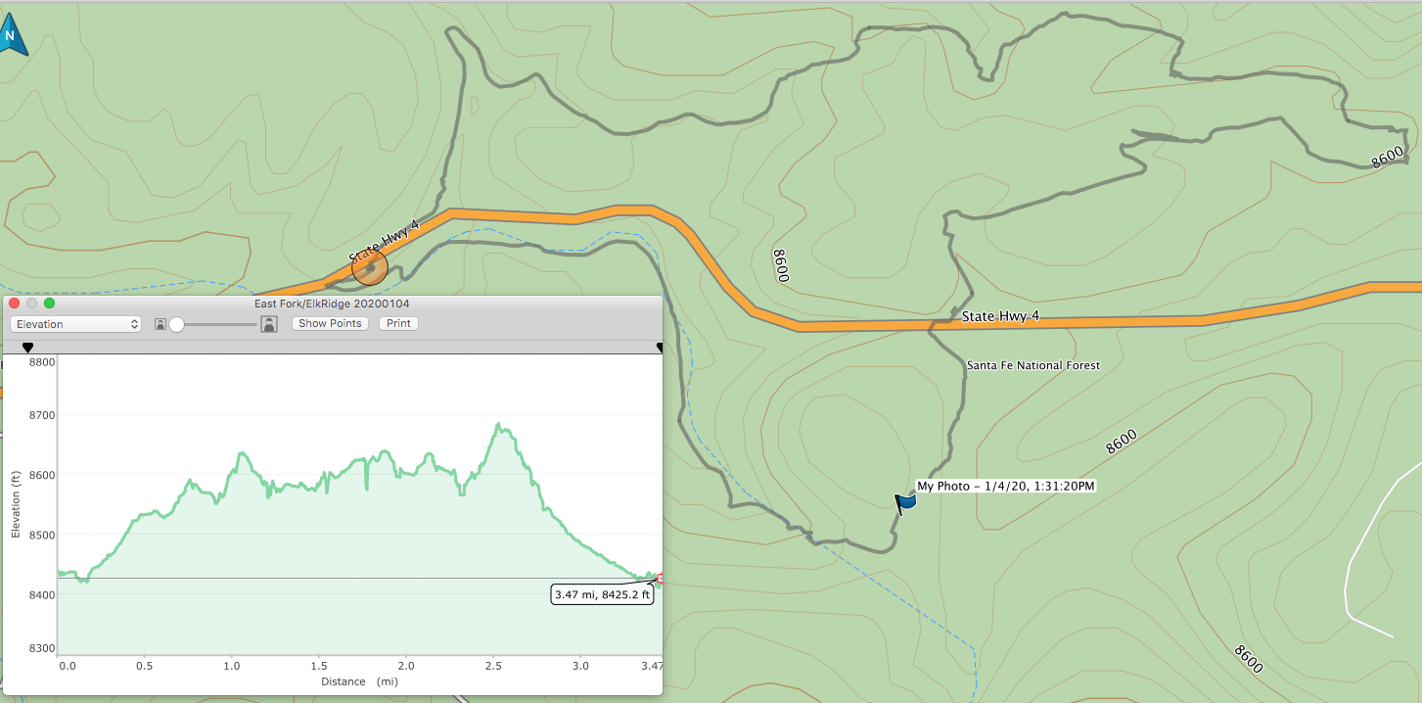
Map of East Fork East Loop, lower Elk Ridge Trail, and lower Ladera Trail skied on Saturday, January 4, 2020.

Parking was at the left (west) end of the loop at the Los Griegos Trailhead,
a very large space plowed by the NMDOT after each storm. The skied route crosses the highway just east of the parking lot and goes
to the north a quarter mile on the Las Conchas Burn Trail. A connector trail goes to the east to a saddle on the East Fork Ridge Trail.
From the saddle, the Loop Trail goes to the east in a clockwise direction on the north side of the ridge in excellent 20-inch deep snow.
From east end of the loop, the trail leads to the west back to the saddle. On Saturday, we did not ski back to the saddle.
Instead, we skied to the north rim of the old pumice mile where we had lunch overlooking the north side of Los Griegos. We then
skied to the SW across the open mine area and through an area thinned a year ago to the highway. We crossed the highway
and began skiing to the south through the Los Griegos thinning area to the Elk Ridge Trail at the power line. We then skied down
this trail to the west to the Ladera Trail which we followed back the parking area. The total distance was about 3.5 miles.
Map and all photos by Mike Meier
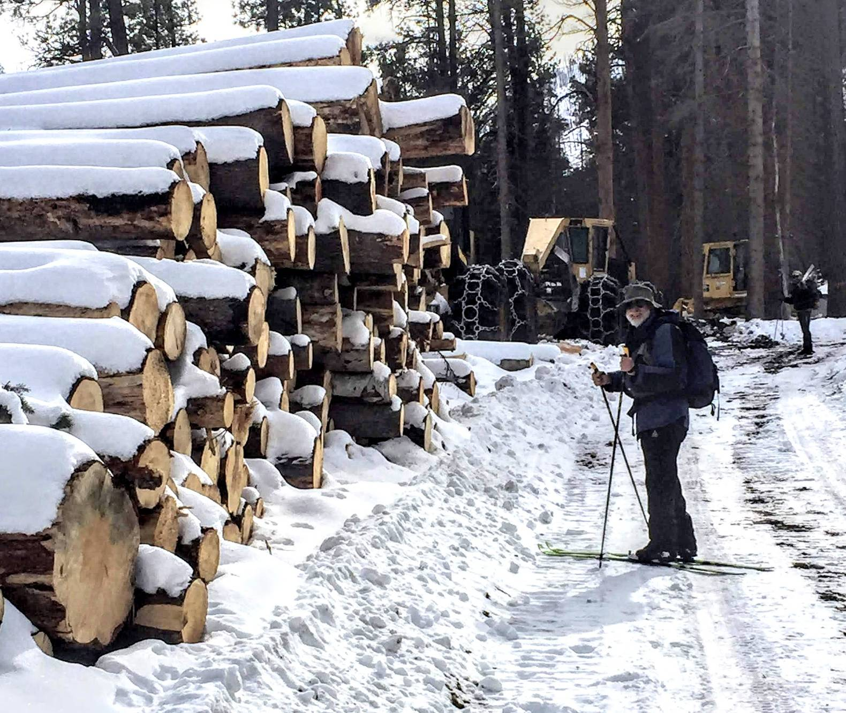
Sam Beard beside a stack of logs collected during the thinning operation on Los Griegos Mountain
south the highway and about a mile east of the Los Griegos parking area.
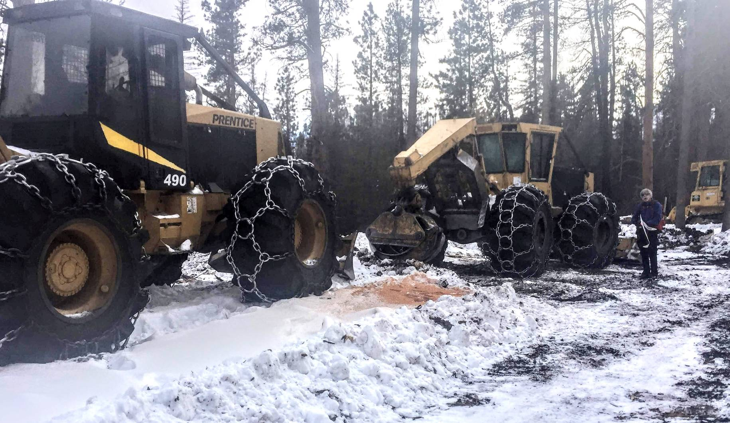
Byron Garner beside two the large skidders that drag logs to the log landing where they are stacked. The large claws on the
short crane grab several trees and pull them to the back side of the skidder that then drags them to the landing.

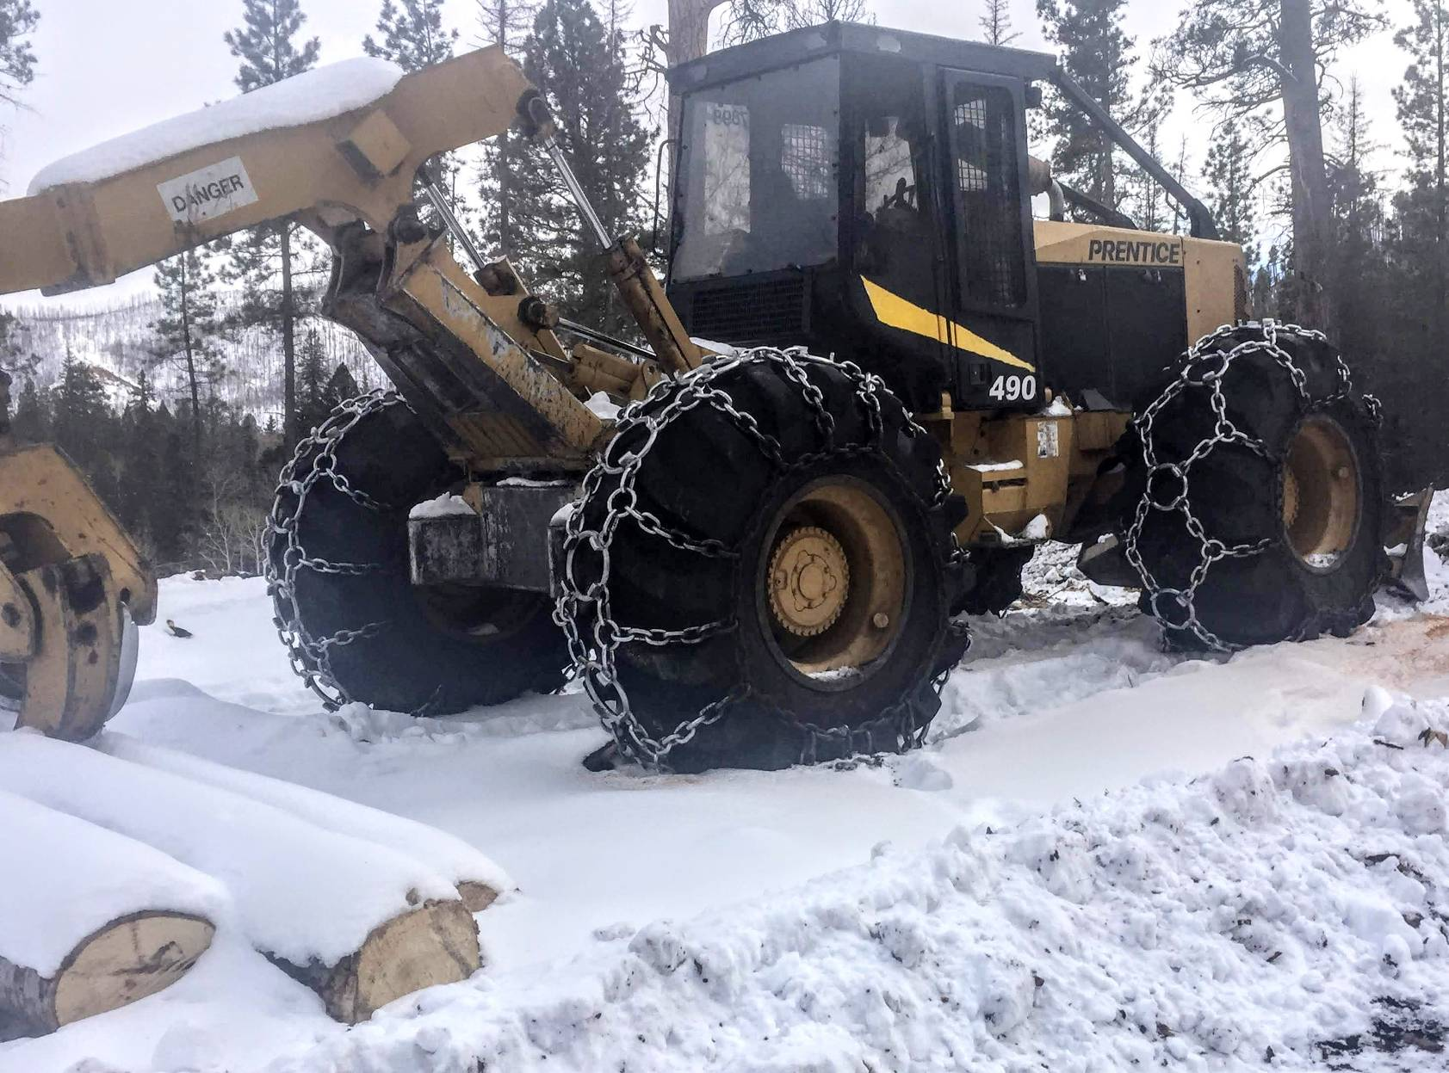
A skidder with very large chains on the wheels to give better traction in the snow.
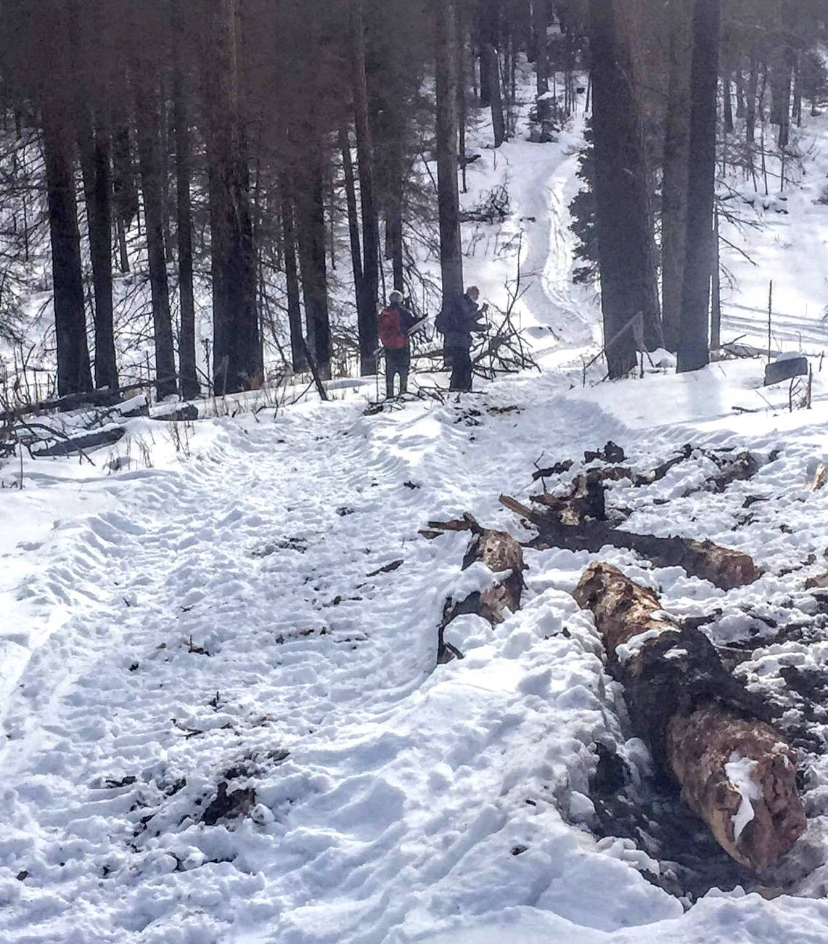
Skidder tracks leading to the Elk Ridge saddle at the power lines.
The tracks continued up the road toward Griegos Junction, a popular destination for skiers.

