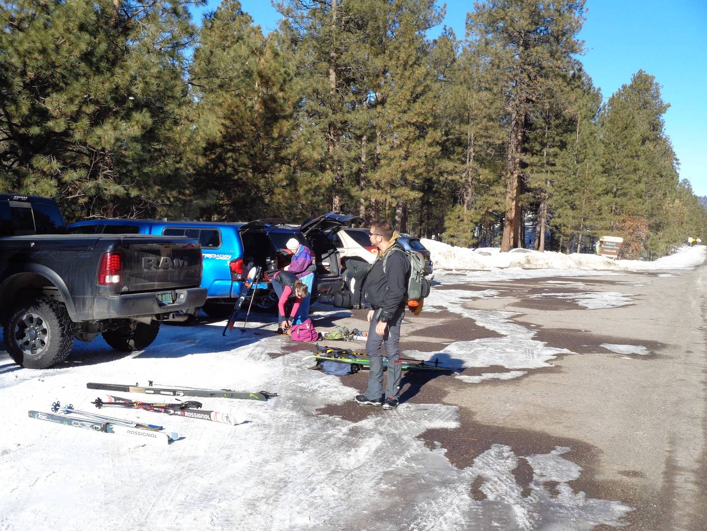
Skiers in the San Diego Overlook parking lot across NM-4 from the trailhead at Redondo Campground on Saturday, Jan. 25, 2020.
Photo by Sam Beard
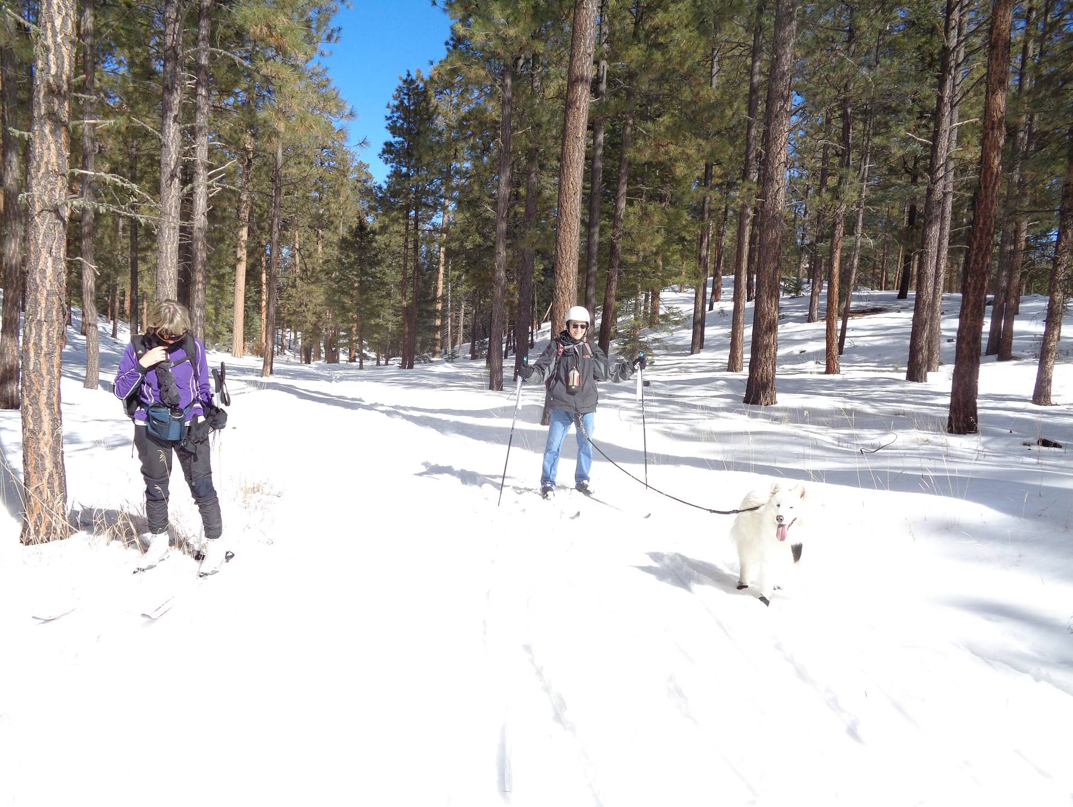
Gary and Carolyn Hughes-Fenchel with their skijoring dog Gusty at the intersection of the Loop Trail and Crater Spur Trail.
Photo by Sam Beard
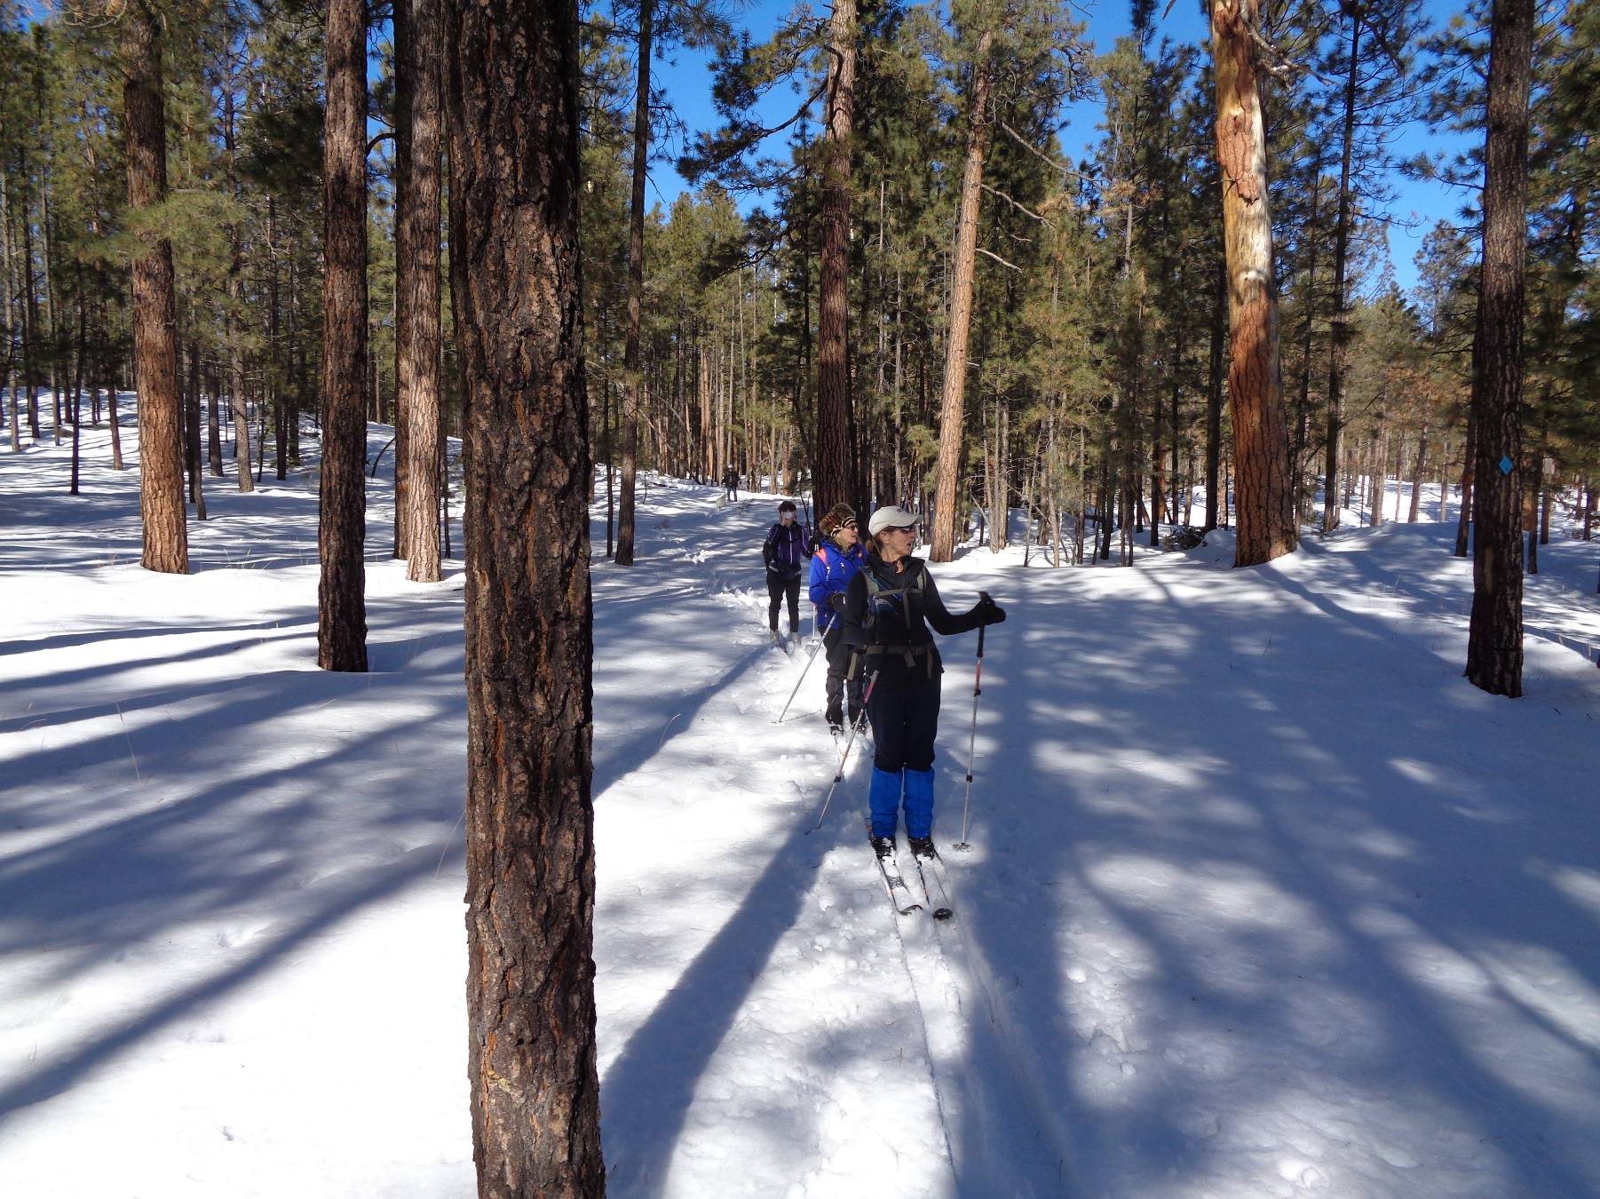
Skiers on the Crater Spur Trail near where this trail meets the Old NM-4 Road. Photo by Sam Beard
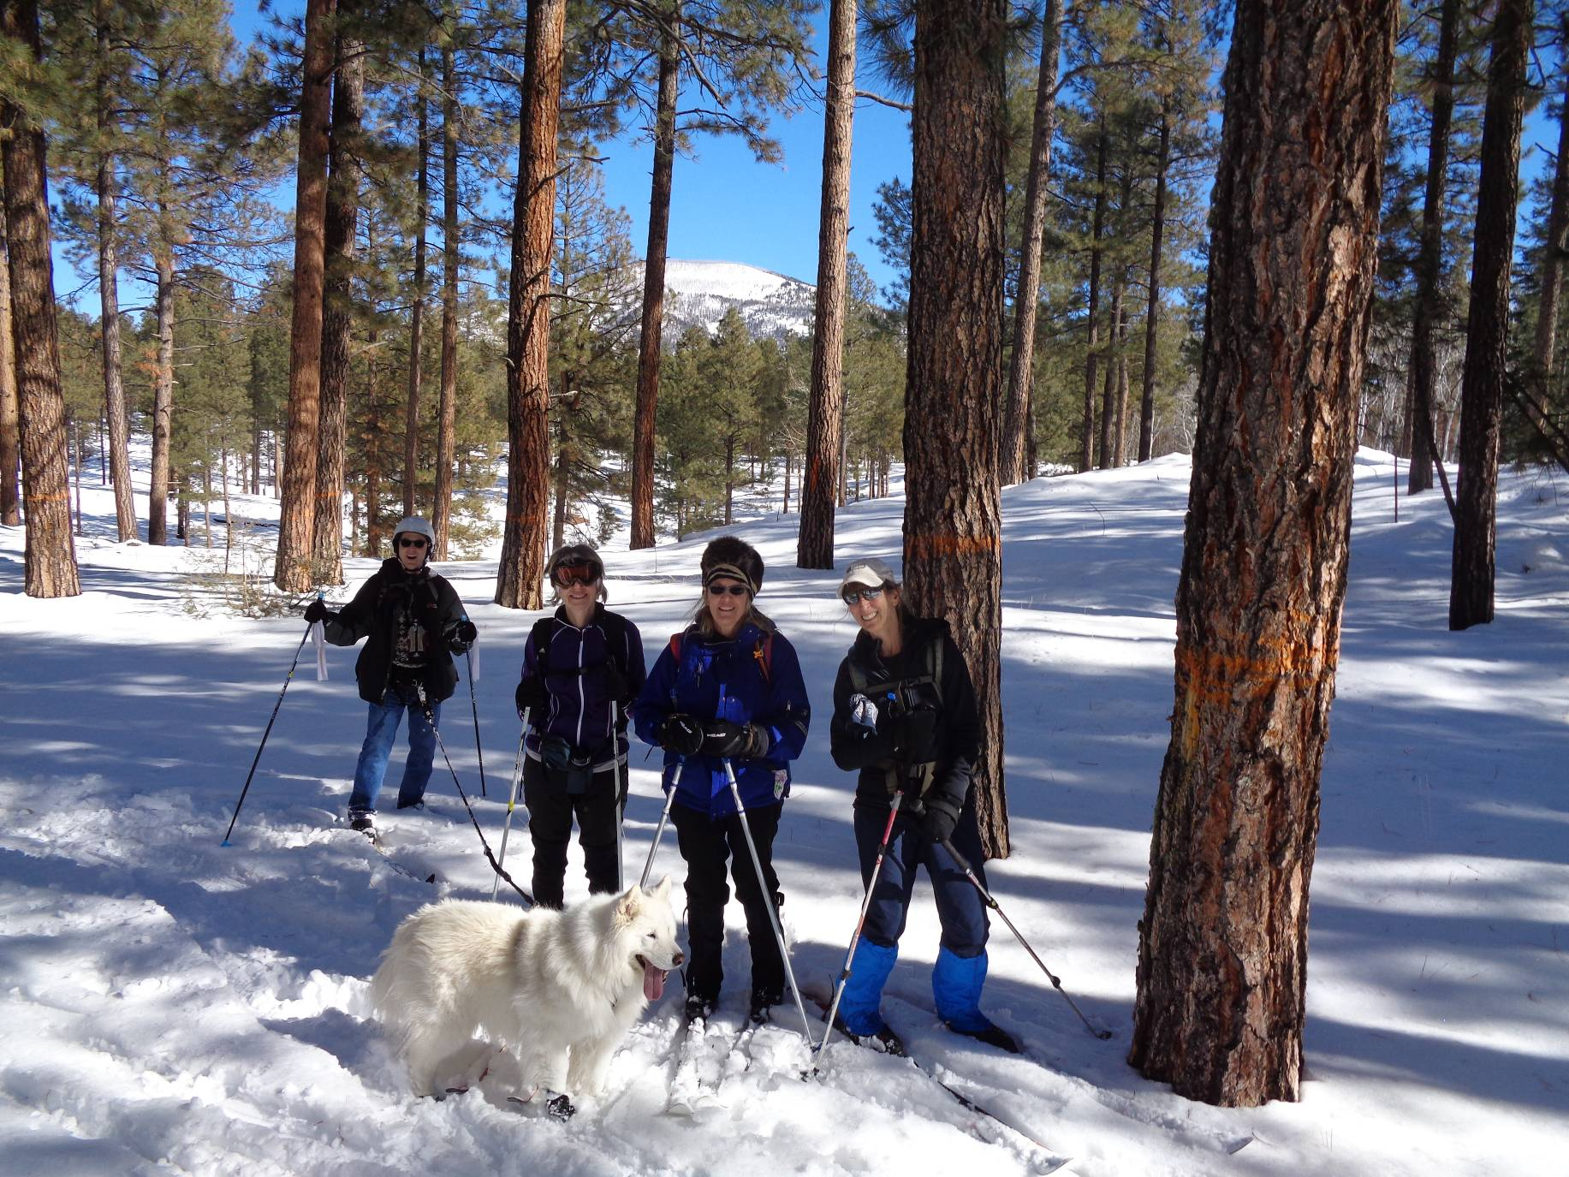
Skiers and Gusty at the south end of the Crater Spur Trail with Redondo Peak in the background. Photo by Sam Beard
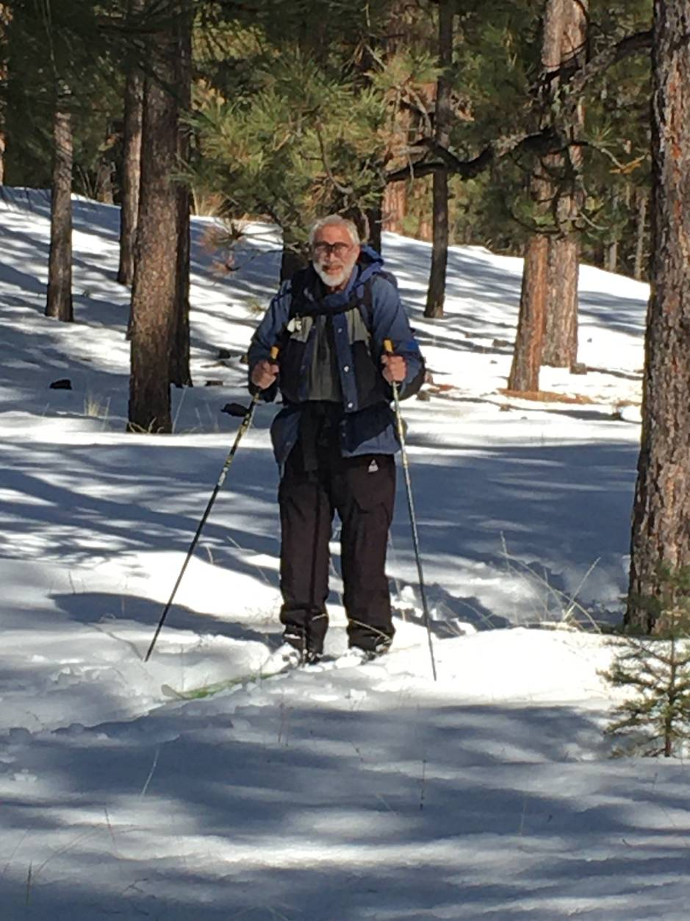
The outing leader.
Photo by Peggy Heinz

