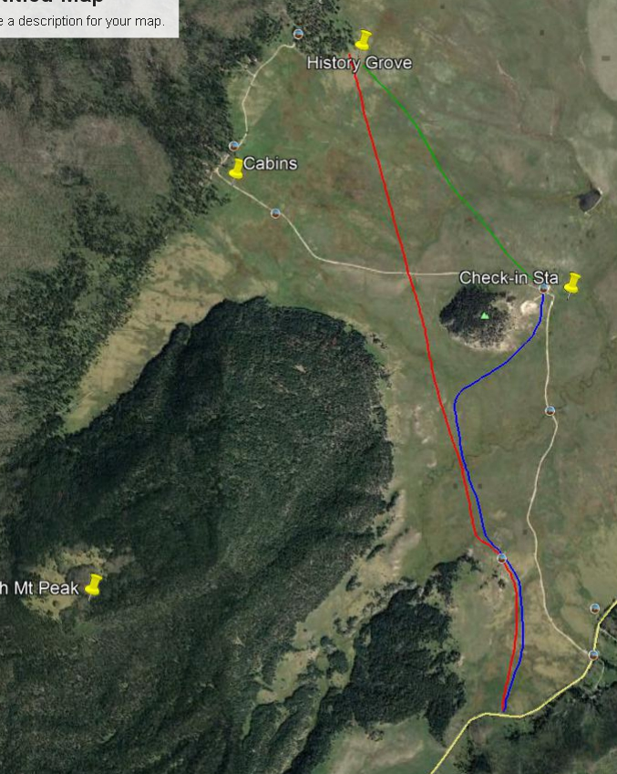
Google Earth Satellite photo map of area where Class I group skied on VCNP on Feb. 8, 2020.
Red – Missing Trailhead on NM-4 to History Grove (3.25 mi.). History Grove to Check-in Station
(1.5 mi.). Blue – Check-in Station to Missing Trailhead (2.25 mi.). (7 miles RT)
All photos by Sam Beard
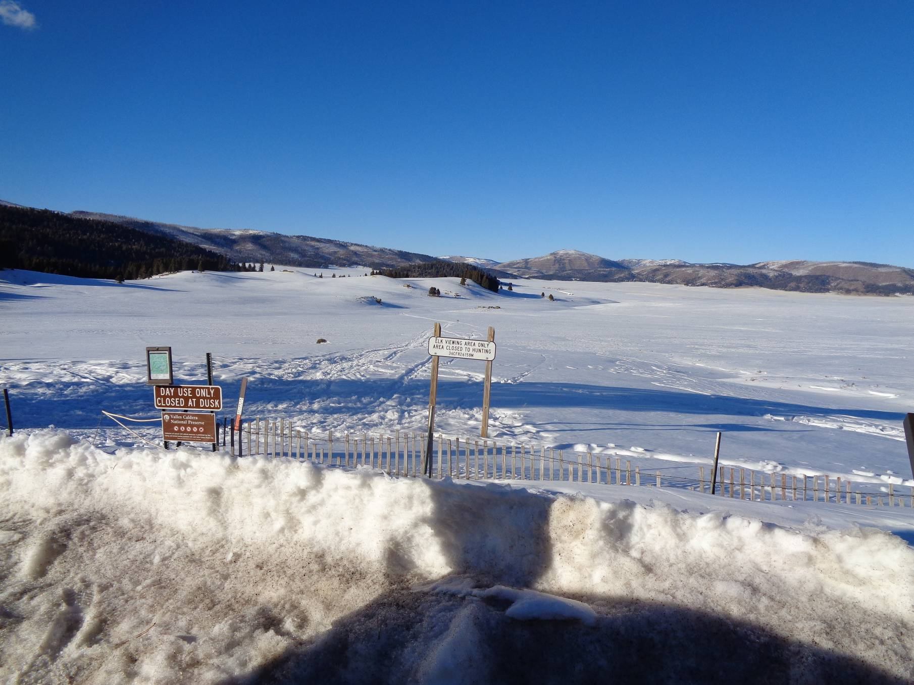
The Missing Cabin Trailhead on the north side of NM-4 about one-quarter mile west of the Valles Caldera National Preserve main
gate that was closed, because the road to the check-in station was being plowed. The trail goes east of the knoll in the center of the
picture and down to the large log cabin. All photos by Sam Beard
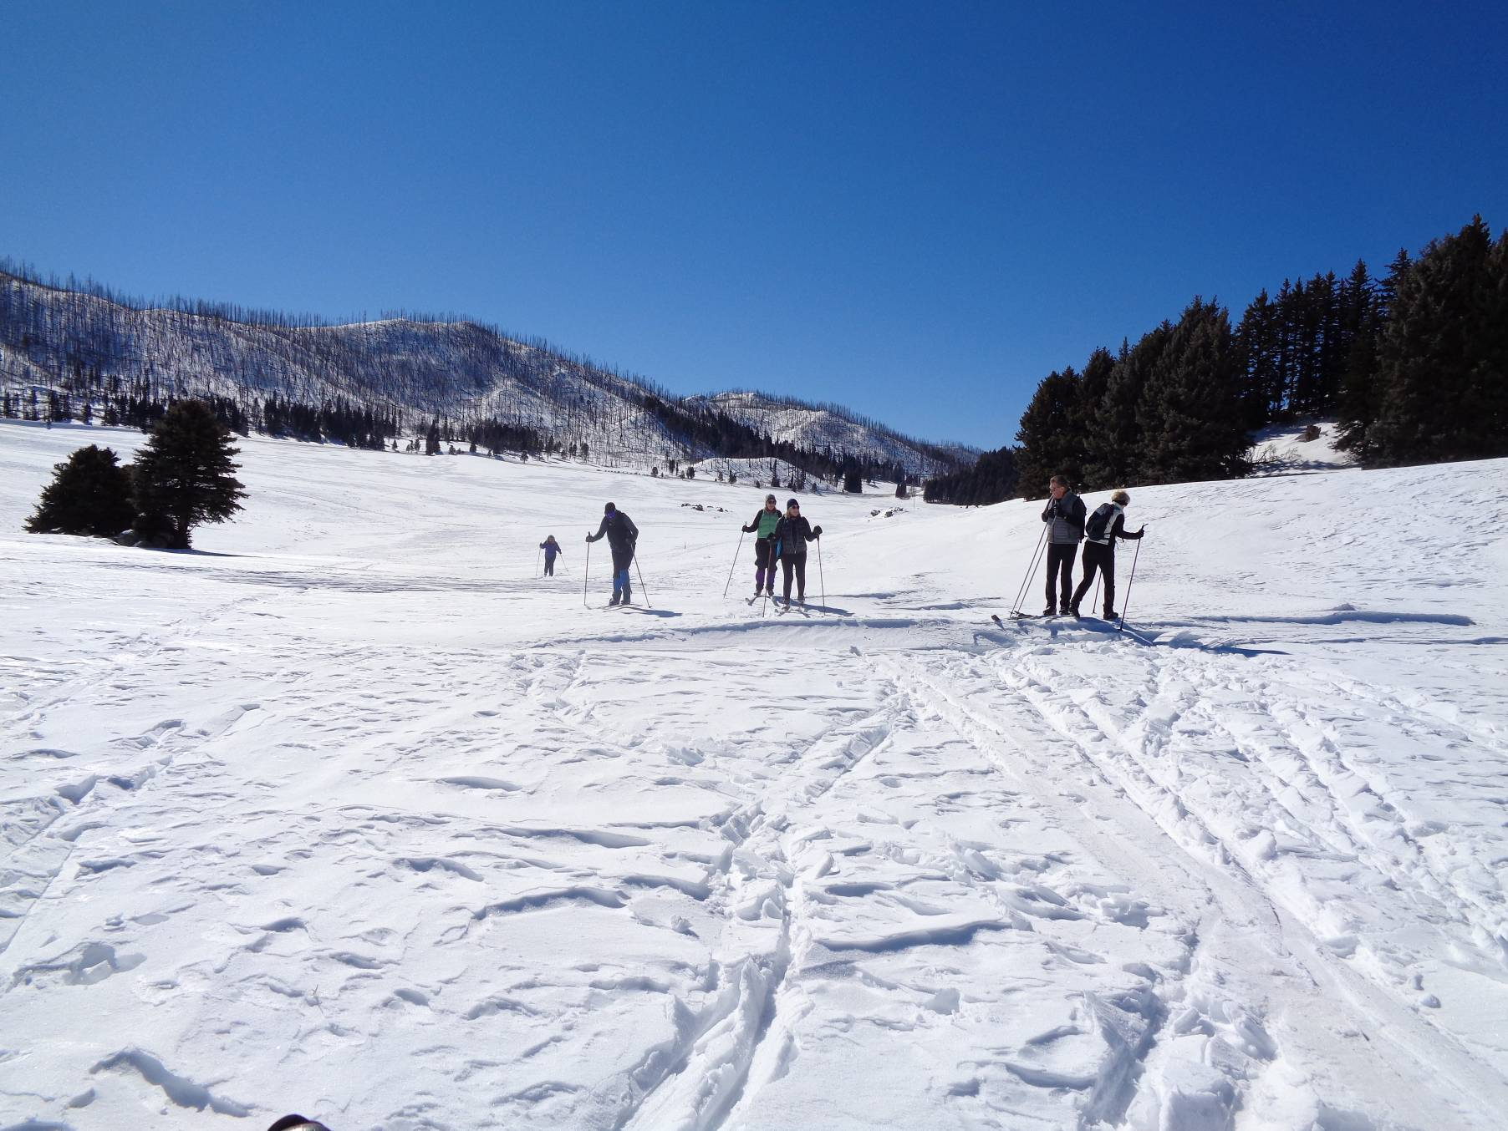
Skiers on the Missing Cabin Trail with the trailhead in the background. The cabin is visible to the north from this point.

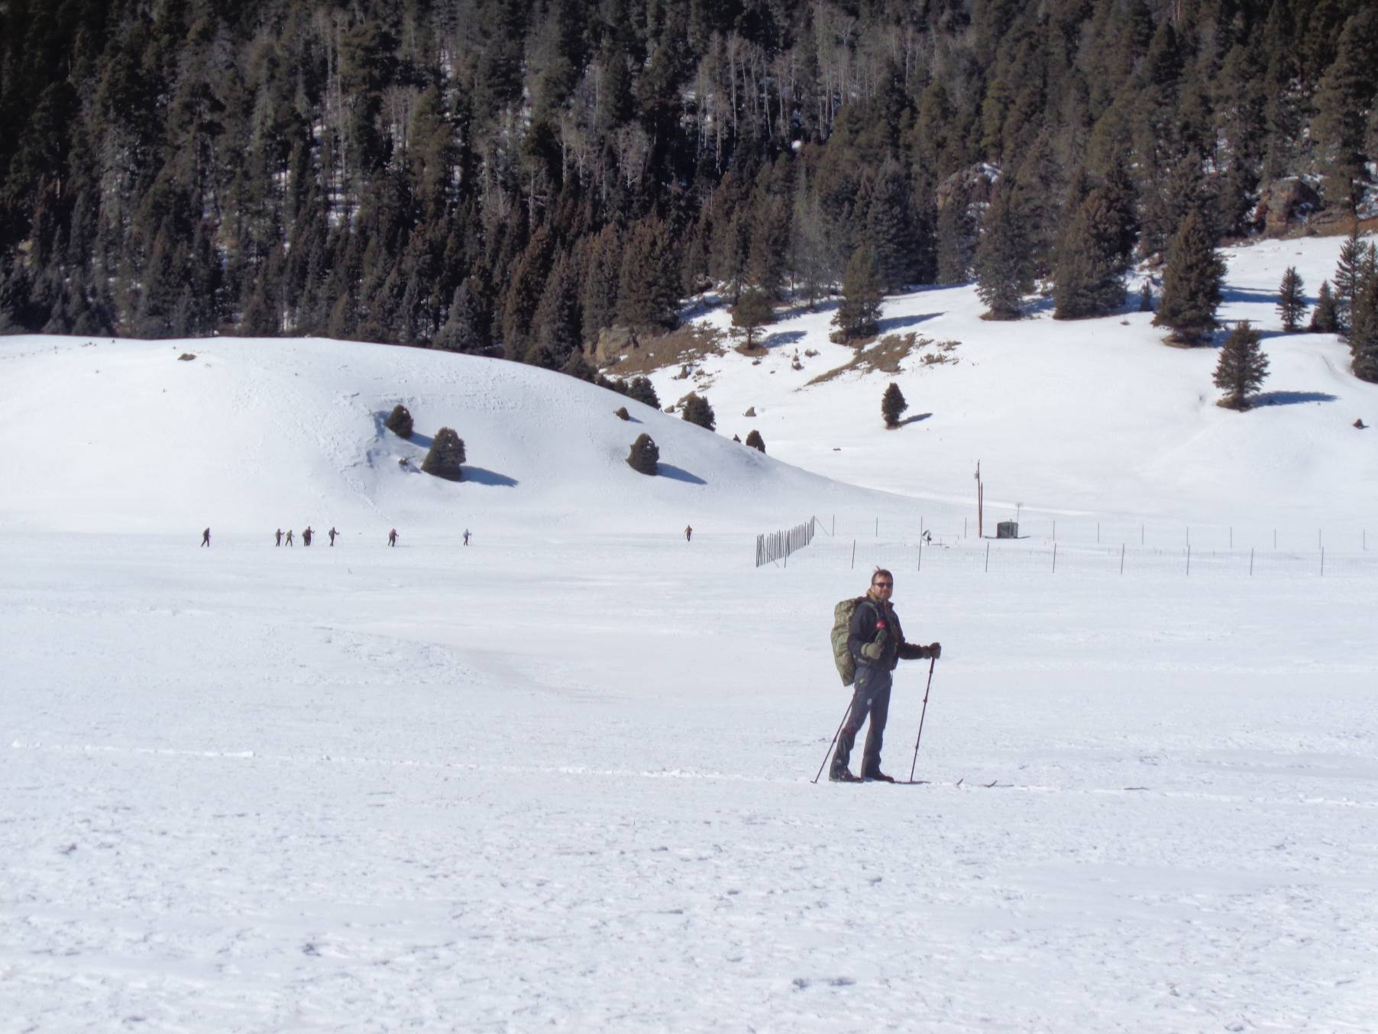
Michael Arndt on the trail from the cabin to Cerro La Jara. The cabin is behind the photographer. The Class II group is in the
background going around the exclusion fence.
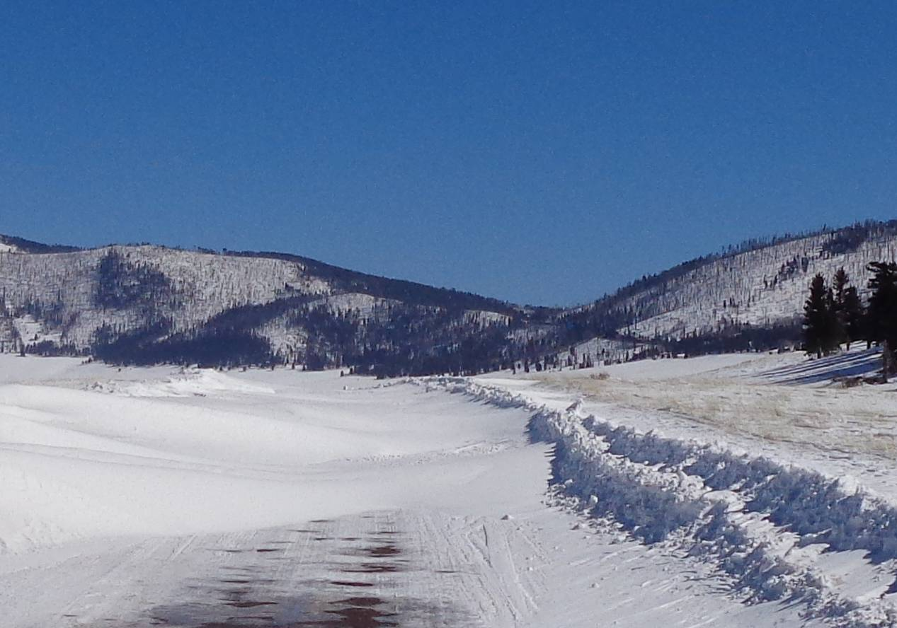
Snow drifts across the road between the check-in station and the cabin area. The trees on the right side of the photo are on the north side of
Cerro La Jara. The Class I group ate lunch here at noon.
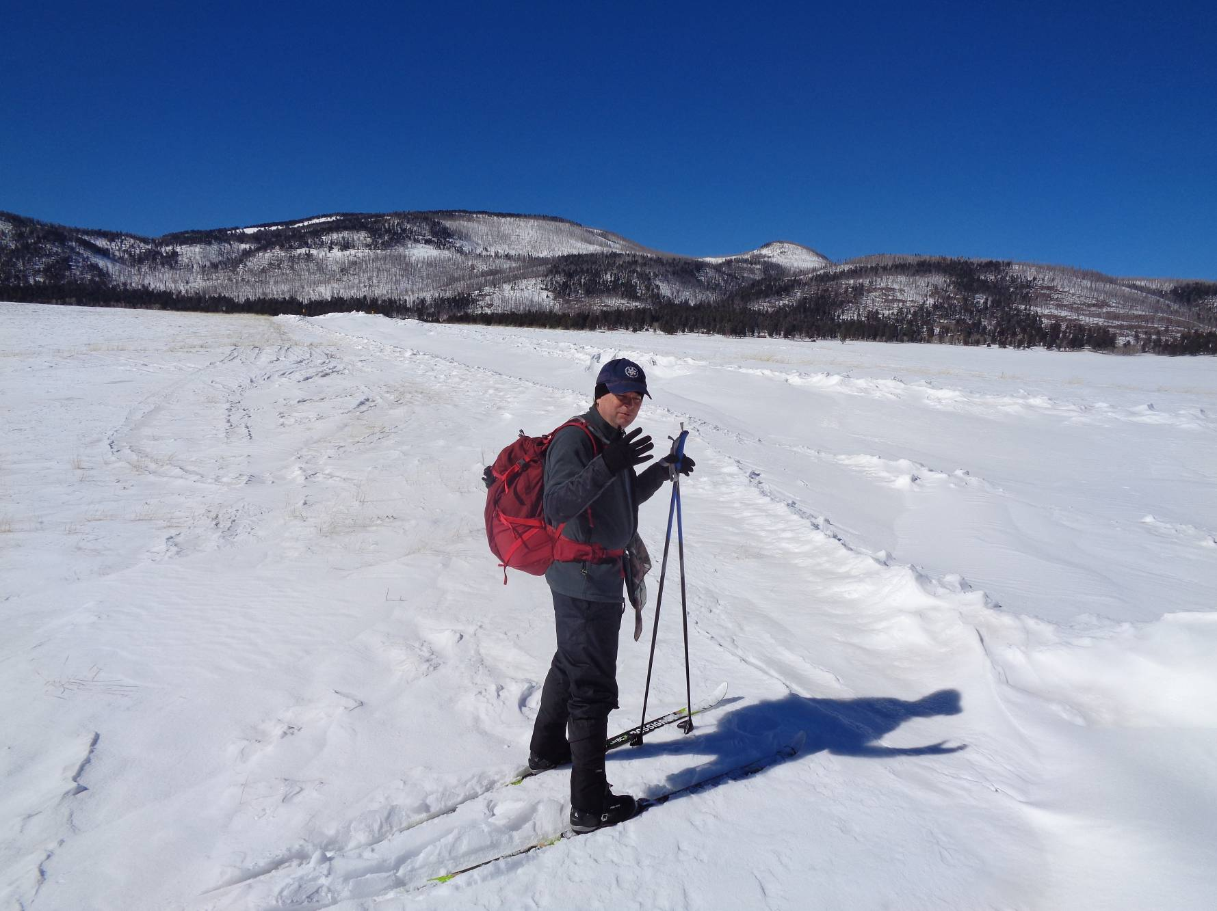
The formerly plowed road to the cabins is in front of Chris. It is filled with 2 to 3 feet of snow blown in by earlier strong winds.

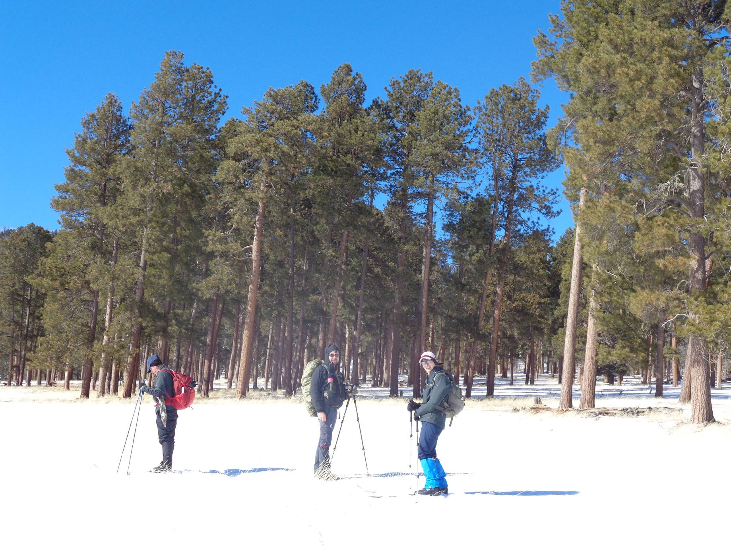
Chris, Michael, and Leslie at the southeast corner of the History Grove that is located 1.5 miles northwest of the check-in station.
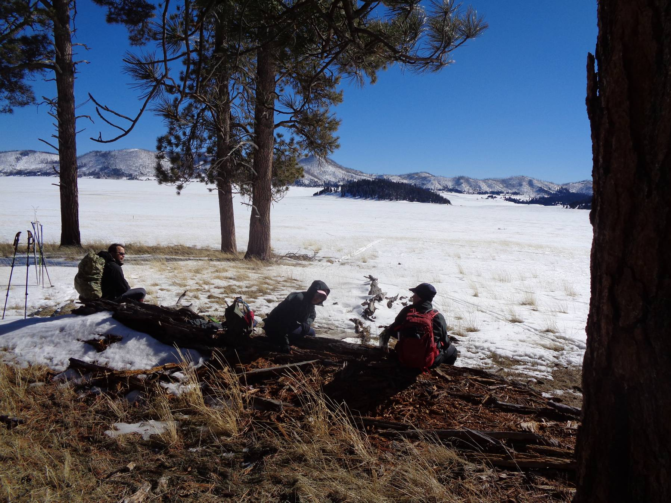
L to R: Michael, Leslie, and Chris eating lunch at the History Grove. Cerro La Jara is the small mountain covered with trees
in the center of the picture. The check-in station is to the left of the small mountain.
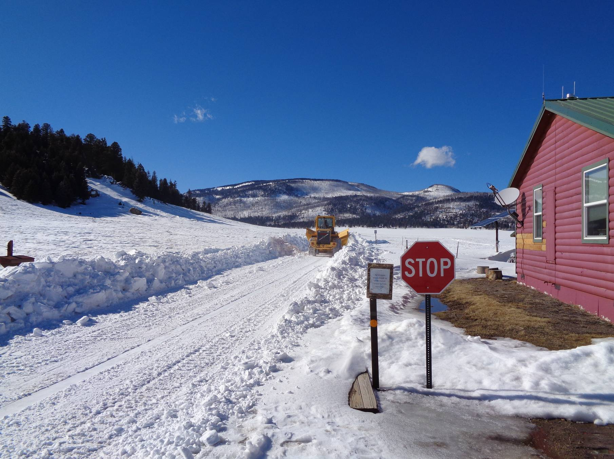
Large front loader with a V-snow plow blade plowing the road by the check-in station where visitors park.

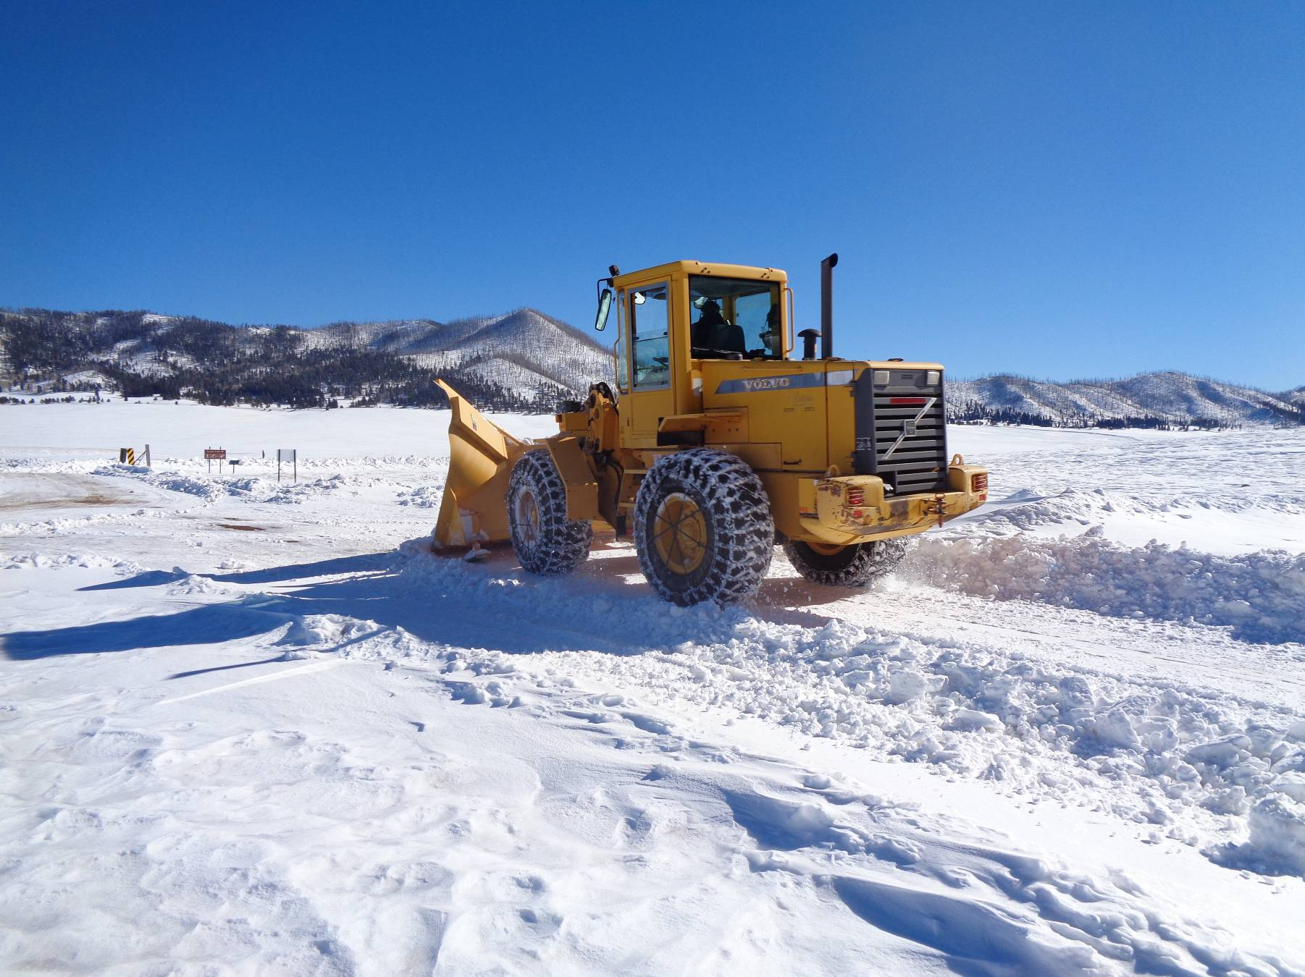
Front loader with a large V-blade and chains of the wheels.

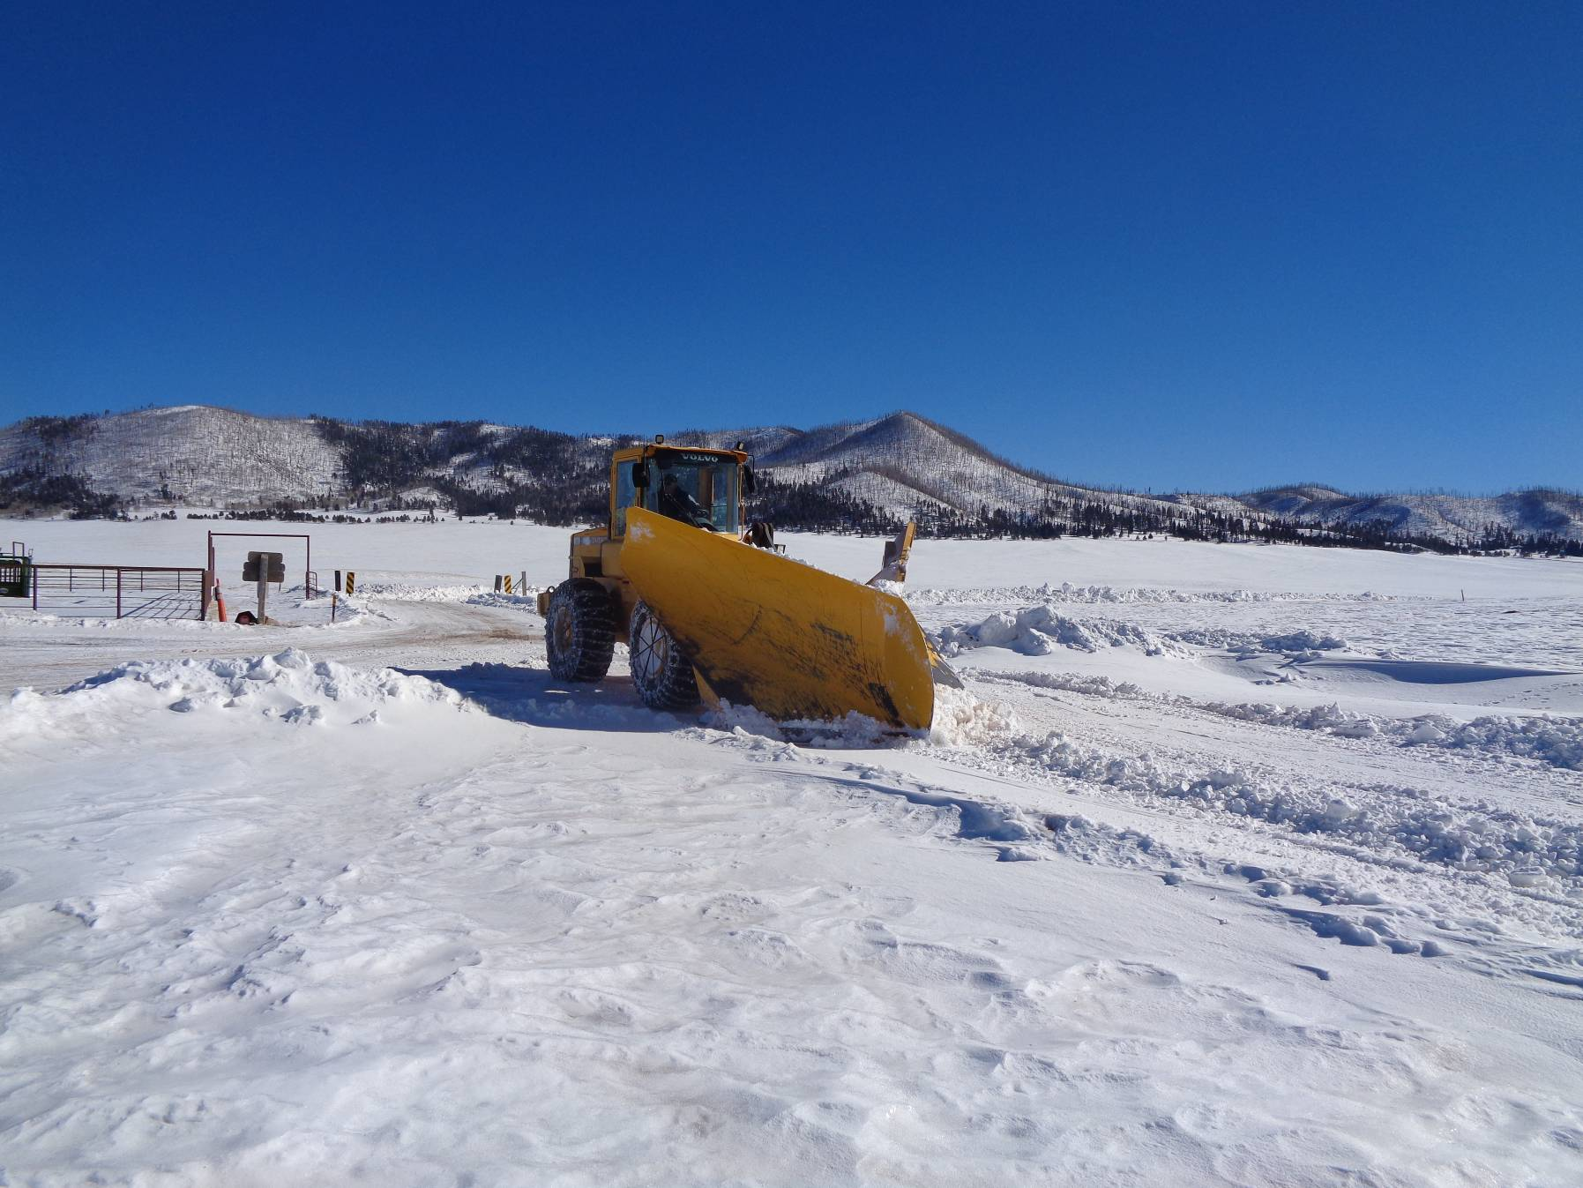
Front loader with V-snow plow blade starting another pass on the road to the cabins.

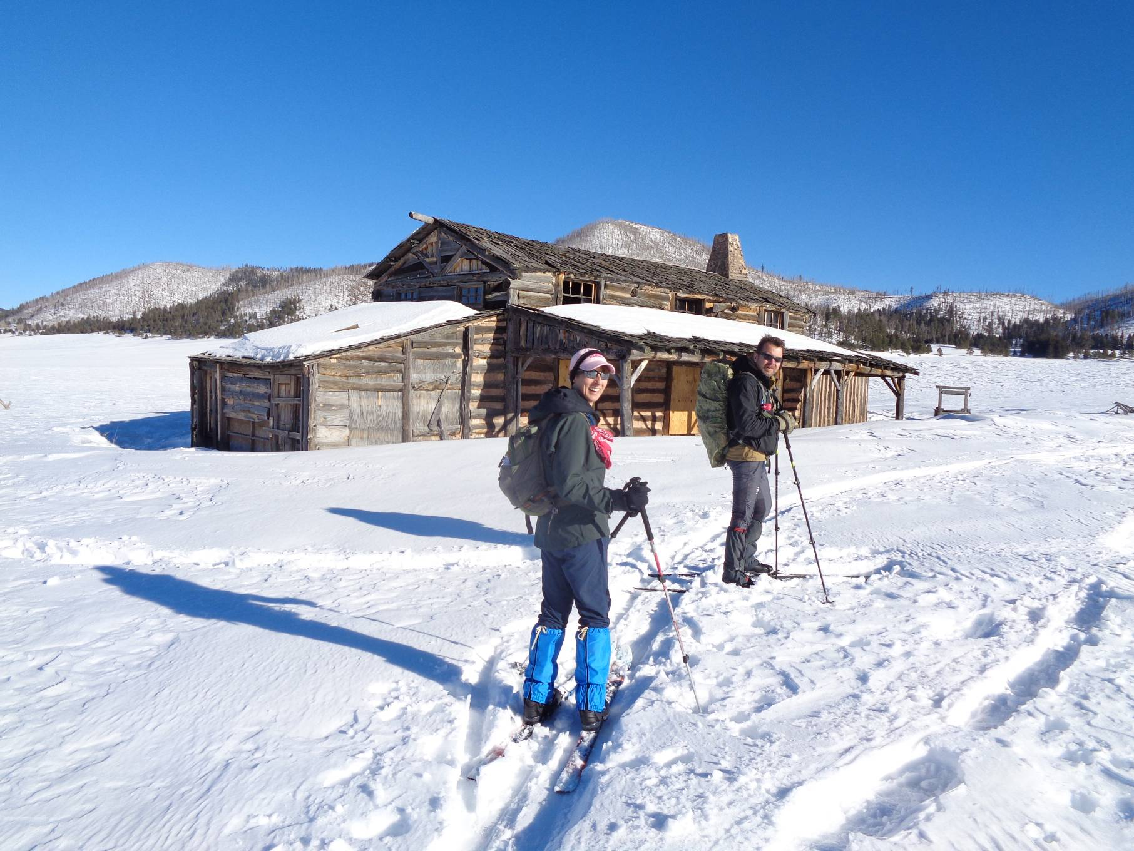
Leslie and Michael at the Missing Cabin that was built several decades ago as a movie set. It is in bad condition, and the
VCNP has nailed plywood over the first floor doors and windows so that visitors cannot enter the building.
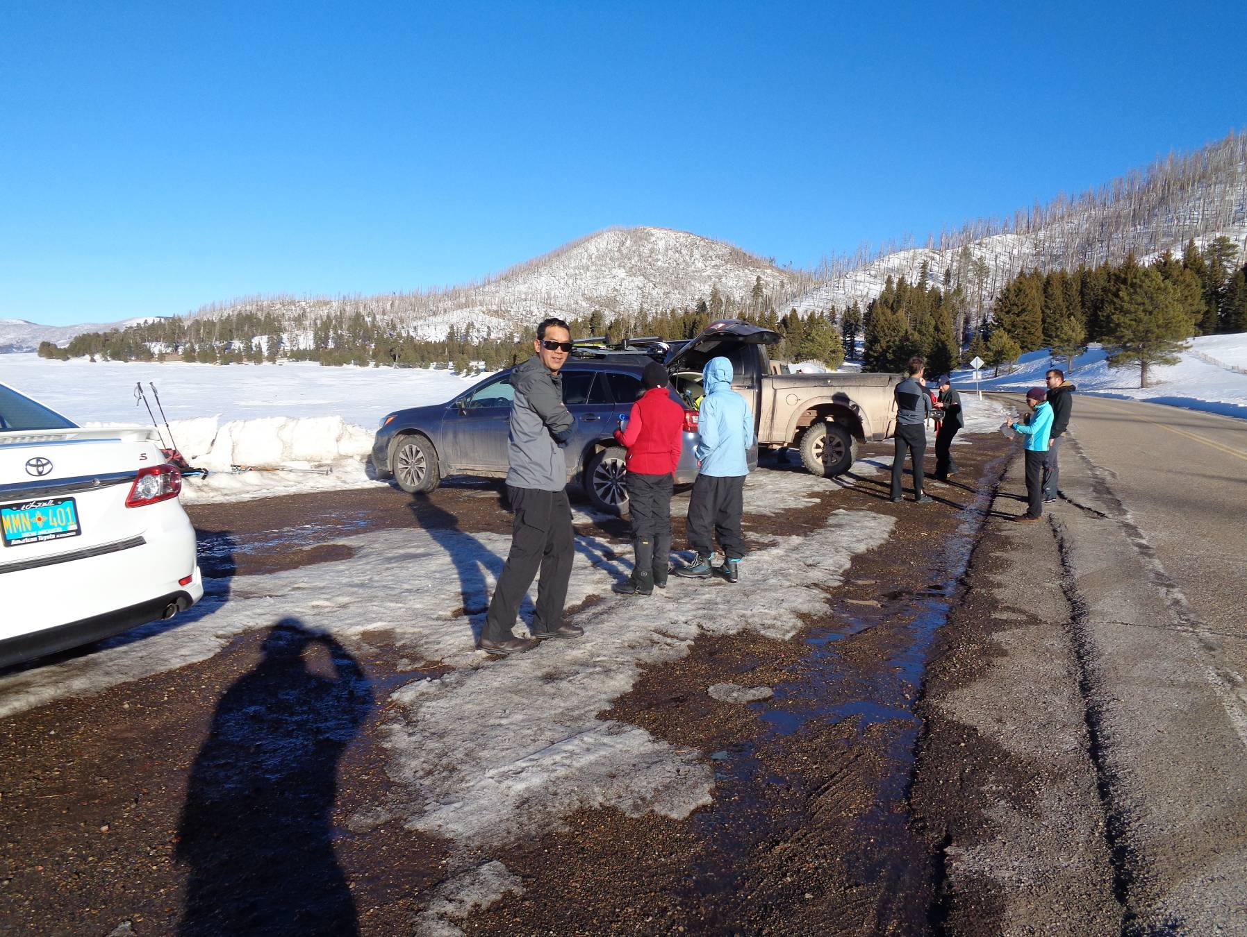
Back at the parking lot on NM-4 at about 4 pm. L to R: Tony Hsu, Phyllis Pryor, and Terri Elisberg

