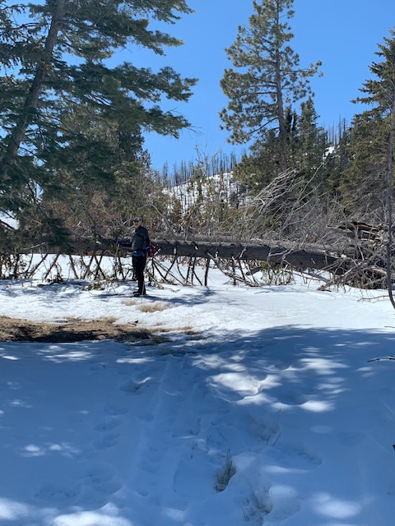
Jim Whitfield going around a large tree in the Rabbit Ridge-Scooter Peak
Saddle on his way to the lunch boulder. Photo by Michael Arndt
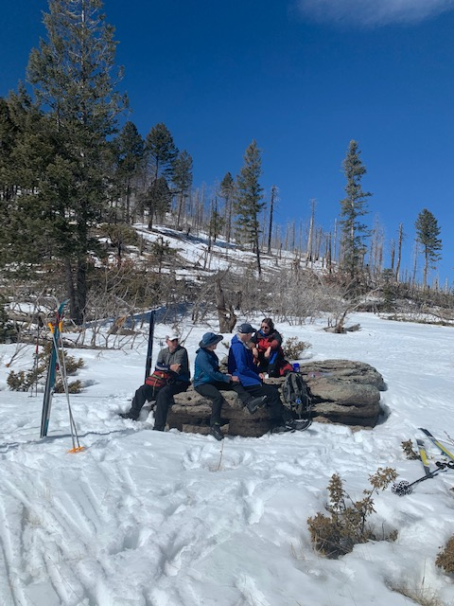
Lunch on a boulder in Rabbit Ridge – Scooter Peak Saddle. L to R: Jim Whitfield,
Frances Meier, Mike Meier, and Deborah Hollis. Photo by Michael Arndt
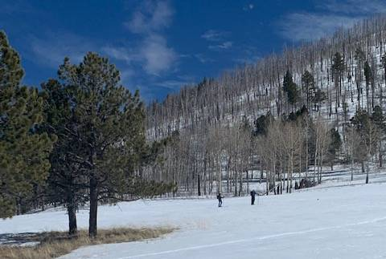
Sam Beard and Leslie LaBry carefully skiing slowly across the hard crust on the meadow on their way down to the trailhead.
Photo by Michael Arndt
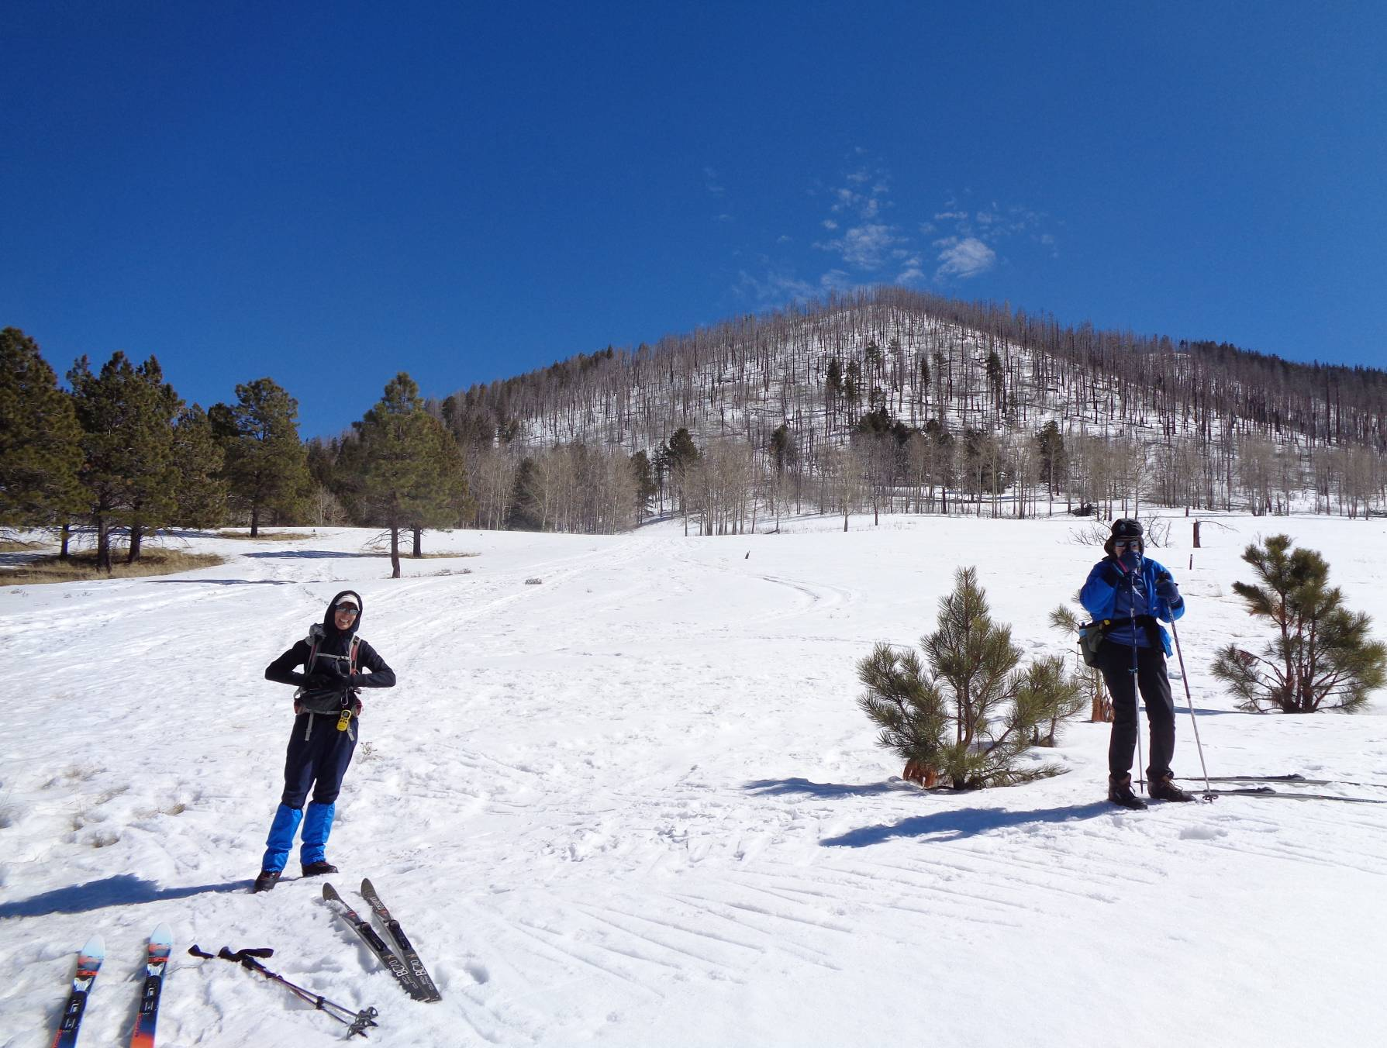
L to R: Leslie LaBry and Anne Hickman returning to the trailhead in the afternoon.
Photo by Sam Beard
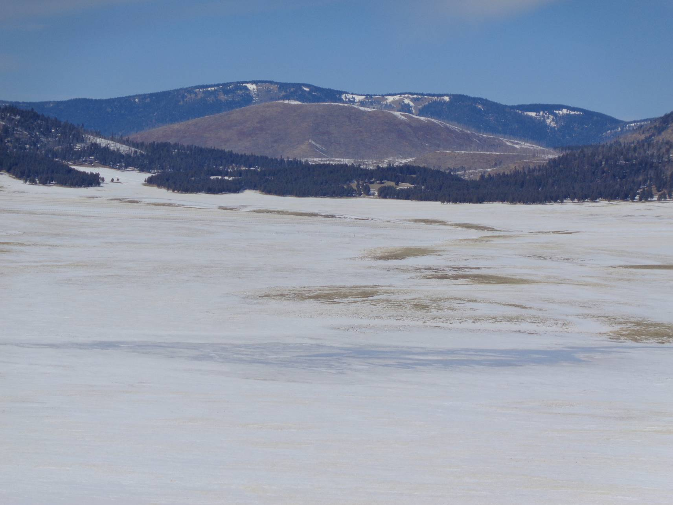
Looking north from Coyote Call Trailhead across Valle Grande. In the foreground, the fuzzy blue color
is East Fork River water over snow. Brown grass is showing on south-facing slopes where the snow has melted,
On the horizon is La Garita Peak on the north boundary of the Valles Caldera National Preserve. Photo by Sam Beard

