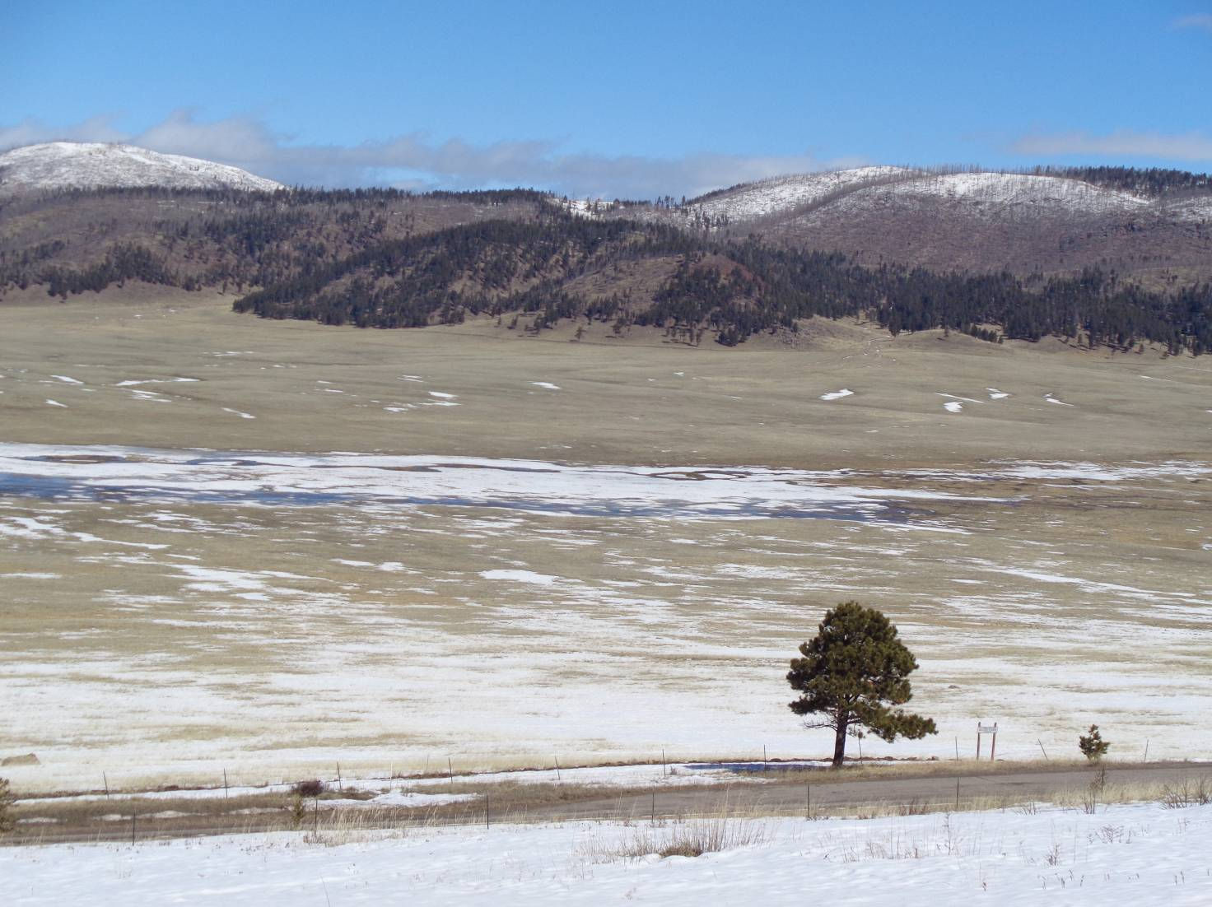
Water from melting snow spreading over the middle part of Valle Grande along the East Fork River.
All photos by Sam Beard unless noted otherwise

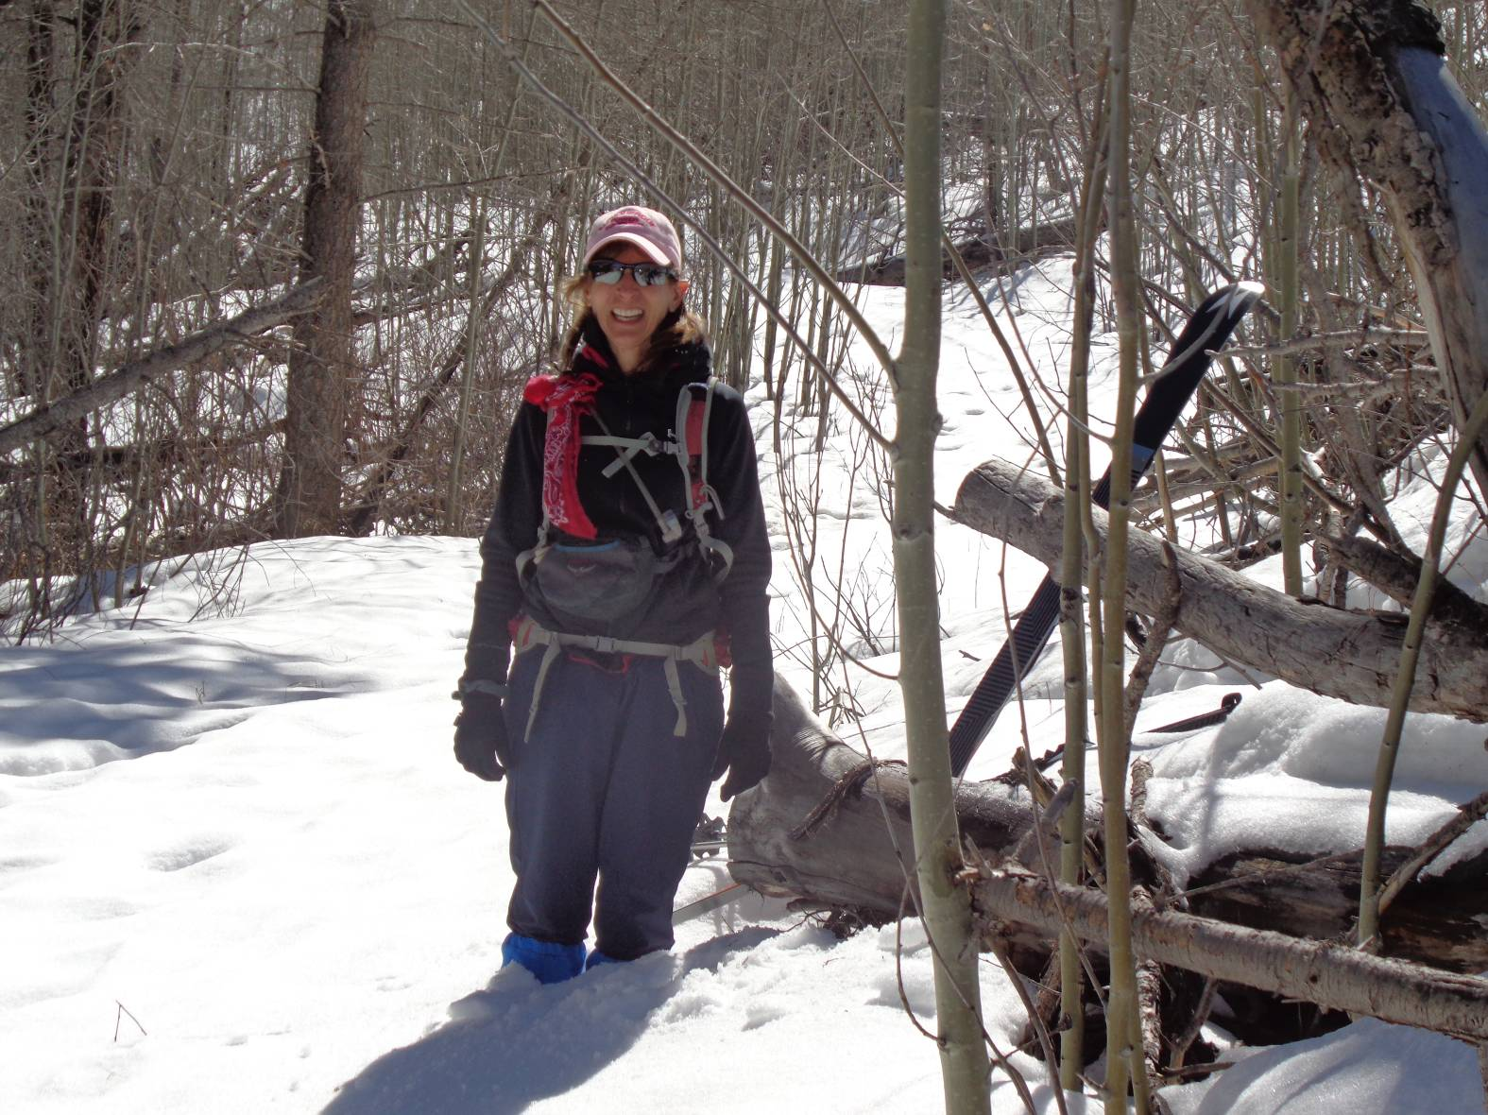
Leslie up to her knees in snow on the lower part of the steep east segment of Coyote Call Trail.
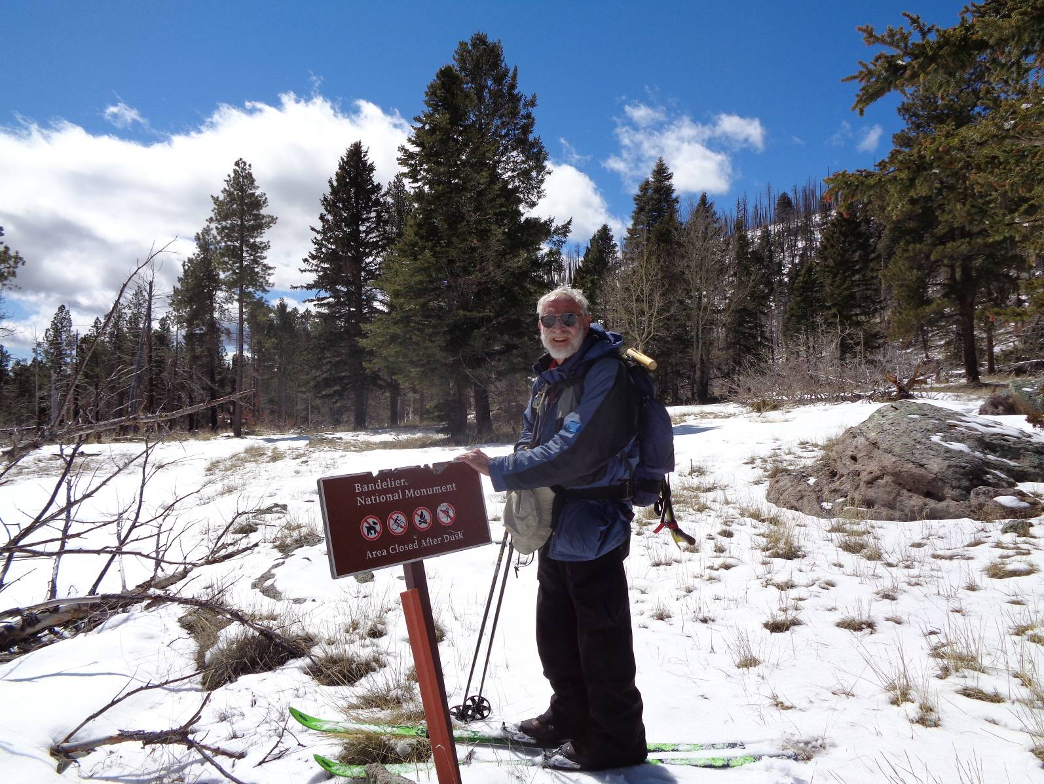
Sam at Bandolier National Monument boundary.
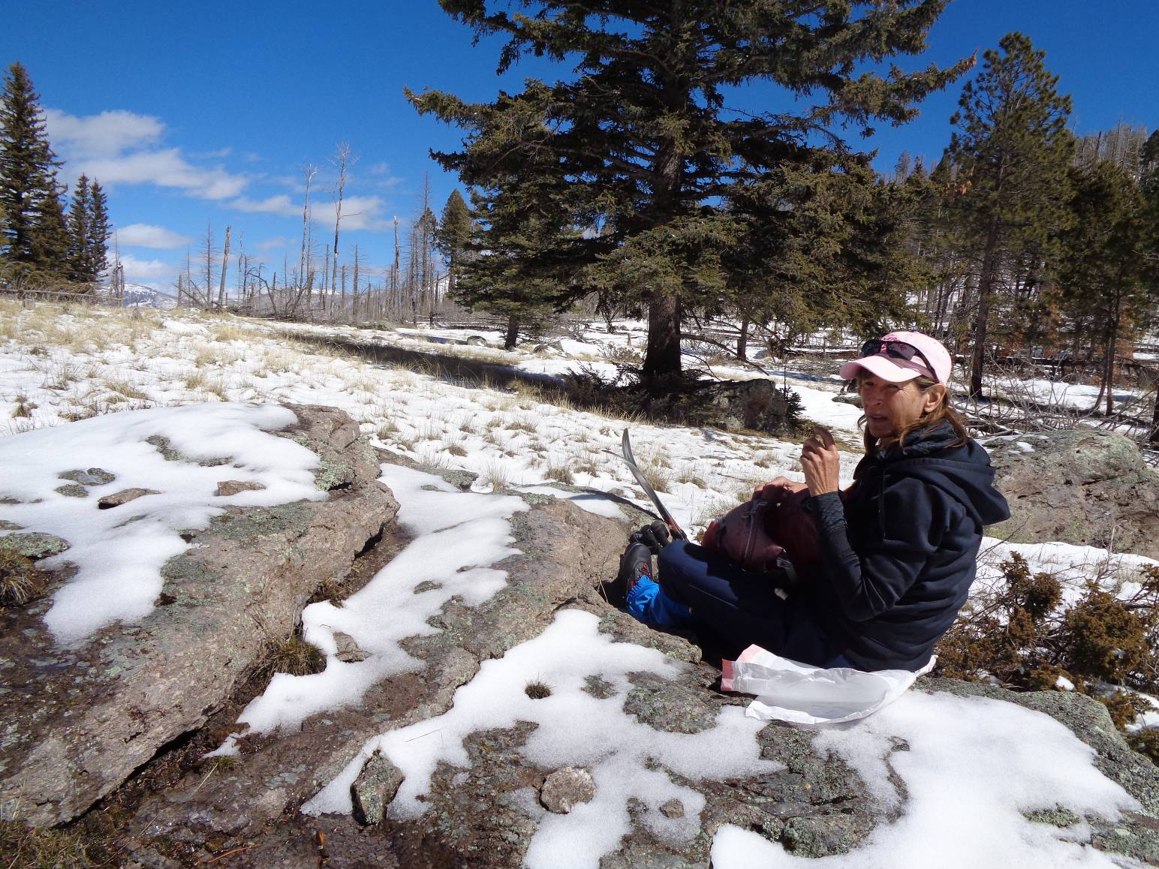
Leslie resting on “Lunch Boulder” in Rabbit Ridge-Scooter Peak Saddle
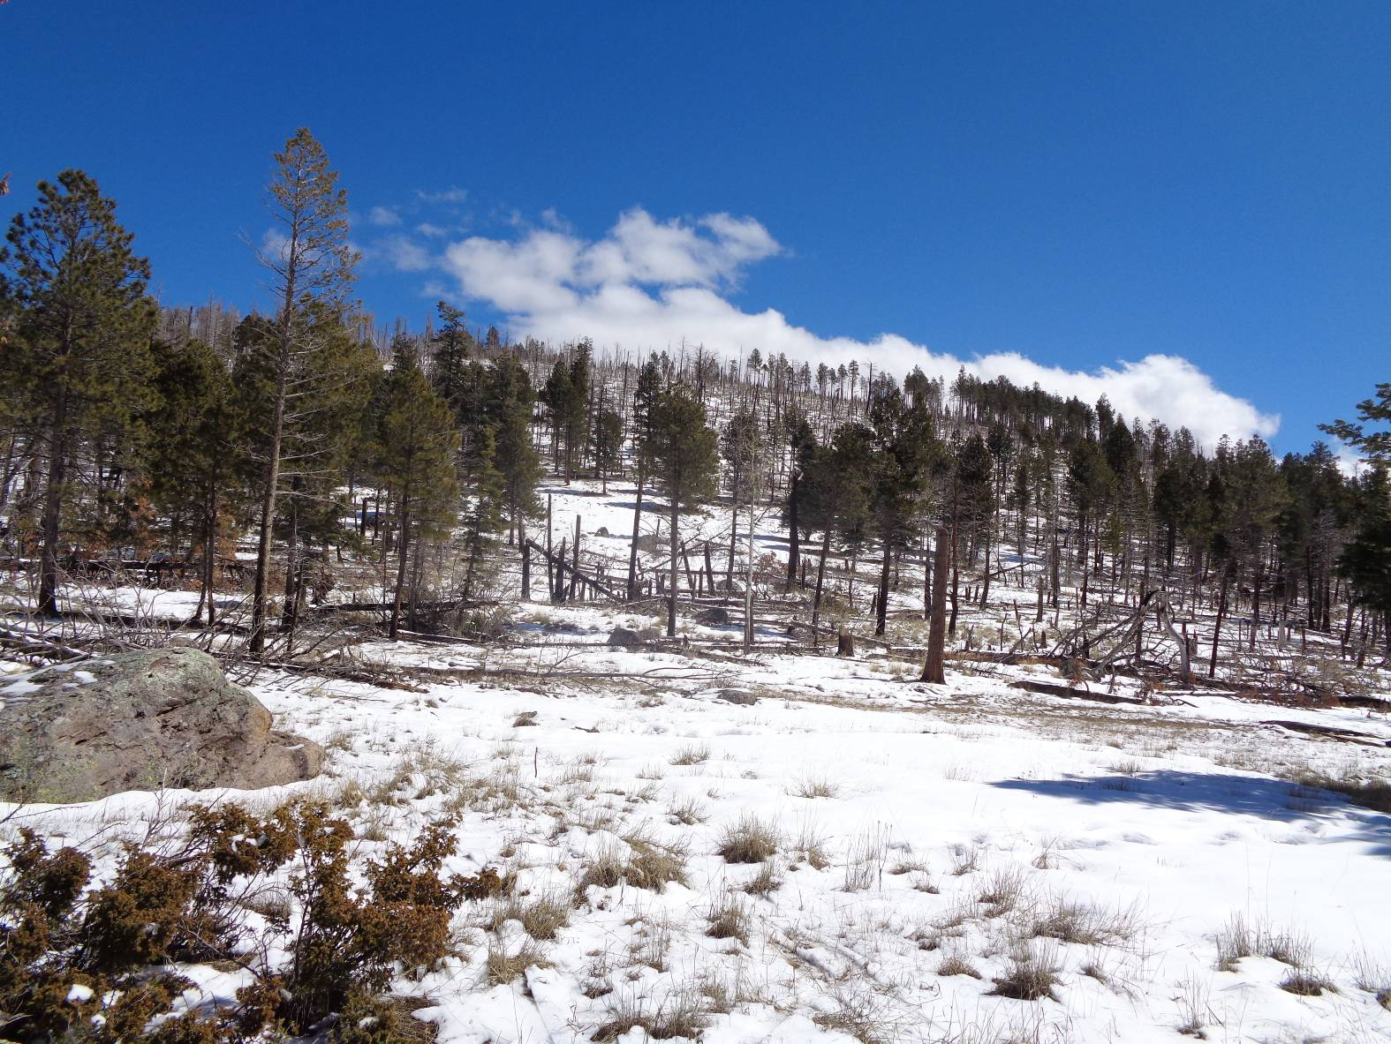
Scooter Peak east of saddle
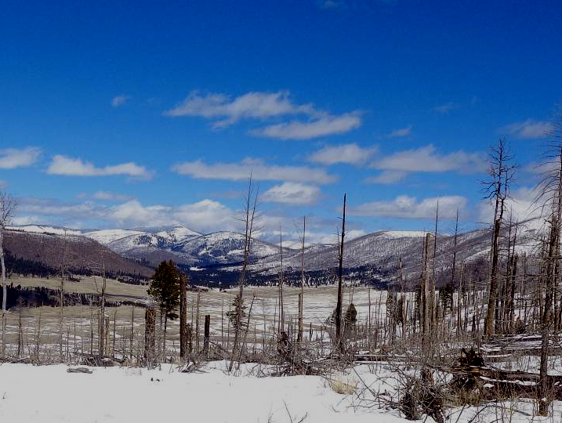
NE part of Valle Grande and NE corner of VCNP from Rabbit Ridge-Scooter Peak Saddle

