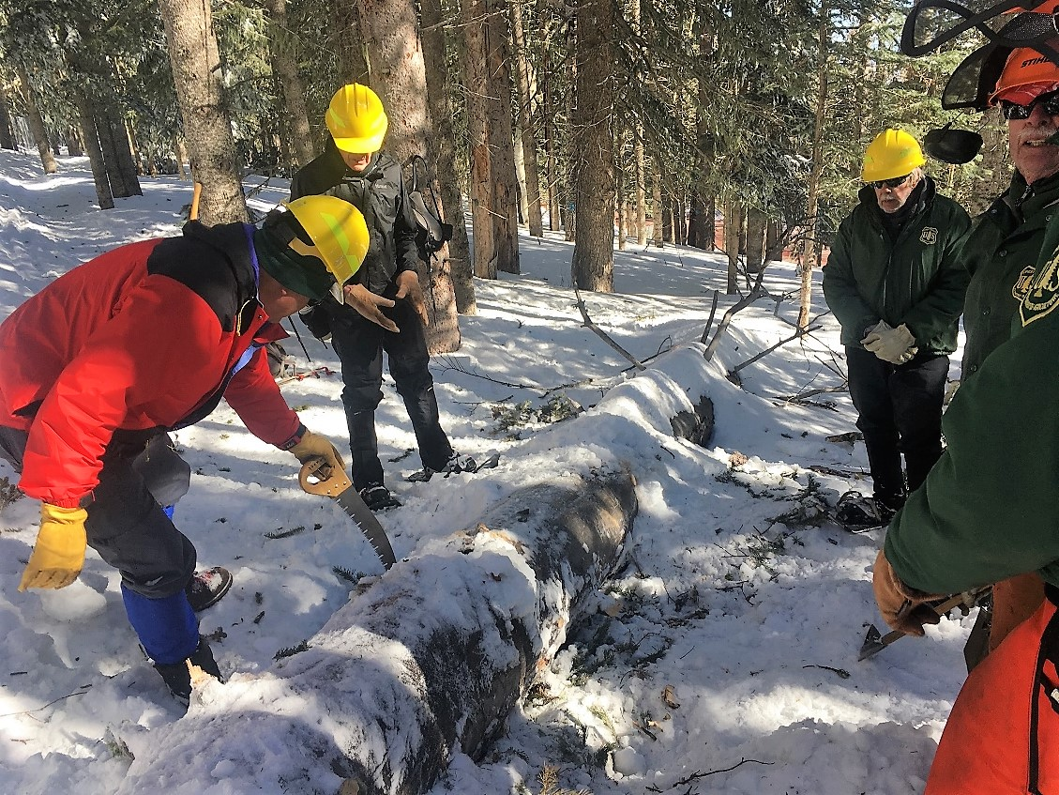

The crew sizes up the 23-inch diameter fallen fir on Crest Trail 130 North. It had fallen across and smashed flat a section of the chain link fence at the electronics site. Dave McCreery is cutting away protruding branches.

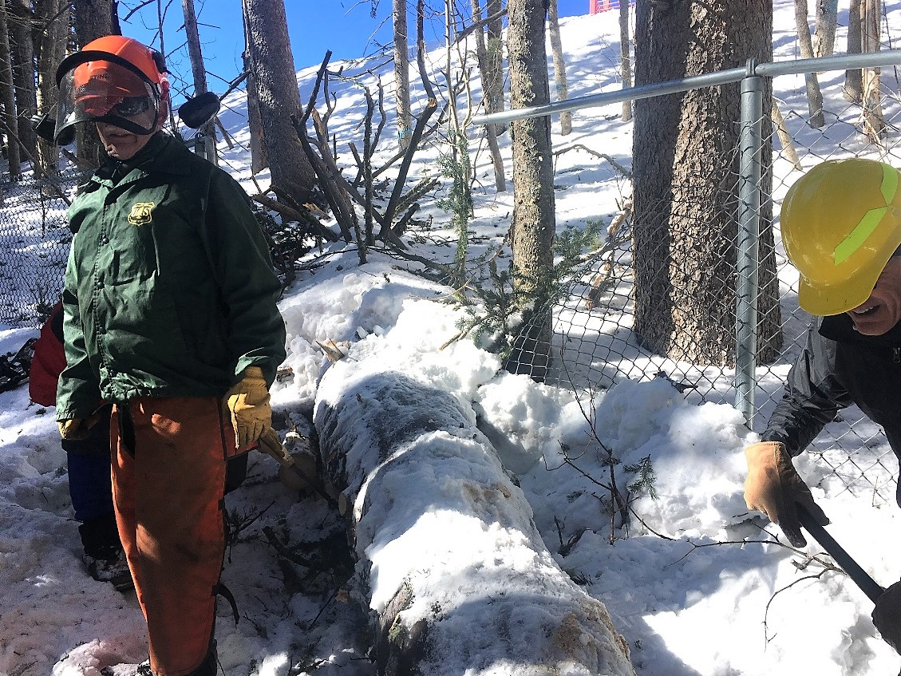

Photo looking uphill showing damage to the fence. The large tree had also taken down a smaller 6-inch diameter tree with it. A lot of snow had to be dug away to provide access for the needed cuts (two cuts on the smaller tree, three on the larger one). A chainsaw was used for this work.

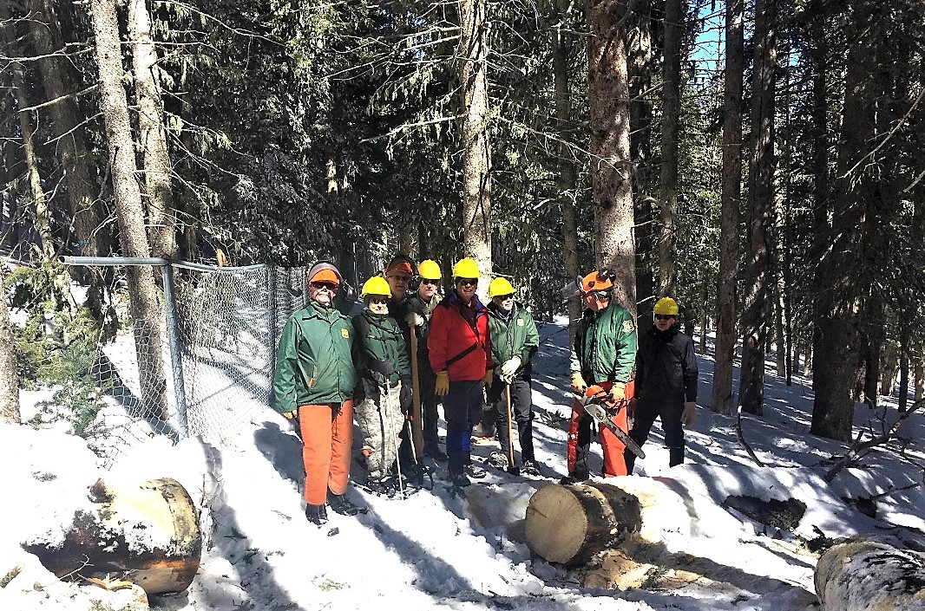

The crew following removal of the Crest Trail 130 trees. (Left to right – Jim Levesque, Rav Nicholson, Jerry Pekarek, Ken Nicholson, Dave McCreery, Byron Garner, Bob Lowder and Sim Cook)

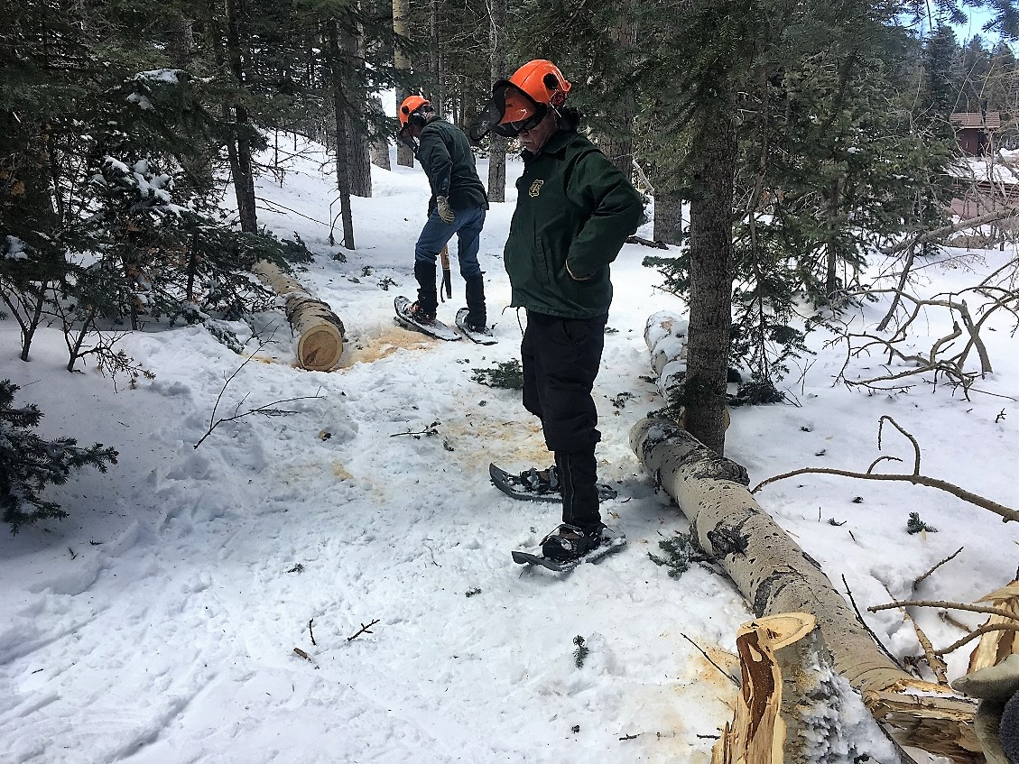

After the work at Crest Trail 130, the crew traveled down to 10K South to remove a tree that had been previously reported down at the junction of 10K and the first ski run. The crew quickly noted that since that initial report that the recent wind storm had done some work in knocking down a lot of trees. This aspen top was located near the parking lot. The top had broken off a tall aspen located uphill to the left of the photo and was buried in deep snow with the lower 12-foot portion sticking up at a 45-degree angle supported by the branches of the tree behind Jim and suspended across the trail. It was cut at the buried end and fell off the supporting branches, then cut again to clear the trail.

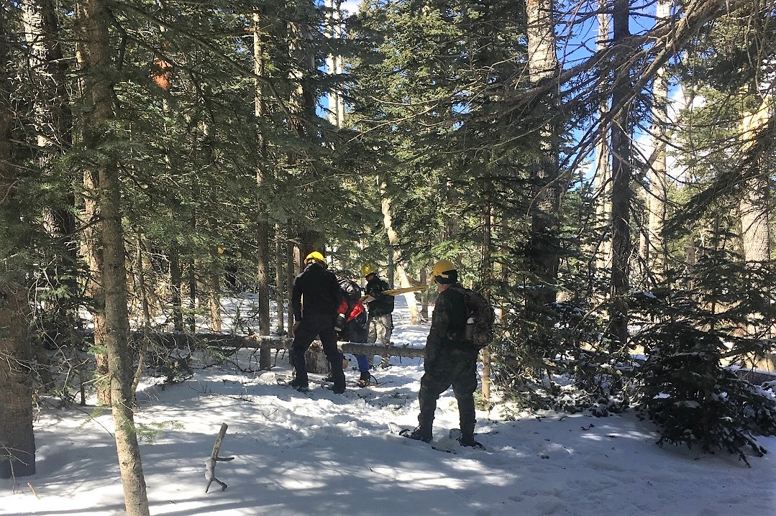

This 4-inch diameter fallen tree, located just 100 feet or so beyond the fallen aspen, was removed. Just beyond this was a large patch of tangled and broken green tree branches and 4-inch diameter tree top which had blocked the trail. This was also removed with a pruning saw.

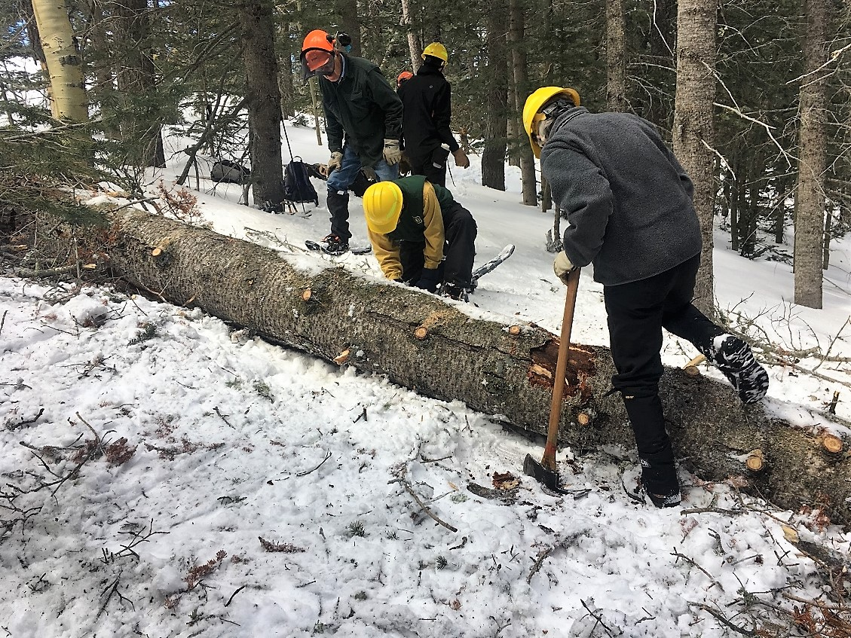

A couple of hundred feet or so down the trail this fallen 18-inch diameter fir was completely blocking the trail. It was full of branches and required a long detour to get around it. After the removal of a large number of both attached and broken off branches, the tree was removed using a crosscut saw. Bob is using a small shovel to dig out snow at one of the cut locations while Byron removes bark from the trunk at the site of the second cut.

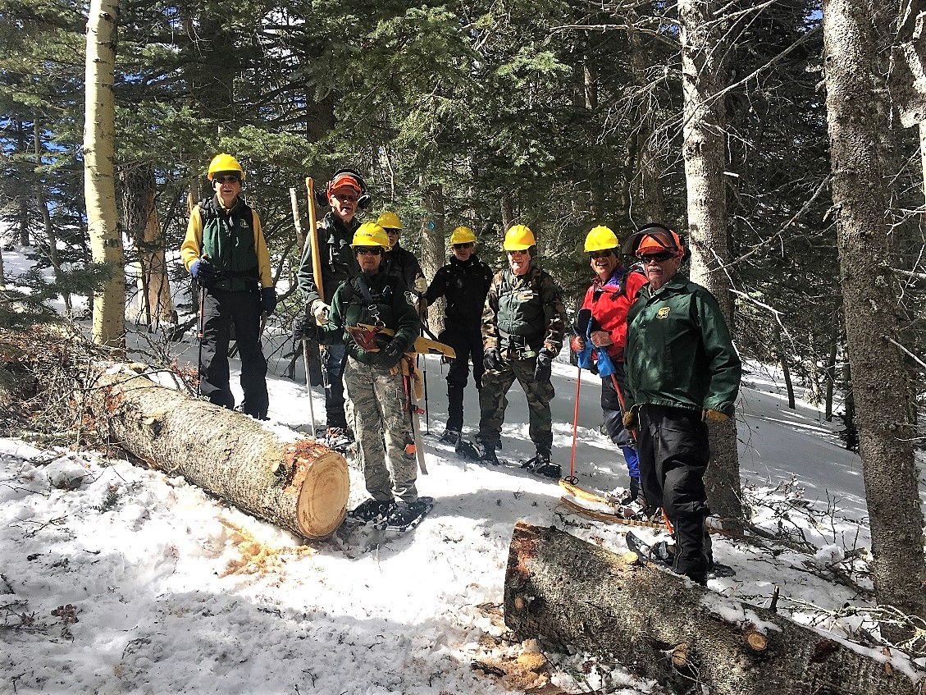

The trail has been reopened.

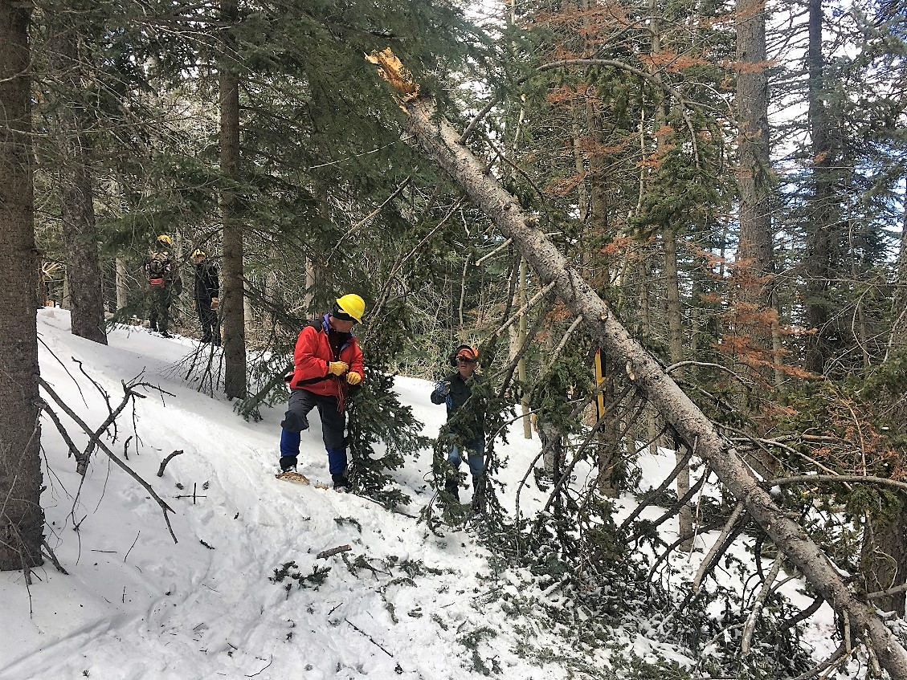

Just downhill from the tree in the previous photo, this 12-inch diameter tree top had broken off and firmly planted itself in the deep snow suspended over the trail. It was so tightly frozen that attempts to pull it down with a rope were not successful. It was late in the day, so rather than spending any more time trying to get it on the ground, enough branches were cut away to allow safe passage for users. The tree will be removed later.