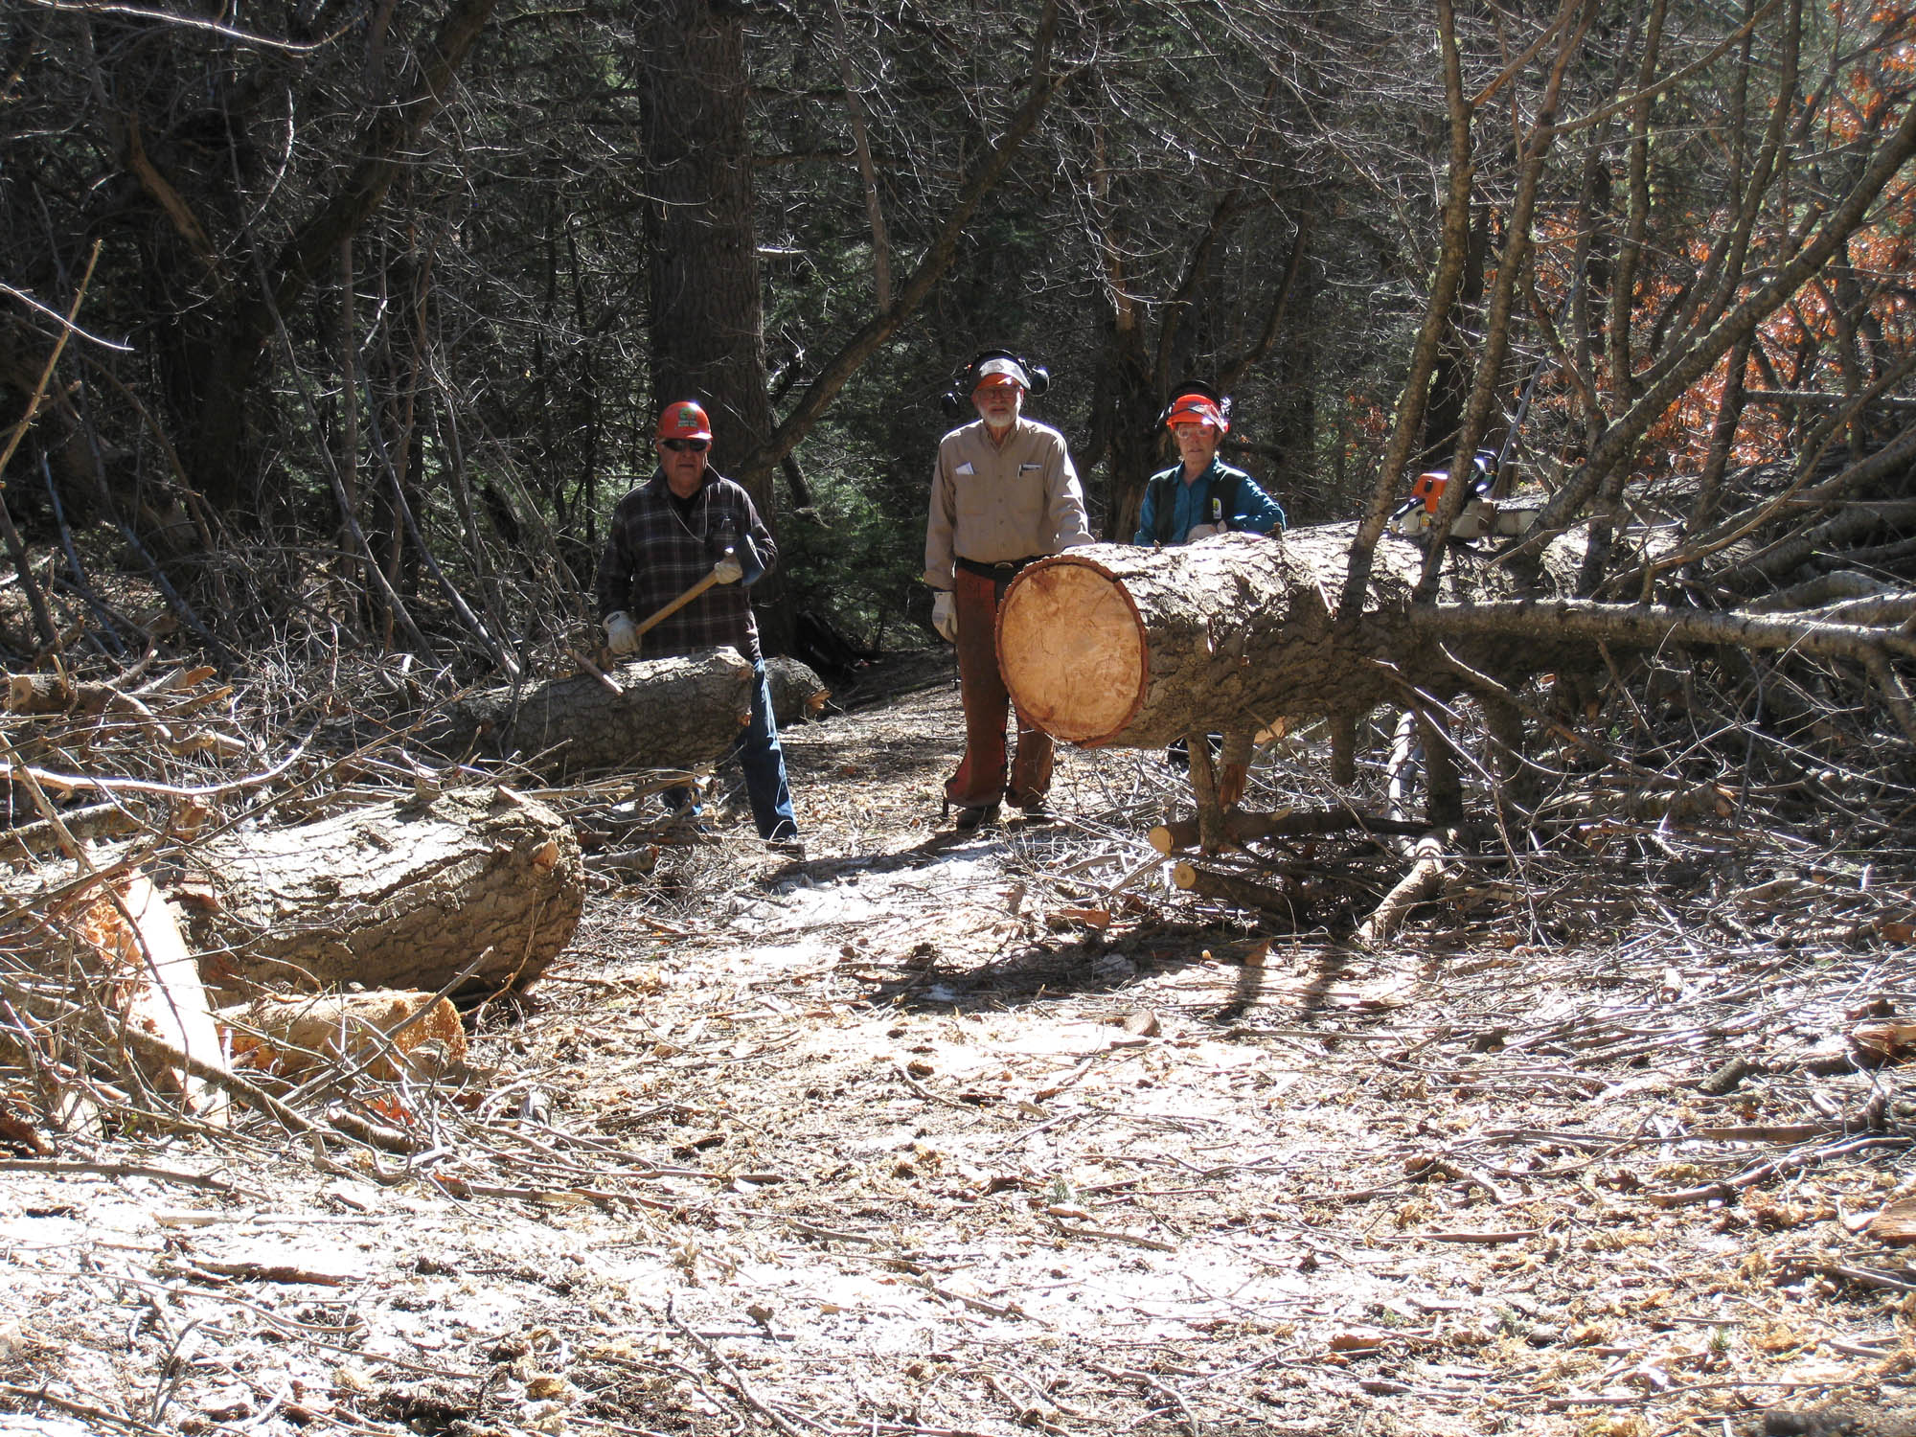
Train wreck on Bill Spring Trail where two large trees and one small tree were removed.
L to R: Lou Romero, Sam Beard, and Bet Gendron.
Photo by Carl Smith

