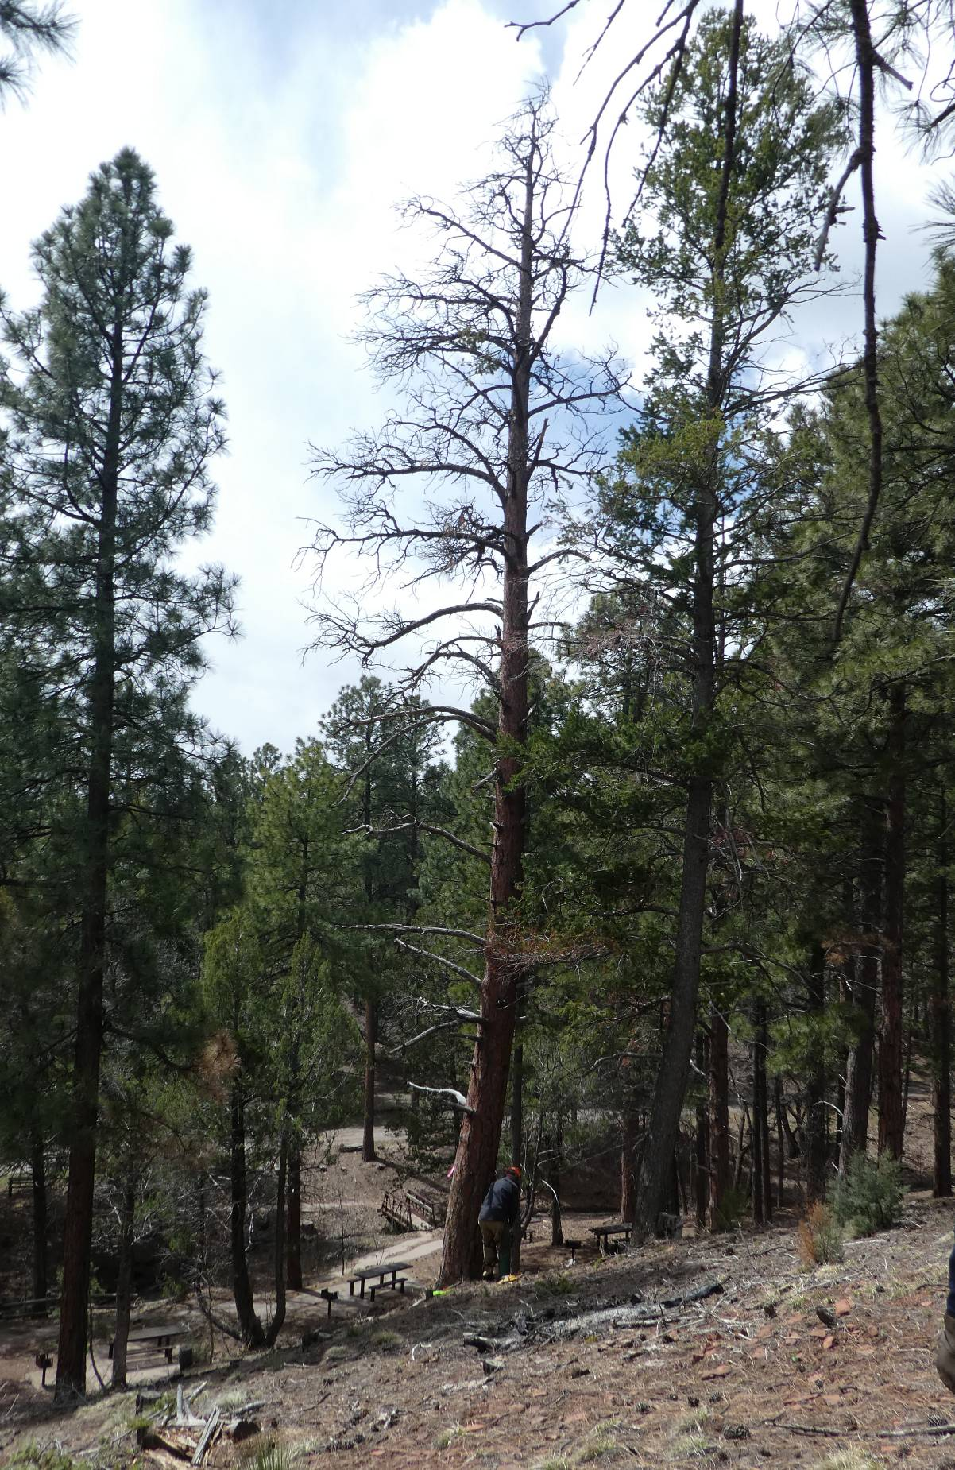
Dan at the base of the tall 23-inch ponderosa pine hazard tree in Cienega PA.
All photos by Sam Beard

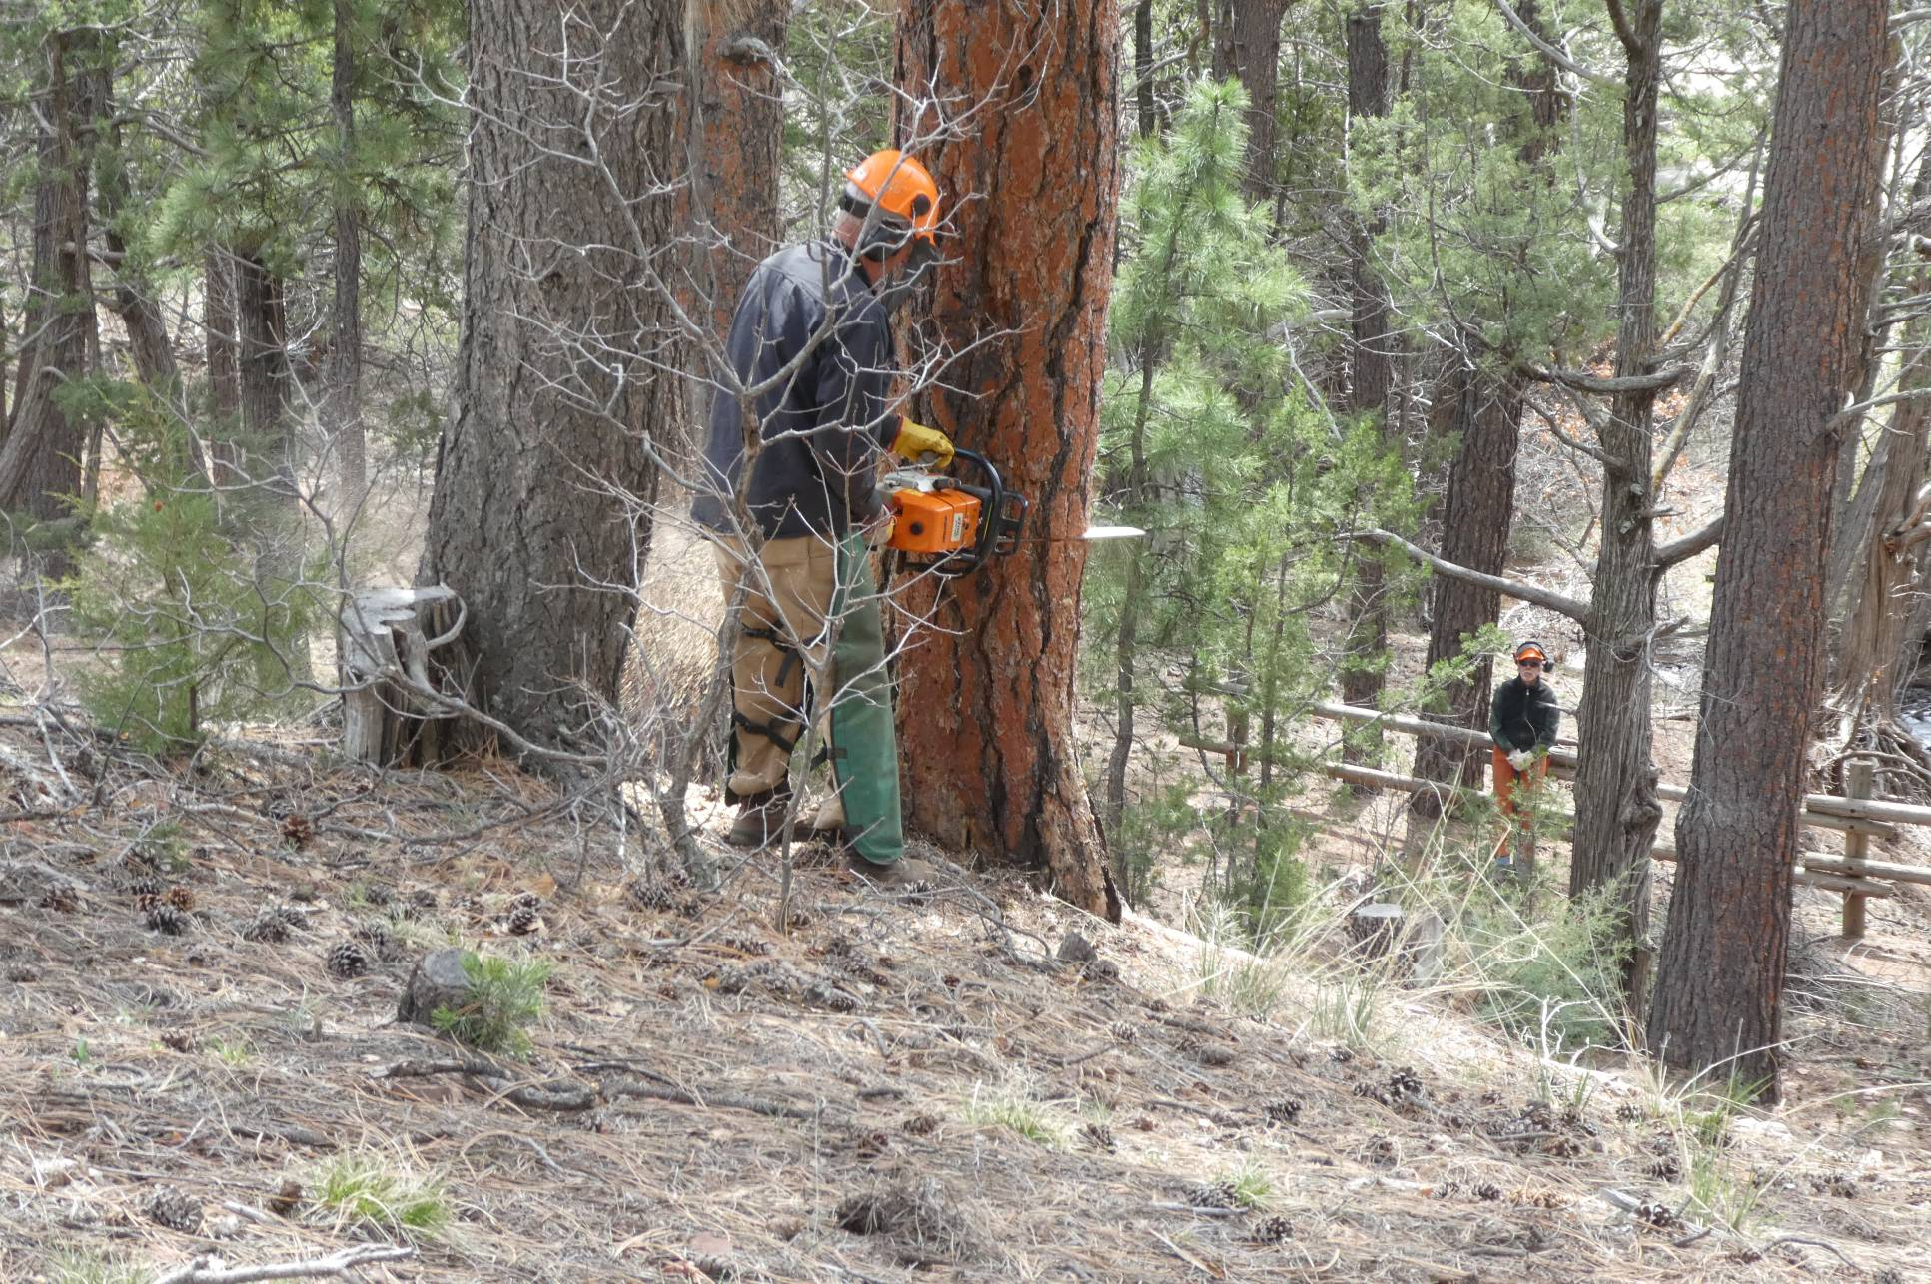
Dan beginning the face cut on the large pine

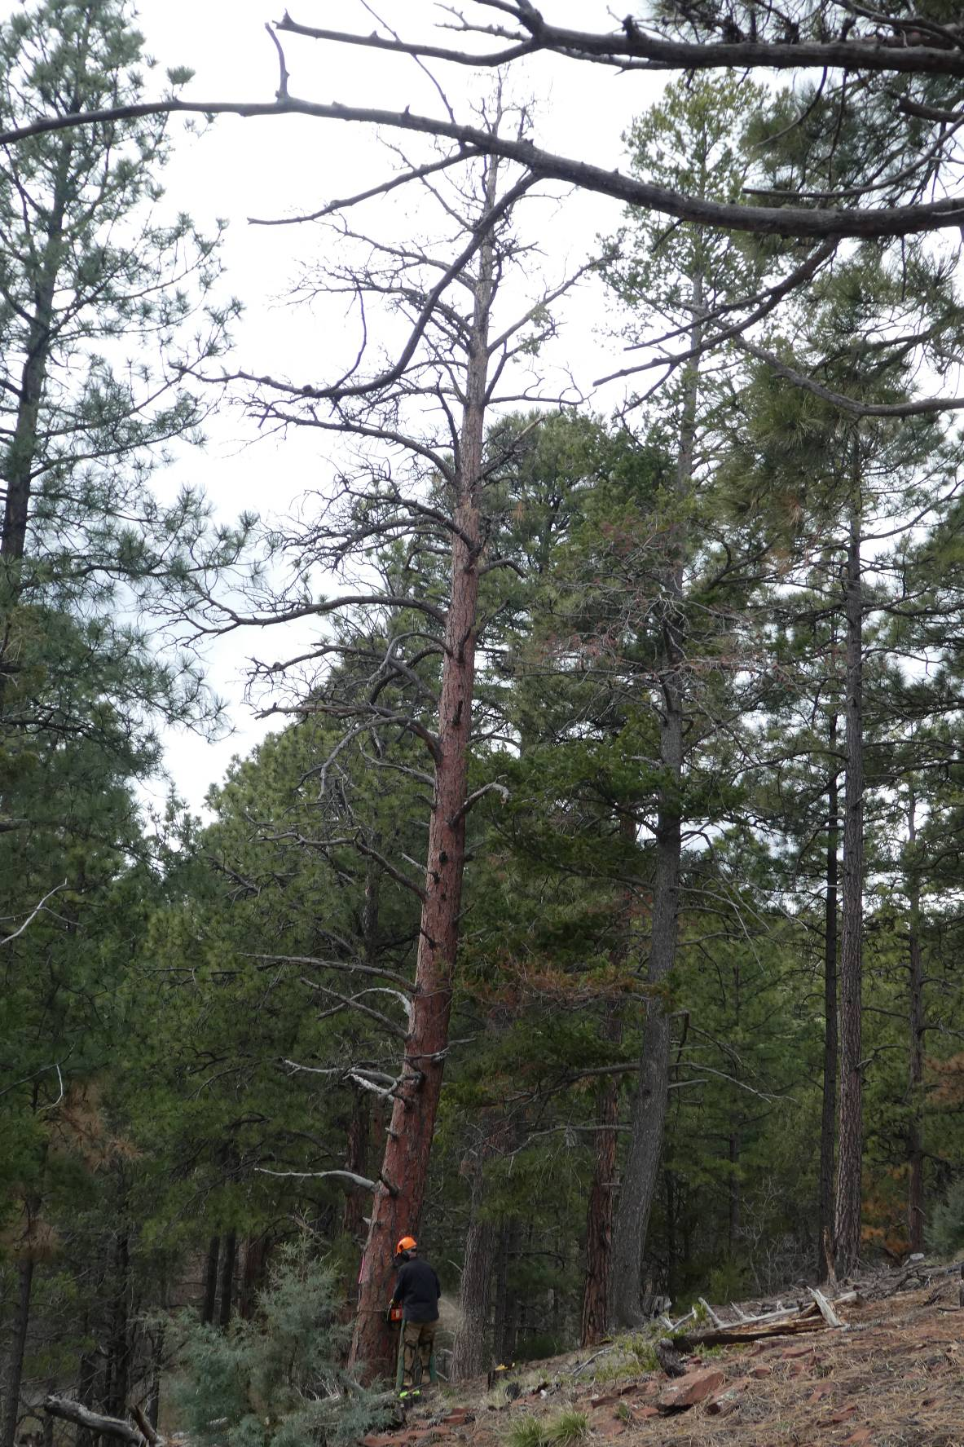
Making the back cut.
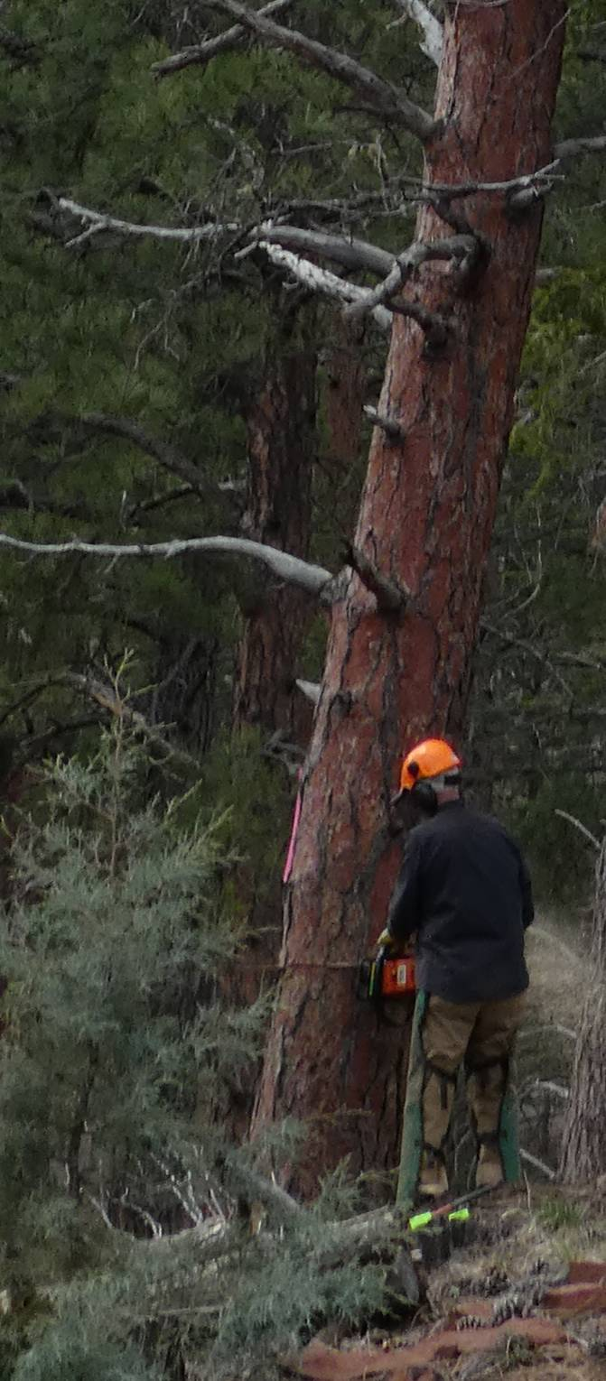
Close-up of the back cut.

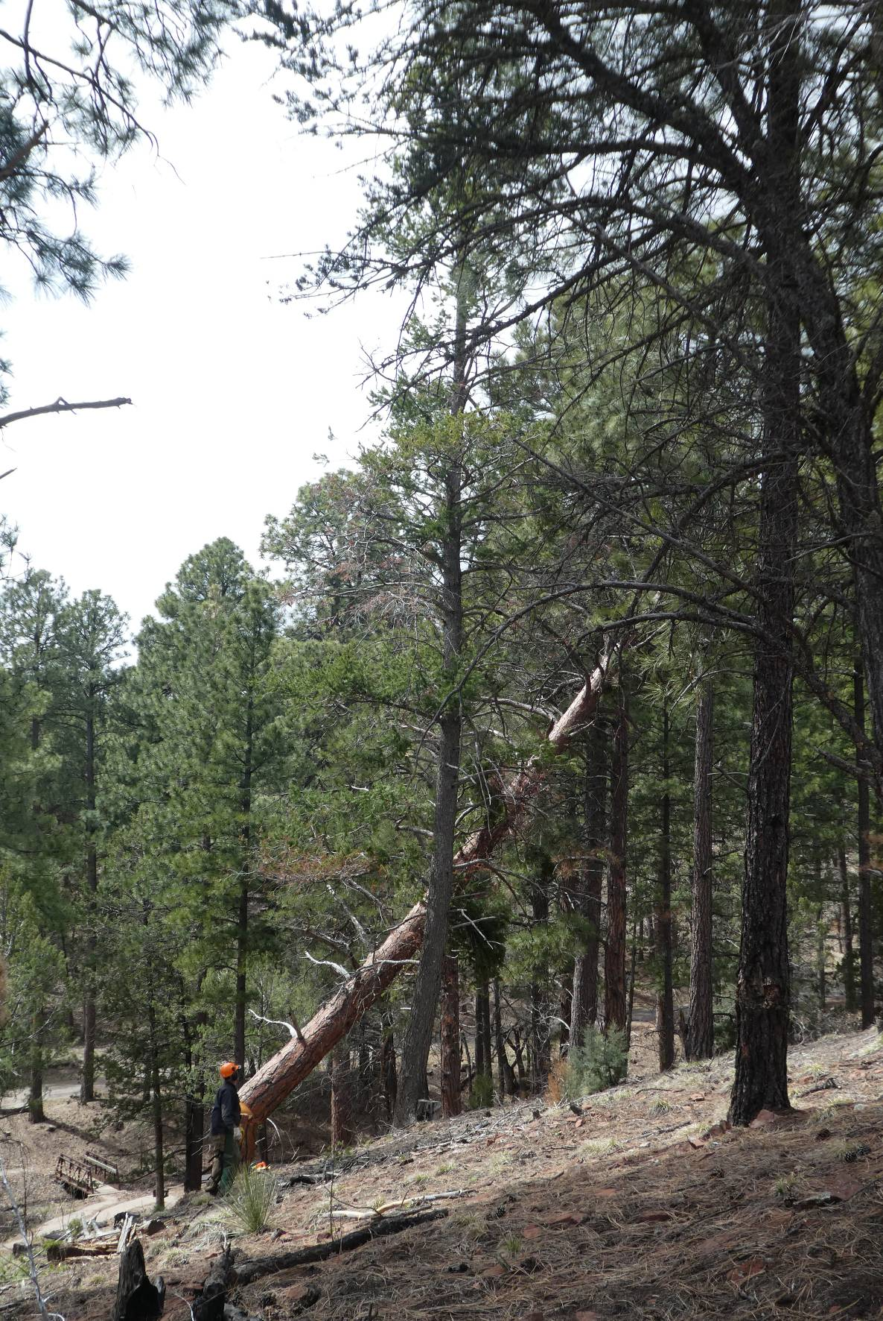
The large tree falling to the ground.

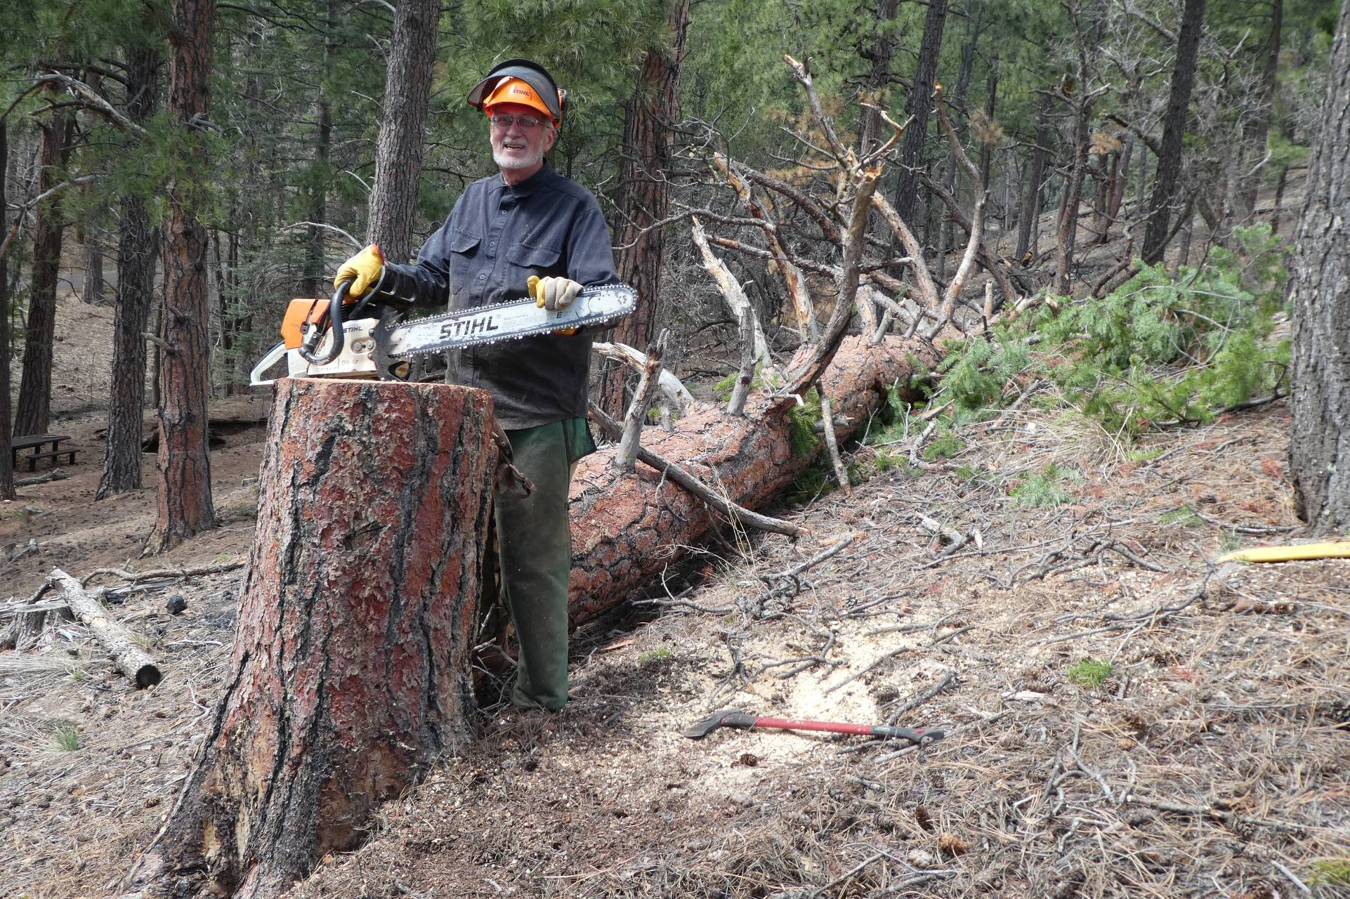
Dan and his tree felled with the FOSM Stihl MS460 chain saw with a 28-inch bar.

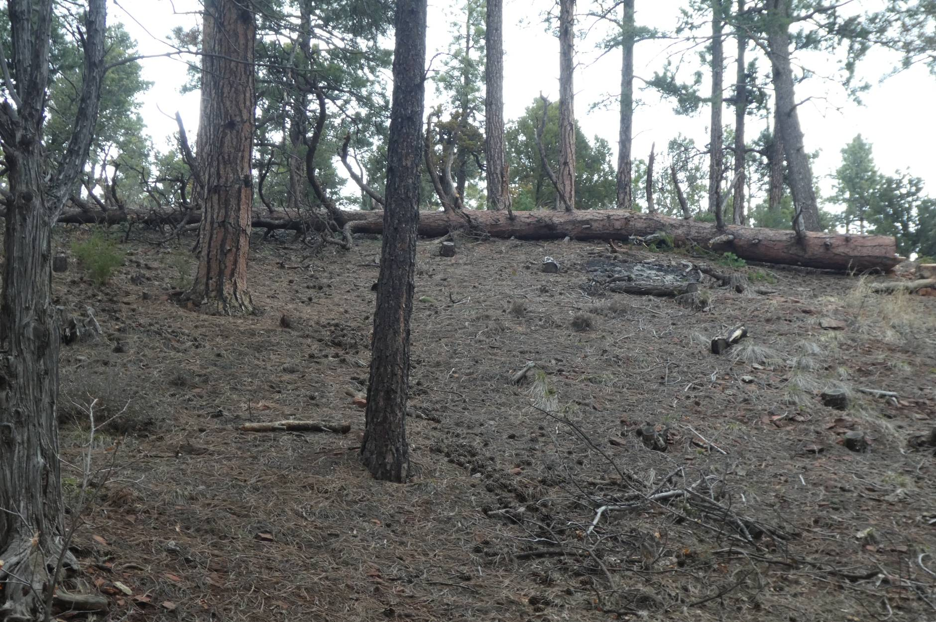
View of the 75-foot felled tree from the Acequia Trail.

