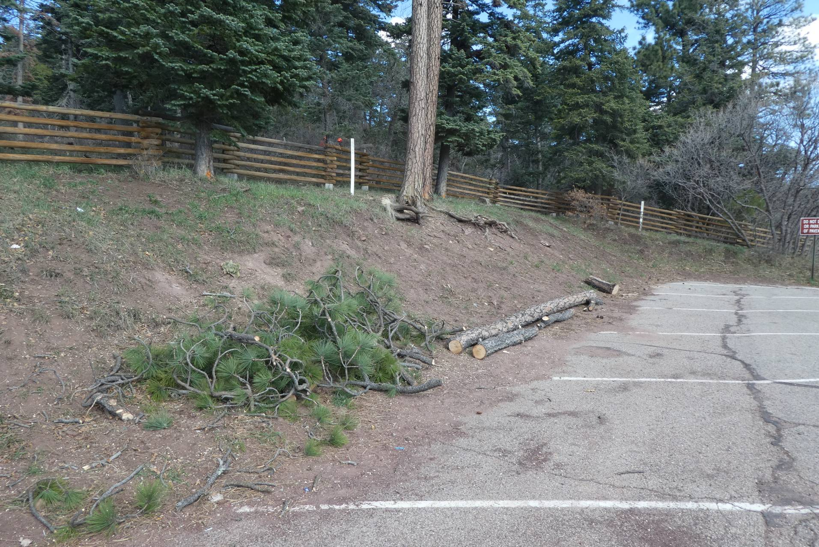
This 9-inch ponderosa pine hazard tree was located near the white post outside the fence at the Tree Spring Trailhead.
All photos by Sam Beard

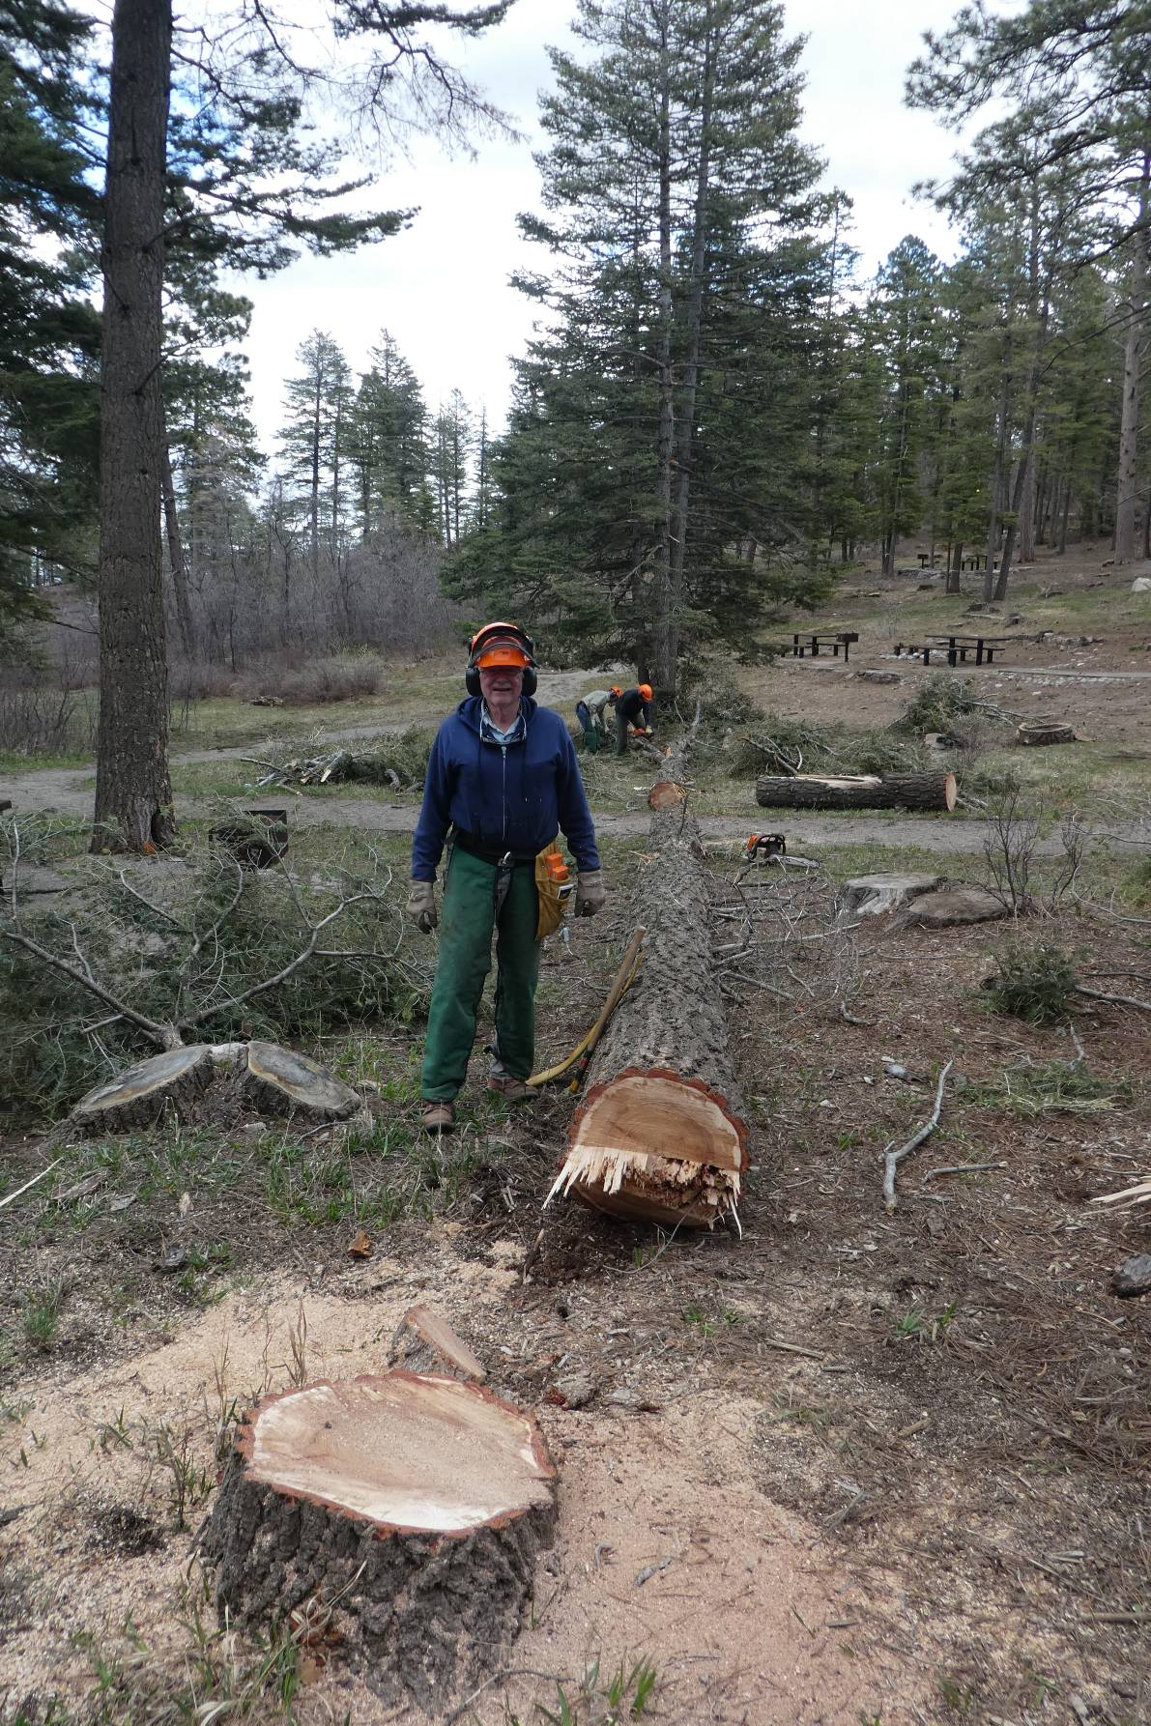
Eric Russell and the 20-inch diameter hazard tree that he felled in Balsam Glade Picnic Area.
The upper end has already been limbed and bucked.

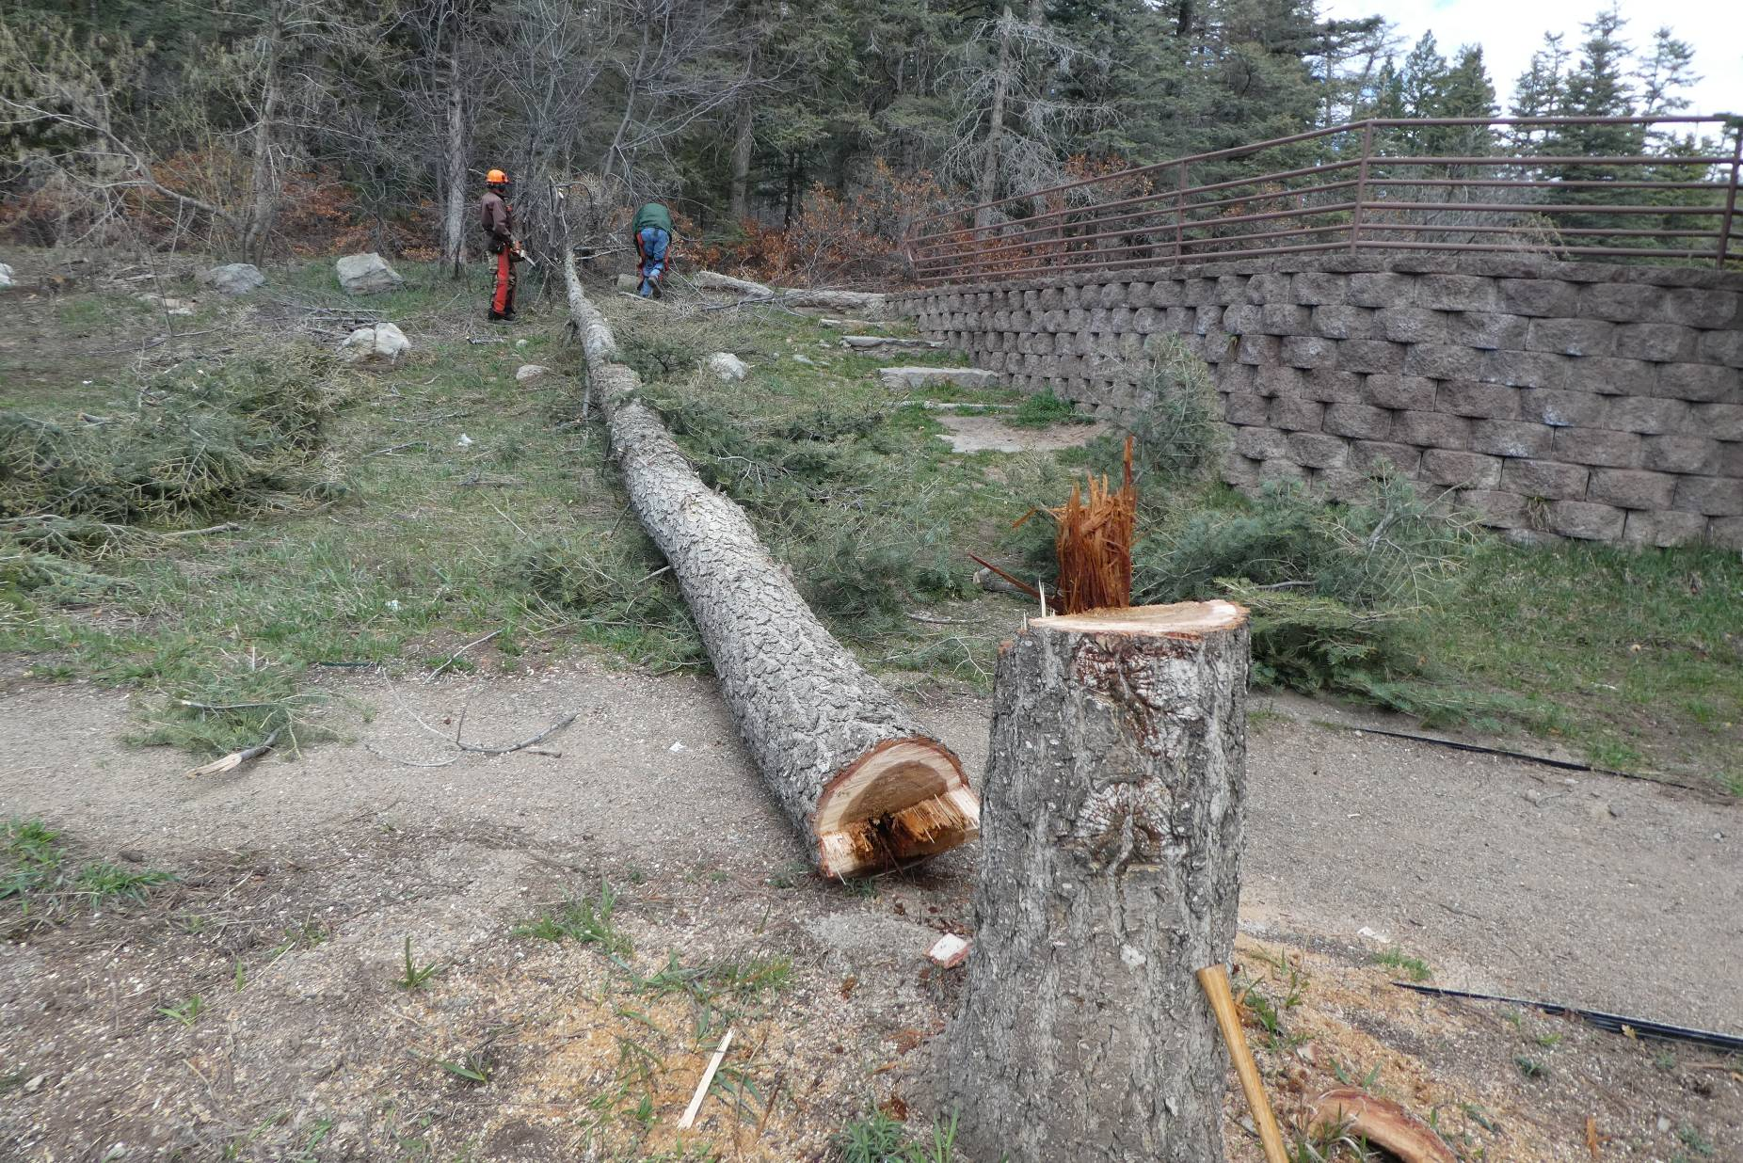
Carl Smith and Byron Garner felled and limbed this 15-inch fir hazard tree at the lower parking lot in Balsam Glade PA.
Later a piece of the log was removed to clear the path. Note that the center of the trunk was rotten.

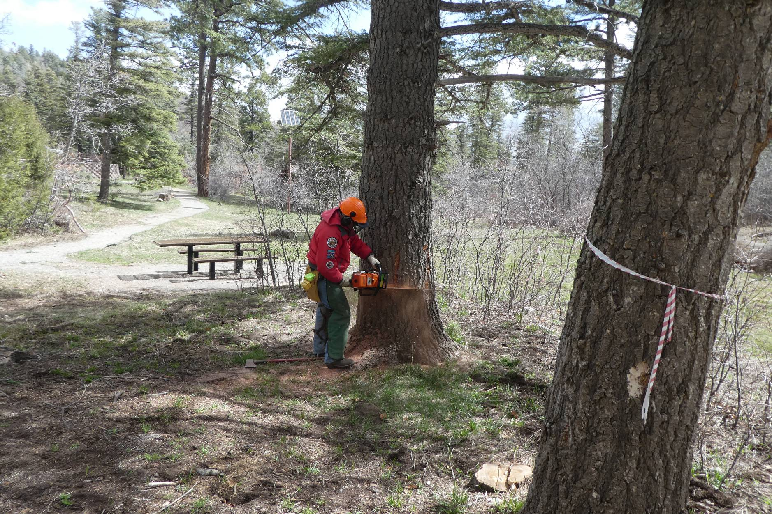
Jerry Carroll beginning to fell this 29-inch diameter fir hazard tree in the lower part of Balsam Glade PA.

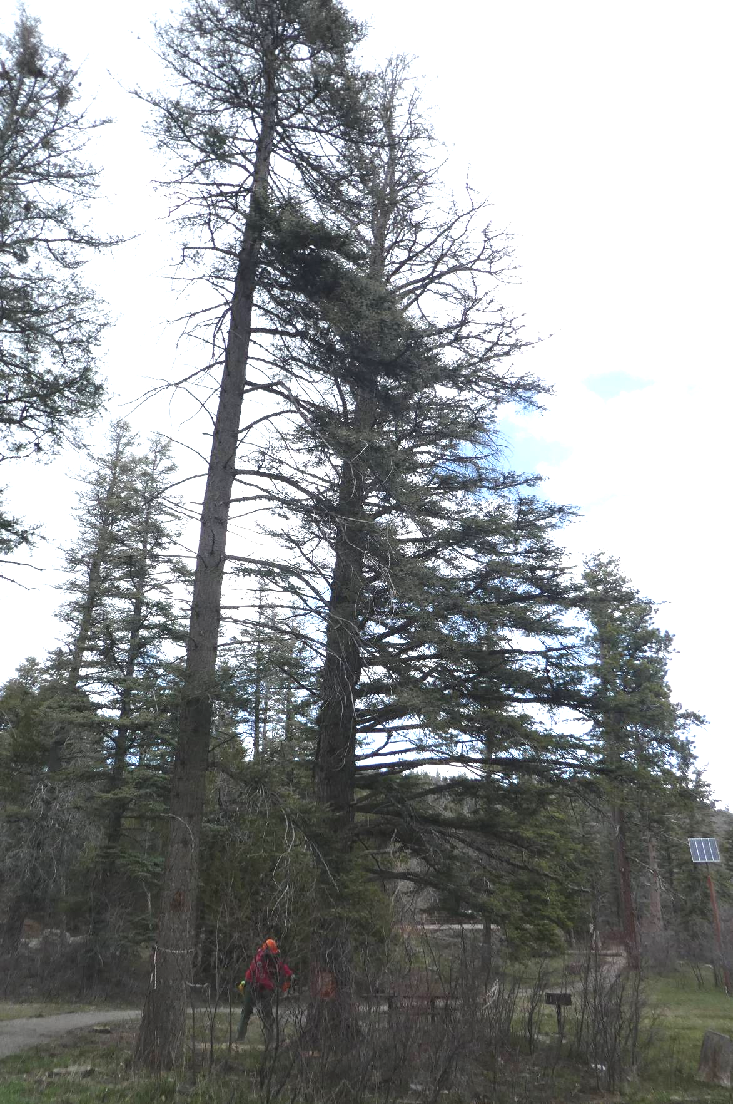
Jerry at the base of this very large fir tree. Note that the top of the tree is dead.

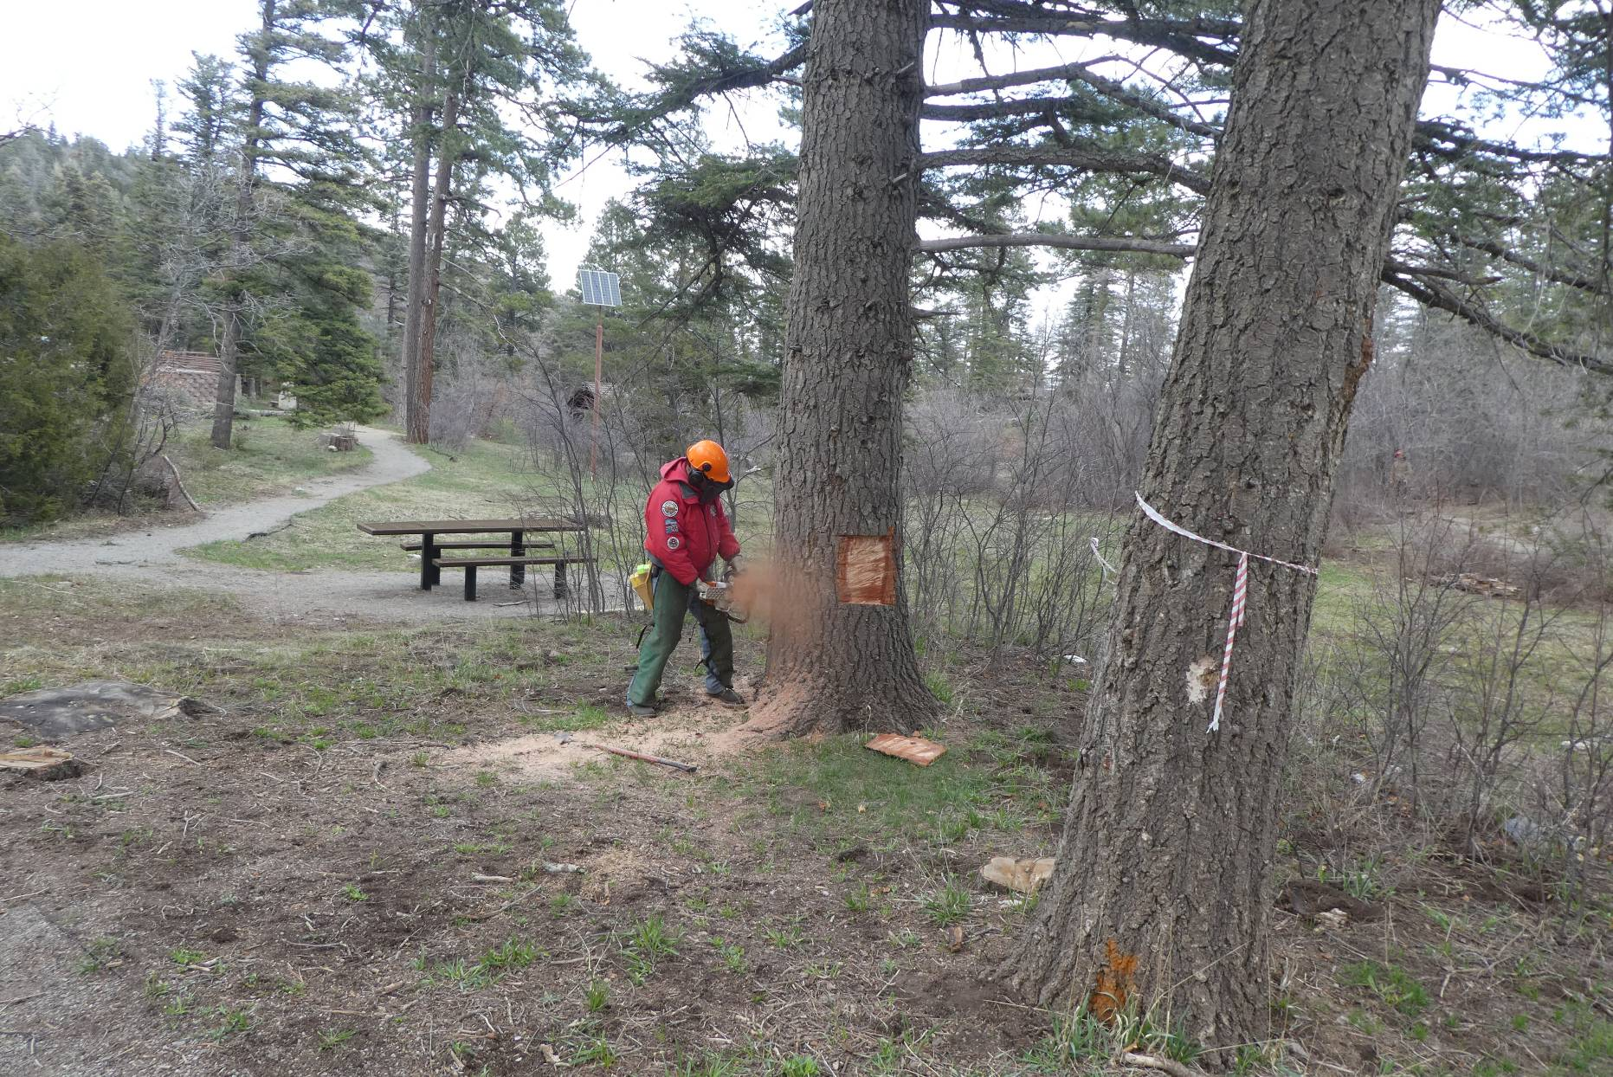
Jerry is completing the cutting of a 2-inch thick slab from each side of the tree so that he is certain that the 32-inch bar on the Stihl
MS 460 chain saw will cut through the trunk. Although the bar is labeled 32-inches long, the effective cutting length if reduced by the attachment section at the power head and the length of the long spikes (dogs) on the front of the engine that helps hold the saw against the trunk
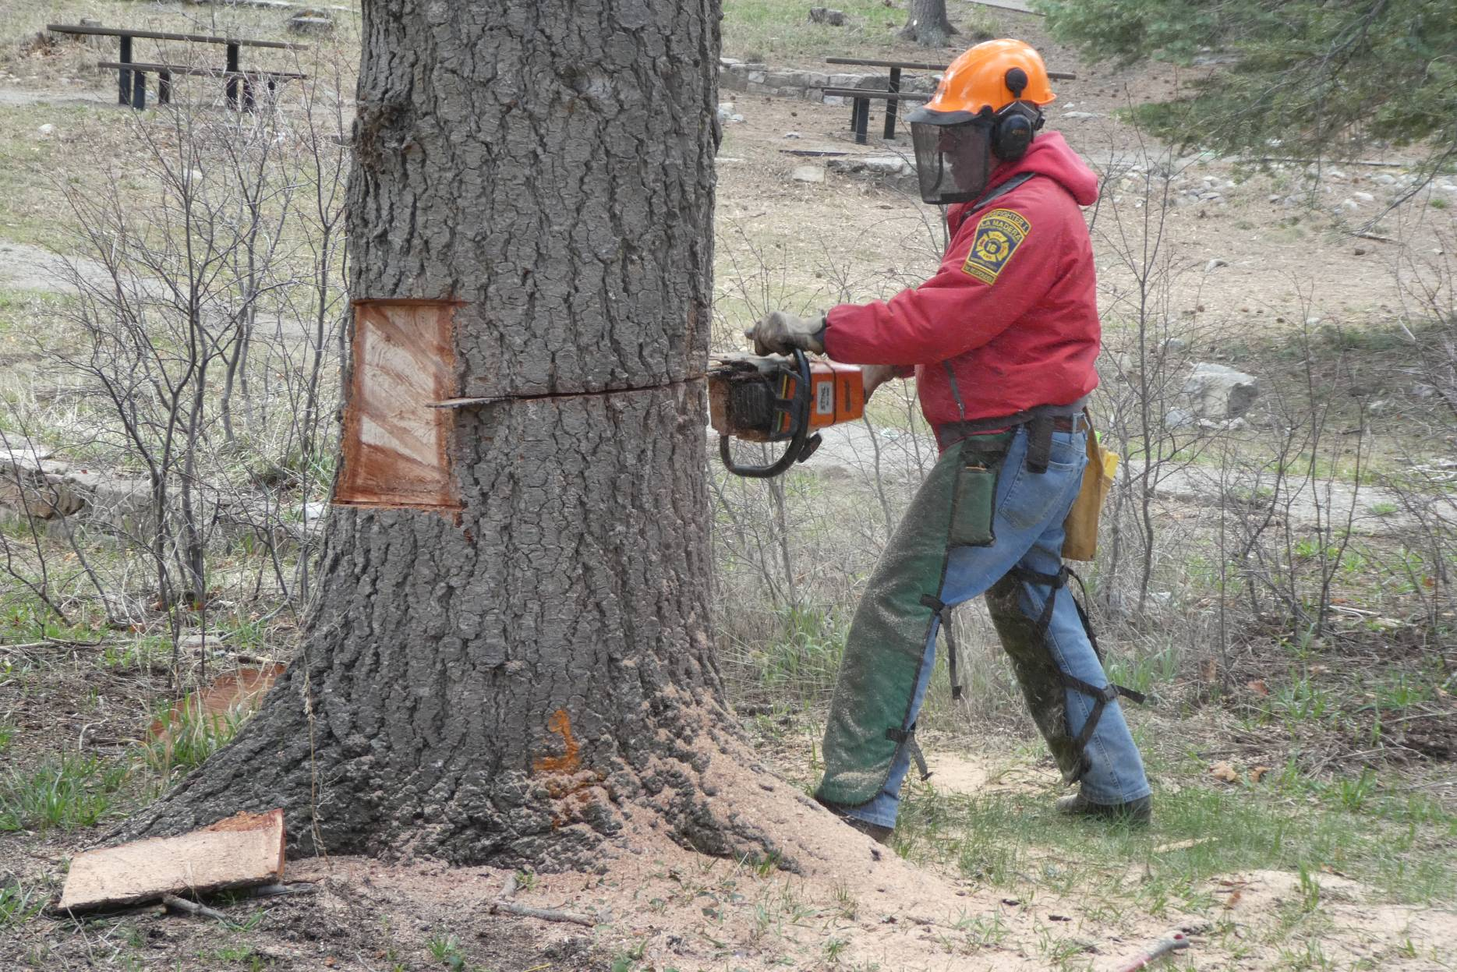
Jerry is beginning his back cut on this tree that was leaning to the left.

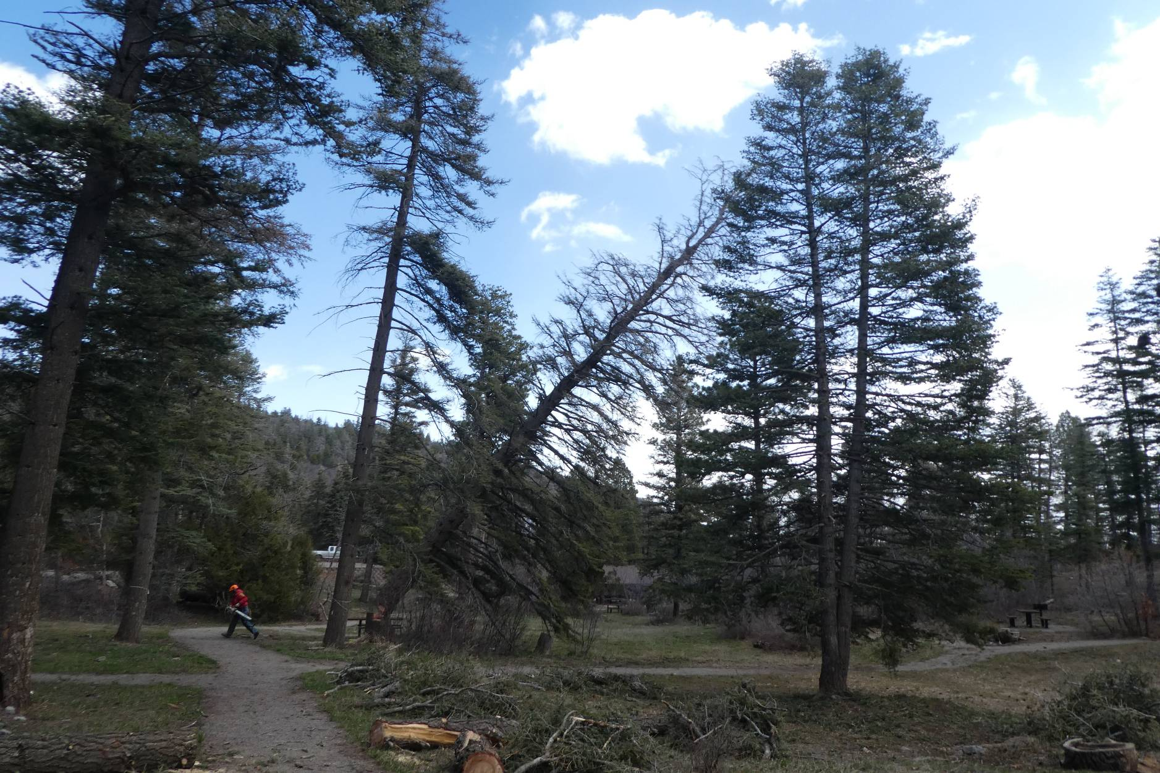
Jerry is running away from the tree that is falling to the ground.

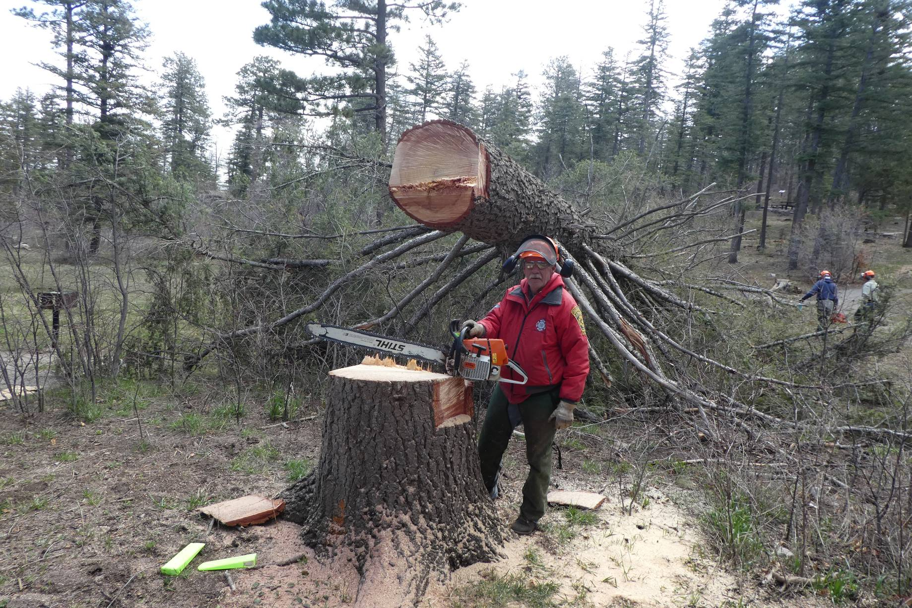
Jerry, the FOSM MS 460 chain saw, and the large hazard tree that he has just felled safely. Note that the cut end of the trunk is
about 7 feet from the ground. The primary objective of limbing and bucking such a large tree is to plan the tasks so that
the very heavy trunk is moved to the ground safely.

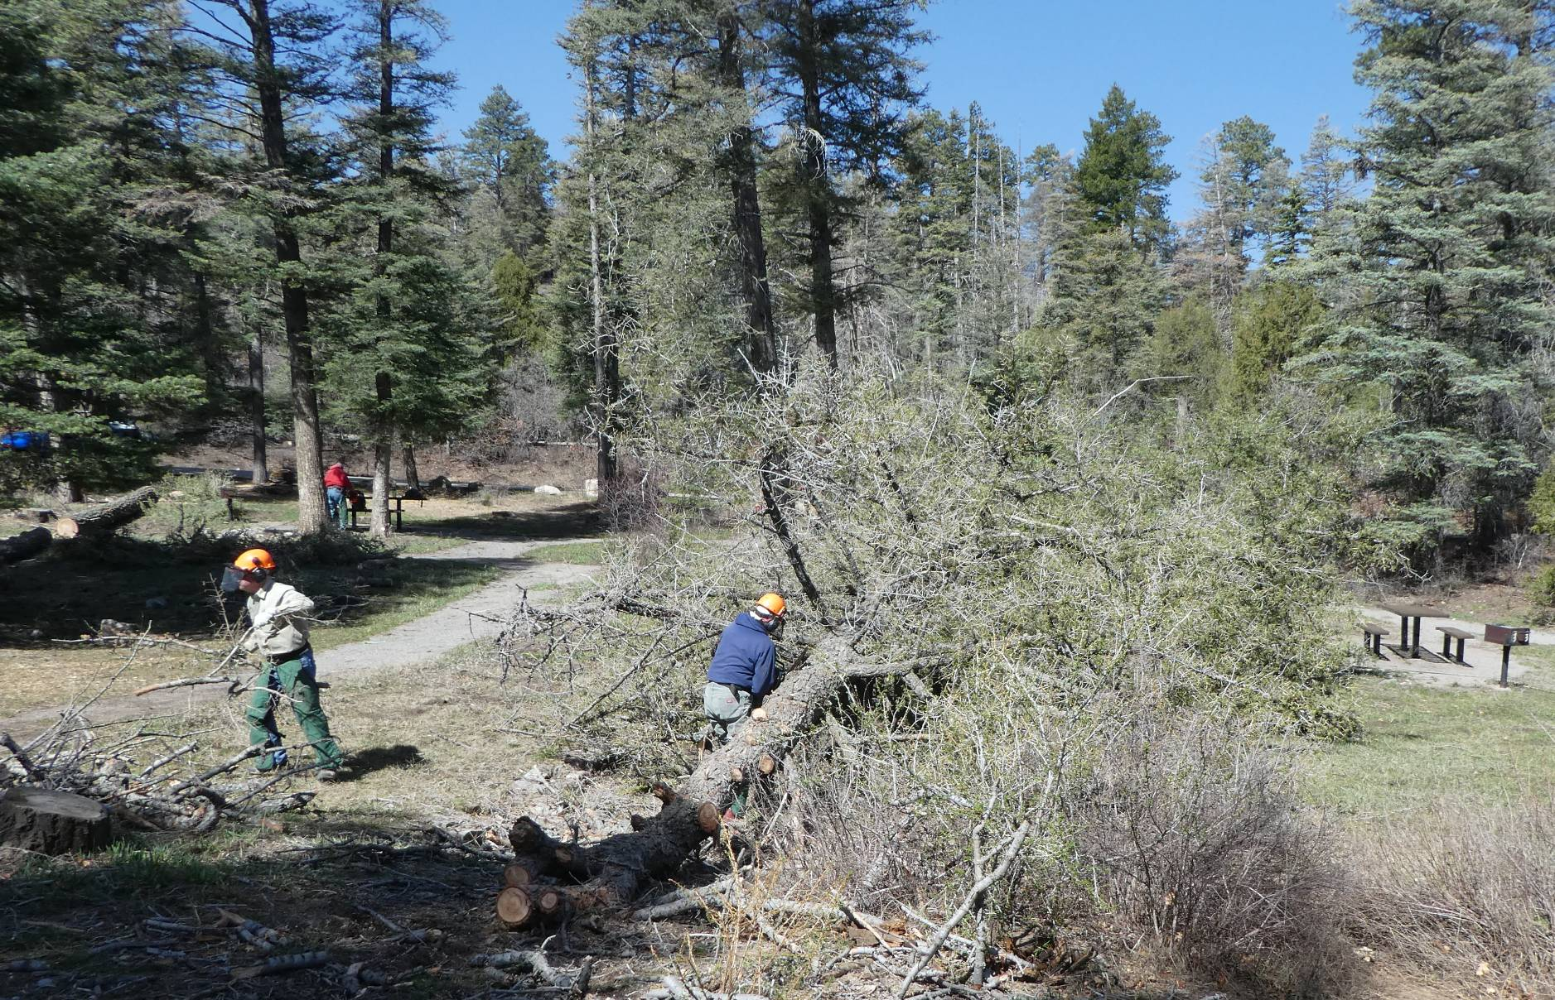
Jerry Pekarek is moving branches to a pile that will be chipped later. Eric Russell is cutting branches with a chain saw.
Note that several feet of the small end of the trunk has already been limbed.

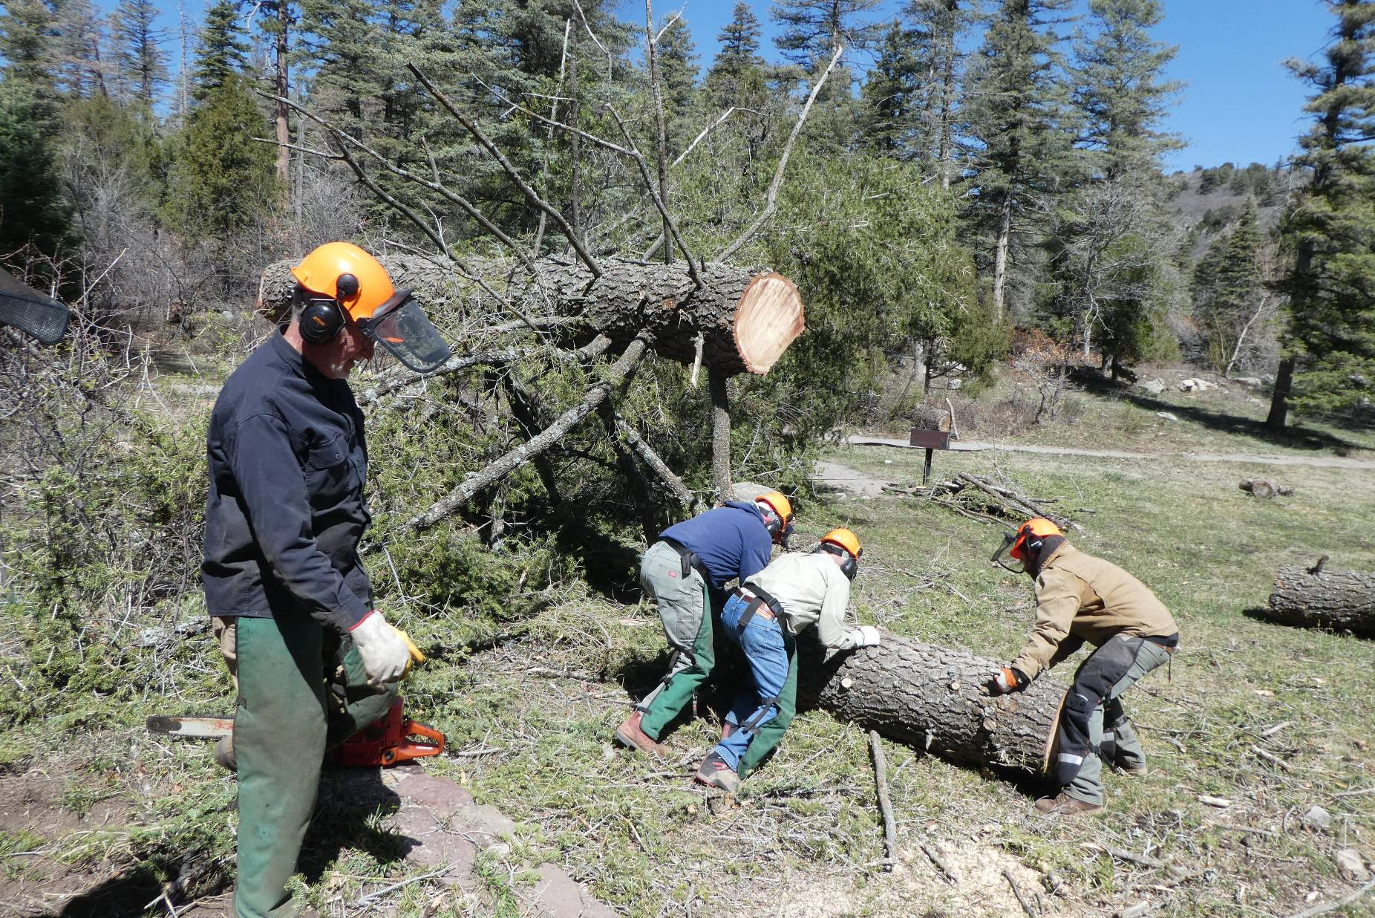
After the upper part of the trunk has been limbed, pieces of the trunk are removed so that the weight of the remaining trunk is reduced.
The large end of the trunk resting on the large branches has rotated down after much of the upper trunk was removed.
Dan Benton is observing Eric Russell, Jerry Pekarek, and Ben Meisner roll a large piece of bucked trunk into the meadow.

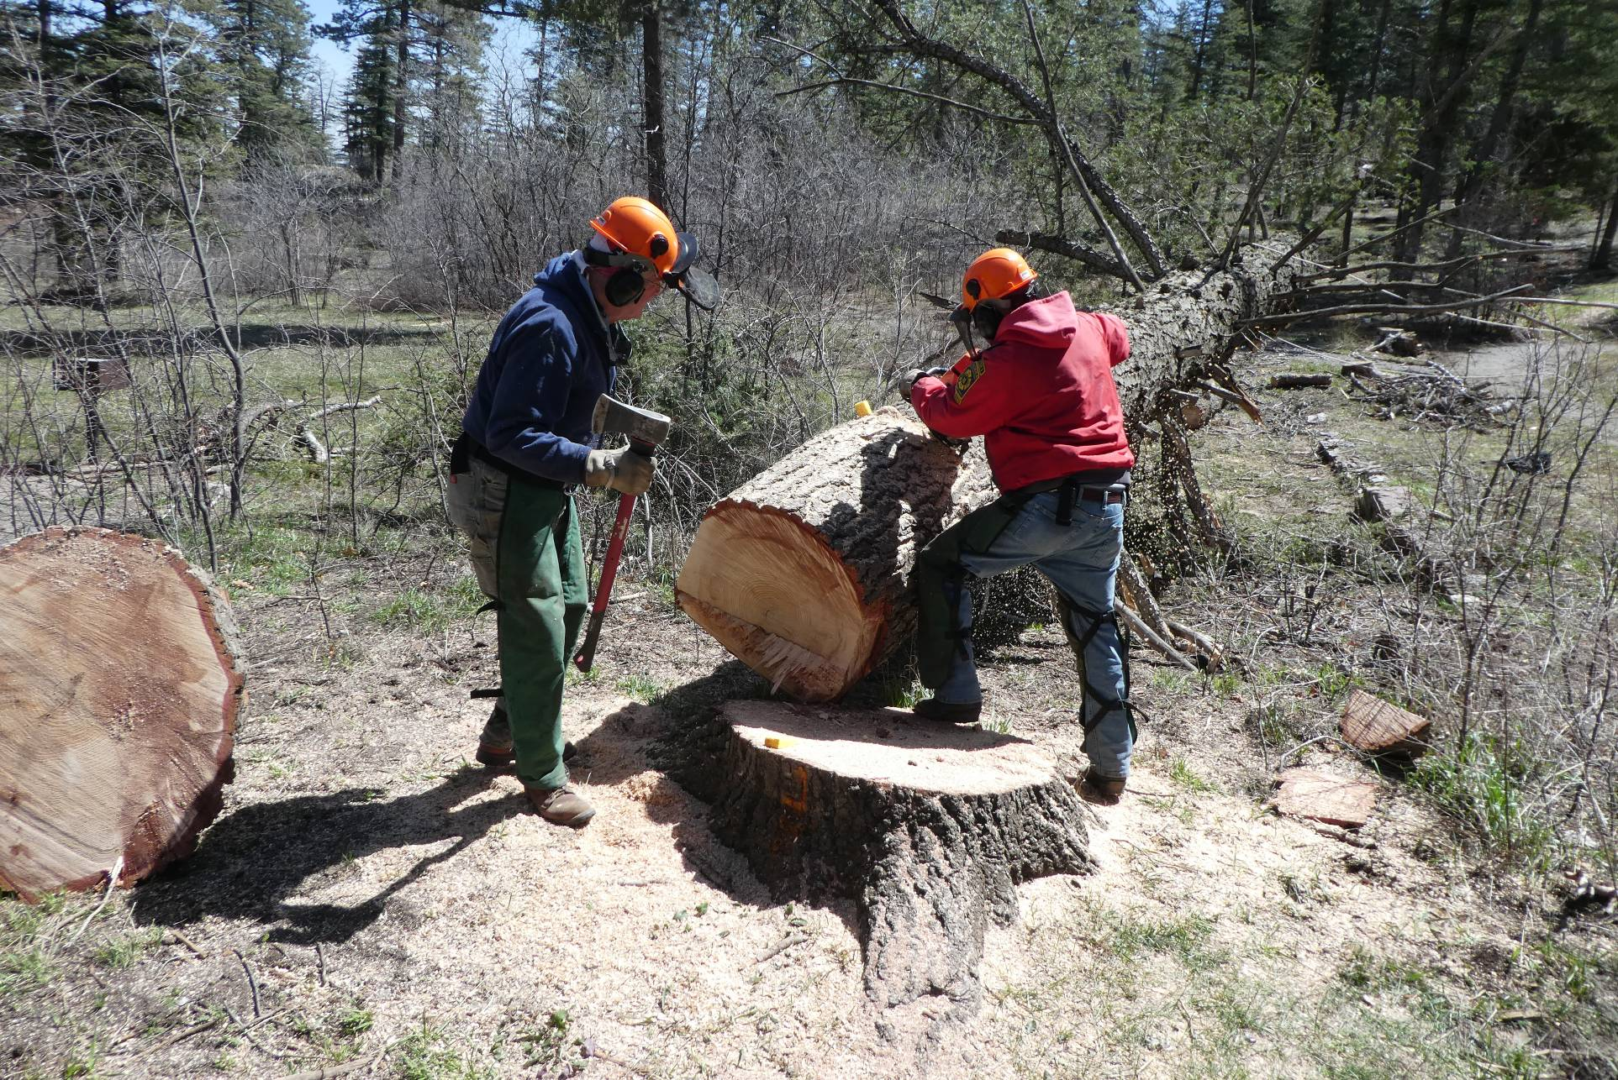
Jerry is cutting several feet off the large end of the trunk while Eric waits to insert a wedge, if it is needed. Note that most of the branches on the right side of the trunk have been removed so that just a few branches are supporting the trunk on that side. After Jerry completed his cut, volunteers pulled a rope to roll the trunk to the right. The rope had been attached much earlier when it was safe to work near the trunk.

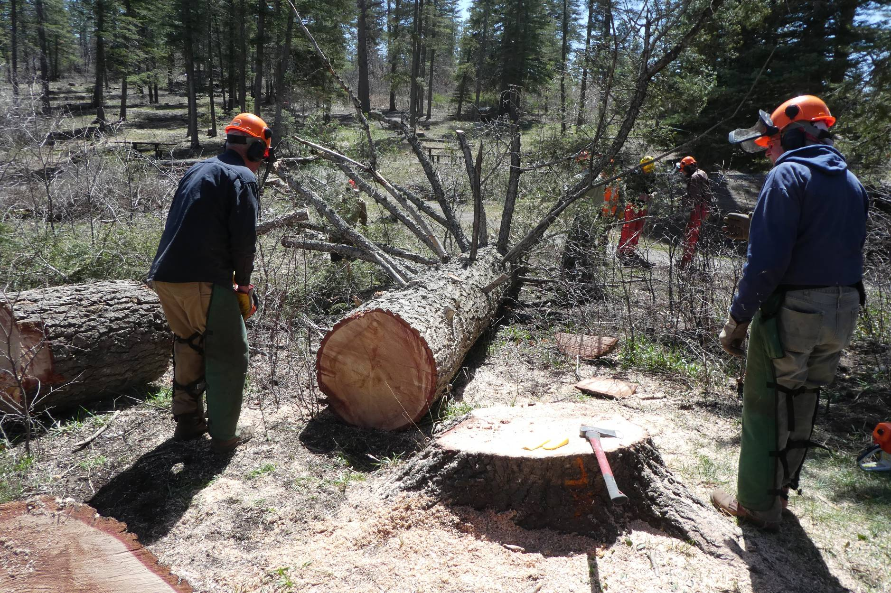
The trunk has been rolled onto its side so that the remaining branches can be removed safely. Note that the stump has been cut lower
with a Stihl MS 660 chain saw with a 36-inch bar. The very heavy piece of the low cut stump is on the left side of the photo.

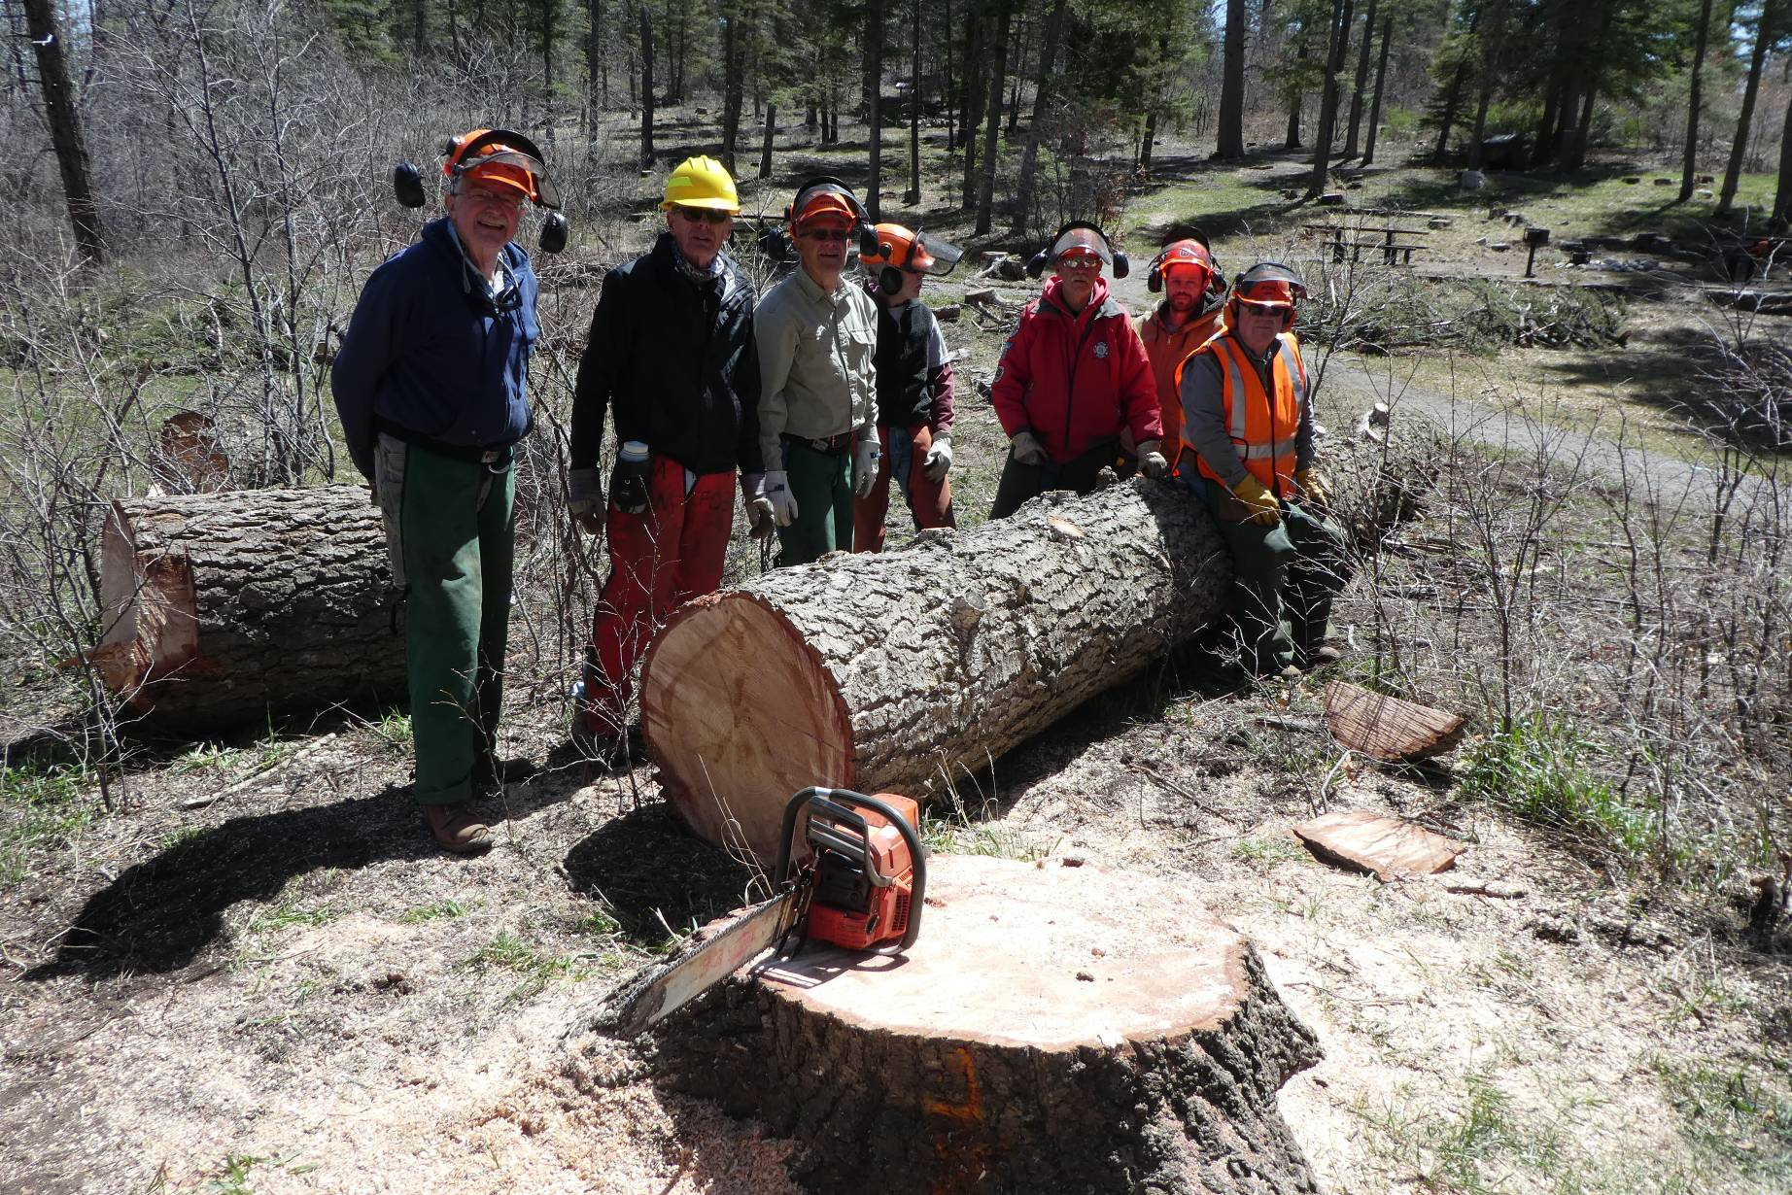
Some of the volunteers who safely felled, limbed, and bucked this very large hazard tree.
L to R: Eric Russell, Sim Cook, Jerry Pekarek, Byron Garner, Jerry Carroll, Ben Meisner, and Dennis Crowther.

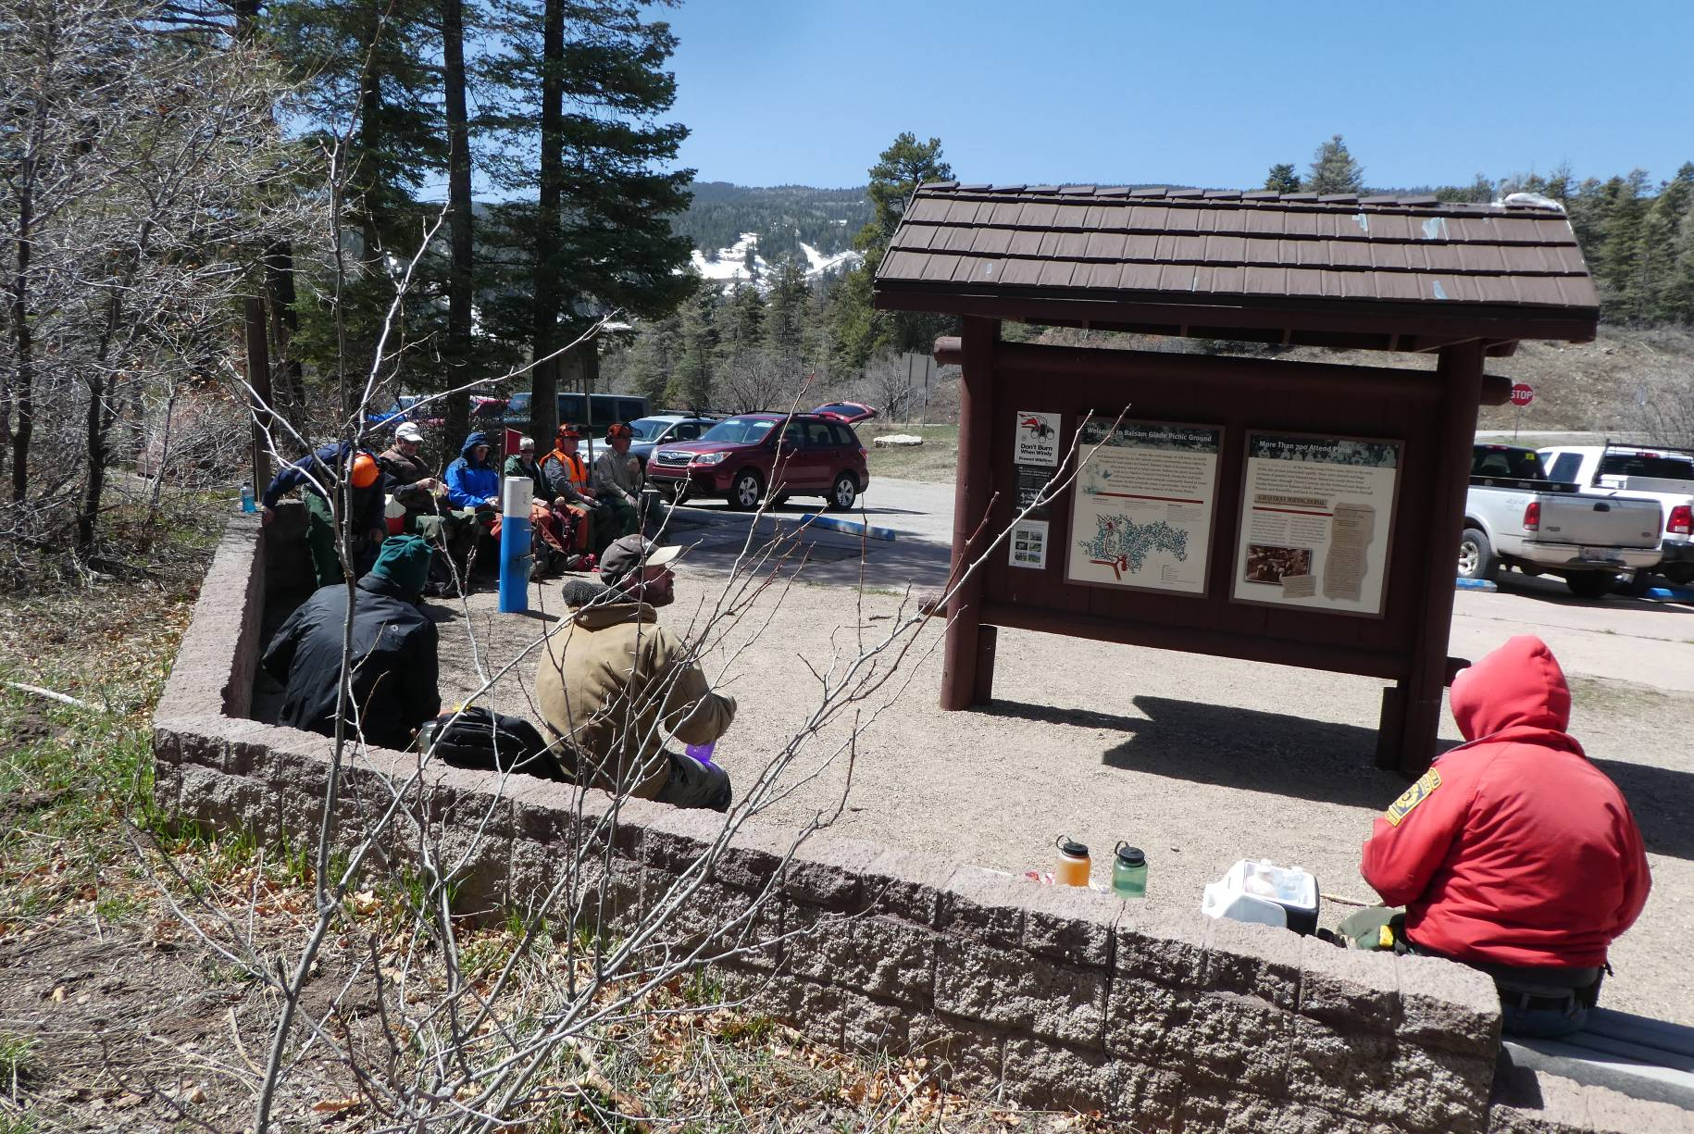
The crew eating lunch at the upper parking lot. Note the snow still on the Sandia Peak Ski Area in the background.

