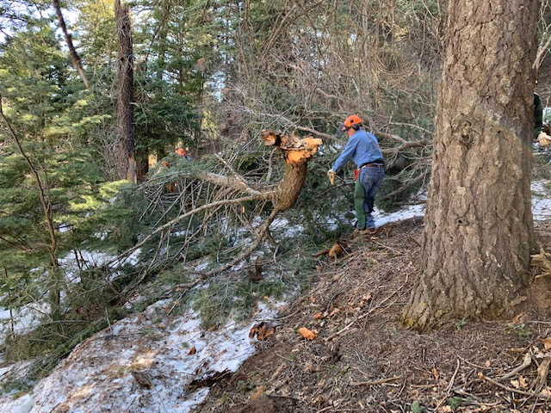
Jerry Pekarek is using a pruning saw to remove branches from one of the trees making up a huge “train wreck” on Oso Corredor trail. Crew members in the far background are starting to clear the blockade from the other end. The trail runs up along the left third of the photo. When all the fallen trees were removed, the trail was covered with deep snow which had not yet melted due to the shade cover provided by the pile of trees.

(Photo by Bob Lowder)

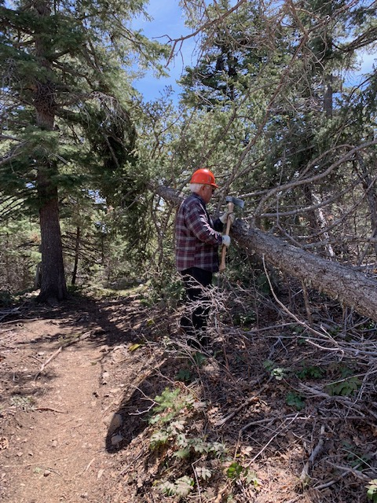
Lou Romero uses his axe to cut away branches from a
tree which had fallen across the trail. Lou is quite
the master with use of that tool. He can remove the
branches quickly and safely as fast as they can be
done with a chainsaw.

(Photo by Bob Lowder)

