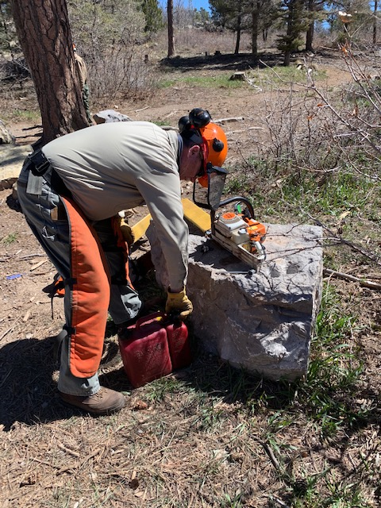
Jim Levesque is preparing to check the fuel/bar oil
levels on the chainsaws, Always a necessary task before
starting work.

(All photos by Sally Lowder)
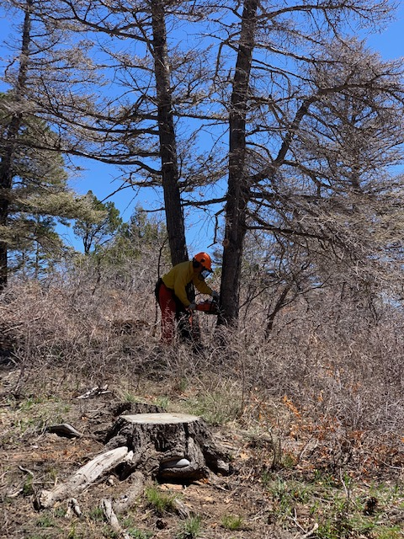
Bob is beginning a cut on the first of two hazard
trees he is removing. (Note – The brush in the picture
is in the near foreground. The area around the tree
has been cleared to provide a safe workspace and two escape
routes for the sawyer to get away from the tree as
it starts to fall.)
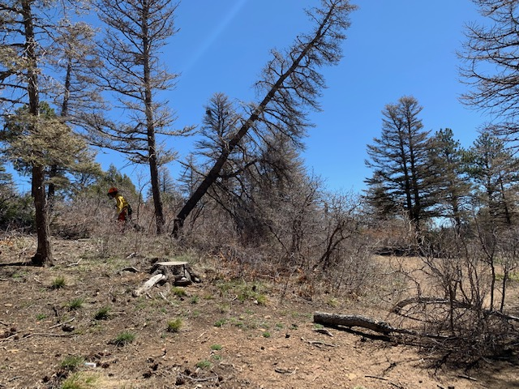
Bob making his escape as the tree falls away. This was one of the dead trees cut to block the illegal roadway to the right.

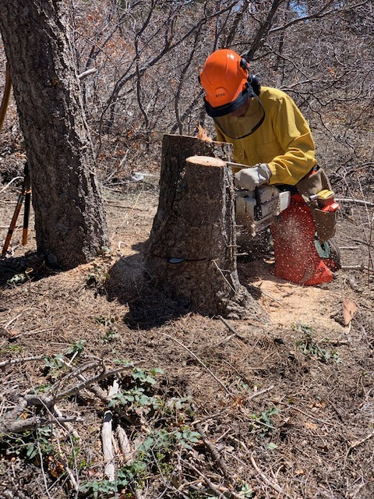
Bob is “low stumping” the tree he has just cut. This
is done to not only remove an unsightly stump but to
also provide a flat, exposed surface to expedite the
natural processes of rot that eventually return the
stump to the soil.
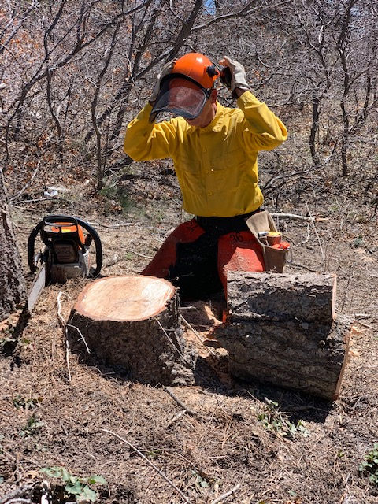
All done! Chainsaw is off, hearing protection no
longer needed. Time to move to the next tree.

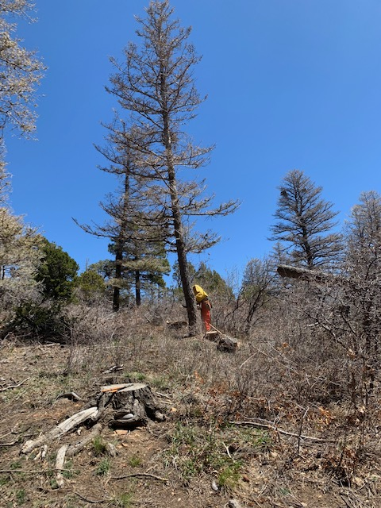
Bob starting the face cut on the second tree. The trunk
of the first tree is seen at the right where it fell
downhill toward the road. The protruding portion of its
trunk was subsequently cut away.
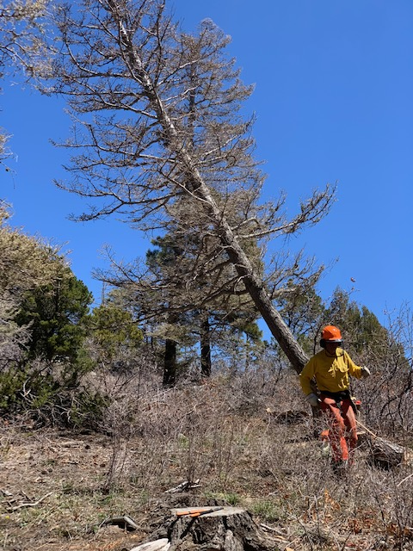
Bob once again decides that a sawyer has no business
hanging around a falling tree. Always nice to have a
nice clear escape route.

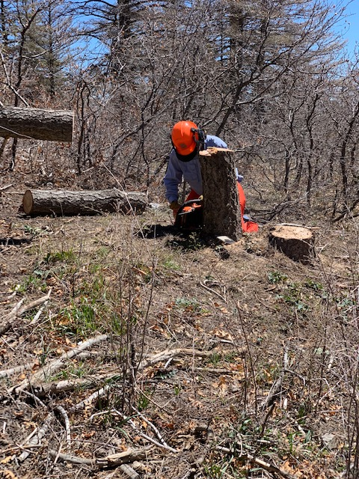
Sawyer trainee Phil Cromer gets some practice in low-stumping.
He has completed his classroom instruction and now is getting field experience prior to his certification test.

