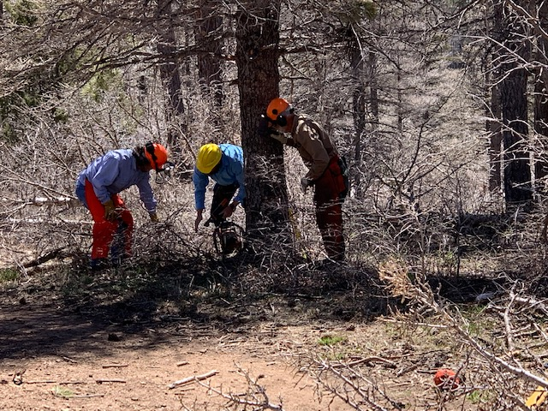

Sam instructing Phil Cromer and Michael Arndt in clearing the sawyers work are for safe felling of this double top tree.

(All photos by Sally Lowder)
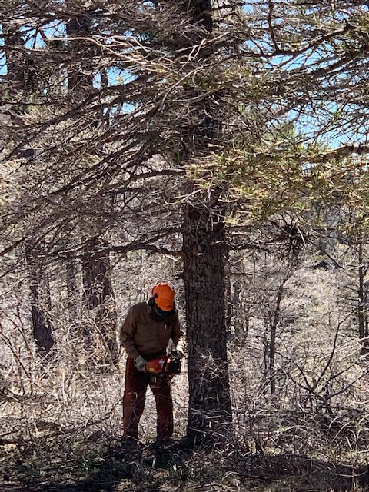

Sam Beard cutting the double top tree.

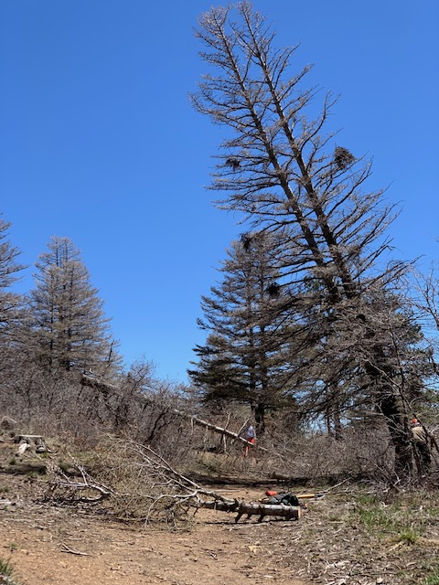

Sam leaving the scene quickly as the double top came crashing
down. Please note the trees in back ground already felled
Over the rogue road.

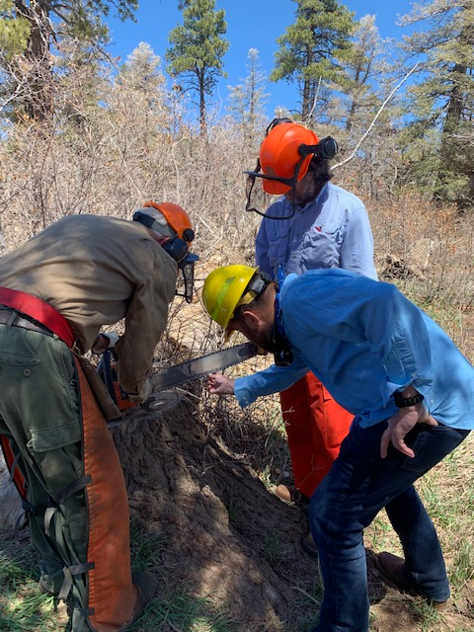

Sam instructing Michael and Phil on tightening a loose chain
on the saw.
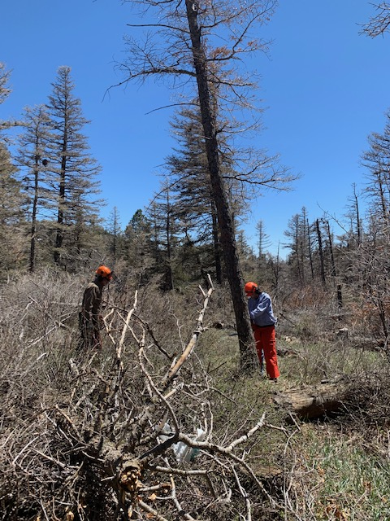

Phil Cromer has selected this tree with a good lean to fell.
Sam is standing near by during the face cut. When the back cut
was being done, Sam was no-where in the vicinity of the tree.
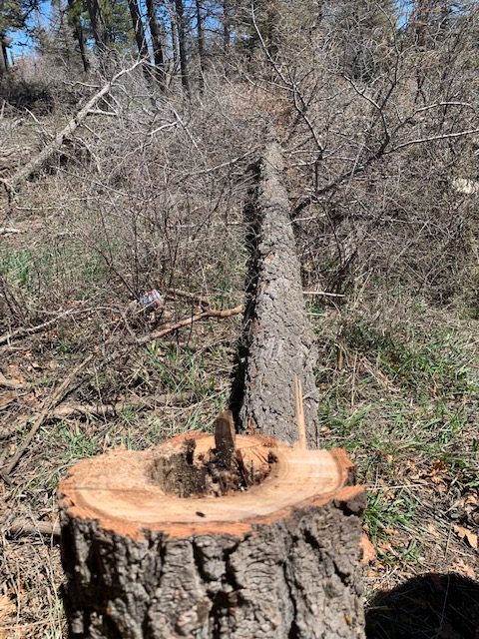

Now we know why this tree died—it was hollow (rotten) on the
inside.

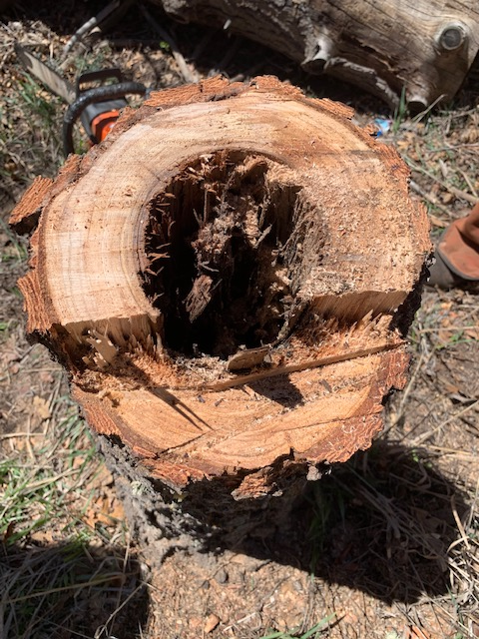
This photograph shows the following parts of a stump (going up across the stump): a. The face cut is the lowest level on the stump, and the tree falls in this direction; b. The splinters show the hinge part of the stump that bends and breaks as the tree falls; c. The back cut is highest level on the stump and the last cut before the tree falls.
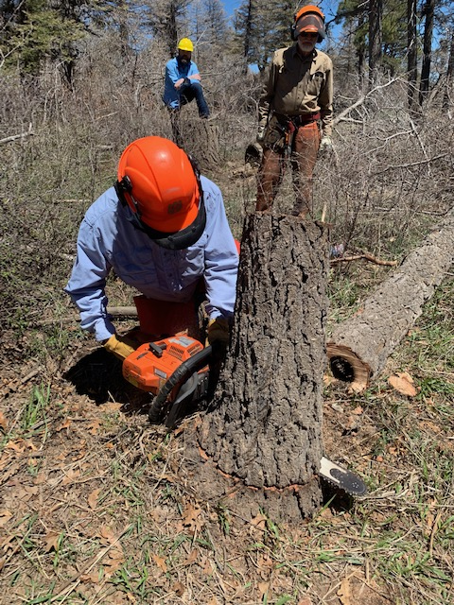

Phil Cromer is low stumping his felled tree. Good job start
to finish.

