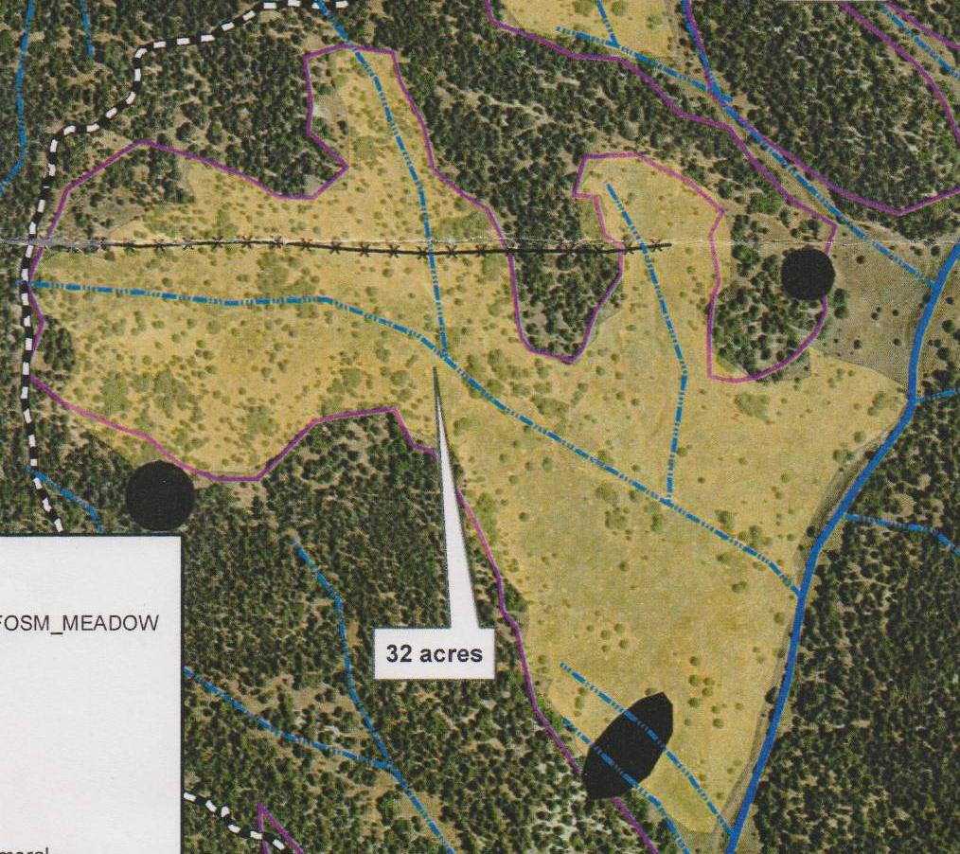
Aaron Johnson’s map of 32 acres of the 36 acres that FOSM committed to thin in three years
as part of the Cedro CFRP. In FY2019 we will be thinning the area S of the main NW-SE drainage.

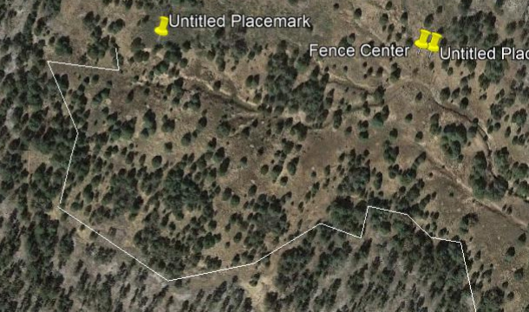
The area defined by the E-W segment of the main drainage and the white line is about 8 acres that we will be thinning as part of the
12 acres we plan to thin in FY2019. The west area boundary defined by Aaron’s and Sam’s lime green flags is shown as the white line that is based on GPS points taken by Sam and Michael Arndt in the fall of 2018.

