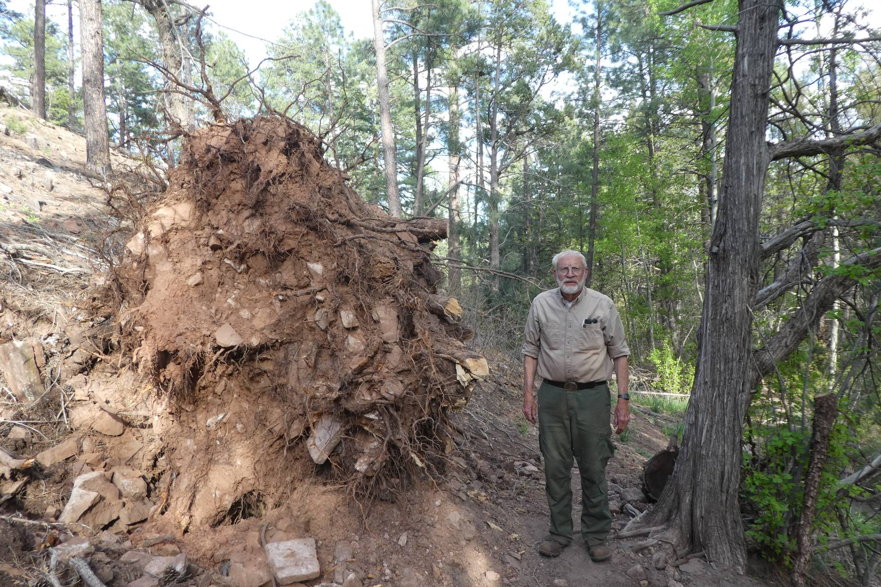
The root ball of the large pine on Acequia Trail where Lou Romero and Steve Roholt cut roots to clear the trail on May 1.
Photo by Michael Arndt

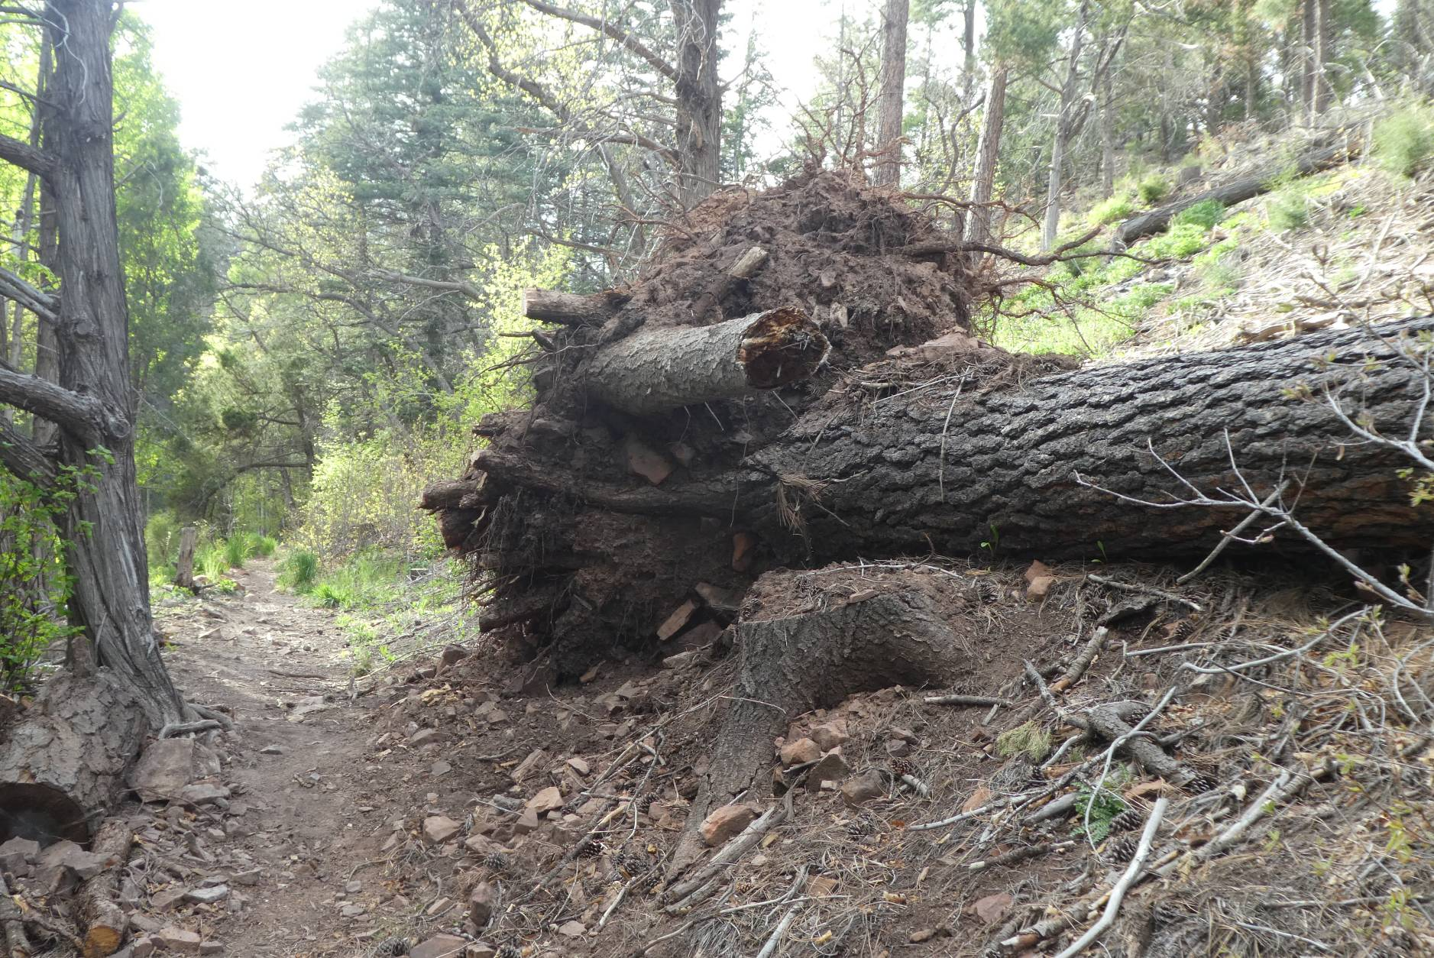
The down stream side of the root ball.
Photo by Sam Beard

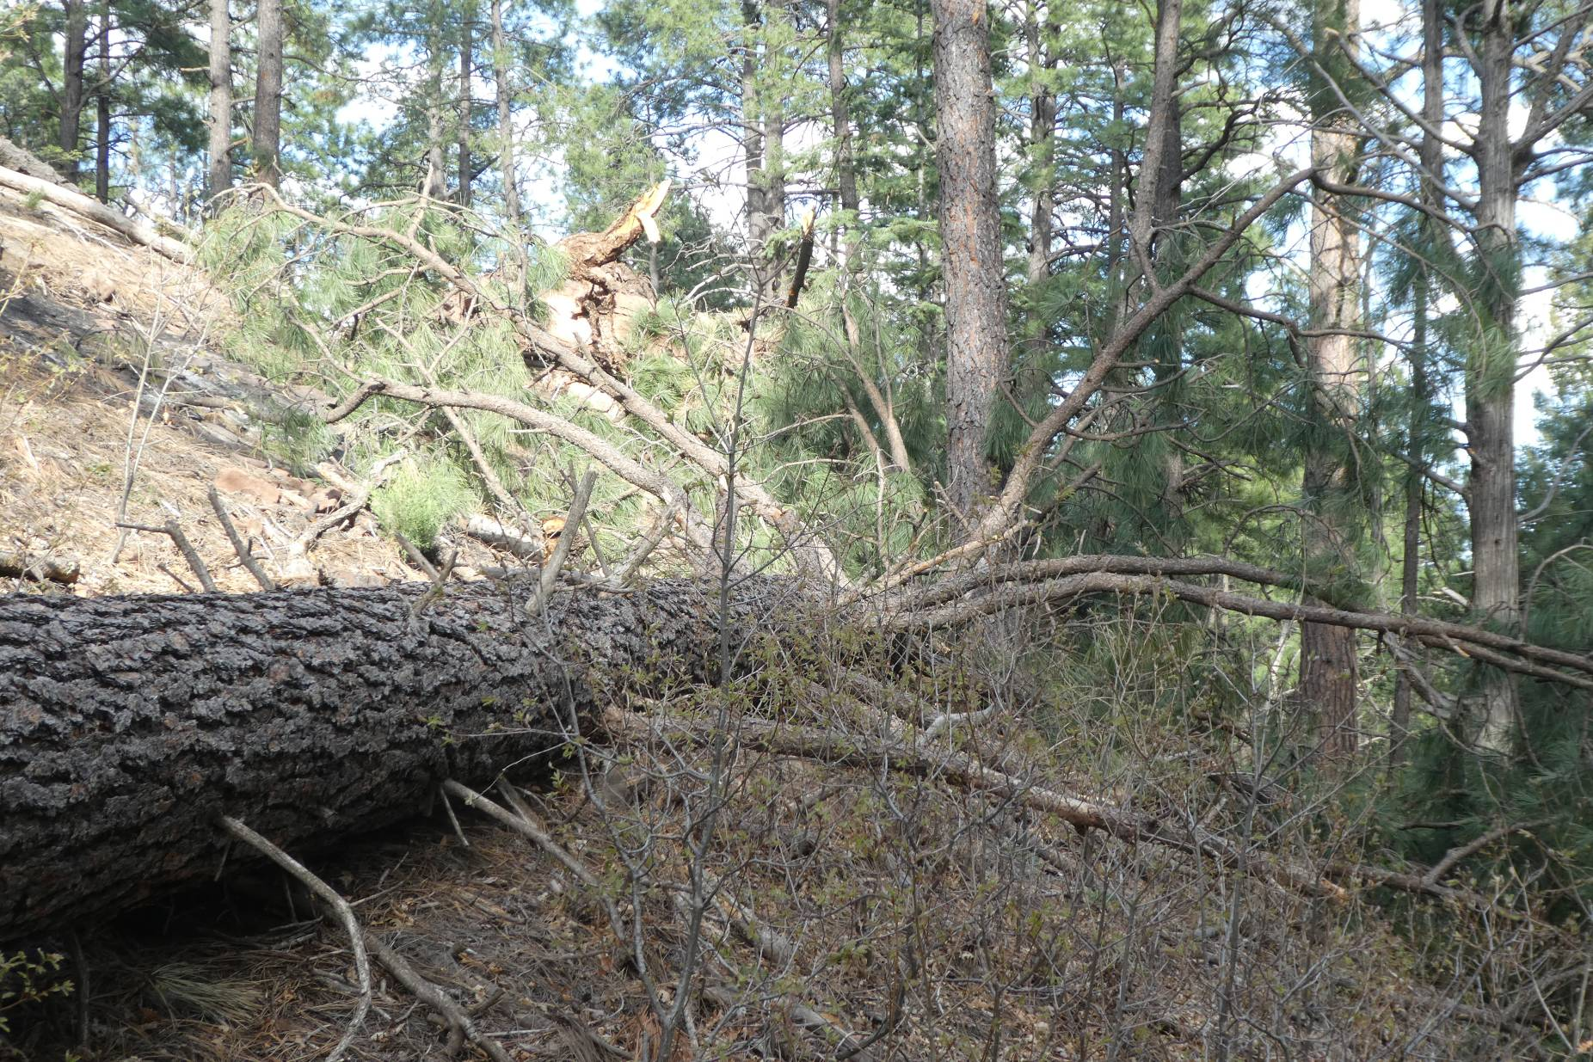
The upper part of the large pine tree on Acequia Trail.
Photo by Sam Beard

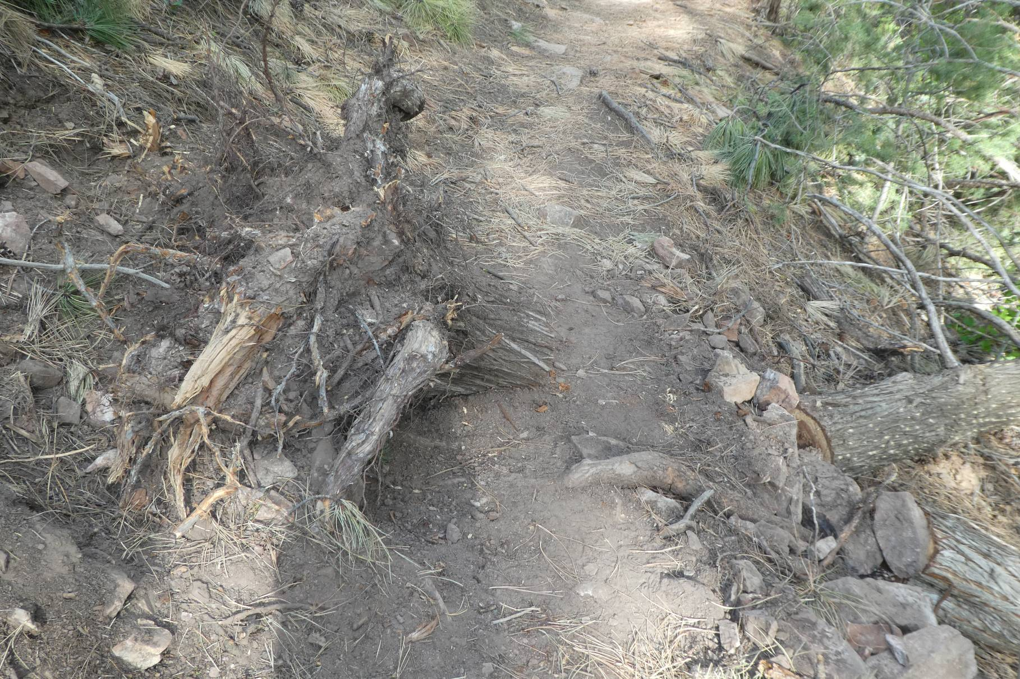
The 8-inch tree that Lou and Steve bucked on Acequia Trail. The root ball and stump are on the left side of the trail, and the trunk is
below the trail on the right. Photo by Sam Beard

