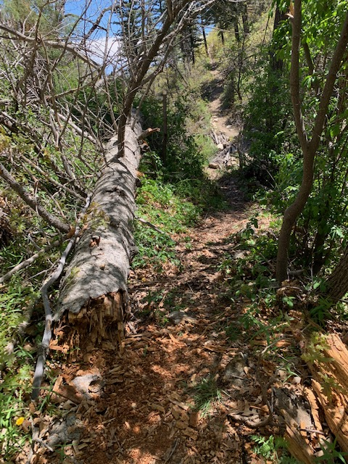

Cienega Trail just at the top of the Faulty junction. You can see Faulty Trail going up the hill at the top of the picture. This section of trail is now clear. There was a train wreck of small diameter “spring poles” over the trail that made for difficult passage even for a short person. We also did lots of brushing in this area.
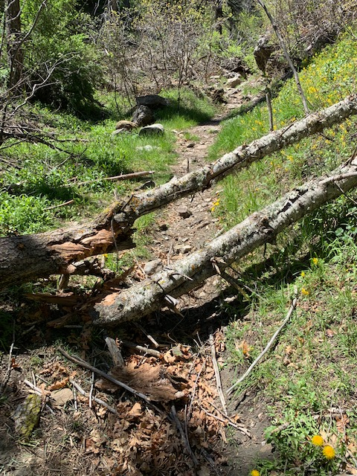

Just a bit further up the trail we came across these two
small trees across the trail. They have been removed and the
debris also removed.
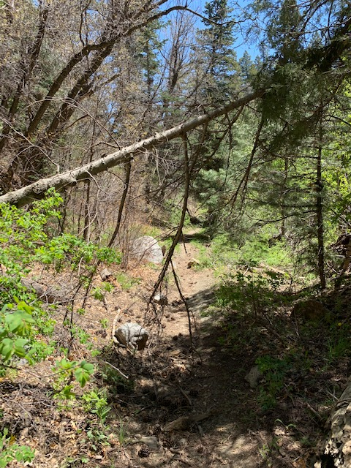

Moving up the trail we came to this poorly supported hang-up.
It was safely removed. There was also some brushing done
In this area.

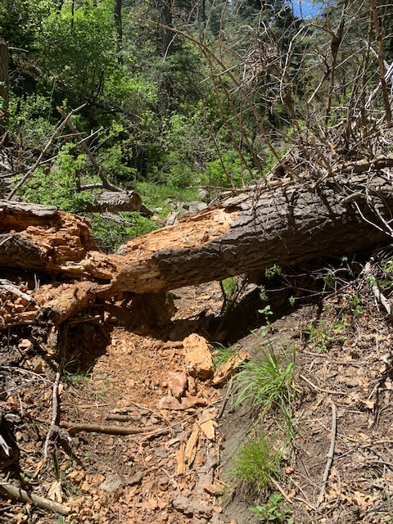

This tree is actually above the last picture. This is as far
Up the trail as we got. We did not have the equipment to
remove this very rotten tree. The end on the left is sitting
on a rock. The only cutting will be on the right side of
the trail. A Pulaski might make short work of this tree!
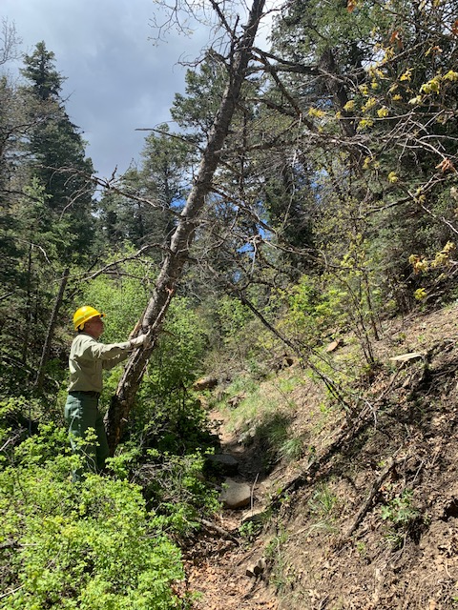

This tree is below the bigger tree. I took this picture
looking back down the trail. Bob decided to do some
work on this tree. It is a small topped tree hung-up in a
small fork in the tree above the trail. It is loose at the
base of the tree where Bob is working. Again, not the proper
equipment to remove the tree. Another day………coming soon
to a FOSM CREW team!

