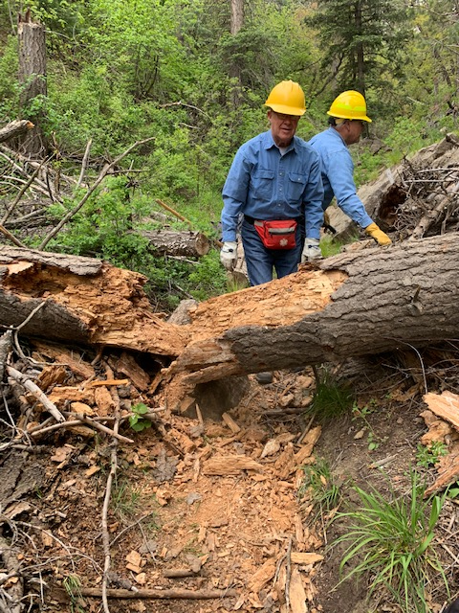
This 18” diameter fallen fir was the first of many
large trees that the crew encountered on Cienega trail.
Jerry and Dave survey the situation. (Note – This is
the same tree shown in Sally’s report of our hike on
Cienega trail last week.)

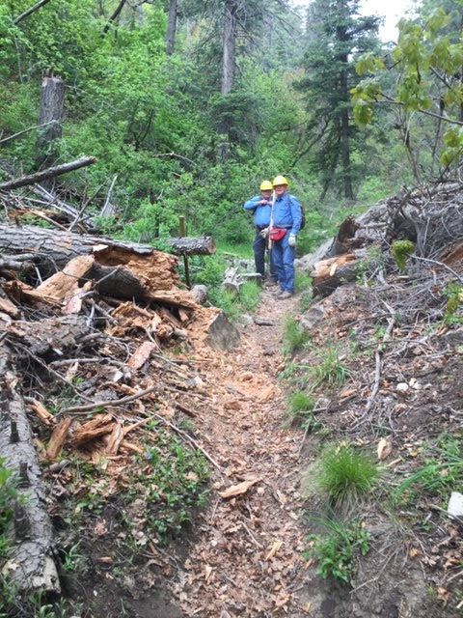
Large tree has been removed.

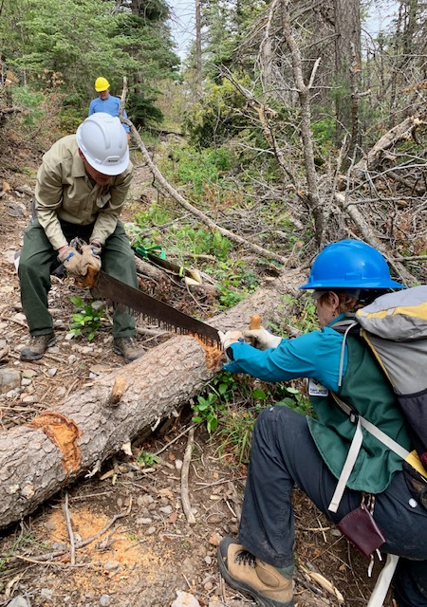
Bill and Bet working on a fallen tree. The areas where
the bark has been removed mark the locations of the cuts.
The bark is removed to protect the saw teeth from possible
imbedded dirt that can dull the saw.

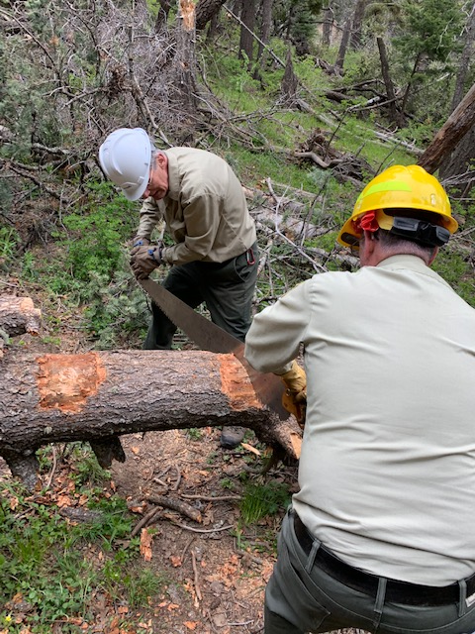
Another obstacle being cut away by Bill and Jim.

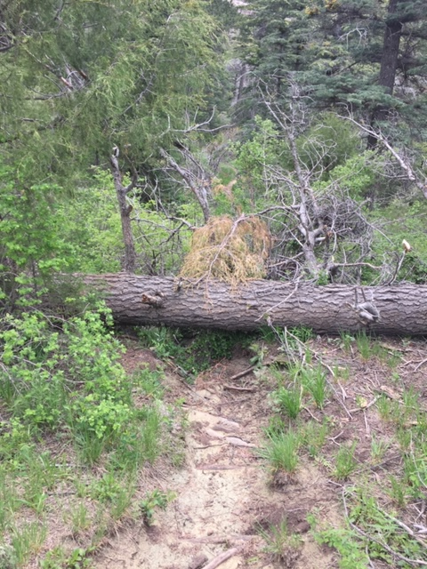
This 19” diameter tree and associated debris was
completely blocking the trail. When these fallen trees
are too big to safely cross over, walk-arounds tend to
develop, many of which are lengthy and/or hazardous.
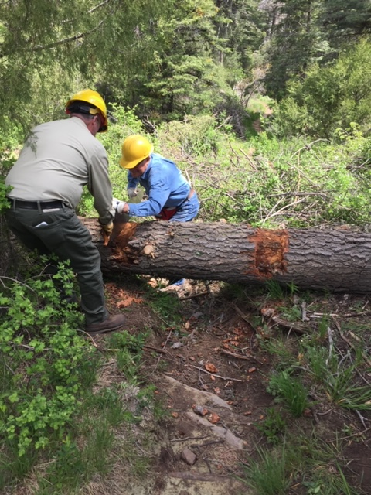
After all the debris has been removed, work begins on
the 19” diameter tree. Jim and Jerry handle the saw.
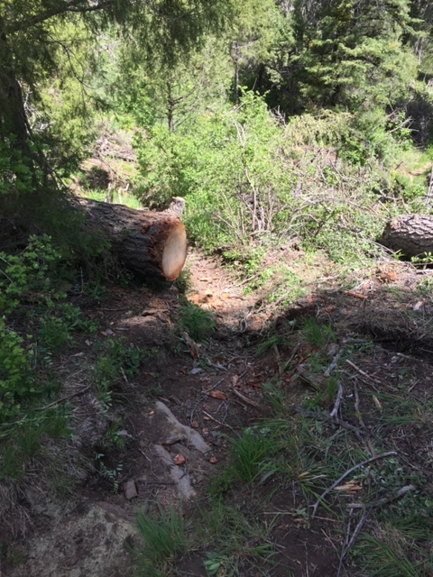
Big tree in previous photos has been cut away and trail
is clear.

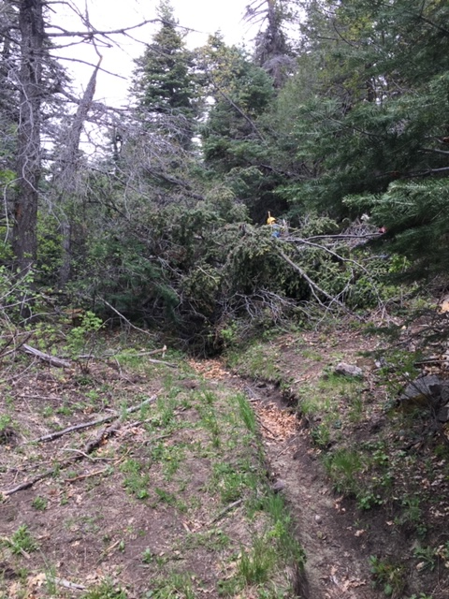
This train wreck made up of at least seven dead or green
trees blocked up to twenty-five feet of the trail and
was likely the largest one ever encountered by our crew.
Jerry is standing near the top of the blockage. His yellow
helmet is barely visible in the distance. Photo is looking uphill.
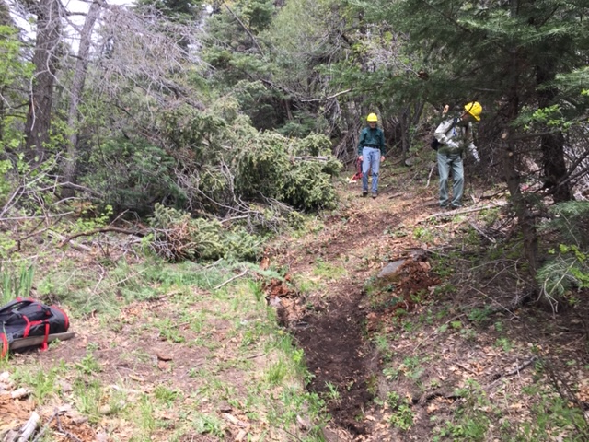
Photo shows the enhanced walk-around at the big train wreck. Byron employed his trail building skills to help create a safe and sustainable alternative to the blocked trail. Actually, the new path is vastly superior to the old trail which had become nothing more than a two-foot deep arroyo here. A lot of
protruding branches were cut back to provide space for the new
trail section.
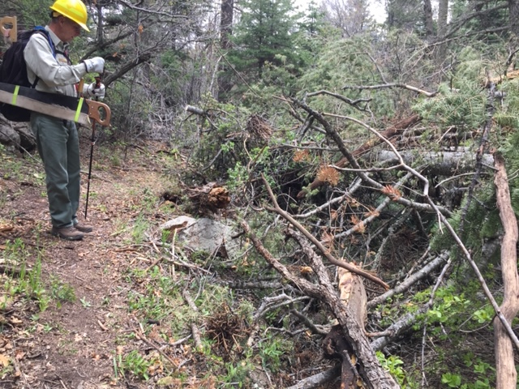
Bob inspects the top end of the big train wreck. It was indeed a
massive tangle of fallen trees and broken treetops. If a 6’ tall
person was standing on the old trail below, his head would not reach up to the grey horizontal tree trunk at the right side of the photo. Bob is standing on the new trail section. This photo is looking downhill.

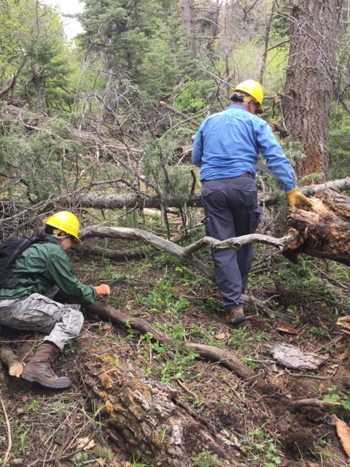
Sometimes the job gets down and dirty. Rav is working
to remove part of yet another mess of fallen trees from
the trail. Dave works on another piece of the puzzle.

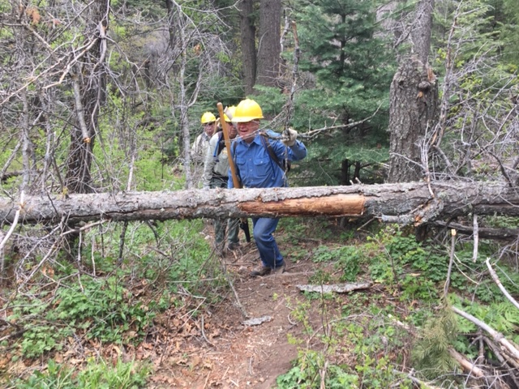
Jerry tosses away a broken piece of branch as the crew approaches a fallen tree across the trail.

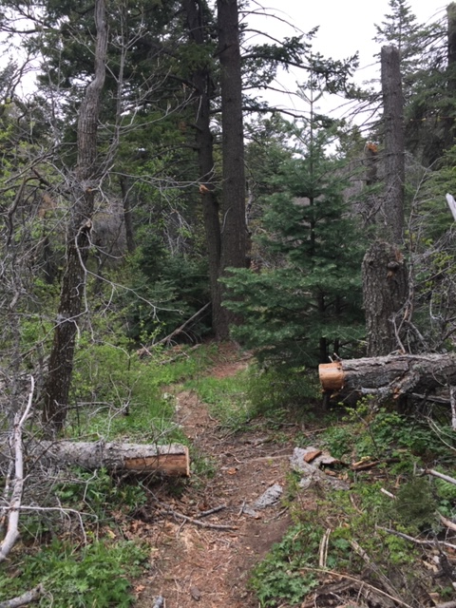
Tree in previous photo is no longer in the way.

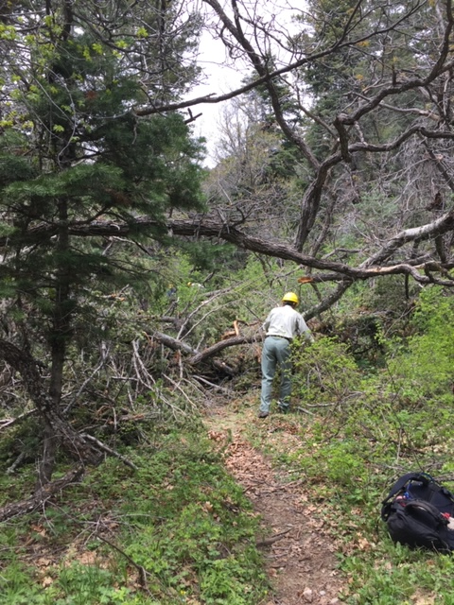
Bob works to remove brush from another train wreck. Like
most such train wrecks, this one required the removal of
trees in “pickup sticks” fashion, one tree at a time in specific
order, to safely remove everything.
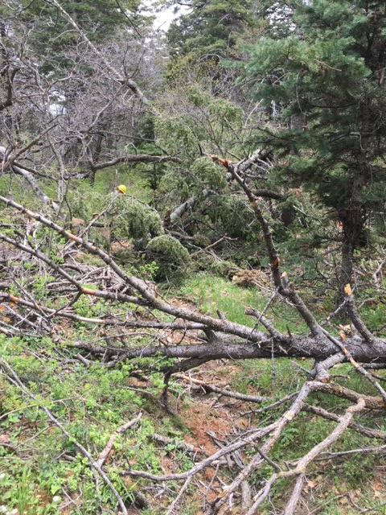
Sometimes there is not much distance between the fallen
trees. This one was just beyond the big train wreck in
the previous picture. It was removed.

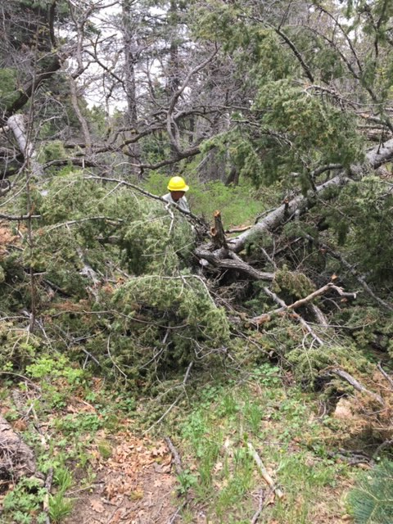
Another view of the big mess. Bob cuts away branches
at the far side.
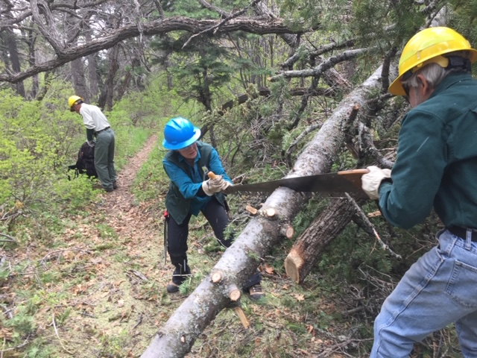
Bet and Byron making the last cut on the train wreck from previous photos.
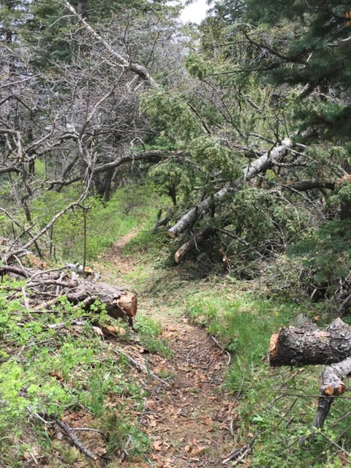
Train wreck gone. Trail portion cleared.

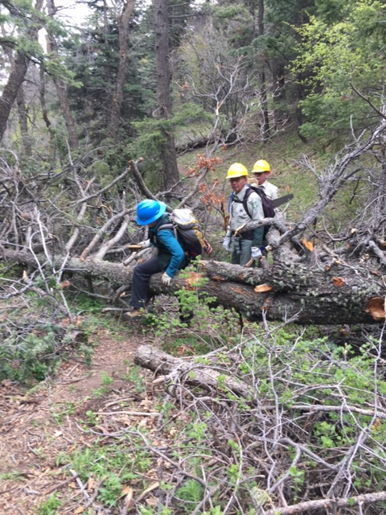
Bet crosses back over fallen tree to remove remaining
protruding branches prior to the work starting to remove
the trunk from the trail.
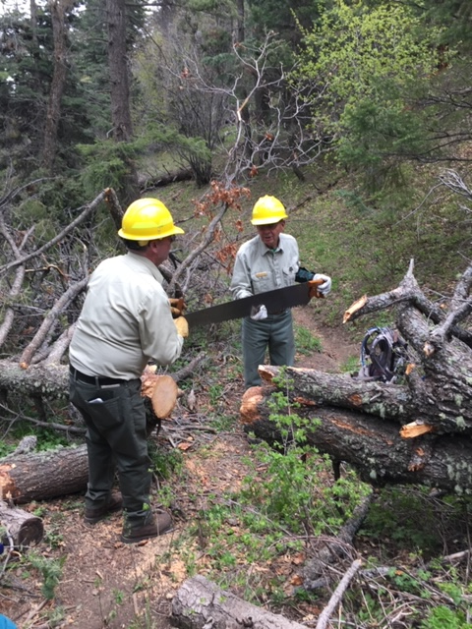
Jim and Bob preparing to place protective sheath back
on the saw so that it can be safely carried to the next
job.
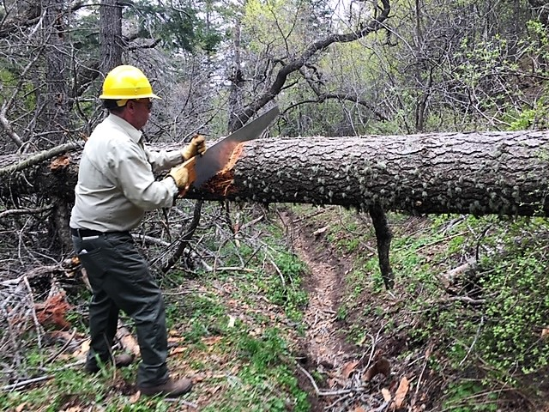
Jim working to remove a 17” diameter fallen tree trunk that was
suspended at head height over the trail.
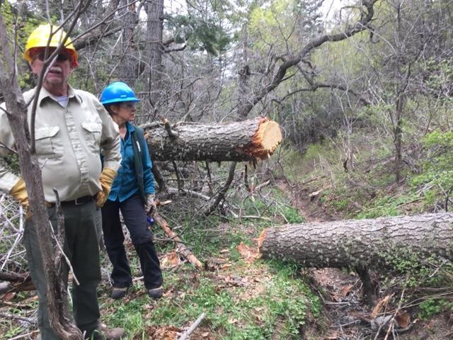
Cut shown in previous photo has been completed. The cut section
was removed to clear the trail.

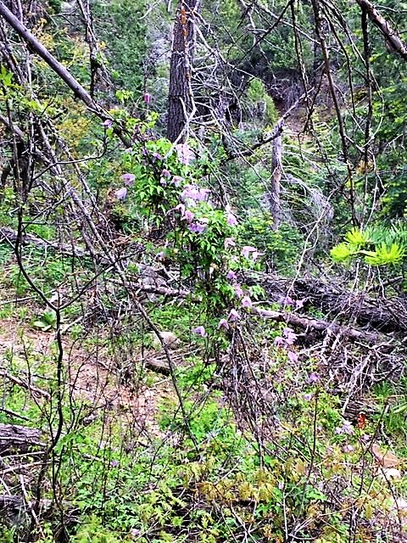
Like other Sandia trails, there was a spring explosion
of flowers along Cienega. This was but one of many Clematis
vines that covered the hillside at this location.

