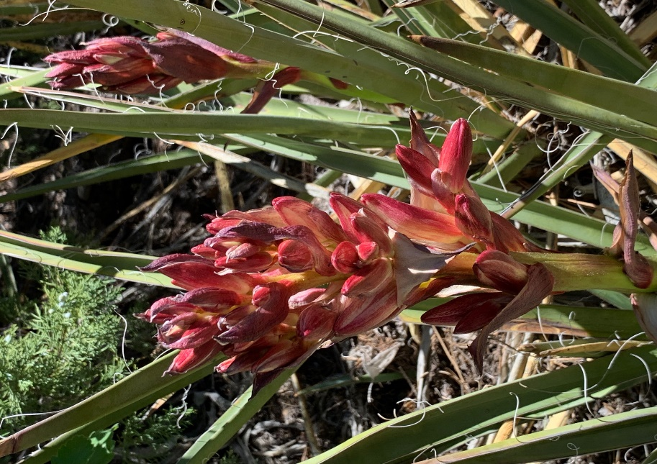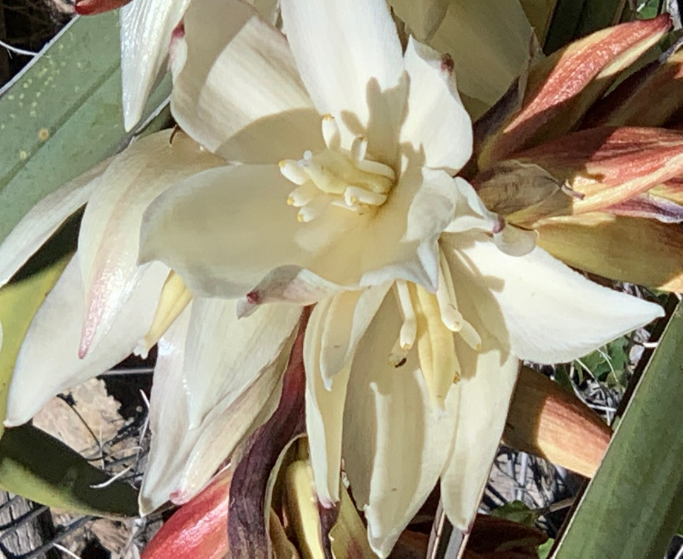

Faulty Trail was just a garden of flowers on Friday. We saw flowers that we had not seen in a long time. The Banana Yucca
in first stage of bloom and it’s flower on the right. These just lined the trail.
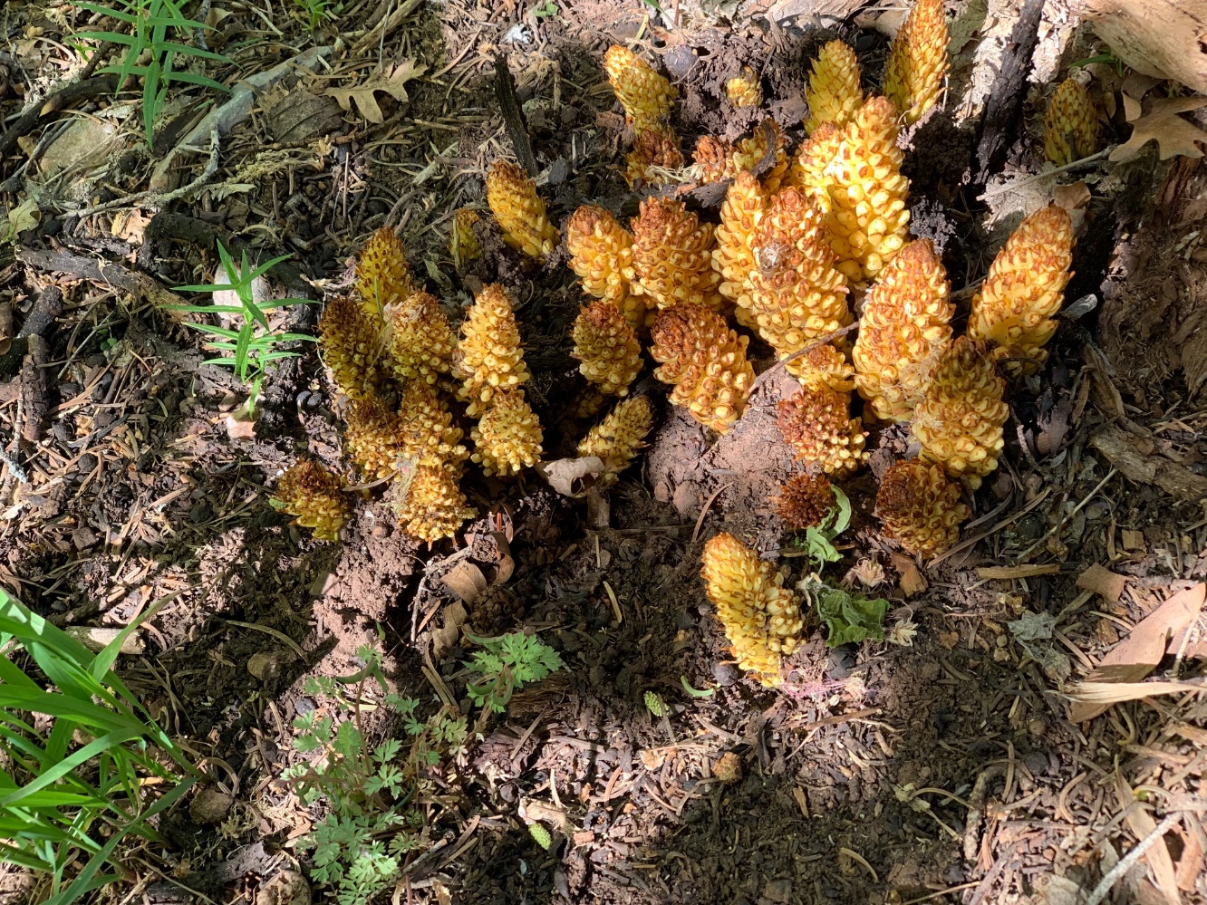

The Bear Corn was everywhere and in various stages of growth. This was one of the more spectacular ones.

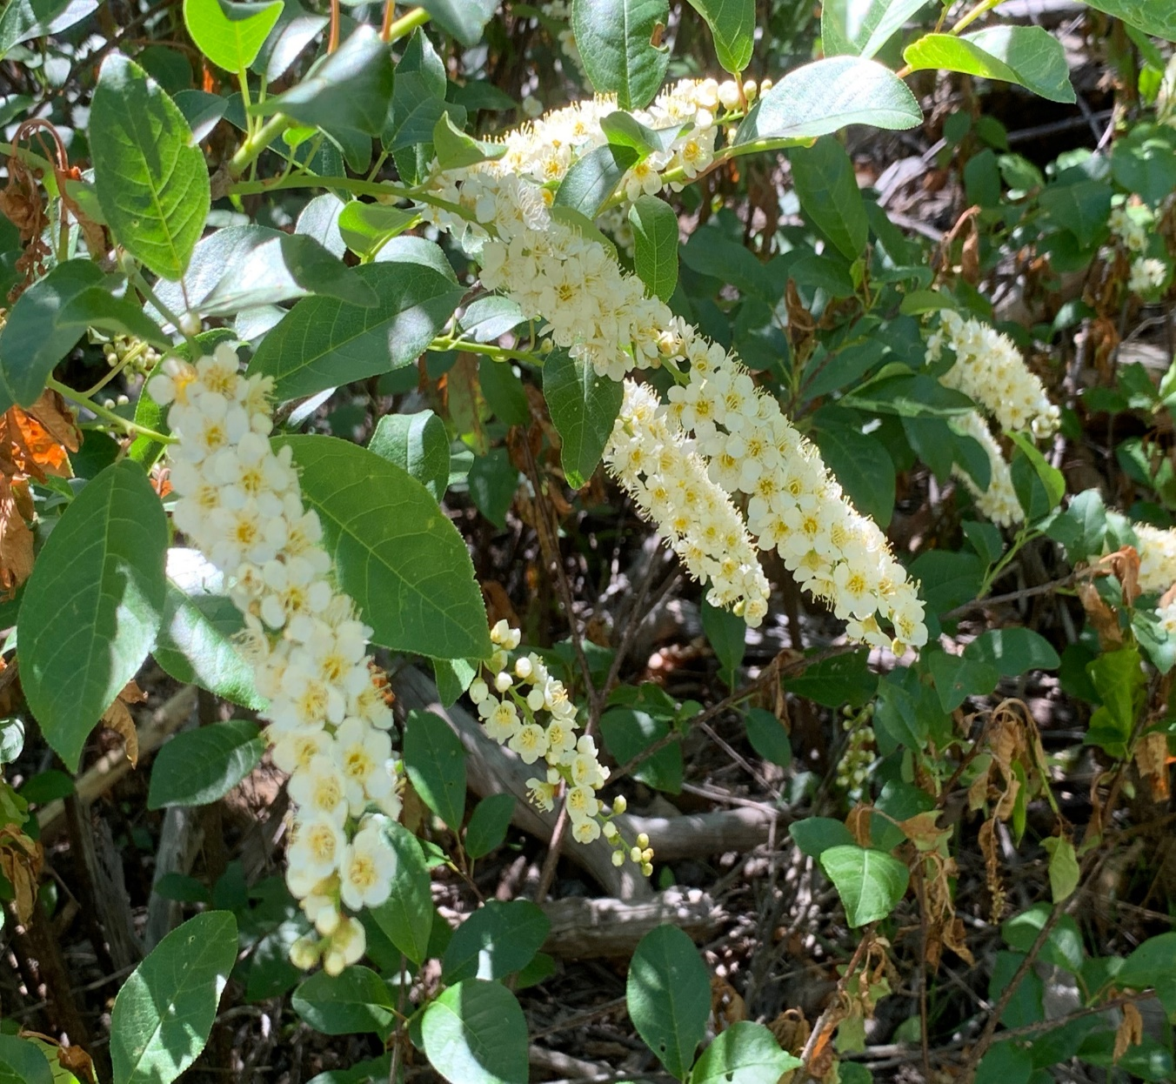

Chokecherry is everywhere from Cienega to Bill Spring. If
you can’t find it, play the wind as it will be blowing the pungent scent your direction. When you see it, the hillsides will be in spectacular bloom. There are some plants still in tight bud.

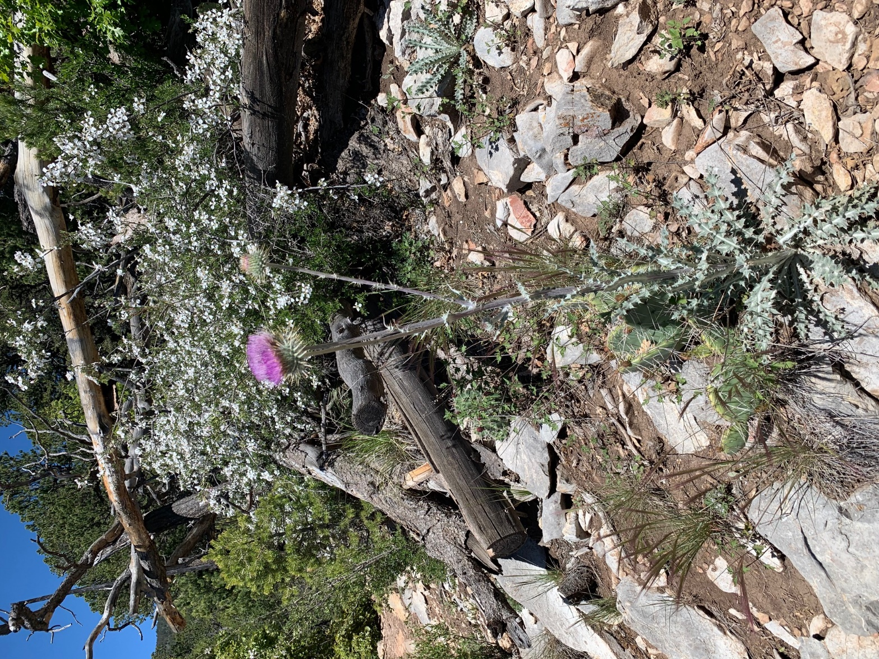

Thistle (native) along with the Cliff Fendler Bush. There
are only small sections with the thistle. The Cliff Bush
is everywhere and most spectacular. Whole hillsides from just
above the trail and upward of 50’ or so are interspersed
with other showy plants.

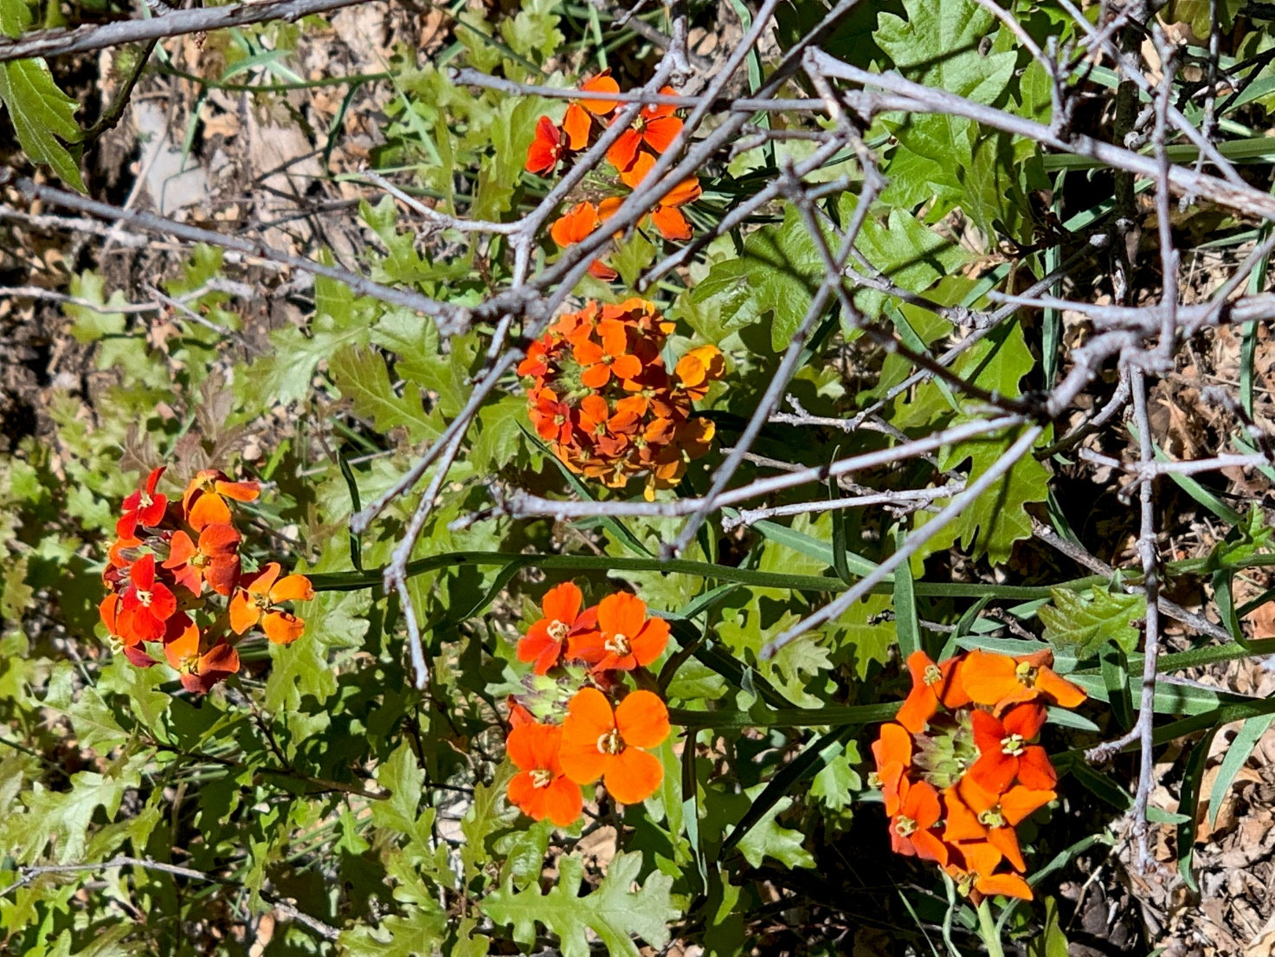

There is the spectacular Wallflower in Burnt orange
Color. Not as numerous on the trails, but when it is
found, it is just like this plant.

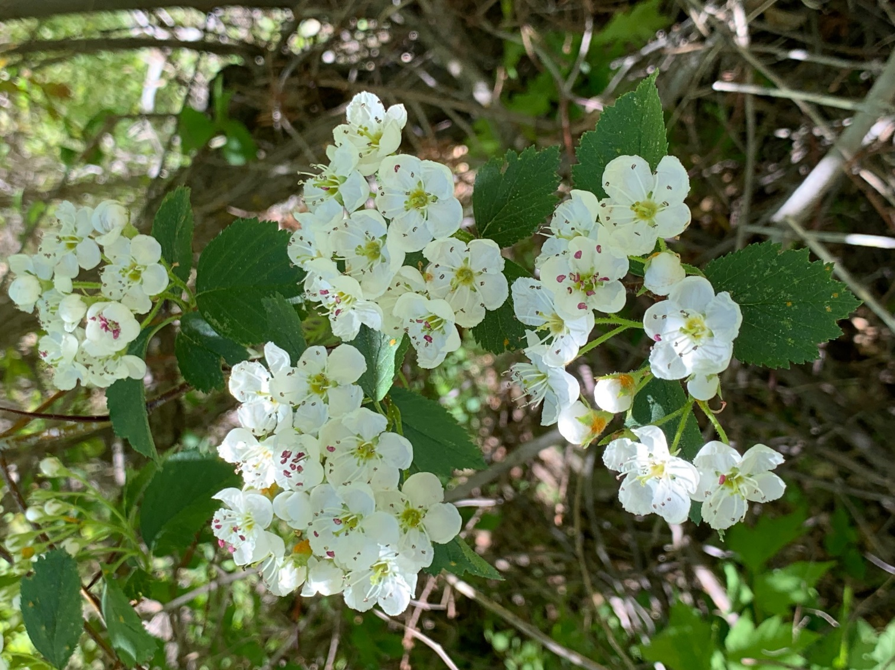

What a beautiful bush the Ninebark is. Again, it seems
to like the Faulty trail.

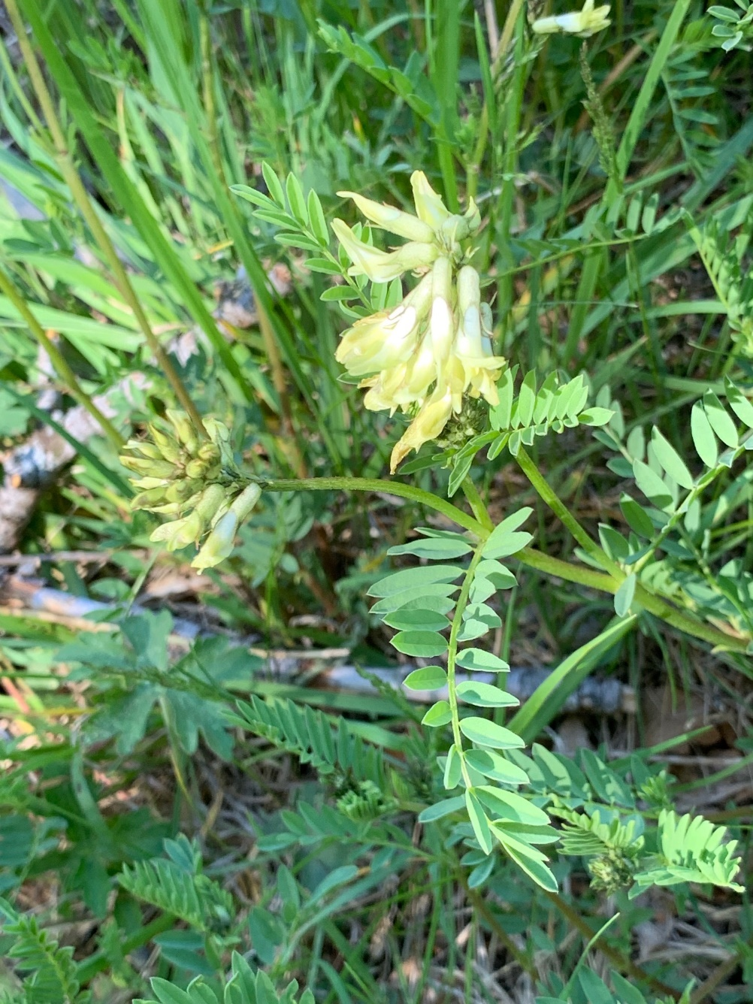

Not many of these plants so it was a treat to
find a few in bloom: Milkvetch.

