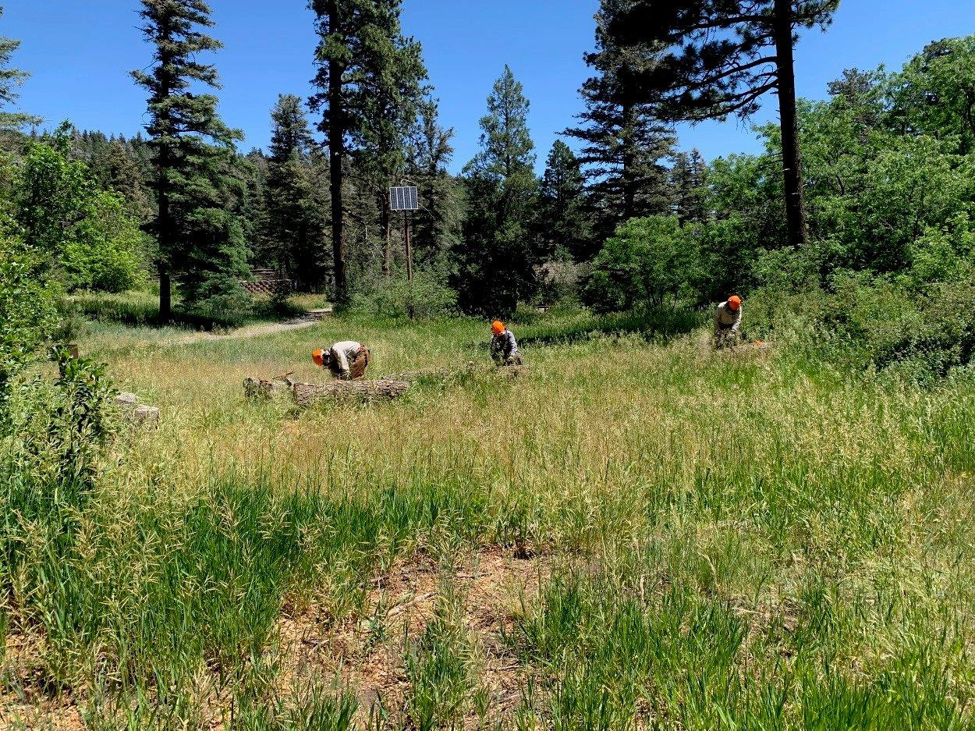
L to R: Sam Beard, Jerry Carroll, and Bill White bucking separate pieces of a 29-inch diameter fir hazard tree
that Jerry felled a few months ago in the lower part of Balsam Glade Picnic Area.
Photo by Sally Lowder
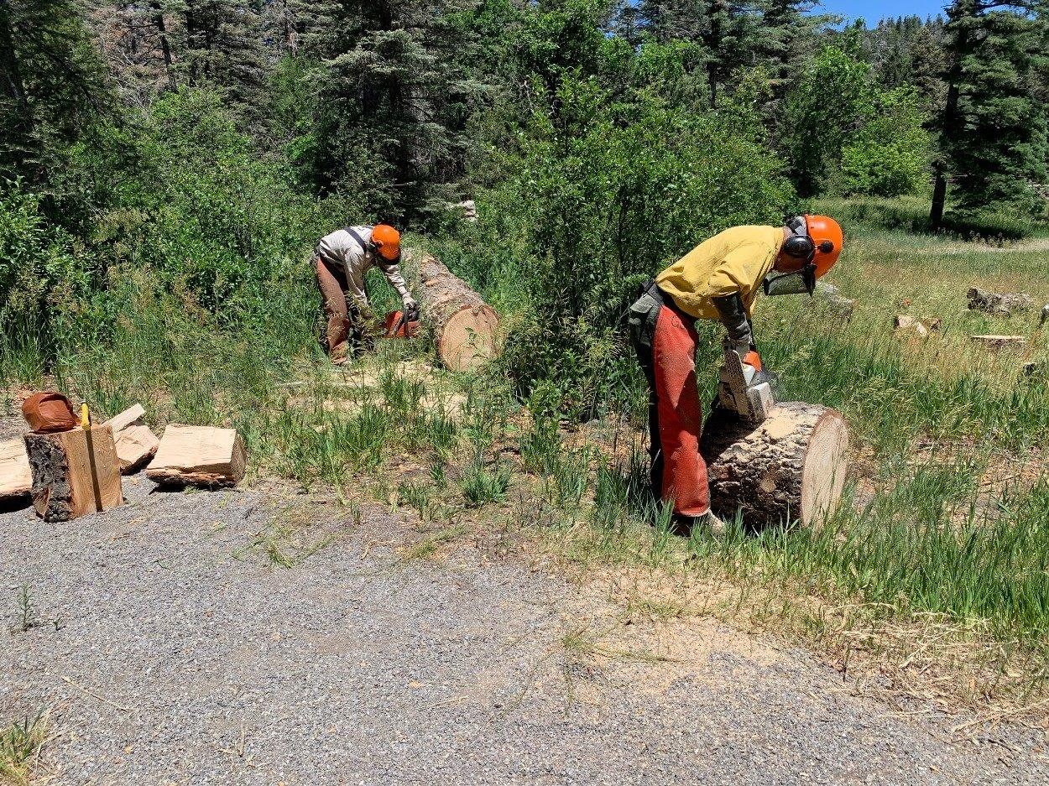
Sam bucking the trunk of the large fir tree, and Bob Lowder bucking a piece of the tree so that it will be easier to split.
Photo by Sally Lowder

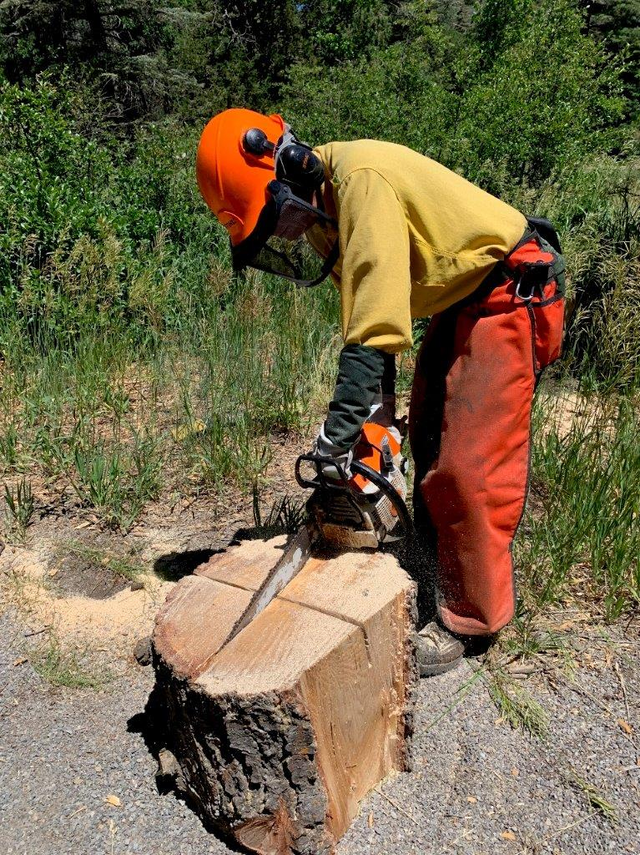
Bob scoring a piece of the fir so that steel splitting wedges can be placed in the grooves.
Photo by Sally Lowder

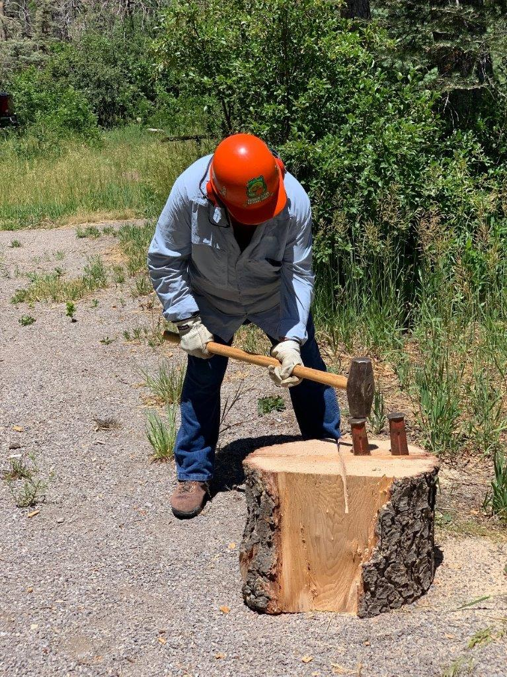
Lou Romero splitting a large piece of the fir tree so that it is easier to handle.
Photo by Sally Lowder

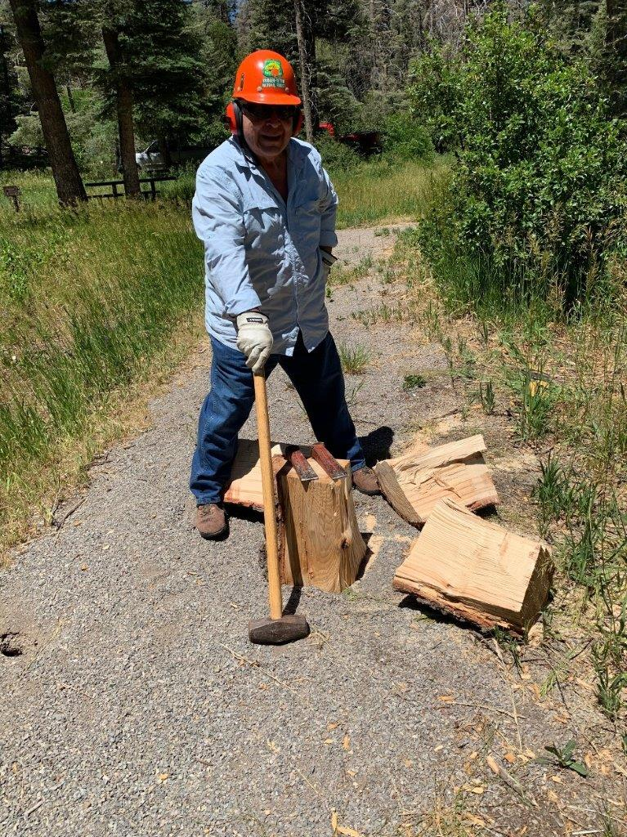
Lou with the four pieces of the fir he just split.
Photo by Sally Lowder

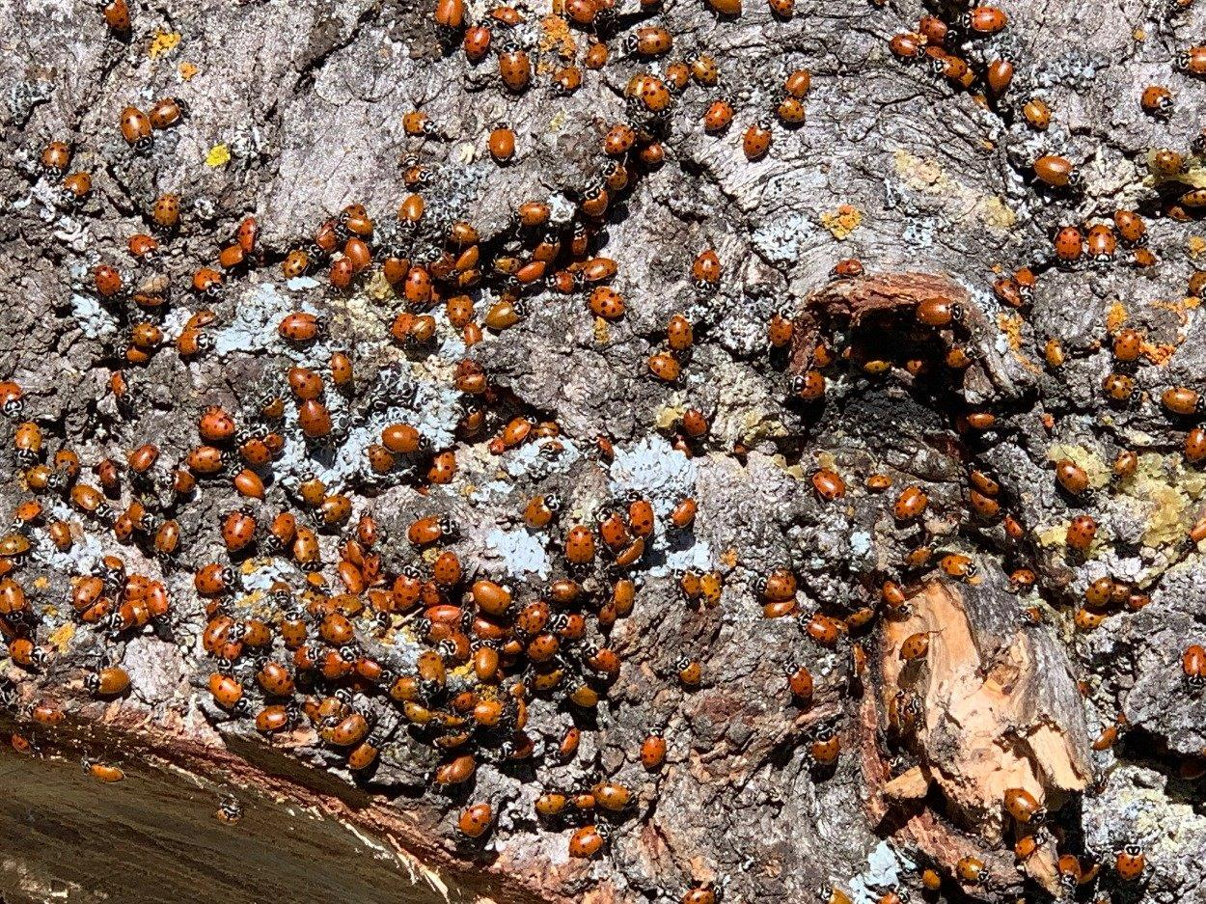
Lady Bugs on tree bark.
Photo by Sally Lowder
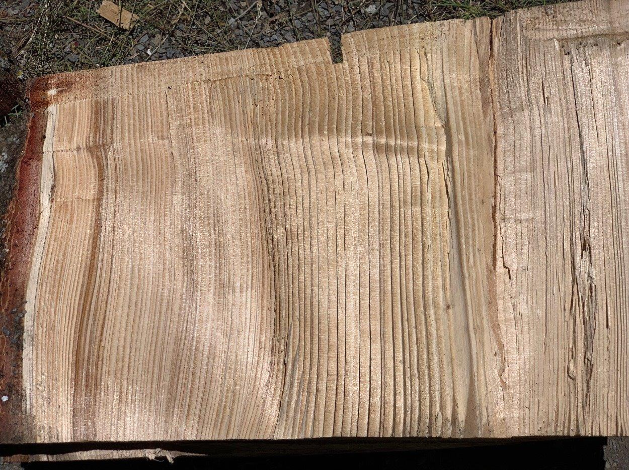
The grain on a piece split fir wood,
Photo by Sally Lowder

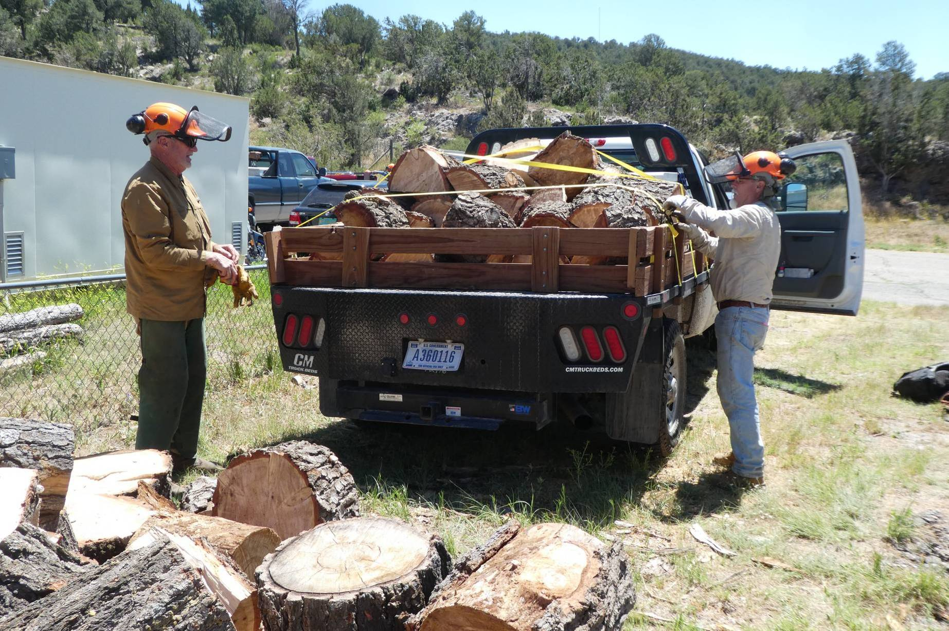
L to R: Dan Benton and Bill White removing tie-down straps from a load of wood from the lower part of Balsam Glade Picnic Area.
The volume of this load is approximately one-half cord. Three loads or a total of one and one-half cords of wood were hauled from
Balsam Glade Picnic Area on Wednesday. Photo by Sam Beard

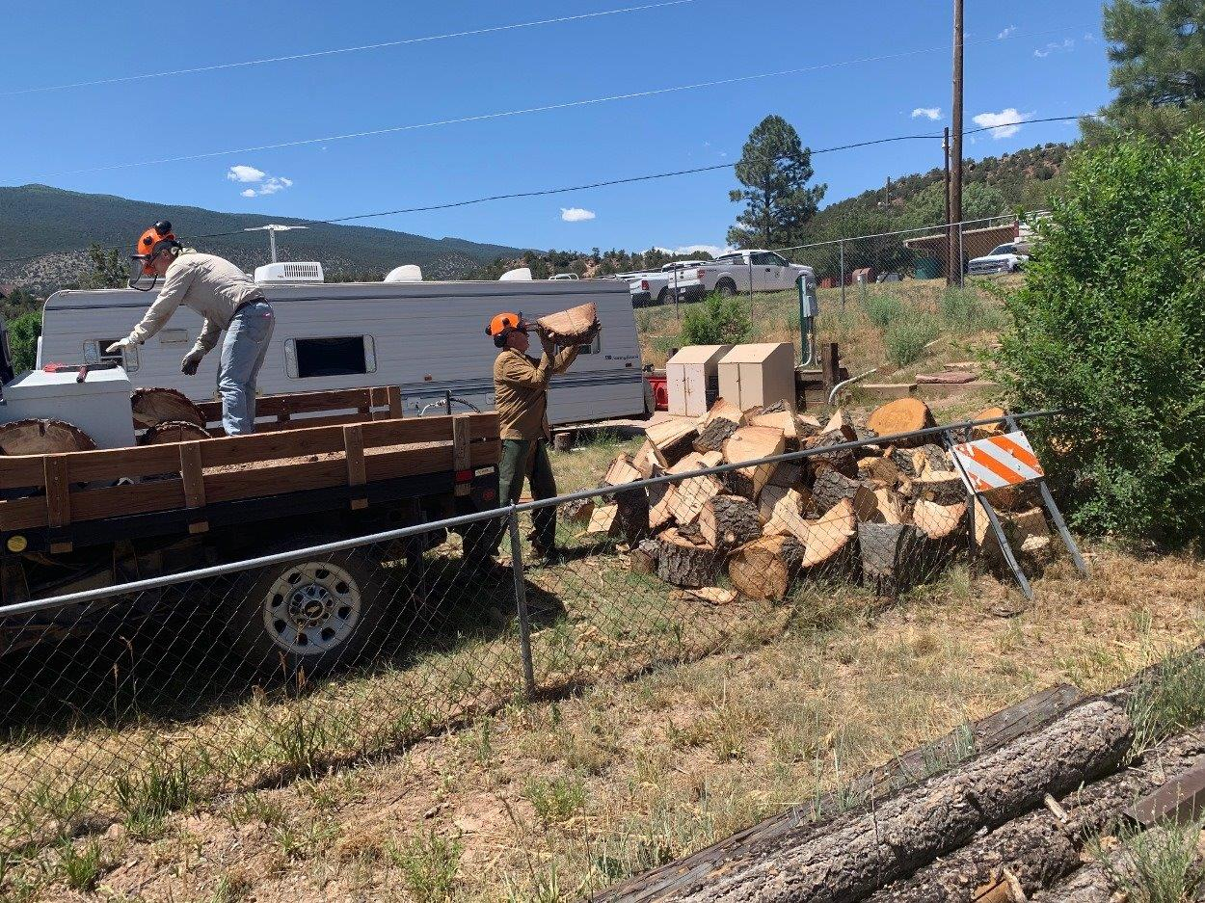
Dan and Bill adding wood to the pile that will be donated to the Mountain Christian Church Wood Ministry for distribution
to needy families in the East Mountain Area.
Photo by Sally Lowder

