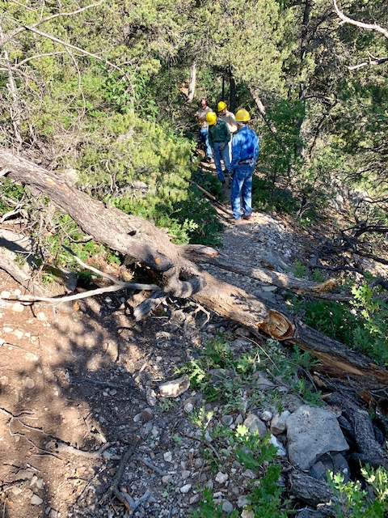
This is the first tree that the crew discovered after
starting up Lower Faulty from the Crest Trail 130 junction
above Canyon Estates. It was removed.

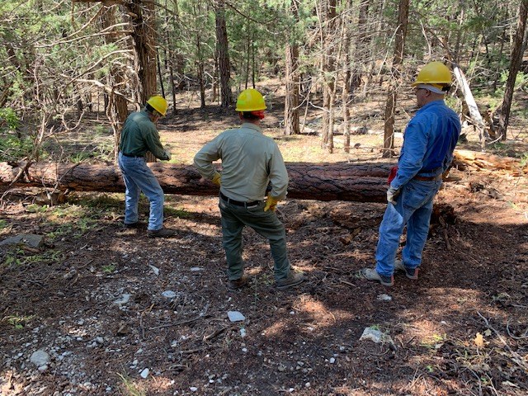
This is the second tree found on Faulty. It is an 18” diameter fallen Ponderosa. After a discussion about the best way to clear the trail, Byron prepares to remove the bark at the cut location. There was a short walk-around at the base of the tree, but since the crew determined that the tree could be removed with a single cut, that was done.

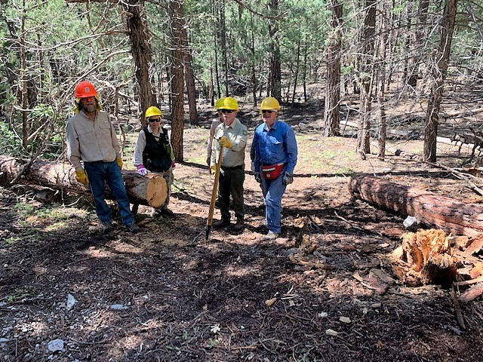
The large Ponderosa has been removed. After it had been cut away from the stump, the lower portion was rolled off and secured.
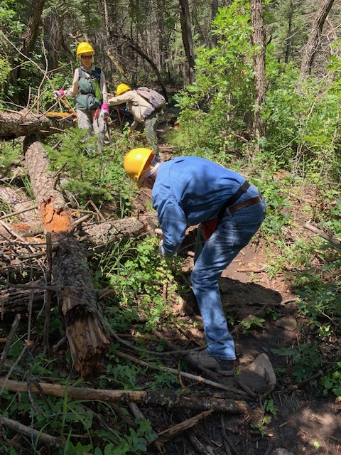
Jerry is cutting away a section of a tree that fell across
the trail at about shin-high level. It created a tripping hazard.
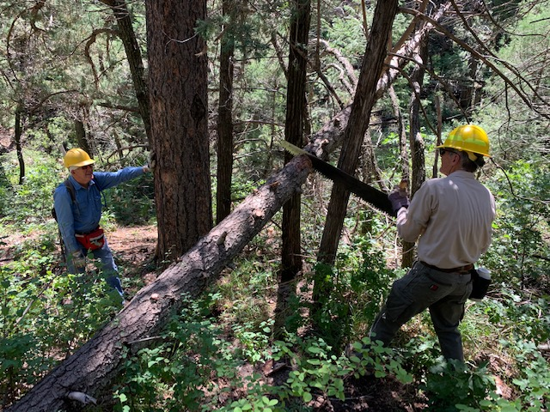
Sim is using a crosscut saw to begin the removal of a tree hung-up across Faulty. After the top had fallen away, the remaining trunk portion was carried away from the trail.

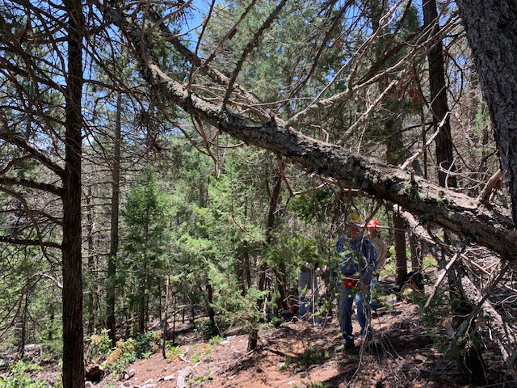
These two trees were hung-up over Faulty. While they were high enough for users to pass under, they were poorly supported and likely to fall in the not too distant future. Since it would be a long hike to come back to get them when they fell, the crew decided to take care of them now. After cutting away and removing a very small tree and other debris under them, the crew used long ropes to pull them to the ground and off the trail.
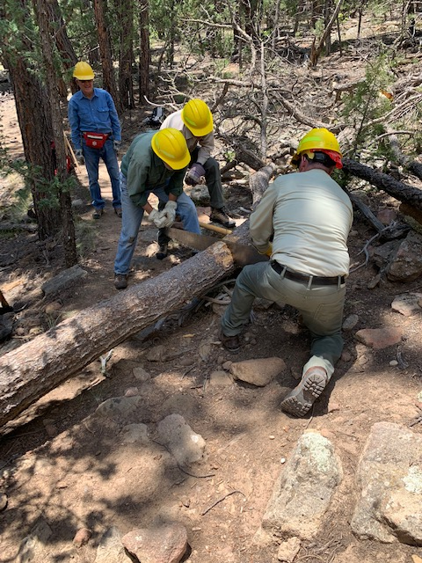
This was the second and largest of two trees removed from
Upper Faulty after the last of the reported fallen trees from Lower Faulty were removed. Since the log had top bind and was too small for wedges, Sim uses the cant hook to support the log and help keep the kerf open for the saw to move freely. After the cut, the lower portion was moved completely away. The upper part was secure and resting directly on a rock outcropping. It was left in place.

